DEVOPS.PROJECT REPORT
STUDENT PLATFORM APPLICATION
Project Documentation, Commands, AWS Evidence and Deployment Guide

Student Name | Pranav jadhav
PRN | 2125UMLM1083
University | Sanjivani University, Kopargaon
Course | B.Tech AIML
Subject | DevOps
Project | Student Platform DevOps Application (unit3 mini project )
GitHub | https://github.com/ pranavjadhav4484 -crypto/student-platform-devops-app-main.git
Academic Year | 2026

1. Abstract
This report documents the Student Platform DevOps application stored in GitHub. It explains the role of version control, application setup, cloud hosting, containerization concepts, and a typical deployment workflow. It also includes real AWS practical screenshots previously supplied by the student and extra illustrative command-terminal images. The illustrative images are examples only; they do not prove that those commands have been run successfully on the current project.

2. Project Details
Project repository: https://github.com/yashkothule01-crypto/student-platform-devops-app-main
Purpose: maintain a student-platform application in source control and document a repeatable way to retrieve, configure, run, validate, and potentially deploy it.
Important verification note: inspect the repository README and file list before running commands. The app entry point, requirements file, Dockerfile, Jenkinsfile, and actual CI/CD configuration can vary. Commands below are labelled by scenario and should only be used when the matching files exist.

3. Aim and Objectives
- Understand the project repository and its file structure.
- Use Git to clone and inspect source code.
- Install project dependencies using the repository's dependency manifest.
- Run and test the app locally before deployment.
- Explain AWS EC2 and SSH access for a Linux cloud server.
- Document optional Docker and CI/CD workflows without claiming unverified execution.

4. Theory

4.1 DevOps
DevOps combines development and IT operations practices to improve collaboration, automation, repeatability, and feedback.

4.2 Git and GitHub
Git tracks code changes; GitHub hosts repositories and supports collaboration, reviews, issues, and automation.

4.3 AWS EC2
EC2 provides virtual servers. An instance is configured with an operating-system image, instance type, network rules, key pair, and storage.

4.4 SSH and MobaXterm
SSH encrypts remote terminal sessions. MobaXterm can connect from Windows to a Linux EC2 instance using the correct username, host, and private key.

4.5 Docker
Docker packages an application and dependencies into a container image. Use Docker commands only if a Dockerfile or compatible setup exists.

4.6 CI/CD
Continuous Integration automates code checks and tests. Continuous Delivery/Deployment automates packaging and release. A Jenkinsfile or workflow file is needed to confirm a pipeline is configured.

5. Conceptual Architecture
Developer → Git repository → build and test → deployment host (for example, EC2) → browser/user. This is a reference architecture, not proof that every stage is currently automated in the supplied repository.

6. Commands — Clone and Inspect Repository
Run in PowerShell, Windows Terminal, or Git Bash. If the folder already exists, change into that folder instead of cloning again.
git --version
git clone https://github.com/yashkothule01-crypto/student-platform-devops-app-main.git
cd student-platform-devops-app-main
git status
git branch
git log -5 --oneline
dir

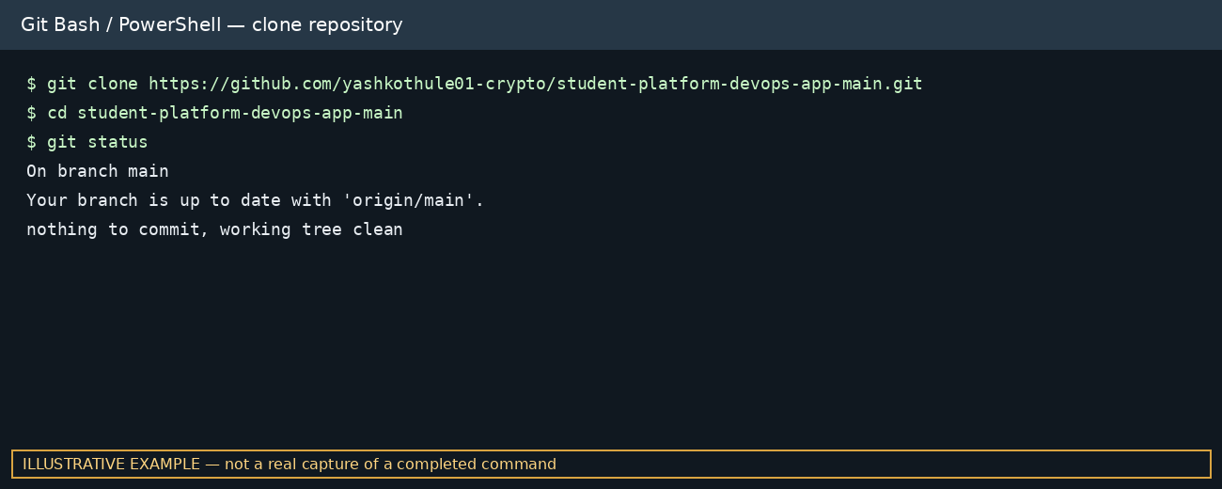
Figure 1. Illustrative terminal example for cloning and inspecting the repository.

7. Commands — Python App (only if this is a Python project)
First inspect the repository for requirements.txt and its README. On Windows PowerShell:
python --version
python -m venv venv
.\venv\Scripts\Activate.ps1
python -m pip install --upgrade pip
pip install -r requirements.txt
# Run the entry point documented in README; examples:
python app.py
# or, if the project uses a package entry point:
python app/app.py

If PowerShell blocks activation, use Command Prompt with: venv\Scripts\activate.bat. Do not run both example entry points; use the one that matches the repository.
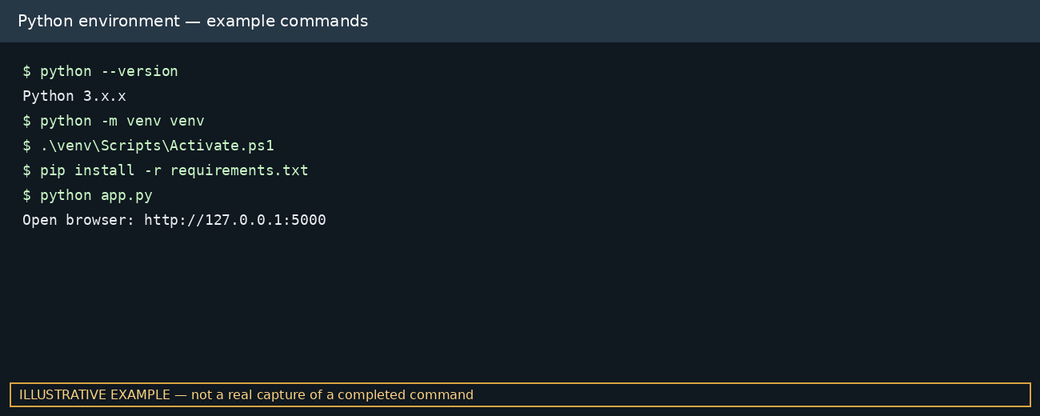
Figure 2. Illustrative Python setup commands; output is not a real execution capture.

8. Useful Git Commands
git status
git pull
git add .
git commit -m "Update project documentation"
git push
git remote -v
git diff

Only commit changes you intend to publish. Never add .env files, passwords, AWS credentials, private keys, or database files containing private information.

9. AWS EC2 and MobaXterm
The next two images are actual AWS screenshots previously supplied for the student's practical record. They show EC2 instance/storage configuration, but do not independently prove that the Student Platform application was deployed on that instance.

9.1 EC2 instance screenshot
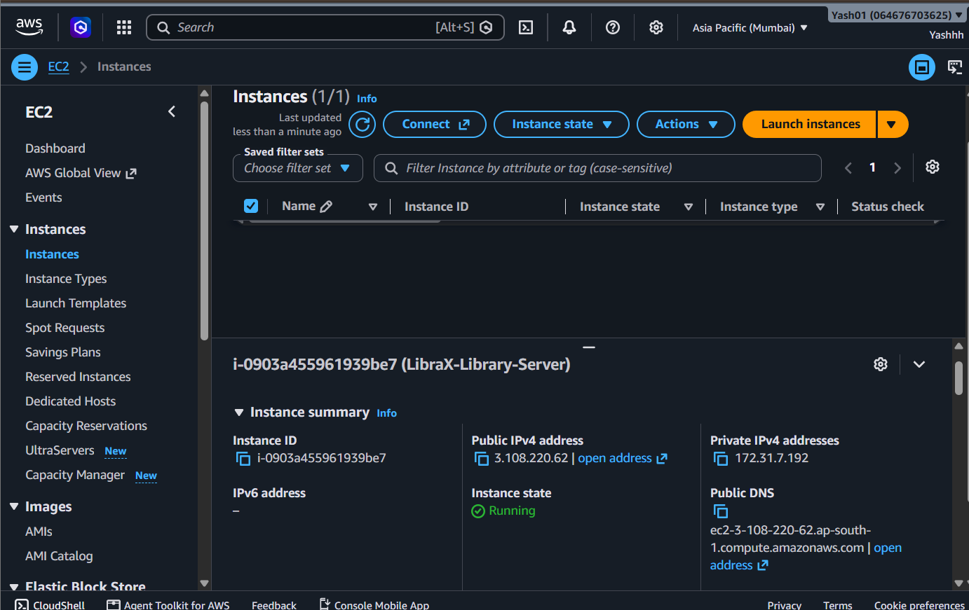
Figure 3. Actual AWS EC2 Instances screenshot previously supplied by the student.

9.2 EC2 storage screenshot
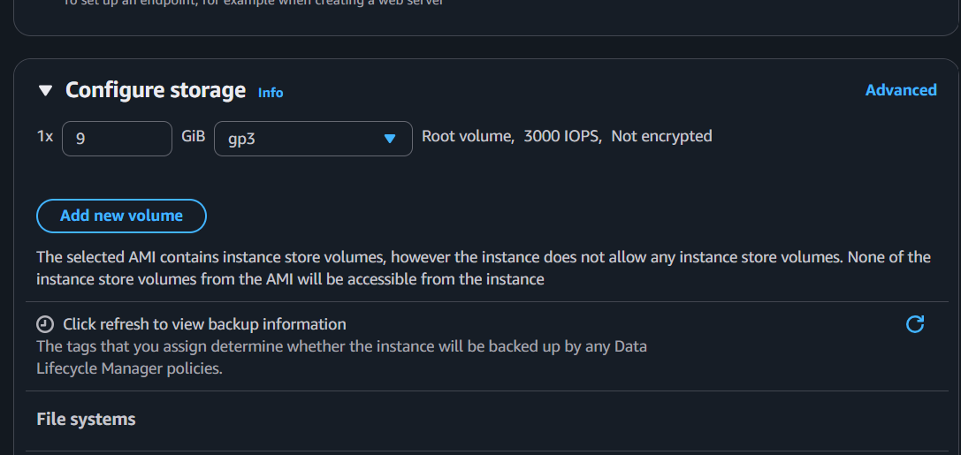
Figure 4. Actual AWS EC2 storage configuration screenshot previously supplied by the student.

9.3 Ubuntu commands after SSH login
After connecting through MobaXterm to the correct EC2 host, run these commands on Ubuntu. Use the Ubuntu username for Ubuntu AMIs; use the username appropriate to the AMI you selected.
whoami
pwd
ls -la
sudo apt update
sudo apt install -y git python3 python3-venv python3-pip
git clone https://github.com/yashkothule01-crypto/student-platform-devops-app-main.git
cd student-platform-devops-app-main
ls -la

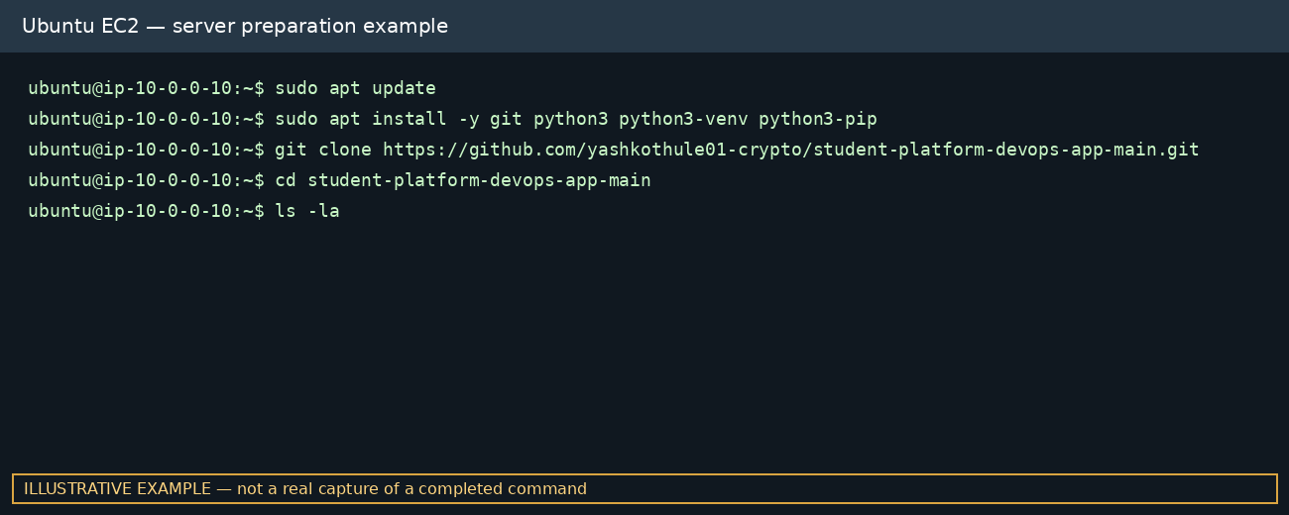
Figure 5. Illustrative EC2 terminal commands; host and output are examples only.

10. Optional Docker Commands
Use this section only if the repository contains a Dockerfile and Docker is installed on the target machine. Check first with: dir (Windows) or ls -la (Linux).
docker --version
docker build -t student-platform:latest .
docker run -d --name student-platform -p 5000:5000 student-platform:latest
docker ps
docker logs -f student-platform
docker stop student-platform
docker rm student-platform

Port 5000 is an example for a Flask-style app; change it to the port configured by the actual application. Do not run a Docker build if no Dockerfile exists.
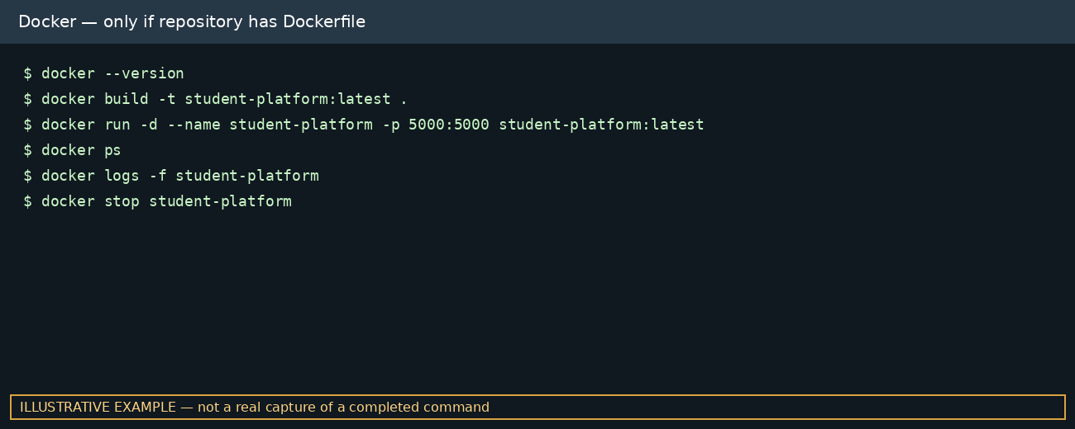
Figure 6. Illustrative Docker commands; not a real build or running container capture.

11. Optional Jenkins / CI-CD Checklist
Before claiming Jenkins CI/CD is implemented, verify whether the repository contains a Jenkinsfile and whether a Jenkins job is configured to use this repository.
- Open Jenkins and create/open the relevant Pipeline job.
- Configure the repository URL and branch (for example, main) only if that is the branch used.
- Use the Jenkinsfile from the repository if it exists; do not paste a generic pipeline without adapting it.
- Run Build Now and inspect the actual console output.
- Capture the real successful/failed build page for evidence.
- Store credentials in Jenkins Credentials, not in source code.

12. Application Verification
# Check files before choosing the run command
dir
# or on Ubuntu
ls -la
# If requirements.txt exists
pip install -r requirements.txt
# Run the command specified by the project README
# Then open the URL/port printed by the app

For a local Flask application the URL is often http://127.0.0.1:5000, but use the address and port printed by the actual application. For EC2 access, configure the security group narrowly to allow only required inbound ports. Do not expose a development server publicly for production use.

13. Troubleshooting

Repository clone fails
Check internet access, repository URL, and whether the repository is public or you have permission.

pip command not found
Use python -m pip --version and python -m pip install -r requirements.txt.

ModuleNotFoundError
Activate the intended virtual environment and install the repository dependencies.

Port already in use
Stop the old app process or configure a different available port.

Cannot access EC2
Check instance state, public address, security group SSH rule, username, and private-key selection.

Dockerfile not found
Confirm the current directory and verify that the repository actually contains a Dockerfile.

14. Security Best Practices
- Keep SSH private keys and passwords secret.
- Restrict SSH to a trusted IP address rather than opening it to all IPs.
- Expose only the ports the application needs.
- Do not commit credentials or .env files to GitHub.
- Use test accounts and remove sensitive identifiers from screenshots shared publicly.
- Stop unused EC2 instances and check AWS costs before leaving resources running.

15. Results and Conclusion
This expanded report records the project identity, core DevOps theory, Git commands, optional Python/Docker commands, EC2 server preparation, and verification guidance. Two real AWS screenshots from the student's earlier practical record are included. Additional terminal images are explicitly labelled illustrative examples, not genuine execution evidence. To complete the evidence section, add actual screenshots of the repository file list, the running application, and any successful build/deployment performed on the student's environment.

