DEVOPS ASSIGNMENT
Automated Maven Build and Test using Jenkins CI

Detailed Implementation Report

Student Name | Pranav jadhav
Programme | B.Tech – Computer Science & Engineering (AI & ML)
Year | Second Year
Project / Assignment | Maven Java Project with Jenkins Continuous Integration
Source Repository | DevOps-Assignments (GitHub)
https://github.com/pranavjadhav4484 -crypto/devops_main_assgniment-.git
Submission evidence includes the GitHub repository structure and Jenkins successful build console.

Contents
- 1. Abstract
- 2. Aim and Objectives
- 3. Tools and Technologies
- 4. System Architecture and Workflow
- 5. Project Repository Structure
- 6. Jenkins Pipeline Implementation
- 7. Implementation Procedure
- 8. Build Result and Evidence
- 9. Memory Issue and Resolution
- 10. Results, Learning Outcomes and Conclusion
- 11. References

Abstract
This assignment demonstrates a basic Continuous Integration (CI) workflow for a Java application using Apache Maven, GitHub, and Jenkins. The source code and Jenkinsfile are maintained in a GitHub repository. Jenkins retrieves the repository, verifies the Java and Maven toolchains, then runs the Maven clean and test lifecycle inside the Java project directory. The final successful console output confirms that the pipeline completed without a reported failure in the recorded run.

Aim and Objectives
Aim: To configure and execute a Jenkins pipeline that checks the Java/Maven environment and builds/tests a Maven Java project from source control.
- Store the assignment source files and Jenkinsfile in a GitHub repository.
- Configure a Jenkins Pipeline job to load its pipeline definition from GitHub (Pipeline script from SCM).
- Verify the installed Java runtime and Maven installation.
- Execute the Maven clean test lifecycle in the project directory.
- Review the build console and capture evidence of a successful pipeline run.

Tools and Technologies
Tool / Technology | Purpose | Evidence / Notes
AWS EC2 / Ubuntu | Hosts the Jenkins server and project build environment. | Jenkins runner was accessed through MobaXterm.
Jenkins 2.580.1 | Orchestrates the CI pipeline and displays build logs. | Pipeline job: DevOps-Assignments-  CI.
Git and GitHub | Version control and remote source repository. | main branch; Jenkinsfile stored at repository root.
Java | Runtime/compiler platform for the Java project. | Pipeline includes java -version.
Apache Maven 3.8.7 | Build automation and test execution. | Pipeline includes mvn -version and mvn clean test.
MobaXterm / SSH | Remote terminal access to the Ubuntu EC2 host. | Used to inspect service status and system memory.

System Architecture and Workflow
The implemented CI workflow is:
- Developer commits the Java project and Jenkinsfile to the GitHub main branch.
- Jenkins Pipeline job reads the Jenkinsfile from the Git repository.
- Jenkins checks out the repository into its workspace.
- The pipeline verifies Java and Maven versions.
- Maven runs from Assignment-Maven-Java/maven-java-project using the clean test lifecycle.
- Jenkins reports the result in the build console and runs the configured post-build message.
Jenkins Pipeline definitions are commonly stored as a Jenkinsfile in source control, allowing the build process to be versioned with the project. Jenkins stages group related work into named steps, and post conditions can report success or failure.
Official Jenkins Pipeline documentation: Jenkins Pipeline
Declarative syntax and post conditions: Pipeline Syntax

Project Repository Structure
The public repository contains the following main entries, as shown in the evidence screenshot:
DevOps-Assignments/
├── Assignment-Maven-Java/
│ └── maven-java-project/
├── Assignment-Terraform-AWS/
├── .gitignore
└── Jenkinsfile
GitHub repository: https://github.com/adityapaithankar25uml-debug/DevOps-Assignments
The Jenkins job is configured with the repository URL above, branch specifier */main, and script path Jenkinsfile. The Jenkinsfile is located at the root of the repository.

Jenkins Pipeline Implementation
The committed Jenkinsfile defines four stages and a post section. The Maven command is configured with a limited heap to reduce memory pressure on the small EC2 instance while keeping tests enabled.
pipeline { agent any

stages { stage('Checkout') { steps { echo 'Source code checked out from GitHub'
}
}
stage('Verify Java') { steps { sh 'java -version'
}
}

stage('Verify Maven') { steps { sh 'mvn -version'
}
}
stage('Build Maven Project') { steps { dir('Assignment-Maven-Java/maven-java-project') { sh 'MAVEN_OPTS="-Xms64m -Xmx192m" mvn -B -ntp clean test'
}
}
}
} post { success { echo 'Build and tests completed successfully!'
} failure { echo 'Build failed. Check the console output.'
}
}
}
Stage descriptions:
- Checkout: emits a message identifying the source-control checkout phase. Jenkins performs SCM checkout as part of the Pipeline-from-SCM job configuration.
- Verify Java: runs java -version to display the Java runtime version.
- Verify Maven: runs mvn -version to confirm Maven and its Java runtime configuration.
- Build Maven Project: changes into the Maven project directory and runs clean test. The clean goal removes previous build output; test executes the project’s configured test phase.
- Post actions: prints a success message when the pipeline succeeds, or a troubleshooting message if it fails.

Implementation Procedure
- Prepare the source repository: Place the Maven Java project under Assignment-Maven-Java/maven-javaproject and store the Jenkinsfile at the repository root.
- Commit and push changes: Commit the Jenkinsfile to the main branch and push it to the GitHub remote so Jenkins can retrieve the latest version.
- Configure the Jenkins job: Create a Pipeline job named DevOps-Assignments-CI. Choose Pipeline script from SCM, select Git, enter the repository URL, set the branch to */main, and set Script Path to Jenkinsfile.
- Run the job: Use Build Now and open the latest build's Console Output to observe the checkout, Java/Maven verification, Maven execution, and post-build message.
- Capture evidence: Save screenshots of the final successful console output and the public GitHub repository structure for the assignment report.

Build Result and Evidence
The submitted screenshot of Jenkins build #4 shows the final lines of the pipeline console, including the postsuccess message and “Finished: SUCCESS”. This is evidence that the recorded run completed successfully.
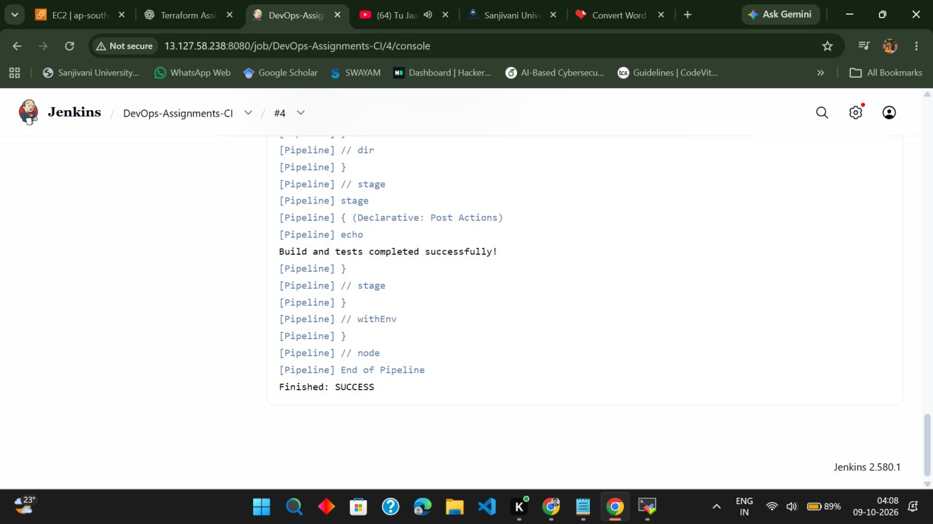
Figure 1. Jenkins build #4 Console Output showing the success message and Finished: SUCCESS.
The GitHub screenshot shows the repository on the main branch with the Assignment-Maven-Java folder, Assignment-Terraform-AWS folder, .gitignore, and Jenkinsfile.
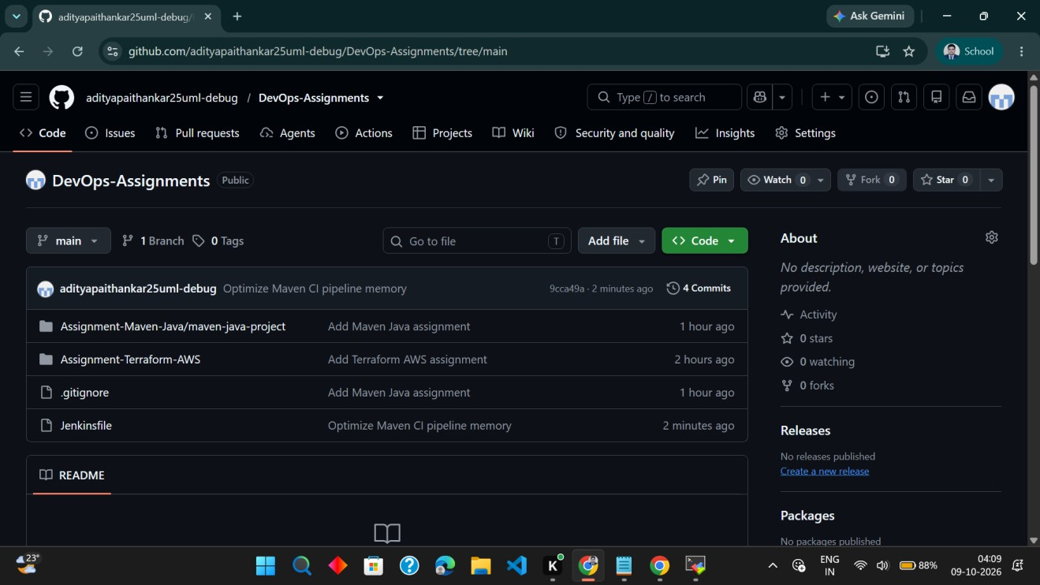
Figure 2. GitHub repository structure for DevOps-Assignments.
Clickable repository link: https://github.com/adityapaithankar25uml-debug/DevOps-Assignments
Jenkins URL (available only while the EC2 service and inbound access are active): http://13.127.58.238:8080/

Memory Issue and Resolution
During earlier runs, Jenkins was terminated by the Linux out-of-memory (OOM) killer. The captured kernel log stated that the Java process used by Jenkins was killed due to memory exhaustion. The instance had approximately 909 MiB RAM and initially had no swap. A 1 GiB swap file was subsequently created and activated, and Jenkins was restarted. The pipeline's Maven command was also adjusted to use MAVEN_OPTS with a 192 MiB maximum heap and quiet/batch flags (-B -ntp), while retaining the clean test goals.
This is a resource mitigation rather than a guarantee that all future builds will fit in the instance's memory. Larger projects or parallel jobs may still require a larger EC2 instance or further memory tuning.

Results, Learning Outcomes and Conclusion
Result: The recorded Jenkins build #4 finished with SUCCESS. The console includes the message “Build and tests completed successfully!” and the final status “Finished: SUCCESS”.
Learning outcomes:
- Understanding how Jenkins uses a Jenkinsfile to define a repeatable pipeline as code.
- Connecting a Jenkins job to a GitHub repository and selecting a branch and script path.
- Verifying Java and Maven in a CI environment.
- Running Maven's clean test lifecycle from the correct project subdirectory.
- Reading Jenkins Console Output and diagnosing memory-related build interruptions on a low-memory server.
Conclusion: The Maven Java project was connected to GitHub and executed through a Jenkins Declarative Pipeline. After addressing memory pressure and limiting Maven's heap, the recorded pipeline completed successfully. The repository and console screenshots provide supporting evidence for the assignment.

References
- Project GitHub repository
- Jenkins Pipeline documentation
- Jenkins Pipeline Syntax reference
- Jenkins Getting Started with Pipeline

