# IMPLEMENTATION OF BIKE SHARING SYSTEM

*submitted in partial fulfilment of the requirements for the degree of*

## BACHELOR OF TECHNOLOGY

*in*

## ELECTRONICS AND COMMUNICATION ENGINEERING

*by*

|  |  |
| --- | --- |
| **Pranav Prakash** | **102165011** |
| **Pranav Kumar Agrawal** | **102153031** |
| **Aditya Jha** | **102103250** |
| **Yati Dhanda** | **102103250** |
| **Sukirat Singh Monga** | **102165014** |

*under the supervision of*

**Dr. Amit Munjal** (Assistant Professor, ECED)

**Dr. Mohit Aggarwal** (Assistant Professor, ECED)



## DEPARTMENT OF ELECTRONICS AND COMMUNICATION ENGINEERING THAPAR INSTITUTE OF ENGINEERING & TECHNOLOGY

**PATIALA**

**December 2024**

# DECLARATION

We hereby declare that the design principles and working prototype model of the project entitled **IMPLEMENTATION OF BICYCLE SHARING SYSTEM** is authentic record of our own work carried out in Electronics and Communication Engineering Department, TIET, Patiala, under the guidance of **Dr Amit Munjal** and **Dr Mohit Agarwal** in the 7th semester

Date: 30 November 2024

|  |  |  |
| --- | --- | --- |
| Pranav Prakash | 102165011 |  |
| Pranav Kumar Agrawal | 102153031 |  |
| Aditya Jha | 102103250 |  |
| Yati Dhanda | 102103250 |  |
| Sukirat Singh Monga | 102165014 |  |

# CERTIFICATE

This is to certify that the report titled **'IMPLEMENTATION OF BICYCLE SHARING SYSTEM** ' submitted by Pranav Prakash, Pranav Kumar Agrawal, Aditya Jha, Yati Dhanda and Sukirat Singh Monga to the Thapar Institute of Engineering & Technology, Patiala, for the award of the degree of Bachelor of Technology, is a record of the project work done by them under our supervision. The contents of this report, in full or in parts, have not been submitted to any other institute or university for the award of any degree or diploma.

Place: Patiala Date: 22-10-2024

**Dr. Amit Munjal** (Assistant Professor, ECED) **Dr. Mohit Aggarwal** (Assistant Professor, ECED)

Department of Electronics and Communication Engineering

TIET Patiala - 147004

# ACKNOWLEDGMENT

We would like to express our thanks to our mentor(s) **Dr. Amit Munjal** and **Dr. Mohit Agarwal**. They have been of great help in our venture, and an indispensable resource of technical knowledge. They are truly amazing mentors to have.

We are also thankful to the faculty members of ECED for their encouragement and constructive feedback during the various stages of the project. Their inputs were instrumental in shaping our ideas and refining our approach.

Special thanks go to our friends and peers who provided us with inspiration, encouragement, and assistance whenever needed. Their collaboration and shared enthusiasm played a crucial role in the project's development.

We thank all those who have contributed either directly or indirectly towards this project. Lastly, we would also like to thank our families for their unyielding love and encouragement. They wanted the best for us and we admire their determination and sacrifice.

Thank you.

# ABSTRACT

The smart bicycle management system aims to provide an efficient, secure, and user- friendly solution for urban transportation. This project integrates modern technology, including a mobile application and a robust locking mechanism, to streamline the process of renting bicycles, thereby addressing urban mobility challenges and promoting eco- friendly transportation alternatives.

The system operates through a series of coordinated steps. Users start by opening the mobile app and scanning the QR code on the bicycle they wish to rent. The app checks the availability of the bicycle in a central database and, if available, proceeds to the payment gateway to complete the booking. Once the booking is confirmed, the system, controlled by an Arduino Nano, activates the motor driver. This driver powers a motor that turns the pinion, which in turn moves the rack, unlocking the bicycle.

After using the bicycle, the user can lock it again through the app. The app sends a signal to the Arduino Nano to initiate the locking sequence. The motor driver activates the motor to move the rack back into the locked position, ensuring the bicycle is secure until the next rental.

This project addresses several critical needs and issues prevalent in urban areas. Traffic congestion is a growing problem in cities worldwide, and providing an alternative mode of transportation can help alleviate this issue. Bicycles are an eco-friendly option, reducing carbon emissions and pollution, which are significant concerns in today’s environment-conscious society. Additionally, the system offers ease of access, allowing users to rent and return bicycles conveniently through a mobile app, thereby enhancing user experience.

The scope of the project targets various user groups, including urban commuters seeking quick and efficient transportation within cities, tourists looking for convenient ways to explore urban areas, and students needing reliable transportation around university campuses. By providing real-time information on bicycle availability and integrating a seamless booking and payment system, the project aims to meet the diverse needs of these user groups effectively.

One of the primary objectives of the project is to promote eco-friendly transportation by encouraging the use of bicycles. Developing a secure locking mechanism is crucial to ensure the safety of the bicycles and user trust in the system. The project also focuses on enhancing the user experience by offering a user-friendly mobile app with features such as QR code scanning, real-time availability tracking, and seamless payment processing

Another key objective is to facilitate easy maintenance and scalability. The system is designed to be easy to maintain, with components that can be quickly serviced or replaced. Additionally, it is scalable, allowing for the accommodation of an increasing number of bicycles and users. Ensuring system security and reliability is also a priority, with robust security measures implemented to protect user data and payment information.

The smart bicycle management system is not just a technological innovation but a practical solution to urban mobility challenges. By providing a convenient, secure, and environmentally friendly transportation option, it aims to reduce traffic congestion, lower pollution levels, and offer a seamless user experience. This project represents a significant step towards sustainable urban transportation, addressing the needs of urban commuters, tourists, and students alike. Through its innovative approach and thoughtful design, the smart bicycle management system has the potential to transform urban mobility and contribute to a greener, more efficient future.

**TABLE OF CONTENTS**

|  |  |
| --- | --- |
| **ACKNOWLEDGEMENTS** | **i** |
| **ABSTRACT** | **ii** |
| **LIST OF FIGURES** | **v** |
| **LIST OF TABLES** | **vi** |
| **ABBREVIATIONS** | **vii** |
| **NOTATION** | **viii** |
| **1 INTRODUCTION** | **1** |
| 1.1 Objectives and Scope . . . . . . . . . . . . . . . . . . . . . . . . . . | 1 |
| **2 LITERATURE SURVEY** | **2** |
| 2.1 Heading . . . . . . . . . . . . . . . . . . . . . . . . . . . . . . . . | 2 |
| 2.1.1 Sub-heading . . . . . . . . . . . . . . . . . . . . . . . . . | 3 |
| **3 PROBLEM FORMULATION AND OBJECTIVES** | **4** |
| **4 PROJECT DESIGN AND DESCRIPTION** | **5** |
| 4.1 Heading 1 . . . . . . . . . . . . . . . . . . . . . . . . . . . . . . . | 5 |
| 4.2 Heading 2 . . . . . . . . . . . . . . . . . . . . . . . . . . . . . . . | 6 |
| 4.3 Heading 3 . . . . . . . . . . . . . . . . . . . . . . . . . . . . . . . . | 7 |
| **5 OUTCOMES AND PROSPECTIVE LEARNING** | **9** |
| **6 PROJECT TIMELINE** | **10** |
| 6.1 Project Timeline . . . . . . . . . . . . . . . . . . . . . . . . . . . . | 10 |
| 6.2 Individual Plan . . . . . . . . . . . . . . . . . . . . . . . . . . . . . | 11 |
| **7 CONCLUSION AND FUTURE WORK** | **12** |

iii

### REFERENCES 13

**A A SAMPLE APPENDIX** **14**

# LIST OF FIGURES

**Figure No. Page No.**

|  |  |
| --- | --- |
| Figure 1 General IOT used is bicycle locking | 4 |
| Figure 2 General IOT Components used in Locking | 4 |
| Figure 3 |  |
| Figure 4 |  |
| Figure 5 |  |
| Figure 6 |  |
| Figure 7 |  |
| Figure 8 |  |
| Figure 9 |  |
| Figure 10 |  |

# LIST OF TABLES

**Table No. Page No.**

|  |  |
| --- | --- |
| Table 1 History of BSS Worldwide | 10 |
| Table 2 Advantages of BSS | 18 |
| Table 3 Cost Analysis | 22 |
| Table 4 |  |
| Table 5 |  |
| Table 6 |  |
| Table 7 |  |

**ABBREVIATIONS**

|  |  |
| --- | --- |
| **TIET** | Thapar Institute of Engineering and Technology |
| **ECE** | Electronics and Communication Engineering |
| **BSS** | Bike Sharing System |
| **IOT** | Internet of Things |
| **BSS** | Bike Sharing System |
|  |  |
| **IDTP** | Institute for Transportation and Development Policy |

**CHAPTER 1**

**INTRODUCTION**

Bicycle-sharing systems (BSS) have emerged as a sustainable and efficient mode of urban transportation, offering eco-friendly alternatives to traditional vehicles. As an innovative project, we have designed a prototype for an IoT-based bicycle-sharing system at TIET Patiala, incorporating both hardware and software. The system's key feature is a smart lock utilizing a rack-and-pinion mechanism driven by a 12V motor, with control via an Arduino Nano and powered through a buck converter. The lock is controlled through Wi-Fi using the ESP8266, which enables communication between the locks and the central system. Additionally, an app provides real-time information about the availability of bicycles at various hostels on campus and integrates a payment gateway for smooth transactions. The use of the L298 Motor Driver enhances the efficiency of motor control, ensuring reliable lock functionality. In the ever-evolving landscape of urban mobility, the paradigm of bicycle-sharing services has emerged as a transformative force, offering sustainable and accessible transportation solutions.

.

### Objectives and scope

**Objectives**

1. **Development of an IoT-based lock system**: Implement a secure, remotely controlled locking mechanism using a **rack and pinion system**.
2. **Bicycle availability tracking**: Provide real-time data on bicycle availability across multiple hostels via a mobile application.
3. **Integration of payment gateway**: Facilitate a seamless transaction process for users renting bicycles.
4. **Wi-Fi-based communication**: Use **ESP8266** for efficient and low-cost wireless communication between bicycles and the central server.
5. **Sustainable transportation**: Promote a sustainable, eco-friendly transportation alternative for students.

**Scope:**

**Campus-wide deployment:** This system can be implemented across the university, improving mobility between hostels and other facilities**.**

**Smart city infrastructure:** With enhancements, the system can be scaled for urban environments, contributing to smart city initiatives.

**Integration with other services:** Future developments could integrate additional features like GPS tracking, advanced payment options, and data analytics to further enhance user experience and system efficiency.

**Research and innovation in IoT:** The project serves as a foundation for further research in IoT applications for transportation, expanding possibilities for automated urban mobility solutions

# CHAPTER 2

**LITERATURE SURVEY**

.

### Overview

The inception of bike-sharing systems can be historically situated around the mid-20th century. The notion amassed traction in Europe and was borne out of community endeavors to furnish sustainable and cost-effective modes of transportation. Nevertheless, technological advancements during the late 1990s and early 2000s, including mobile communication and GPS, enabled the development of automated and more sophisticated bike-sharing systems.

The concept of bicycle-sharing systems (BSS) has evolved significantly since its inception in the 1960s. One of the earliest known systems was the Witte Fietsenplan (White Bicycle Plan), launched in Amsterdam in 1965. This initiative, though short-lived, involved publicly available bicycles that could be used and left at any location. However, it failed due to theft and lack of accountability. This early attempt laid the groundwork for subsequent systems that incorporated mechanisms to track bicycle usage and secure them from theft. Over the years, bicycle-sharing systems matured into second-generation schemes, most notably exemplified by Copenhagen’s Bycyklen in 1995, which introduced coin-operated locking systems to improve control over bicycle access.

The third generation of bicycle-sharing systems emerged with the integration of information technology in the early 2000s. These systems employed smart docks and electronic payment systems, offering real-time information about bicycle availability at docking stations. The Vélib’ system in Paris, launched in 2007, marked a significant leap forward by providing users with access to bicycles via membership cards, allowing better management and scalability. The system was integrated with a payment gateway and offered real-time data on bicycle availability at various docking stations, making it one of the most successful examples of urban bicycle-sharing programs.

In recent years, with the advancement of technology, fourth-generation systems have emerged, which are dockless and rely heavily on IoT (Internet of Things) for tracking and managing bicycles. These systems, like Mobike and Ofo in China, use GPS and wireless communication (via Wi-Fi, Bluetooth, or cellular networks) to provide users with precise location data and the ability to lock and unlock bicycles through mobile apps. These advancements reduce infrastructure costs by eliminating the need for docking stations and increase convenience by allowing bicycles to be picked up or dropped off anywhere within the service area.

Building upon this technological evolution, our project aligns with these modern systems by integrating an IoT-based smart lock using Wi-Fi communication through the ESP8266 microcontroller. By leveraging Arduino and wireless technology, our system ensures secure and remote control of bicycle locks, similar to fourth-generation dockless systems. Furthermore, the integration of a payment gateway and mobile application mirrors the convenience offered by contemporary systems. However, our prototype introduces a unique feature in the form of a rack and pinion mechanism for the lock, which enhances mechanical reliability compared to conventional electromagnetic or GPS-based locks.

Thus, our project contributes to the ongoing development of IoT-driven bicycle-sharing systems while addressing specific campus transportation needs. Through this approach, we aim to provide a scalable and secure solution that can serve both small campuses and larger urban environments, advancing the concept of sustainable and smart urban mobility. **The following figures represent our approach with IOT and BSS.**

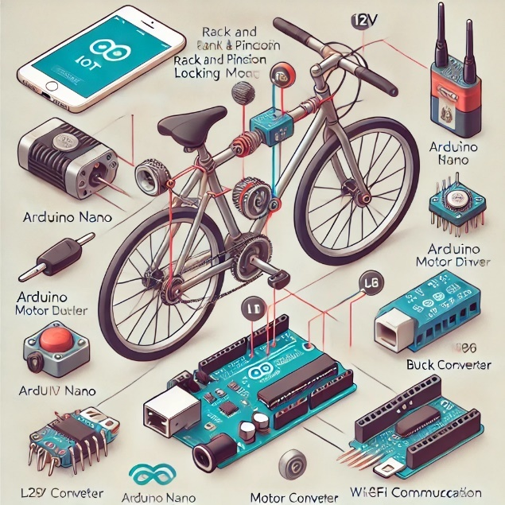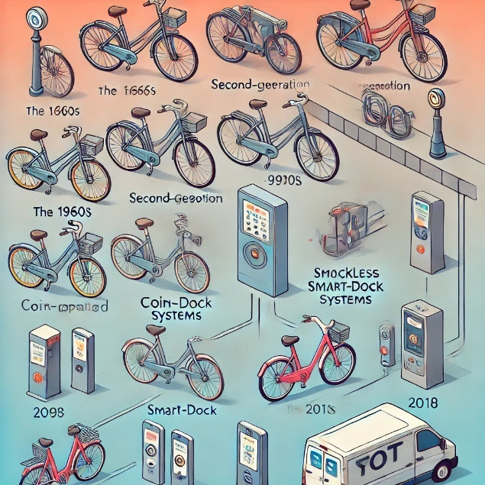

Figure:1 IOT used in bicycle locks Figure:2 IOT Components used in a general lock

.

BSS commonly operates a fleet of bicycles available for individuals to rent on a short-term basis. Users can locate and unlock bicycles via a mobile application or at assigned mooring stations. A multitude of academic articles have investigated the operation of BSS, focusing on critical elements, including the availability of bicycles, docking stations, payment mechanisms, and user interfaces. The significance of effective bike redistribution strategies in guaranteeing bike availability at locations with high demand has been underscored in numerous studies.

The IoT is vital to the operation and administration of BSS. Extensive scholarly discourse has examined the diverse implementations of IoT technology within these systems. The connectivity and IoT sensors facilitate the continuous monitoring of bicycle locations, tracking bike utilization patterns, and acquiring valuable data to optimize the system. The IoT empowers administrators to optimize the management of bicycle fleets, monitor maintenance requirements, and improve user experiences by integrating functionalities such as intelligent locks and up-to-date information on bike availability.

Bike-sharing systems (BSS) have garnered considerable interest as an environmentally friendly and effective means of transportation within urban environments. Numerous studies have demonstrated the advantages of integrating IoT into BSS. Utilizing GPS and cellular technologies, IoT-based bike monitoring systems furnish precise data regarding the whereabouts of bicycles, thereby streamlining the processes of bike distribution and retrieval.

This results in increased bike accessibility, operational expenses, and user contentment. In addition, IoT-enabled bike-sharing systems provide operators with data-driven insights regarding user behavior, travel patterns, and demand trends, enabling them to enhance services accordingly.

There are obstacles to implementing IoT in BSS, notwithstanding the benefits. Scholarly articles have raised concerns regarding privacy and data security in relation to location tracking and user information. User consent, data protection encryption, and encryption are

critical factors to bear in mind when developing BSS based on the Internet of Things. Additionally, sufficient financial resources and technical expertise are required to integrate and maintain IoT infrastructure.

Literature indicates that the continuous implementation of IoT may present BSS with promising future prospects. Sophisticated analytics and machine learning methodologies can be applied to the immense quantities of data gathered by IoT sensors in order to optimize system operations and develop predictive models for bicycle demand.

Incorporating smart city initiatives and transportation networks can offer users uninterrupted access to multimodal transportation alternatives. Additionally, the implementation of electric bicycles and the utilization of renewable energy sources can augment the sustainability of BSS.

Overall, the literature reviews about Bike Sharing Systems (BSS) offer significant contributions by shedding light on diverse facets of this pioneering mode of transportation. The historical progression of BSS demonstrates its transformation from initiatives driven by the community to technologically advanced systems.

The present situation underscores BSS's extensive implementation and triumph, which has yielded manifold advantages including diminished vehicular congestion, enhanced air quality, and improved transportation accessibility.

Utilizing the Internet of Things (IoT) in BSS has fundamentally altered their operation. IoT technology enables monitoring, tracking, and optimizing bike availability in real-time, enhancing operational efficiency and user satisfaction. The incorporation of IoT sensors and connectivity yields significant data that supports system administration and decision-making, thereby facilitating ongoing enhancements in the quality of services provided.

Nevertheless, the literature also addresses obstacles and factors to be considered when implementing IoT in BSS. It is crucial to thoroughly address privacy and data security concerns and the technical and financial requirements of IoT infrastructure. Subsequent investigations will focus on these obstacles, protecting user privacy and creating sustainable and economical Internet of Things solutions for BSS.

In anticipation of the future, BSS exhibits auspicious prospects. The incorporation of smart cities, machine learning, and analytics can optimize the operations of BSS, improve the user experience, and encourage the adoption of sustainable transportation options. The adoption of electric bicycles powered by renewable energy sources has the potential to mitigate carbon emissions and advance eco-friendly modes of transportation.

In general, the integration of BSS with IoT signifies a substantial progression in the field of urban transportation. By means of additional scholarly investigation, inventive approaches, and cooperative efforts among the academic, industrial, and policy sectors, BSS may persistently develop and make a positive contribution toward the establishment of intelligent, sustainable, and inclusive urban environments.

The results obtained from these literature reviews serve as a fundamental basis for subsequent research and contribute to the formulation and execution of BSS initiatives and policies globally.

### Bikesharing in Europe, the Americas, and Asia: Past, present, and future. Transportation Research Record: Journal of the Transportation Research Board, 2143(1), 159-167 by Shaheen, S. A., Guzman, S., & Zhang, H. (2010).

The 2010 research paper, "Bikesharing in Europe, the Americas, and Asia: Past, Present, and Future," authored by Shaheen, Guzman, and Zhang, stands as a ground-breaking and influential contribution within the realm of bike-sharing systems (BSS). This significant piece of literature offers a thorough and all-encompassing analysis of the historical evolution, current state, and potential future developments of BSS worldwide.

The paper's importance lies in its meticulous examination, which spans the historical development, present condition, and possible future trajectories of BSS across all continents, providing researchers and practitioners in urban transportation with a wealth of valuable information.

The article unfolds as a delightfully exhaustive and perceptive exploration of the development of bike-sharing systems in Europe, the Americas, and Asia. The authors guide the reader through a nuanced and meticulously researched chronological tour of the subject's past. By delving into historical events, the paper establishes a robust foundation for a comprehensive examination, allowing readers to grasp bike-sharing's intricate origins and early dynamics.

This historical inquiry is an indispensable resource, offering critical insights into the complex contextual underpinnings of bike-sharing. It effectively illuminates the factors that stimulated its establishment and the early obstacles encountered by pioneering systems.

Moving beyond historical perspectives, the paper contributes significantly to understanding bike-sharing systems. It thoroughly analyzes the current state of BSS across continents, examining case studies and summarizing the characteristics of various programs. This nuanced examination is invaluable for researchers and practitioners, providing

The paper engages with the future trajectory of bike-sharing, offering a forward-looking perspective that considers emerging trends, technological advancements, and evolving urban dynamics. By exploring potential avenues for growth and improvement, the authors contribute to discussions on the sustainability and scalability of bike-sharing systems, providing valuable insights for policymakers and urban planners. The comprehensive coverage, historical depth, and forward-thinking approach make this research paper an enduring and influential piece of bike-sharing systems literature.

In addition to historical perspectives, the review deftly and comprehensively scrutinizes the present state of bike-sharing networks worldwide, leaving no aspect unexplored. By methodically researching numerous case studies and summarising the distinctive features of individual initiatives, the authors furnish readers with a marvelously nuanced and comprehensive overview of the plethora of models and operational frameworks presently in use across the globe.

This thorough and comprehensive analysis is a priceless resource for scholars and professionals seeking a truly holistic and all-encompassing perspective on the present state of BSS. It considers the distinctive and complex contextual elements that substantially impact their development, execution, and overall efficacy.

The research adopts a prospective stance by examining the future course of bike-sharing and deftly painting a picture that accounts for emerging trends, revolutionary technological developments, and urban environment dynamics. The authors make a substantial scholarly contribution to the ongoing discourse surrounding the scalability and sustainability of bike-sharing systems through their astute examination of potential avenues for growth and enhancement.

By doing so, they offer a multitude of noteworthy perspectives that possess the capacity to serve as an essential guide for progressive urban planners and legislators as they traverse the intricate landscape of forthcoming urban mobility.

 Table 1: History of BSS worldwide

The evaluation additionally acknowledges the myriad and varied strategies implemented by distinct regions and localities in the implementation and administration of bike-sharing initiatives. The authors emphasize the wide array of organizational structures and financial models utilized in various geographic settings, from publicly funded initiatives to the strategic and active participation of private enterprises. This meticulous and nuanced inquiry significantly enhances our comprehension of the intrinsic complexities associated with the construction and upkeep of bike-sharing systems in diverse urban environments.

By adopting this judicious and carefully considered methodology, informed readers are able to discern and grasp regional trends, recognize discrepancies in system architecture, and comprehend the complex elements that invariably impact the triumphant achievements or formidable obstacles encountered by BSS in different regions across the globe.

Moreover, the authors' focus extends beyond BSS's technical and operational facets. Conversely, they meticulously examine the intricacies of social and environmental consequences, eloquently demonstrating how these systems significantly promote sustainable urban mobility and foster advantageous modifications in commuting patterns.

This comprehensive and multifaceted perspective aligns with ongoing and urgent dialogues regarding the pivotal role of BSS in mitigating environmental issues and actively advocating for a more sustainable, environmentally conscious, and healthier urban environment.

Ultimately, the extensive and groundbreaking review authored by Shaheen, Guzman, and Zhang occupies a pivotal position and solidifies itself as a fundamental and indispensable element within the vast and continuously evolving body of literature concerning bike-sharing systems.

Its exhaustive and methodical examination of historical advancements serves as a cornerstone, shedding light on bike-sharing's roots and evolutionary dynamics. Simultaneously, its comprehensive analysis of present operational methodologies provides an in-depth understanding of the diverse global models and frameworks.

Moreover, the astute projections for the future contribute to its enduring relevance, offering a visionary perspective that anticipates trends and challenges in the swiftly progressing domain of urban transportation. This comprehensive approach furnishes researchers, policymakers, and practitioners engaged in the dynamic field with an unparalleled accumulation of knowledge, creating a robust foundation for informed decision-making and strategic planning.

With bike-sharing's continuous development and establishment as a fundamental element of sustainable urban mobility, this review unambiguously and consistently functions as a reliable and lasting resource for understanding its complex worldwide path. Its enduring value lies in documenting the historical evolution and current status of bike-sharing systems and in influencing the subtle aspects of their future trajectory.

As bike-sharing continues to evolve as a critical component of sustainable urban mobility, this review stands as a beacon, offering timeless insights that transcend temporal boundaries. Its status as a lasting resource underscores its role as a guiding compass for those navigating the multifaceted challenges and opportunities within the realm of urban transportation planning and implementation.

### Research findings from existing literature

Research has consistently demonstrated that bike-sharing systems positively influence air quality and reduce traffic congestion, thus establishing them as a paradigm shift in urban transportation. According to many studies, the incorporation of bike-sharing systems into urban environments has been found to reduce traffic congestion.

These systems effectively mitigate traffic-related issues in densely populated urban areas by offering an alternative mode of transit for short-distance journeys, thus alleviating the strain on road congestion. In addition, a significant enhancement in air quality and a favorable ecological consequence ensures from the reduction in dependence on conventional modes of transportation, which contribute to the emission of greenhouse gases.

Bicycle-sharing systems have been the subject of extensive scholarly attention due to their manifold advantages that transcend environmental concerns. Empirical evidence consistently underscores the favorable association that bike-sharing utilization has with the promotion of physically active and health-conscious ways of life.

A heightened level of physical activity is frequently reported by users of bike-sharing systems, which contributes to an overall improvement in cardiovascular health and well-being. Bike-sharing systems are positioned as comprehensive contributors to healthier urban environments due to their ability to diminish environmental impact while also promoting health, which is consistent with broader public health and sustainability objectives.

The"last-mile" obstacle that is frequently associated with conventional public transit is effectively addressed by this user-friendly and economical mode of transportation.

For individuals in search of a rapid and efficient mode of transportation for short-distance commutes, bike-sharing systems are an appealing alternative due to their affordability and convenience. This pertains to the increasing focus on developing urban transport alternatives that are both sustainable and easily accessible.

The potential for dockless bike-sharing systems to provide greater flexibility and convenience in comparison to conventional moored systems has been underscored in research publications. Dockless bicycle systems obviate the necessity for stationary mooring stations by enabling users to fetch and return bicycles at diverse locations.

The added versatility facilitates a more extensive acceptance of bike-sharing as a feasible mode of transportation by enabling individuals to utilize bikes at their discretion. User satisfaction and system accessibility are both enhanced by eliminating docking station restrictions, according to the findings.

The existing body of literature extensively emphasizes the ancillary positive impacts of bike-sharing systems on urban mobility, which supplement the immediate benefits of diminished traffic congestion and enhanced air quality. Scholarly investigations consistently emphasize the potential of these systems to mitigate the burden on public transport infrastructure and decrease the need for parking spaces.

In light of the difficulties posed by urban areas' congested infrastructure and spatial constraints, the utilization of bike-sharing systems as adjunctive transportation options becomes a pivotal element in improving the overall efficiency and sustainability of urban mobility networks. In addition to their immediate advantages, these systems play a role in restructuring the urban transport domain as a whole through the mitigation of strain on pre existing infrastructure and the resolution of persistent challenges related to parking and congestion.

Furthermore, scholarly investigation has established that bike-sharing systems play a crucial role in enhancing urban connectivity and accessibility. These systems foster smooth integration into established transit networks, serving as conduits connecting various modes of

transportation. The results underscore the acknowledgment of the importance of diverse and integrated modes of transport for urban residents.

The interdependence and prioritization of multimodal transportation are consistent with the changing comprehension of urban mobility, which underscores the necessity for a range of integrated alternatives to accommodate the varied requirements of urban residents.

Within this framework, bike-sharing systems manifest not solely as independent remedies but also as essential elements that contribute to the overarching concept of an interconnected and easily navigable urban transportation system.

The transformative capacity of bike-sharing systems is further elucidated in the literature through their positive influence on the sustainability of urban living. In the pursuit of mitigating the urgent issues of environmental degradation and climate change, the significance of bike-sharing in nurturing a more sustainable urban environment and reducing carbon emissions becomes progressively apparent.

By virtue of their interdependence with more extensive sustainability objectives, these systems actively contribute to the development of environmentally conscious and robust urban environments. Hence, the research results emphasize the immediate advantages of bike-sharing and their congruence with broader objectives for sustainable urban progress.

Academic research consistently underscores the multifarious contributions of bike-sharing systems, placing particular emphasis on their capacity to instigate positive transformations in urban mobility. In addition to their potential to mitigate traffic congestion and improve air quality, these systems serve as catalysts for a paradigm shift in urban transportation.

Bike-sharing systems are intrinsic to the continuous evolution of urban mobility due to the acknowledgment of their supplementary function, connectivity advantages, and compatibility with sustainability objectives. This understanding, which is grounded in research, offers a significant basis for transportation professionals, policymakers, and urban planners who are in quest of comprehensive resolutions to the intricate dilemmas of modern urban life.

In summary, the substantial body of research on bike-sharing systems has produced numerous favorable outcomes encompassing critical facets, including ecological ramifications, community well-being, financial advantages, and improved urban mobility.

These systems demonstrate their adaptability as crucial elements in promoting sustainable urban living by providing practical solutions to urgent challenges such as air pollution; traffic congestion-induced physical barriers, and the pursuit of uninterrupted accessibility.

The literature identifies numerous positive outcomes that highlight the capacity of bike-sharing systems to alter the urban transportation landscape significantly. These systems function as change agents that effectively tackle pressing issues and establish a model for urban development that is more sustainable and prioritizes the well-being of its inhabitants.

The innovative potential of bike-sharing systems is emphasized by the collective findings as they shape the future course of urban transportation. The transportation systems' ability to facilitate economical and adaptable travel alternatives, mitigate traffic congestion, enhance air quality, and encourage physical activity and good health establish them as crucial elements in the continuous development of urban mobility.

In the pursuit of innovative and efficient solutions, these research-based insights provide a valuable resource for policymakers, urban planners, and transportation professionals as cities confront the intricacies of sustainable development.

The comprehensive body of knowledge obtained from this extensive investigation into bike-sharing systems makes a valuable contribution to improving existing urban transportation frameworks and the forward-thinking design of future urban environments that place equal emphasis on accessibility, public health, and environmental sustainability.

### Research gaps

A comprehensive review of the scholarly articles on BSS reveals several research gaps that merit further investigation. Firstly, there is a need for a deeper understanding of user behavior, preferences, and factors influencing user adoption, satisfaction, and usage patterns in different BSS.

While studies have explored user perceptions and motivations, there still needs to be more consensus on the key drivers of user behavior and the impact of various contextual factors on user choices. Exploring these aspects can provide valuable insights for BSS operators in designing user-centric systems and enhancing user experiences.

Secondly, the safety measures, risk factors, and security concerns related to BSS require more attention. Theft prevention strategies, rider safety, and infrastructure design for safer riding experiences are critical areas that need further investigation.

Understanding the risks and challenges associated with BSS can help develop effective interventions to mitigate these concerns, such as improved locking mechanisms, surveillance systems, and awareness campaigns.

Thirdly, promoting responsible bike-sharing behavior and interventions to encourage sustainable transportation choices and minimize misuse or vandalism require more research. While some studies have explored user education initiatives and behavioral interventions, there is a need for a comprehensive evaluation of their effectiveness and scalability.

Identifying effective strategies to promote responsible behavior, such as incentivizing proper bike usage and addressing the social norms and cultural factors that influence user behavior, can contribute to BSS's long-term sustainability and success.

The current body of literature on bike-sharing systems identifies many significant research gaps that present potential for future exploration and scholarly investigation. Further investigation is required to comprehend user preferences, the aspects impacting their contentment, and the causes influencing their choice to utilize or refrain from bike-sharing systems.

Although certain studies address user behavior and attitudes, there is still a need to uncover a more profound understanding of the complexities underlying user preferences and satisfaction. Researching to understand the intricate motives and preferences of bike-sharing customers would yield useful insights for system designers, operators, and policymakers. This knowledge would ultimately help optimize these systems to improve user happiness and increase adoption rates.

Another important area of research focuses on safety precautions and issues related to bike-sharing systems. Additional inquiry is necessary to examine thorough safety measures, including theft deterrence, rider protection, and infrastructure planning that encourages secure riding encounters.

It is crucial to address these challenges in order to guarantee the long-term success and sustainability of the bike-sharing program. Researchers may significantly contribute to developing recommendations and practice that prioritizes user well-being and the entire system by exploring practical strategies to reduce theft, improve rider safety, and optimize infrastructure.

The final study gap in the existing literature pertains to the necessity of conducting additional investigations on promoting responsible conduct inside bike-sharing systems. This entails instructing users on design principles, reducing instances of misuse, and thwarting acts of vandalism.

Previous research acknowledges the difficulties linked to abuse and vandalism but fails to offer a thorough understanding of successful approaches to encourage responsible conduct. Examining educational programs, behavioral nudges, and policy interventions can provide significant information for operators and legislators aiming to cultivate a culture of responsibility among bike-sharing users.

Furthermore, the research requires a more thorough examination of the ecological consequences associated with bike-sharing programs. It is imperative to comprehensively examine the ecological impact of these systems, encompassing the life cycle study of bicycles, station infrastructure, and the overall environmental viability of bike-sharing.

Gaining a comprehensive understanding of the environmental consequences will aid in developing responsible urban planning and ensure that bike-sharing activities align with wider sustainability objectives.

Moreover, there are research deficiencies in investigating the fairness components of bike-sharing systems. Although certain studies briefly discuss matters of accessibility and inclusivity, there is a requirement for a more intricate comprehension of how bike-sharing systems might effectively tackle social and economic inequalities.

Examining the effects of various pricing models, station location tactics, and outreach programs on equity in bike-sharing usage can provide valuable insights for creating more inclusive systems that cater to a wide range of user groups.

To fully understand the adoption and usage patterns of bike-sharing systems, it is crucial to thoroughly investigate the socioeconomic and cultural elements that influence them while also considering equality considerations.

An investigation of the interplay between cultural nuances, societal norms, and demographic features in relation to bike-sharing adoption can yield useful insights for tailoring systems to particular urban settings and different communities. One significant area of research that needs attention is bike-sharing systems' long-term viability and expandability.

Although certain studies briefly mention the environmental advantages and good effects on reducing urban congestion, a more thorough investigation is necessary to comprehend the long-term sustainability of these systems in ever-changing metropolitan environments. An in-depth examination of financial viability, models for expanding the bike-sharing system, and the changing position of bike-sharing in future urban mobility frameworks will enhance our understanding of the potential obstacles and prospects for long-term success.

In conclusion, the scholarly articles on BSS highlight several research gaps that require further investigation. Understanding user behavior, ensuring safety and security, promoting responsible bike-sharing behavior, evaluating social and environmental impacts, and exploring the economic viability of BSS are critical areas for future research. Addressing these gaps will contribute to developing more efficient, user-centric, and sustainable bike-sharing systems, benefiting individuals and communities.

In general, the integration of BSS with IoT signifies a substantial progression in the field of urban transportation. By means of additional scholarly investigation, inventive approaches, and cooperative efforts among the academic, industrial, and policy sectors, BSS may persistently develop and make a positive contribution towards the establishment of intelligent, sustainable, and inclusive urban environments. The results obtained from these literature reviews serve as a fundamental basis for subsequent research and contribute to the formulation and execution of BSS initiatives and policies on a global scale.

The following tables summarizes the importance of bike sharing system along with their benefits to the society at large.

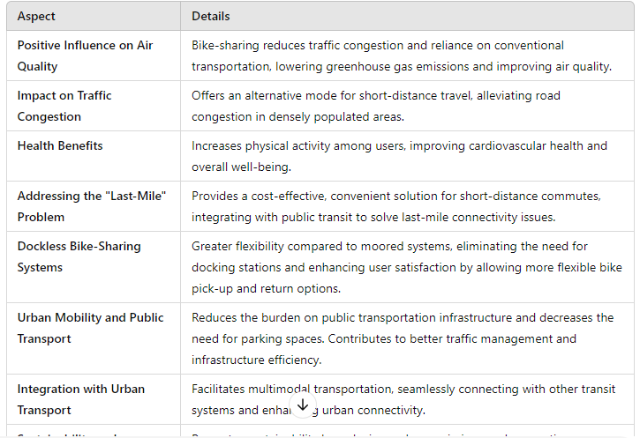

Table 2: The Advantages of Bike Sharing System

# CHAPTER 3

**PROBLEM FORMULATION AND OBJECTIVES**

## INTRODUCTION

The BSS project is a pioneering initiative aimed at redefining contemporary bike-sharing systems in response to the evolving urban mobility landscape. This project aims to integrate IoT technology and a user-friendly mobile app interface to create a sustainable and efficient transportation solution. The project's core goal is to create a resilient and environmentally friendly bike-sharing ecosystem by utilizing real-time data exchange, secure APIs, and precise GPS tracking.

The primary goal is to improve urban mobility by offering users a streamlined, accessible, and sustainable mode of transportation. Sustainability is more than an attribute; it is a fundamental principle ingrained in the project's ethos, dedicated to reducing carbon emissions and traffic congestion in urban areas.

Overcoming challenges encountered during the project's evolution, such as real-time synchronization and ensuring secure data communication, necessitated strategic solutions. Central to this project is a commitment to fostering positive urban impact. By promoting the use of bikes through an intuitive and accessible platform, the BSS project not only advocates for sustainable commuting but also contributes to the establishment of smarter and greener cities. As we delve into the intricacies of this transformative initiative, we invite exploration into a future where urban mobility is not merely a necessity but a sophisticated, sustainable, and user-friendly experience for all.

## PURPOSE

The purpose of the BSS project for our college campus is to create a sustainable and convenient transportation system tailored to the unique needs of our academic community. This initiative aims to alleviate campus congestion, reduce our carbon footprint, and offer students and staff an accessible and eco-friendly alternative to traditional commuting methods.

The project focuses on enhancing the user experience by developing a user-friendly mobile app that facilitates easy bike location, booking, and unlocking, catering specifically to the campus environment. By promoting sustainable transportation and leveraging technology, the BSS project contributes to a greener and more streamlined college campus, fostering a sense of community and environmental responsibility.

## PROJECT SCOPE

The BSS project on campus covers the entire lifecycle of a sustainable bike-sharing system. This includes creating an easy-to-use mobile app for bike location and booking, incorporating real-time data exchange capabilities on bikes for efficient communication, and ensuring secure transactions. The project aims to improve bike availability using GPS tracking and smart algorithms while prioritizing user safety with obstacle avoidance mechanisms. Wireless connectivity allows for real-time monitoring and data exchange. Thorough testing, deployment, user training, and ongoing monitoring and maintenance are all essential components of the project, all of which contribute to the development of a comprehensive, user-friendly, and long-term bike-sharing ecosystem tailored to the needs of the college community.

## OTHER APPROVED OBJECTIVES

The approved objectives for the project within the college campus align with the overarching goal of creating a seamless, sustainable, and user-centric bike-sharing system. These objectives encompass various aspects, ranging from user experience to environmental impact.

### Simple Design:

**Intuitive User Interface**: Craft a user-friendly mobile app interface with an intuitive design, ensuring that users can easily navigate through the app without the need for extensive instructions.

**Clean Aesthetics**: Embrace minimalist design principles, prioritizing clarity and simplicity in visual elements to enhance the overall user experience.

### Easy Accessibility:

**Seamless Onboarding Process:** Develop a straightforward onboarding process for new users, minimizing steps required to register and start using the bike-sharing system.

**Accessible Information:** Ensure that essential information regarding the bike-sharing system, including operating instructions and policies, is readily available and easy to comprehend.

### Exclusivity to Campus:

**Campus Authentication:** Implement a secure campus authentication system to ensure that only authorized individuals with valid campus credentials can access and use the bike-sharing.

### Financial Accessibility:

**Affordable Pricing Structure:** Establish an affordable pricing structure that aligns with the financial constraints of students, faculty, and staff, ensuring that the bike-sharing service remains accessible to a broad demographic.

## PROJECT OUTCOMES

The completion of the BSS project is expected to result in a transformative shift in the transportation dynamics of the college campus, fostering a sustainable and user-centric mobility culture. We anticipate a significant reduction in on-campus congestion and personal vehicle usage with the successful implementation of the bike-sharing system, enhancing the overall mobility experience for our college community. The benefits go beyond practical benefits, fostering community engagement and inclusivity through various interactive events and programs.

The project aims to contribute measurably to environmental sustainability by reducing the carbon footprint associated with campus commuting as users seamlessly navigate the user-friendly mobile app, enjoying a positive and efficient experience. Financial accessibility remains a pillar, ensuring the bike-sharing system remains affordable and accessible.

## COST ANALYSIS

|  |  |  |  |
| --- | --- | --- | --- |
| **S.No.** | **Name of the Component** | **Quantity** | **Price(Rs)** |
| 1 | ESP8266 & Cable | 1 | 700 |
| 2 | Arduino Nano | 2 | 600 |
| 3 | Lithium Battery 18650 | 1 | 50 |
| 4 | Buck Converter | 1 | 70 |
| 5 | 12-volt Motor | 1 | 300 |
| 6 | Rack and pinon | 1 | 800 |
| 7 | Jumper Wires | 15 | 70 |
| 8 | L2988 Motor Driver | 1 | 160 |
| 9 | Iron Stand | 1 | 500 |
| 10 | Udemy Course | 1 | 500 |

Table 3: Cost Analysis

## DELIVERABLES

### User-Friendly Mobile Application:

This app will act as a central hub, allowing users to easily locate, book, and unlock bikes while also providing important information. High usability ratings, positive user feedback, and seamless functionality across multiple devices will be used to determine success.

### Integration of IoT Devices:

Integration of Internet of Things (IoT) devices onto the bikes is pivotal for real-time data exchange, GPS tracking, and communication with the central system. The success of this deliverable relies on reliable data transmission, accurate GPS tracking, and seamless communication between the bikes and the central server.

### Secure User Authentication System:

Implementation of a secure user authentication system linked to campus credentials is required for exclusive access to members of the college community. This helps to ensure the overall safety and integrity of the bike-sharing system.

### Documentation of Safety Protocols:

Clear documentation of safety protocols, operational policies, and user guidelines is essential to ensure the safe and responsible use of the bike-sharing system. The success of this deliverable will be measured by user comprehension and adherence to safety guidelines, minimal safety incidents, and effective communication of emergency procedures.

### Environmental Impact Assessments:

Regular assessments and reports detailing the environmental impact of the bike-sharing system constitute a critical deliverable. This includes metrics on reduced carbon emissions and the overall sustainability of the system, reflecting the commitment to positive environmental practices.

## POTENTIAL RISKS AND MITIGATION SUGGESTIONS:

Identifying potential risks is a critical step in project planning. Several risks should be considered for the project within the college campus to address and mitigate potential challenges proactively.

**Technical Glitches:** Potential technical flaws, such as system bugs, connectivity issues, or disruptions in IoT device functionality, endanger the system's smooth operation. These flaws could cause user frustration, service interruptions, and decreased system reliability.

**Mitigation:** Implement a comprehensive testing strategy at various development stages, including unit testing, integration testing, and user acceptance testing. Establish a responsive technical support system to quickly identify and address any technical issues that may arise post-launch.

**Regulatory Compliance:** Changes in local regulations, legal requirements, or permitting issues may impact the project's compliance and authorization to operate on the college campus.

**Mitigation**: Stay informed about local regulations and communicate openly with regulatory bodies. Proactively adapt the project to comply with any changes in legal requirements, ensuring continuous authorization to operate.

**Safety Concerns:** Concerns about safety, such as accidents, bike malfunctions, or user misconduct, endanger both user safety and the reputation of the bike-sharing system. Addressing these concerns is critical to maintaining trust and ensuring the system's long-term success.

**Mitigation:** Create and share clear safety protocols and operational guidelines. Conduct regular safety checks on bike racks and paths. Implement an effective reporting and emergency response system to address safety concerns promptly and transparently.

**Financial Sustainability:** Unexpected financial challenges, such as unexpected maintenance costs, low user retention leading to revenue shortfalls, or insufficient budgeting, may impact the project's long-term viability and sustainability.

**Mitigation:** Conduct a thorough financial analysis before and during the project, accounting for potential contingencies. Implement contingency budgeting to deal with unexpected costs. Assess the project's financial health regularly and adjust strategies as needed.

**Operational Disruptions:**The smooth operation of the bike-sharing system may be hampered by operational disruptions such as system outages, station malfunctions, or logistical issues. These interruptions can cause user dissatisfaction and have a negative impact on the overall user experience.

**Mitigation:** Establish strict operational procedures and perform regular maintenance on bike stations and IoT devices. Create backup plans to deal with operational disruptions as soon as possible, minimizing downtime and ensuring continuous service availability.

**Security Breaches:** Security breaches, such as unauthorized access to user data, system hacking, or bike theft, pose a significant risk to user privacy and the integrity of the bike-sharing system.

**Mitigation:** Implement strong cybersecurity safeguards, such as encryption protocols, secure user authentication, and regular security updates. Conduct regular security audits to identify and address potential vulnerabilities while maintaining user data confidentiality and integrity.

**Community Resistance:** User adoption and acceptance may be hampered by resistance from certain segments of the college community, whether due to cultural factors, perceived inconvenience, or skepticism towards technological innovations.

**Mitigation:** Encourage open communication channels with the community, participate in community consultations to address concerns, and tailor promotional campaigns to highlight the positive impact of the bike-sharing system on campus life.

# CHAPTER 4

**PROJECT DESIGN AND DESCRIPTION**

## DESCRIPTION

Creating a bicycle rental system based on IOT smart locks involves integrating technology into traditional bike rental services. This system is mainly designed to automate and centralize the task of renting a bicycle. This project makes it easier for the user to rent a bicycle and hence promotes the usage of bicycles over pollution and traffic causing vehicles. The system utilizes IOT-enabled smart locks installed on each bike.

These locks are connected through the internet, enabling remote access and control. Users interact with the system through a mobile app interface. These locks are equipped with a microcontroller, and wireless connectivity. They secure the bikes and can be remotely locked or unlocked. A server manages the entire system. The app stores bike and user data, handles payment gateway processes and rental requests, and communicates with the smart locks.

Users access the system through an application. They can view available bikes, locate nearby stations, rent bikes, and unlock/lock them using the app. Each bike is equipped with an IOT smart lock and registered into the system. The lock is associated with a unique identifier. Users open the app and view available bikes nearby, along with their current status (available/rented). They select a bike, check its details, and initiate the rental process.

Upon rental confirmation and payment processing, a signal is sent to the designated smart lock to unlock the bike. Users can ride the bike tracked by the system. The smart lock continuously communicates with the app, updating its status (in-use, available). Once the user finishes the ride, they park the bike at any designated station. They use the app signaling the server that the ride has ended. The system calculates the rental duration and charges the user's registered payment method accordingly.

## U.G SUBJECTS

The below-mentioned courses contribute to different aspects of the project: -

* Electronic Engineering (UEC001): This course provides fundamental electronics knowledge. It helps us understand the working of components and circuits used in the making of this project.
* Electrical Engineering (UEE001): Circuit theory, power distribution, and electronics are introduced in this introductory course on electricity. It sheds light on how the smart locks electrical systems function.
* Engineering Design Project-I (UTA016) and Engineering Design Project (UTA024): These courses are based on the practical application of the engineering skills learned by making projects based on electronics and mechanics
* IOT Based Systems (UEC715): The concepts and practical uses of IOT (Internet of Things) technology are the focus of this course. The project's goal of developing an Internet of Things– based lock is explicitly addressed. It helps with the planning and execution of the projects connection and control systems by covering issues including wireless communication and IoT platforms.

Overall, these courses contribute valuable knowledge and skills required to design, develop, and implement the various aspects of our bicycle rental services project.

## IEEE STANDARDS USED

The below-mentioned IEEE standards are used for different aspects of the project:

* 2413-2019 - IEEE Standard for an Architectural Framework for the Internet of Things (IOT): This standard provides a framework for designing and implementing IOT systems. It is directly relevant to the project as it guides the overall architecture and design considerations for the IOT based smart lock.
* 802.1X (Port-Based Network Access Control) This standard provides authentication for devices trying to connect to a network, ensuring only authorized devices (smart locks) can access the rental system's network infrastructure.
* 802.11-2016 - IEEE Standard for Local and Metropolitan Area Networks: This standard pertains to wireless LAN (Wi-Fi) technology. It is relevant to the project's

Wi-Fi module and wireless communication, ensuring compatibility and adherence to the standardized protocols for efficient and reliable wireless data transmission.

## SURVEY OF TOOLS AND TECHNOLOGIES

## MICROCONTROLLER

## COMPARISONS AMONG THE VARIOUS AVAILABLE OPTIONS

* + - * + **ESP8266:** A low-cost, Wi-Fi-enabled microcontroller, ideal for IoT projects.
        + **ESP32:** A versatile microcontroller with Wi-Fi and Bluetooth capabilities, suitable for IoT and robotics.
        + **Arduino Mega 2560:** An Arduino board with numerous I/O pins for complex projects.
        + **Arduino UNO:** A beginner-friendly microcontroller board, great for learning and prototyping.
        + **Arduino Due:** A powerful board for moderate to advanced projects, featuring a 32-bit ARM core.
        + **Arduino Nano:** A compact Arduino board suitable for small-scale projects.
        + **Raspberry Pi Pico:** A microcontroller board with MicroPython support for diverse applications.
        + **STM32 Nucleo Boards:** A series of microcontroller development boards with varying capabilities for embedded systems.

### Processing Power:

* + - * + **ESP8266:** Low to moderate processing power suitable for simpler tasks.
        + **ESP32:** Higher processing power compared to ESP8266, capable of more complex tasks.
        + **Arduino Mega 2560:** Moderate processing power suitable for various robotics applications.
        + **Arduino UNO:** Basic processing power for simpler robotics tasks.
        + **Arduino Due:** Significantly higher processing power compared to UNO, suitable for complex projects.
        + **Arduino Nano:** Similar to UNO but smaller in size.
        + **Raspberry Pi Pico:** Moderate processing power with dual cores.
        + **STM32 Nucleo Boards:** Offer various models with varying processing power, suitable for a wide range of projects.

### Memory:

* + - * + **ESP8266:** Limited memory.
        + **ESP32:** More memory compared to ESP8266.
        + **Arduino Mega 2560:** Adequate memory for most robotic applications.
        + **Arduino UNO:** Limited memory.
        + **Arduino Due:** More memory than UNO.
        + **Arduino Nano:** Limited memory.
        + **Raspberry Pi Pico:** Limited memory.
        + **STM32 Nucleo Boards:** Memory varies depending on the model.

### I/O Pins:

* + - * + **ESP8266:** Limited I/O pins.
        + **ESP32:** Offers a good number of I/O pins.
        + **Arduino Mega 2560:** Abundant I/O pins suitable for complex robot designs.
        + **Arduino UNO:** Limited I/O pins.
        + **Arduino Due:** Offers more I/O pins than UNO.
        + **Arduino Nano:** Limited I/O pins.
        + **Raspberry Pi Pico:** Moderate number of GPIO pins.
        + **STM32 Nucleo Boards:** The number of I/O pins varies by model.

### Connectivity:

* + - * + **ESP8266:** Built-in Wi-Fi connectivity.
        + **ESP32:** Dual-core processor and built-in Wi-Fi and Bluetooth.
        + **Arduino Mega 2560:** Limited connectivity options without additional shields.
        + **Arduino UNO:** Basic connectivity options.
        + **Arduino Due:** Limited connectivity options without additional shields.
        + **Arduino Nano:** Basic connectivity options.
        + **Raspberry Pi Pico:** No built-in connectivity.
        + **STM32 Nucleo Boards:** Connectivity options vary by model.

### Community Support:

* + - * + **ESP8266:** Strong community support with a wealth of online resources.
        + **ESP32:** Strong community support with extensive libraries and documentation.
        + **Arduino Mega 2560:** Well-established Arduino community.
        + **Arduino UNO:** Extensive Arduino community.
        + **Arduino Due:** Strong support but less common.
        + **Arduino Nano:** Supported by the Arduino community.
        + **Raspberry Pi Pico:** Growing community but less extensive than Arduino or Raspberry Pi.
        + **STM32 Nucleo Boards:** Good community support, especially for STM32 microcontrollers.

### Cost:

* + - * + **ESP8266:** Affordable.
        + **ESP32:** Affordable.
        + **Arduino Mega 2560:** Affordable.
        + **Arduino UNO:** Very affordable.
        + **Arduino Due:** Moderately priced.
        + **Arduino Nano:** Very affordable.
        + **Raspberry Pi Pico:** Very affordable.
        + **STM32 Nucleo Boards:** Price varies by model.

### Power Efficiency:

* + - * + **ESP8266:** Moderate power consumption.
        + **ESP32:** Moderate power consumption.
        + **Arduino Mega 2560:** Moderate power consumption.
        + **Arduino UNO:** Low power consumption.
        + **Arduino Due:** Moderate power consumption.
        + **Arduino Nano:** Low power consumption.
        + **Raspberry Pi Pico:** Low power consumption.
        + **STM32 Nucleo Boards:** Power consumption varies by model.

### Development Environment:

* + - * + **ESP8266:** Arduino IDE with additional libraries.
        + **ESP32:** Arduino IDE with additional libraries.
        + **Arduino Mega 2560:** Arduino IDE.
        + **Arduino UNO:** Arduino IDE.
        + **Arduino Due:** Arduino IDE.
        + **Arduino Nano:** Arduino IDE.
        + **Raspberry Pi Pico:** C/C++ with MicroPython support.
        + **STM32 Nucleo Boards:** STM32CubeIDE or Arduino IDE.

### Form Factor:

* + - * + **ESP8266:** Compact modules.
        + **ESParduino uno32:** Compact modules.
        + **Arduino Mega 2560:** Larger form factor.
        + **Arduino UNO:** Standard form factor.
        + **Arduino Due:** Larger form factor.
        + **Arduino Nano:** Compact form factor.
        + **Raspberry Pi Pico:** Compact form factor.
        + **STM32 Nucleo Boards:** Varies by model.

### Real-Time Capabilities:

* + - * + **ESP8266:** Limited real-time capabilities.
        + **ESP32:** Better real-time capabilities.
        + **Arduino Mega 2560:** Limited real-time capabilities.
        + **Arduino UNO:** Limited real-time capabilities.
        + **Arduino Due:** Better real-time capabilities.
        + **Arduino Nano:** Limited real-time capabilities.
        + **Ra**spberry Pi Pico: Limited real-time capabilities.
        + **STM32 Nucleo Boards:** Good real-time capabilities**.**

## PREFERENCE

The choice of the ESP8266 among the options can be justified based on several factors :-

* + - * + [**Inexpensive:** The ESP8266 is a low-cost option, with some development kits priced](https://www.makerguides.com/nodemcu-esp8266-vs-arduino-uno-board/) [as low](https://www.makerguides.com/nodemcu-esp8266-vs-arduino-uno-board/).This makes it an attractive choice for hobbyists and makers who want to experiment with Wi-Fi connectivity without breaking the bank.
        + [**Wi-Fi Connectivity:** The ESP8266 has integrated Wi-Fi and a full TCP/IP stack,](https://www.makerguides.com/nodemcu-esp8266-vs-arduino-uno-board/) [making it easy to connect to the internet](https://www.makerguides.com/nodemcu-esp8266-vs-arduino-uno-board/) [2](https://www.instructables.com/ESP8266-As-a-Microcontroller/).
        + [**Flexible Design:** The ESP8266 is highly flexible and can be used in a variety of](https://www.makerguides.com/nodemcu-esp8266-vs-arduino-uno-board/) [applications, including smart home devices, IoT projects, and more](https://www.makerguides.com/nodemcu-esp8266-vs-arduino-uno-board/) [2](https://www.instructables.com/ESP8266-As-a-Microcontroller/).
        + [**Compatible Development Environments:** The ESP8266 is compatible with a range](https://www.makerguides.com/nodemcu-esp8266-vs-arduino-uno-board/) [of development environments, including Arduino IDE, eLua, and MicroPython 1](https://www.makerguides.com/nodemcu-esp8266-vs-arduino-uno-board/)[2](https://www.instructables.com/ESP8266-As-a-Microcontroller/).
        + [**Enhanced Functionality:** The ESP8266 chip and board have been enhanced over](https://www.makerguides.com/nodemcu-esp8266-vs-arduino-uno-board/) [time, with features such as chip clock rate acceleration and a new analog digital](https://www.makerguides.com/nodemcu-esp8266-vs-arduino-uno-board/) [converter (ADC) to improve sensitivity 1](https://www.makerguides.com/nodemcu-esp8266-vs-arduino-uno-board/).
        + [**Low Power Consumption:** The ESP8266 consumes less power than other](https://www.makerguides.com/nodemcu-esp8266-vs-arduino-uno-board/) [microcontrollers, making it ideal for battery-powered applications 1](https://www.makerguides.com/nodemcu-esp8266-vs-arduino-uno-board/).
        + [**Integrated Wi-Fi:** The ESP8266 has integrated Wi-Fi, which eliminates the need for](https://www.makerguides.com/nodemcu-esp8266-vs-arduino-uno-board/) [additional hardware 1](https://www.makerguides.com/nodemcu-esp8266-vs-arduino-uno-board/).
        + [**Large Community:** The ESP8266 has a large and active community of developers,](https://www.makerguides.com/nodemcu-esp8266-vs-arduino-uno-board/) [which means that there are plenty of resources available for troubleshooting and](https://www.makerguides.com/nodemcu-esp8266-vs-arduino-uno-board/) [development](https://www.makerguides.com/nodemcu-esp8266-vs-arduino-uno-board/).

Figure-1

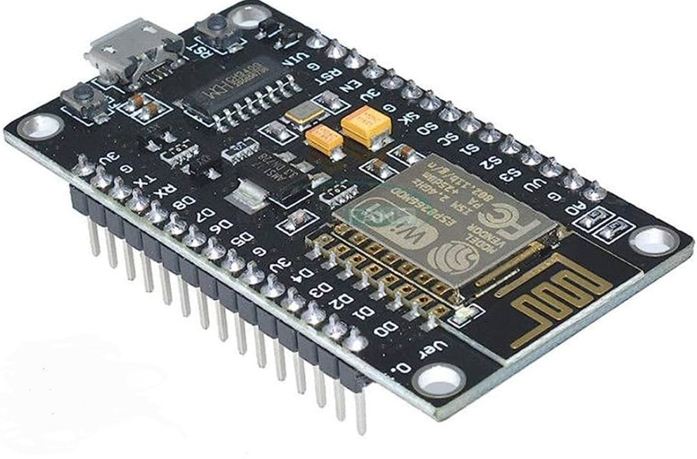

## BATTERY FOR POWER SUPPLY

## COMPARISONS AMONG THE VARIOUS AVAILABLE OPTIONS

* + - * + Valve Regulated Lead-Acid (VRLA) Battery: VRLA batteries, including Absorbent Glass Mat (AGM) and Gel cell batteries, are maintenance-free and sealed lead-acid batteries. They are well-suited for applications like uninterruptible power supplies (UPS), emergency lighting, and some portable devices.
        + Lithium-Ion (Li-ion) Battery: These batteries are known for their high energy density, lightweight, and long cycle life. They are commonly used in portable electronic devices, electric vehicles (EVs), and smart trolleys. They offer a good balance between energy capacity and weight, making them ideal for mobile applications.
        + Lithium Iron Phosphate Battery: LiFePO4 batteries are a subset of lithium-ion batteries with specific advantages, including a longer lifespan, increased safety, and stable performance.
        + Nickel-Metal Hydride Battery: NiMH batteries are rechargeable and offer a good compromise between capacity and cost. They are commonly used in

cordless phones, power tools, and portable electronics they are more environment friendly.

* + - * + Alkaline Battery: Alkaline batteries are non-rechargeable and are widely available in various sizes (e.g., AA, AAA, C, D). They are suitable for low-drain devices like remote controls, flashlights, and clocks.
        + Sealed Lead-Acid (SLA) Battery: These batteries are similar to VRLA batteries but often used in larger, high-capacity applications, such as emergency backup systems, electric wheelchairs, and larger uninterruptible power supplies.
        + Valve Regulated Lead-Acid (VRLA) Battery: Principle: VRLA batteries use lead dioxide and sponge lead for the positive and negative plates, sulfuric acid as the electrolyte, and a valve-regulated design to recombine hydrogen and oxygen for maintenance-free operation. Advantages: Reliable and cost-effective, maintenance-free. Disadvantages: Bulky, limited cycle life.
        + Lithium-Ion (Li-ion) Battery: Principle: Li-ion batteries use lithium cobalt oxide or other lithium compounds as the cathode and carbon as the anode to create a voltage potential between them. Advantages: Lightweight, long cycle life.
        + Lithium Iron Phosphate (LiFePO4) Battery: Principle: LiFePO4 batteries use lithium iron phosphate as the cathode material, offering stability and longer cycle life. Advantages: Long cycle life and durability. Disadvantages: Slightly heavier and bulkier.
        + Nickel-Metal Hydride (NiMH) Battery: Principle: NiMH batteries use a nickel oxide-hydroxide cathode and a hydrogen-absorbing alloy anode to store energy through reversible electrochemical reactions. Advantages: Good balance between capacity and cost. Disadvantages: Memory effect (partial discharge) if not properly managed.
        + Alkaline Battery: Principle: Alkaline batteries use zinc as the anode, manganese dioxide as the cathode, and an alkaline electrolyte to generate electricity through chemical reactions.Advantages: Widely available and affordable, long shelf life. Disadvantages: Non-rechargeable.
        + Sealed Lead-Acid (SLA) Battery: Principle: SLA batteries are similar to VRLA batteries and use lead dioxide and sponge lead plates with sulfuric acid

as the electrolyte. Advantages: Cost-effective,well-established technology. Disadvantages: Heavy and bulky.

## PREFERENCE

Here are some reasons Lithium-Ion (Li-ion) 18650 battery is preferred:-

* + - * + Energy Density: Li-ion batteries, especially the 18650 variant, offer a higher energy density compared to VRLA, NiMH, alkaline, and SLA batteries. This means they can store more energy in a smaller and lighter form factor, which is crucial for small IoT devices like smart locks.
        + Longevity and Cycle Life: Li-ion batteries typically have a longer lifespan and can endure more charge-discharge cycles compared to VRLA, SLA, and NiMH batteries. This extended lifespan is beneficial for our lock requiring long-term and reliable power sources.
        + Self-Discharge Rate: Li-ion batteries have a lower self-discharge rate compared to NiMH and alkaline batteries, meaning they hold their charge better over time, making them suitable for intermittent use in IoT devices like smart locks.
        + Rechargeability: Li-ion batteries, including the 18650 variant, are rechargeable and can be recharged numerous times without significant loss in capacity, unlike alkaline batteries. This reusability makes them more cost-effective and convenient for long-term usage.
        + Size and Form Factor: The 18650 form factor of Li-ion batteries fits well within the design constraints of many IoT devices, offering a balance between size and capacity. VRLA and SLA batteries are larger and heavier, making them less suitable for our compact smart lock.
        + Voltage Stability: Li-ion batteries provide a relatively stable voltage throughout their discharge cycle, ensuring consistent and reliable power delivery, which is crucial for the continuous operation of smart locks.
        + Environmental Impact: Li-ion batteries tend to have a lower environmental impact compared to some other battery chemistries like NiMH and lead-acid batteries (SLA and VRLA), as they contain fewer hazardous materials adhering to our motto of a healthier alternative to pollution generating vehicles.

Figure-2



## MOTORS

## COMPARISONS AMONG THE VARIOUS AVAILABLE OPTIONS

* + - * + L298N: L298N is a dual H-bridge motor driver that can control two DC motors or one stepper motor. It is mostly used in robotics and small electronic projects for its simplicity and reliability.
        + A4988 and DRV8825: These are stepper motor drivers used in 3D printers and CNC machines, capable of providing micro-stepping capabilities and precise control of stepper motors.
        + DRV8833: A dual H-bridge motor driver designed for small robots and projects. It can control two DC motors or one stepper motor.
        + L6203: It is a dual full-bridge driver designed for high-power DC motor control applications, such as electric scooters and electric vehicles.
        + MC33926 and LMD18200: These motor drivers are designed for higher currents and are used in applications like motorized vehicles and industrial machinery.
        + TIP120 and ULN2003A: These are Darlington transistor arrays that can be used for simple low-power motor control in DIY projects and small appliances.
        + Raspberry Pi Motor HAT and Arduino Motor Shield: These are add-on boards for Raspberry Pi and Arduino microcontrollers that provide motor control capabilities, making them ideal for educational projects
        + L298N Motor Driver: Principle: It switches the polarity of the motor terminals to achieve forward, backward, and braking actions. Advantages: Simple and widely available, can handle moderate currents and voltages. Disadvantages: Generate significant heat during operation, inefficient due to voltage drops across its transistors.
        + A4988 and DRV8825 Stepper Motor Drivers: Principle: These drivers use pulse-width modulation (PWM) to control the current supplied to the windings of stepper motors. Advantages: Efficient and less heat generation. Disadvantages: Higher cost compared to simple DC motor drivers.
        + MC33926 and LMD18200 Motor Driver: Principle: Uses PWM to regulate current to the motor windings. It supports micro-stepping and higher current ratings. Advantages: Suitable for high-current stepper motors, precise control, and position holding. Disadvantages: Relatively complex setup and cost.
        + TIP120 and ULN2003A Stepper Motor Drivers: Principle: These advanced drivers use Trinamic's proprietary technology, including stealthChop for quiet operation and stallGuard for motor monitoring. Advantages: Exceptionally quiet and efficient operation, superior control. Disadvantages: Relatively expensive, requires firmware configuration for optimal performance.
        + Raspberry Pi Motor HAT and Arduino Motor Shield: Principle: They use integrated motor driver chips to control motor direction and speed. Advantages: Convenient motor control, easy integration with popular development boards. Disadvantages: Limited to lower-power motors, may consume GPIO pins on the microcontroller.

## PREFERENCE

Here are some reasons SERVO MOTOR MG995 is preferred:

* + - * + Precision and Control: Servo motors like the MG995 offer precise control over angular rotation, which is crucial for the lock mechanism in a smart bike lock. This precise control allows for accurate locking and unlocking actions.
        + Simplicity in Control: Servo motors are relatively straightforward to control compared to some motor drivers that might require complex circuitry and programming. They often require just a PWM (Pulse Width Modulation) signal to control the position.
        + Built-in Position Feedback: Servo motors typically have built-in position feedback systems (potentiometers) that enable the controller to know the exact position of the motor shaft. This feedback helps ensure accurate locking and unlocking without additional sensors. While other motor drivers might not inherently provide feedback on position or speed, necessitating additional sensors or mechanisms to ensure accurate lock/unlock actions.
        + Compact Size: Servo motors tend to be smaller and more compact compared to some motor drivers, making them suitable for integration into the limited space available in a smart lock mechanism. These other drivers are larger or bulkier hence not suitable for our lock.
        + Ease of Integration: Servo motors, especially hobbyist-grade ones like the MG995, are readily available, cost-effective, and easy to integrate into DIY projects due to their simple interface and compatibility with microcontrollers. Motor drivers like L298N, A4988, DRV8833, L6203, MC33926, TIP120, and ULN2003A might require

additional circuitry, more complex control algorithms, or external components for precise control and operation.

* + - * + Higher Power Requirements: Some of the mentioned motor drivers are designed for higher power applications, making them less suitable for smaller-scale, low-power smart lock systems.

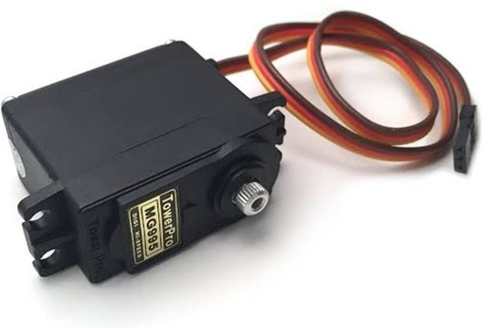

Figure-3

## VOLTAGE REGULATOR

## COMPARISONS AMONG THE VARIOUS AVAILABLE OPTIONS

* + - * + **Linear Voltage Regulators**: These regulators are simple and easy to use. They are available in two types: series and shunt regulators. [The most common linear voltage](https://www.utmel.com/blog/categories/integrated%20circuit/voltage-regulator-types-working-and-applications) [regulators are the 78XX and 79XX series, which are used for positive and negative](https://www.utmel.com/blog/categories/integrated%20circuit/voltage-regulator-types-working-and-applications) [voltage output, respectively](https://www.utmel.com/blog/categories/integrated%20circuit/voltage-regulator-types-working-and-applications) . The 78XX series provides a fixed output voltage ranging from 5V to 24V, while the 79XX series provides a fixed output voltage ranging from

-5V to -24V. [Both series have a maximum current capacity of 1.5A](https://www.utmel.com/blog/categories/integrated%20circuit/voltage-regulator-types-working-and-applications).

* + - * + **Switching Voltage Regulators**: These regulators are more efficient than linear regulators and are used in applications where high efficiency is required. [They are](https://www.utmel.com/blog/categories/integrated%20circuit/voltage-regulator-types-working-and-applications) [available in three types: step-up, step-down, and inverter voltage regulators](https://www.utmel.com/blog/categories/integrated%20circuit/voltage-regulator-types-working-and-applications) . [Some](https://www.elprocus.com/types-of-voltage-regulators-and-working-principle/) [popular switching voltage regulators include LM2575, LM2576, LM2595, LM2675,](https://www.elprocus.com/types-of-voltage-regulators-and-working-principle/) [LM2676, LM2677, LM2678, and LM2679 3](https://www.elprocus.com/types-of-voltage-regulators-and-working-principle/).
        + **Adjustable Voltage Regulators:** These regulators can be adjusted to provide a range of output voltages. [The most common adjustable voltage regulator is the LM317](https://www.utmel.com/blog/categories/integrated%20circuit/voltage-regulator-types-working-and-applications) [regulator IC, which can provide an output voltage between 1.2V and 37V](https://www.utmel.com/blog/categories/integrated%20circuit/voltage-regulator-types-working-and-applications) [2](https://www.electronicshub.org/types-of-voltage-regulators/). [It has a](https://www.electronicshub.org/types-of-voltage-regulators/) [maximum current capacity of 1.5A 2](https://www.electronicshub.org/types-of-voltage-regulators/).
        + **Zener Diode Voltage Regulators**: These regulators use a Zener diode to regulate the voltage. [They are simple and inexpensive but are not as efficient as other types of](https://www.utmel.com/blog/categories/integrated%20circuit/voltage-regulator-types-working-and-applications) [regulators](https://www.utmel.com/blog/categories/integrated%20circuit/voltage-regulator-types-working-and-applications) [3](https://www.elprocus.com/types-of-voltage-regulators-and-working-principle/). [Some popular Zener diode voltage regulators include 1N4728A,](https://www.elprocus.com/types-of-voltage-regulators-and-working-principle/) [1N4729A, 1N4730A, 1N4731A, 1N4732A](https://www.elprocus.com/types-of-voltage-regulators-and-working-principle/) etc.
        + **IC Voltage Regulators**: These regulators are integrated circuits that can be classified into different types. A common type of classification is 3-terminal voltage regulators and 5 or multi-terminal voltage regulators. [Another popular way of classifying IC](https://www.utmel.com/blog/categories/integrated%20circuit/voltage-regulator-types-working-and-applications) [voltage regulators is by identifying them as linear voltage regulators and switching](https://www.utmel.com/blog/categories/integrated%20circuit/voltage-regulator-types-working-and-applications) [voltage regulators](https://www.utmel.com/blog/categories/integrated%20circuit/voltage-regulator-types-working-and-applications) [4](https://www.circuitstoday.com/ic-voltage-regulators).

## PREFERENCES

Here are some reasons why the 7805 regulator is preferred over other voltage regulators:

[The 7805 is a type of linear voltage regulator that provides a fixed output voltage of 5V](https://electronics.stackexchange.com/questions/28188/7805-vs-78l05-voltage-regulators) . [It is](https://electronics.stackexchange.com/questions/213527/differences-between-lm317-ams1117-and-l7805) [a three-terminal device that can handle an input voltage range of 7V to 35V](https://electronics.stackexchange.com/questions/213527/differences-between-lm317-ams1117-and-l7805).

* + - * + [**Simplicity:** The 7805 is simple and easy to use, making it an attractive choice for](https://robocraze.com/blogs/post/what-is-7805-voltage-regulator-its-working) [hobbyists and makers](https://robocraze.com/blogs/post/what-is-7805-voltage-regulator-its-working) .
        + [**Low Cost:** The 7805 is a low-cost option, making it an attractive choice for projects](https://robocraze.com/blogs/post/what-is-7805-voltage-regulator-its-working) [with a tight budget](https://robocraze.com/blogs/post/what-is-7805-voltage-regulator-its-working) .
        + [**Ease of Use:** The 7805 is easy to use and requires very few external components to](https://electronics.stackexchange.com/questions/28188/7805-vs-78l05-voltage-regulators) [function properly](https://electronics.stackexchange.com/questions/28188/7805-vs-78l05-voltage-regulators) .
        + [**Availability:** The 7805 is widely available and can be purchased from many different](https://robocraze.com/blogs/post/what-is-7805-voltage-regulator-its-working) [suppliers](https://robocraze.com/blogs/post/what-is-7805-voltage-regulator-its-working) .
        + [**Output Voltage:** The 7805 provides a fixed output voltage of 5V, which is suitable](https://electronics.stackexchange.com/questions/28188/7805-vs-78l05-voltage-regulators) [for many applications](https://electronics.stackexchange.com/questions/28188/7805-vs-78l05-voltage-regulators) .
        + [**Current Capacity**: The 7805 can deliver up to 1.5A of current (with heat sink)](https://robocraze.com/blogs/post/what-is-7805-voltage-regulator-its-working) .
        + **Built-in Features**: The 7805 has both internal current limiting and thermal shutdown features.



Figure-4

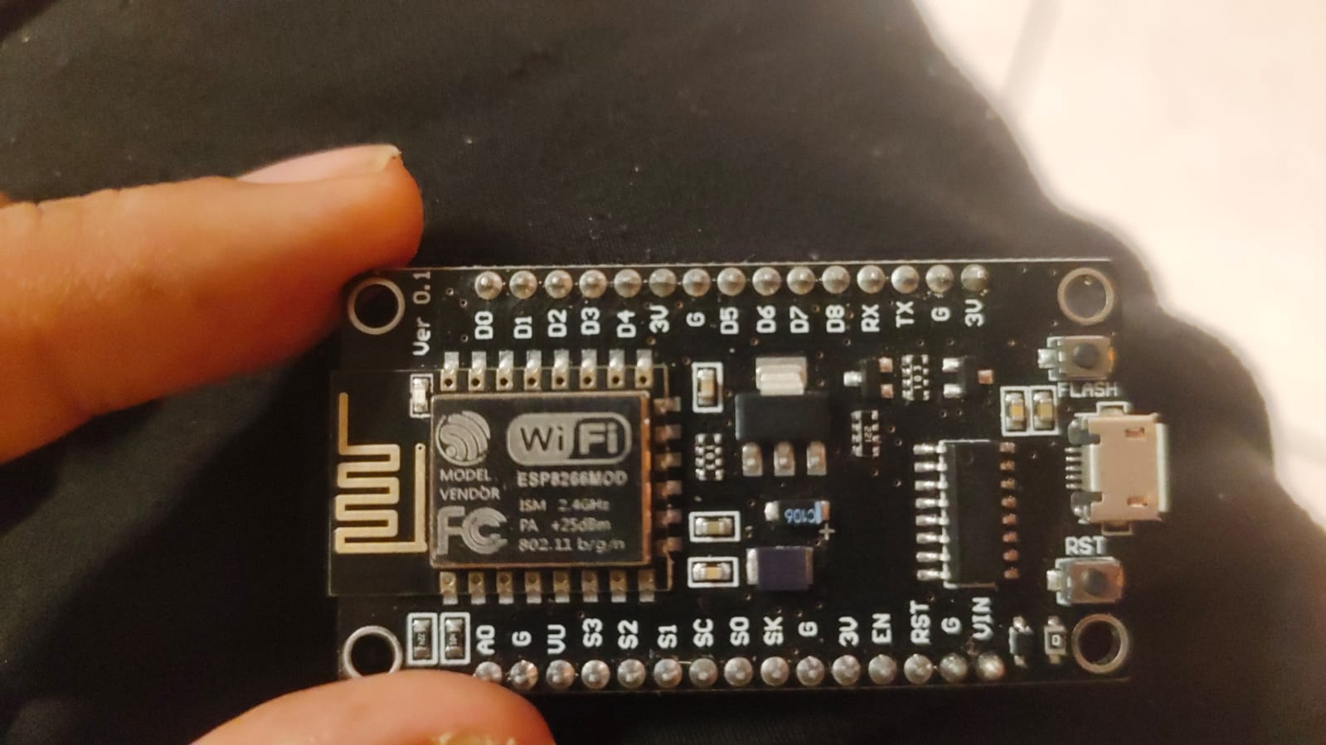

Stand

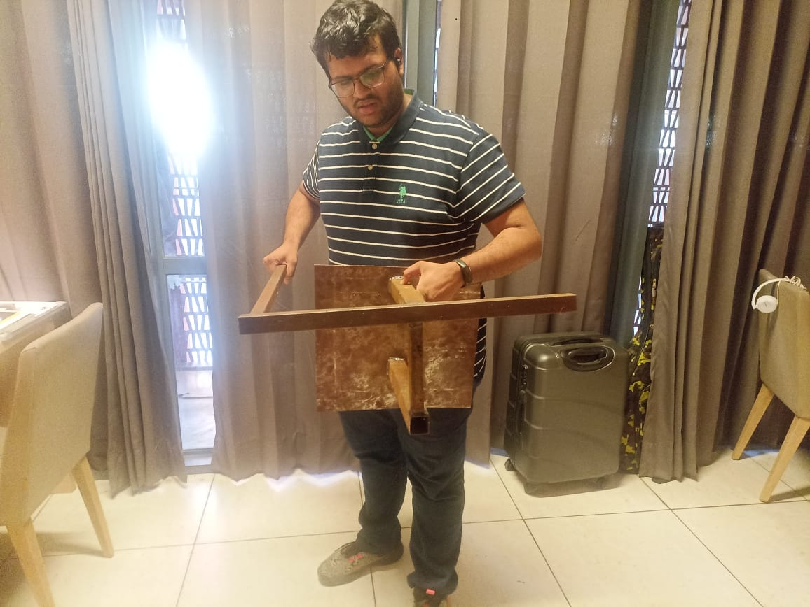

Rack and Pin Mechanism .

**SOFTWARE:**

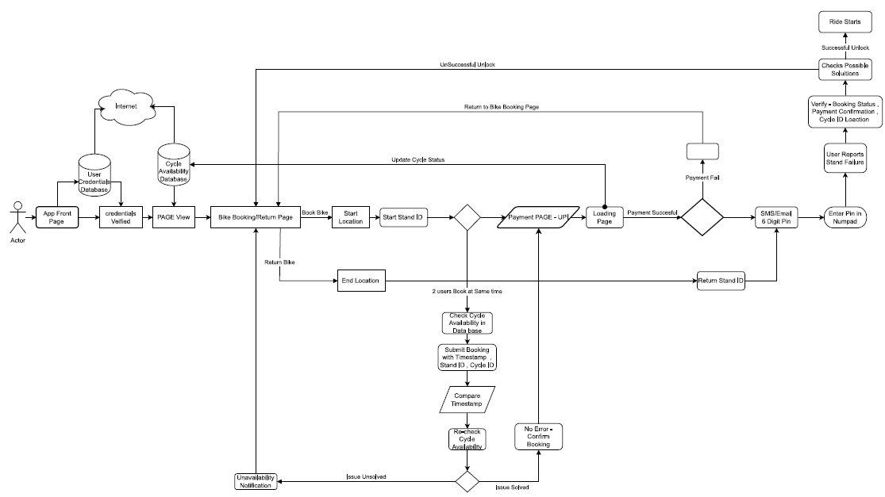

Initial Flow chart

How to Use App: -

Step 1: Open App.

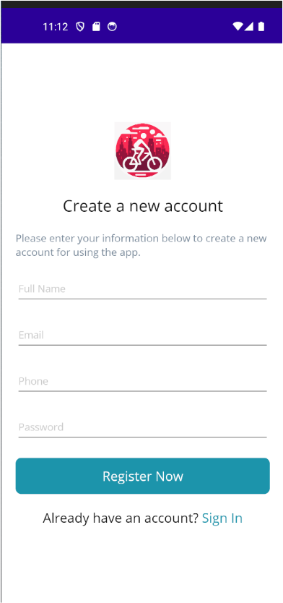

Step 2: Enter your Credentials

Example –

Full Name – Pranav Kumar Agrawal

Email - [pranavkagrawal@gmail.com](mailto:pranavkagrawal@gmail.com)

Phone – 9876543210

Password - 1234

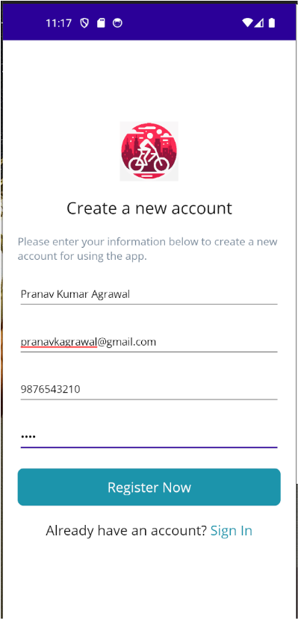

Step 3: Click on Register Now Button. Welcome Back Screen Appears.



Step 4: Enter your Credentials. Then Click on Sign In Blue Button.

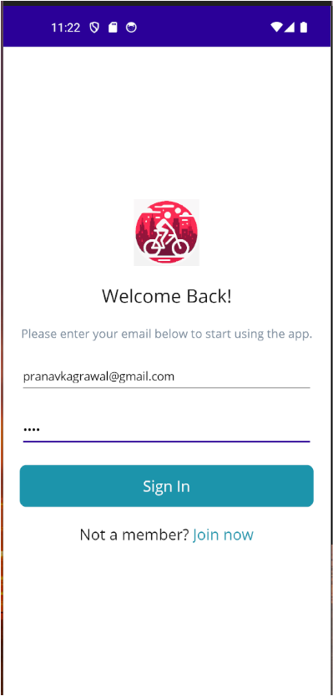

Step 5: App Main Page appears. For Now, we navigate to Boys Hostel. Click on Boys Hostel Icon.

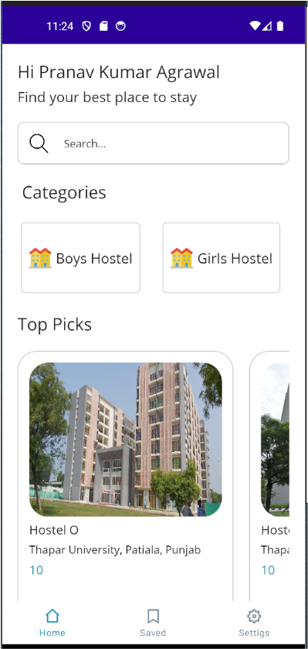

Step 6: Lets, select Hostel M. 10 Represents cost that is Rs. 10 to pays for using BSS. Click on Hostel M icon.

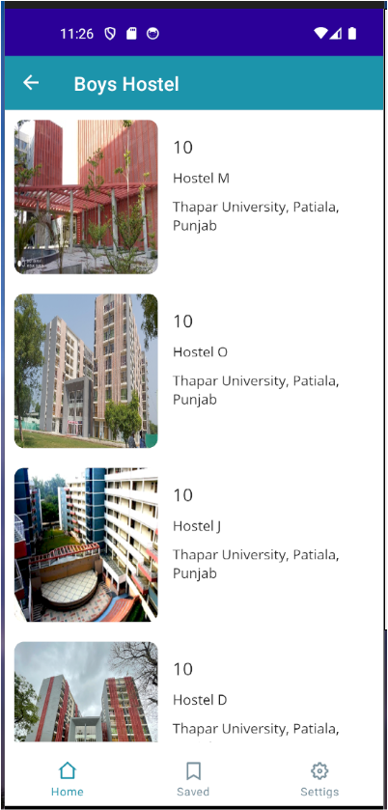

Step 7: Click on Book Now Icon.

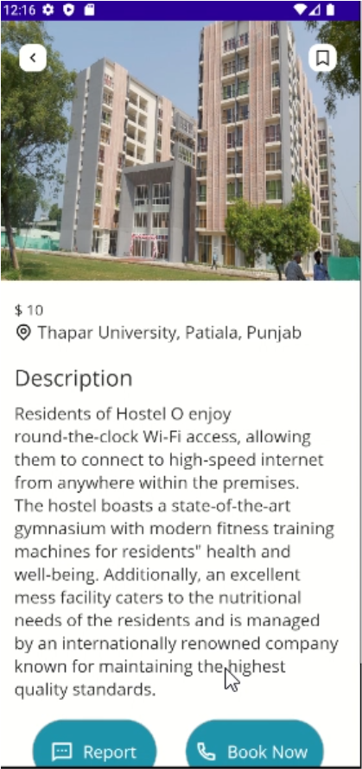

Step 8: Now Click on OFF Icon. This will unlock BSS Lock in stand.

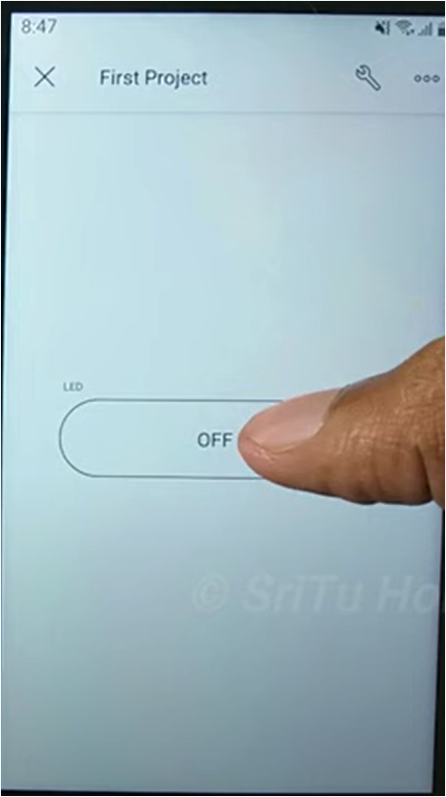

DataBase : -

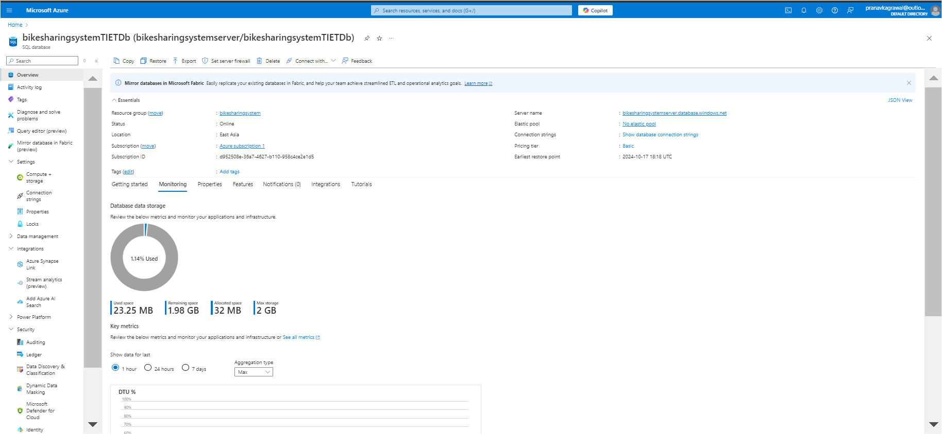

Server -

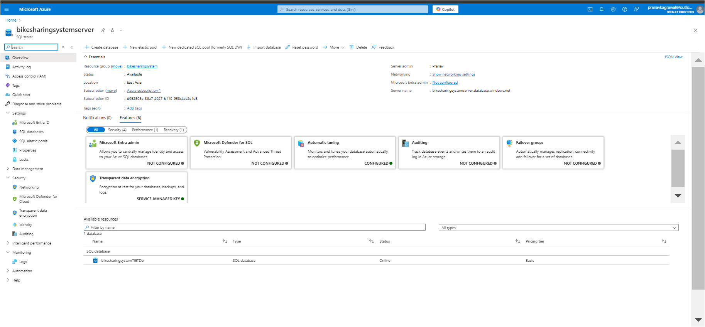

Web App–

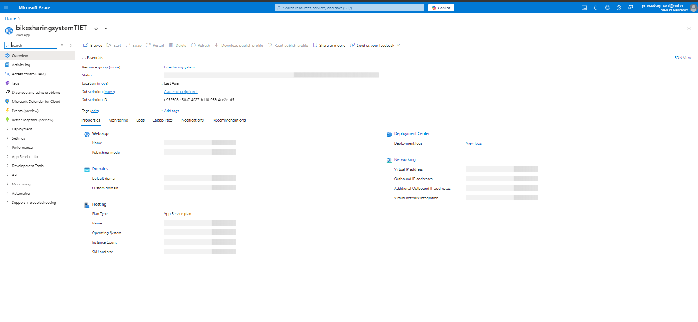

Resource Group -

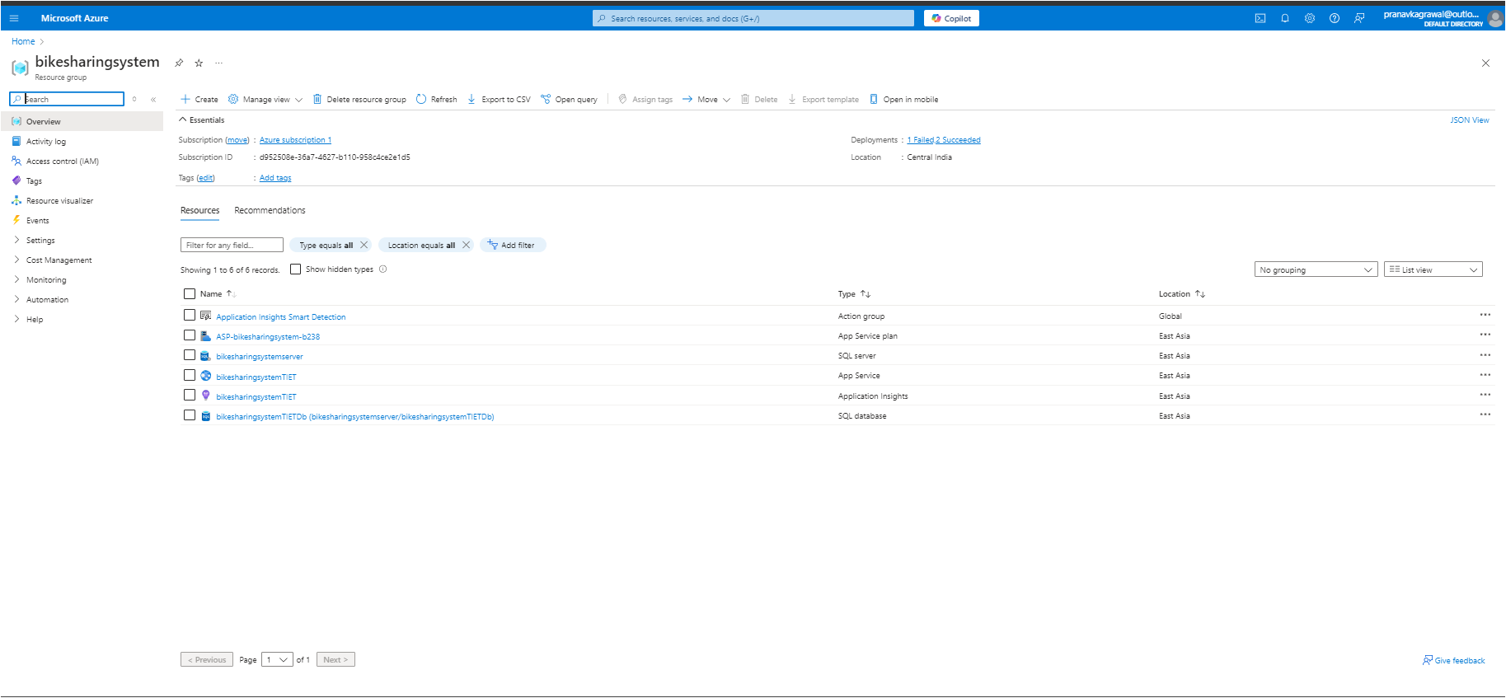

# CHAPTER 5

**OUTCOMES AND PROSPECTIVE LEARNING**

### Prospective learning

By actively participating in the development of the Bike Sharing System, individuals will gain a wide range of technical skills that are essential for effectively navigating the current technological environment. Developing expertise in software development, database administration, and IoT integration will establish a strong groundwork for subsequent scholarly or vocational undertakings in associated disciplines. By engaging in this immersive experience, individuals will not only increase their technical proficiency but also develop the adaptability that is required in ever-changing technological environments.

The project's scope transcends technical expertise and encompasses the field of project management. Through planning and executing a complex undertaking, participants will acquire invaluable experience. This requires establishing unambiguous project objectives, managing timelines with precision, and traversing the complexities of project dynamics. This aspect of the undertaking holds the potential to cultivate a methodical and strategic mindset towards resolving issues, thereby making a substantial contribution to the participants' skill set in project management.

The development of the Bike Sharing System places significant importance on cultivating problem-solving and innovation capabilities. All attendees will be actively involved in the process of identifying and resolving the inherent challenges of the undertaking. This procedure functions as a crucible in which critical thinking and innovation are cultivated. By applying theoretical knowledge in the real world, participants will be encouraged to generate innovative solutions, thereby improving their problem-solving abilities and cultivating an innovative mindset. This is a set of skills that is in high demand in both academic and professional domains.

In addition, the project's collaborative nature guarantees a significant emphasis on the development of cooperation and collaboration abilities. By collaborating closely with members of a diverse team, participants will gain experience navigating the complexities of collaborative environments. This not only improves their capacity for efficient collaboration but also provides them with exposure to a variety of viewpoints, which expands their comprehension of the complexities and difficulties associated with cooperation.

The initiative concludes by placing an emphasis on the development of presentation and reporting abilities. Mentors and project committees will be informed of the actively communicated project objectives, progress, and results by participants. This aspect of the project functions as a catalyst for honing communication skills, guaranteeing that individuals are capable of expressing intricate technical notions with unambiguity and accuracy—a competency that is essential in both scholarly and vocational environments.

Fundamentally, the potential educational benefits of the Bike Sharing System initiative transcend the short-term objectives of the undertaking, endowing participants with an extraordinarily diverse repertoire of abilities that will prove indispensable in their subsequent scholarly and vocational endeavours.

### Outcome

A crucial component of our undertaking to create a dependable and effective Bike Sharing System (BSS) was the implementation of a WI-FI module simulation in the Arduino Integrated Development Environment (IDE). The simulation outcomes were crucial in confirming the functionality and precision of the GPS integration implemented in our system.

By conducting extensive simulations and rigorous testing, we successfully evaluated the GPS module's real-time functionality, thereby guaranteeing its smooth assimilation into the overarching structure of the BSS. By providing a controlled testing environment and enabling the identification and resolution of potential issues, the Arduino IDE simulation ensured that the final implementation of the GPS tracking system would be dependable and accurate.

Edit pic here

Figure-9

Extending beyond the digital domain, a momentous achievement in our undertaking was the effective deployment of the BSS Smart Lock, supported by an exhaustive circuit blueprint and accompanying photographic records. A vital component of our system, the smart lock was painstakingly crafted to guarantee the security and efficacy of bike-sharing transactions.

The visual documentation in the form of an accompanying circuit photograph attests to the meticulous attention to detail and intricate craftsmanship that went into the creation of this vital component. The photograph depicts the convergence of cables, sensors, and microcontrollers, illustrating how these hardware components work together to provide functionality to the smart lock. By virtue of this physical manifestation, our team's technical expertise is not only emphasised, but it also functions as a valuable point of reference for subsequent iterations or improvements to the BSS Smart Lock.

In addition, the circuit photograph serves as a visual record of the project's progression, providing collaborators and stakeholders with an insight into the hardware implementation's complexities. The purpose of this documentation is twofold: to promote transparency and to function as a fundamental resource for troubleshooting and maintenance. This represents the

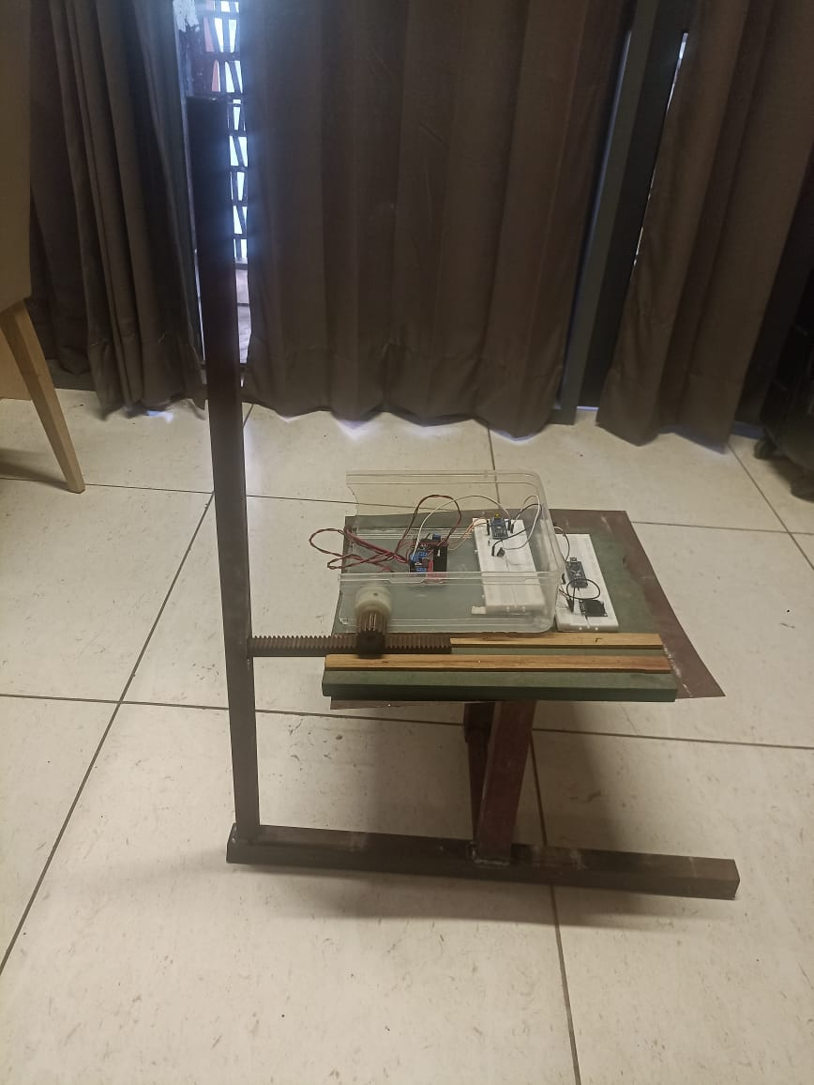

integration of theoretical understanding and practical application, emphasising the concrete result of our endeavours in developing the Bike Sharing System.

Figure-10

In brief, the results section of this report highlights the intersection of theoretical simulation and practical application, with particular emphasis on the effective integration of a GPS module facilitated by Arduino IDE simulation. The tangible manifestation of our efforts takes the shape of a BSS Smart Lock circuit, which has been meticulously designed and documented. The aforementioned results highlight the extent of our technical accomplishments, establishing the foundation for a fully operational and all-encompassing bike-sharing system.

**CHAPTER 6**

**PROJECT TIMELINE**

# Project Timeline

Edit picture here ---see

Table-2

# Individual Plan

1. Pranav Kumar Agrawal 102153031

|  |  |  |  |  |  |  |  |  |  |  |  |  |  |
| --- | --- | --- | --- | --- | --- | --- | --- | --- | --- | --- | --- | --- | --- |
| **S.No.** | **Activity** | **Jan** | **Feb** | **Mar** | **Apr** | **May** | **Jun** | **Jul** | **Aug** | **Sept** | **Oct** | **Nov** | **Dec** |
| 1. | Project Plannin g and Discussi on |  |  |  |  |  |  |  |  |  |  |  |  |
| 2. | Researc h |  |  |  |  |  |  |  |  |  |  |  |  |
| 3. | Review Articles |  |  |  |  |  |  |  |  |  |  |  |  |
| 4. | Study of various compon ents |  |  |  |  |  |  |  |  |  |  |  |  |
| 5. | Presenta tion |  |  |  |  |  |  |  |  |  |  |  |  |
| 6. | Mid-Ter m Report |  |  |  |  |  |  |  |  |  |  |  |  |
| 7. | Circuit Synthesi  -s |  |  |  |  |  |  |  |  |  |  |  |  |
| 8. | Creating IoT App |  |  |  |  |  |  |  |  |  |  |  |  |
| 9. | Final Improve ments and testing |  |  |  |  |  |  |  |  |  |  |  |  |
| 10. | Presenta  -tion |  |  |  |  |  |  |  |  |  |  |  |  |

Table-3

1. Pranav Prakash 102165011

|  |  |  |  |  |  |  |  |  |  |  |  |  |  |
| --- | --- | --- | --- | --- | --- | --- | --- | --- | --- | --- | --- | --- | --- |
| **S.No.** | **Activity** | **Jan** | **Feb** | **Mar** | **Apr** | **May** | **Jun** | **Jul** | **Aug** | **Sept** | **Oct** | **Nov** | **Dec** |
| 1. | Project Plannin g and Discussi on |  |  |  |  |  |  |  |  |  |  |  |  |
| 2. | Researc h |  |  |  |  |  |  |  |  |  |  |  |  |
| 3. | Review Articles |  |  |  |  |  |  |  |  |  |  |  |  |
| 4. | Hardwar e Compait ablity |  |  |  |  |  |  |  |  |  |  |  |  |
| 6. | Presenta tion |  |  |  |  |  |  |  |  |  |  |  |  |
| 7. | Mid-Ter m Report |  |  |  |  |  |  |  |  |  |  |  |  |
| 8. | Circuit Synthesi s |  |  |  |  |  |  |  |  |  |  |  |  |
| 9. | QoL Changes |  |  |  |  |  |  |  |  |  |  |  |  |
| 10. | Final Improve ments |  |  |  |  |  |  |  |  |  |  |  |  |
| 11. | Presenta  -tion |  |  |  |  |  |  |  |  |  |  |  |  |

Table-4

1. Aditya Jha 102103250

|  |  |  |  |  |  |  |  |  |  |  |  |  |  |
| --- | --- | --- | --- | --- | --- | --- | --- | --- | --- | --- | --- | --- | --- |
| **S.No.** | **Activity** | **Jan** | **Feb** | **Mar** | **Apr** | **May** | **Jun** | **Jul** | **Aug** | **Sept** | **Oct** | **Nov** | **Dec** |
| 1. | Project Plannin g and Discussi on |  |  |  |  |  |  |  |  |  |  |  |  |
| 2. | Researc h |  |  |  |  |  |  |  |  |  |  |  |  |
| 3. | Review Articles |  |  |  |  |  |  |  |  |  |  |  |  |
| 4. | Study of various compon ents |  |  |  |  |  |  |  |  |  |  |  |  |
| 5. | Presenta tion |  |  |  |  |  |  |  |  |  |  |  |  |
| 6. | Mid-Ter m Report |  |  |  |  |  |  |  |  |  |  |  |  |
| 7. | Circuit Synthesi  -s |  |  |  |  |  |  |  |  |  |  |  |  |
| 8. | Reliabili ty Tests |  |  |  |  |  |  |  |  |  |  |  |  |
| 9.. | Final Improve ments and testing |  |  |  |  |  |  |  |  |  |  |  |  |
| 10. | Presenta  -tion |  |  |  |  |  |  |  |  |  |  |  |  |

Table-5

1. Yati Dhanda 102103250

|  |  |  |  |  |  |  |  |  |  |  |  |  |  |
| --- | --- | --- | --- | --- | --- | --- | --- | --- | --- | --- | --- | --- | --- |
| **S.No.** | **Activity** | **Jan** | **Feb** | **Mar** | **Apr** | **May** | **Jun** | **Jul** | **Aug** | **Sept** | **Oct** | **Nov** | **Dec** |
| 1. | Project Plannin g and Discussi on |  |  |  |  |  |  |  |  |  |  |  |  |
| 2. | Researc h |  |  |  |  |  |  |  |  |  |  |  |  |
| 3. | Review Articles |  |  |  |  |  |  |  |  |  |  |  |  |
| 4. | Study of various compon ents |  |  |  |  |  |  |  |  |  |  |  |  |
| 6. | Presenta tion |  |  |  |  |  |  |  |  |  |  |  |  |
| 7. | Mid-Ter m Report |  |  |  |  |  |  |  |  |  |  |  |  |
| 8. | Circuit Synthesi  -s |  |  |  |  |  |  |  |  |  |  |  |  |
| 9. | QoL Changes |  |  |  |  |  |  |  |  |  |  |  |  |
| 10. | Final Improve ments and testing |  |  |  |  |  |  |  |  |  |  |  |  |
| 11. | Presenta  -tion |  |  |  |  |  |  |  |  |  |  |  |  |

Table-6

1. Sukirat Singh Monga 102165014

|  |  |  |  |  |  |  |  |  |  |  |  |  |  |
| --- | --- | --- | --- | --- | --- | --- | --- | --- | --- | --- | --- | --- | --- |
| **S.No.** | **Activity** | **Jan** | **Feb** | **Mar** | **Apr** | **May** | **Jun** | **Jul** | **Aug** | **Sept** | **Oct** | **Nov** | **Dec** |
| 1. | Project Plannin g and Discussi on |  |  |  |  |  |  |  |  |  |  |  |  |
| 2. | Researc h |  |  |  |  |  |  |  |  |  |  |  |  |
| 3. | Review Articles |  |  |  |  |  |  |  |  |  |  |  |  |
| 4. | Study of various compon ents |  |  |  |  |  |  |  |  |  |  |  |  |
| 6. | Presenta tion |  |  |  |  |  |  |  |  |  |  |  |  |
| 7. | Mid-Ter m Report |  |  |  |  |  |  |  |  |  |  |  |  |
| 8. | Circuit Synthesi  -s |  |  |  |  |  |  |  |  |  |  |  |  |
| 9. | Reliabili ty Tests |  |  |  |  |  |  |  |  |  |  |  |  |
| 10. | Final Improve ments and testing |  |  |  |  |  |  |  |  |  |  |  |  |
| 11. | Presenta  -tion |  |  |  |  |  |  |  |  |  |  |  |  |

Table-7

# CHAPTER 7

**CONCLUSION AND FUTURE WORK**

In summary, the Bike Sharing System (BSS) initiative signifies a paradigm shift at the intersection of sustainable urban mobility, technology, and sustainability. The investigation conducted in this report has shed light on the historical development of bike-sharing systems, placing their importance in the context of promoting environmentally friendly modes of transportation worldwide.

This extensive synopsis establishes the foundation for comprehending the wider context within which our undertaking functions, recognising the extensive heritage and ongoing development of bike-sharing as a crucial component in the contemporary urban mobility paradigm.

Establishing precise goals and a precisely defined scope for the project served as a critical pillar in directing our combined endeavours towards a concrete and influential result. During the preliminary stages of project planning, the establishment of clear objectives served as a compass, guaranteeing that our pursuits were intentional and in line with the overarching aims of the Bike Sharing System (BSS) initiative.

The rigorous delineation facilitated the team's ability to maintain concentration, thereby cultivating a collective comprehension of the project's objective and intended results. The clearly defined scope served as an essential demarcation, stipulating the boundaries of our undertaking and guaranteeing that our endeavours remained focused and efficient.

By placing a deliberate emphasis on connecting abstract ideals with tangible implementations, the project formulation served as the fundamental principle that directed our inventive methodology. The formulation process served as the critical crucible wherein abstract ideas were refined into implementable strategies, thereby facilitating the implementation of the project.

Central to this paradigm shift was the deliberate integration of Internet of Things (IoT) devices, a decision emphasised by the significant consequences it entailed. The result of this strategic integration was the development of the advanced Smart Lock system, which served as a critical component of the BSS framework.

In addition to augmenting the security and efficacy of bike-sharing, this technological integration harmoniously corresponds with current developments in smart city infrastructure. By adopting this approach, our endeavour not only serves as evidence of forward-thinking but also seamlessly integrates into the larger discourse surrounding interconnected and environmentally sustainable urban ecosystems.

By further examining the project description, we are able to discern the complexities of the BSS, with particular emphasis on the Smart Lock's design and functionality. The Smart Lock plays a critical role in ensuring the success of the system by integrating Internet of Things devices, which enables an intelligent and streamlined bike-sharing experience.

The implementation of a GPS module is particularly noteworthy as it facilitates accurate monitoring and effective administration of the communal bicycles. The aforementioned level of complexity highlights the dedication to creating a progressive system that not only attends to urgent transit requirements but also corresponds with the progression of smart city developments.

With the completion of our project adhering to the designated schedule, every stage made a substantial contribution to the overall effectiveness and achievement of the Bike Sharing System. The strictly followed project timeline functioned as a reflection and a guide for the collaborative and iterative nature of the development process. The process involved a methodical advancement from ideation to implementation, which culminated in a unified and operational system that perfectly corresponds to the original project objectives.

The BSS report functions as an all-encompassing examination of the historical development, present condition, and prospective course of bike-sharing systems. Our investigation delves into the extensive history of these systems, placing their importance within the wider context of urban mobility. Concurrently, it illuminates the current condition of bike-sharing, underscoring its pivotal function in promoting sustainable transportation alternatives.

In anticipation of the future, the report presents a forward-thinking analysis, speculating on the way bike-sharing systems will evolve into essential elements of smart city infrastructure. The impressive feat of seamlessly integrating Internet of Things (IoT) devices, particularly within the Smart Lock, is noteworthy. The integration in question represents more than just a technological achievement; it exemplifies the ingenuity and flexibility that lie at the heart of our undertaking.

Furthermore, our efforts transcend the immediate concern of addressing the urgent requirement for environmentally sustainable conveyance in urban areas. It serves as a catalyst, inciting ongoing progress in the wider domain of smart city infrastructure. Through the exploration and expansion of traditional bike-sharing systems, our initiative makes a valuable contribution to the continuous development of intelligent urban transportation solutions.

Hence, the report represents the ultimate result of a rigorously carried out undertaking, demonstrating the commitment and proficiency of our group. Concurrently, it drives progress, functioning as a launching platform for subsequent undertakings in the ongoing quest for inventive, astute, and environmentally conscious resolutions to the complexities of urban transportation.

# REFERENCES

1. Andersen, L., P. Schnohr, M. Schroll, and H.O. Hein. 2000. All-cause mortality associated with physical activity during leisure time, work, sports, and cycling to 53 work. Archives of Internal Medicine. 160:1621-1628. [http://archinte.ama-ssn.](http://archinte.ama-ssn/) org/cgi/content/full/160/11/1621/.
2. Avenir du Vehicule Electrique Mediterraneen. 2008. February 28. [http://translate.](http://translate/) [google.com/translate?prev=_t&hl=en&ie=UTF-8&u=http%3A%2F%2Fwww](http://www/). avem.fr%2Factualite-monaco-des-velos-electriques-en-libre-service-386. html&sl=fr&tl=en&history_state0/[.](http://translate./)Ayotte, A. 2009. Conversation with author. July 13.
3. Bansal, P., Kockelman, K. M., & Singh, M. P. (2018). Commuter mode choice and free-floating bikesharing: A case study of four North American cities. Transportation

Research Part D: Transport and Environment, 63, 722-742. Barcelona de Serveis Municipals. undated. BSM Organización. http://www.bsmsa. es/index.php?id=10&L=1[/](http://www.bsmsa./).

1. BBC. 2009. Thefts puncture Paris bike scheme. February 10. [http://news.bbc.](http://news.bbc/) co.uk/2/hi/europe/7881079.stm/.
2. B-cycle. 2009. What is B-cycle? [http://www.bcycle.com/.](http://www.bcycle.com/)
3. Bicincitta’. 2009a. Gallery. [http://bicincitta.com/gallery.asp/.](http://bicincitta.com/gallery.asp/)
4. Bicincitta’.2009b.Genoa[.http://74.125.113.132/translate_c?hl=en&sl=it&u=](http://74.125.113.132/translate_c?hl=en&sl=it&u) [http://www.bicincitta.com/citta_v3.asp%3Fid%3D33&prev=/search%3Fq](http://www.bicincitta.com/citta_v3.asp%3Fid%3D33%26prev%3D/search%3Fq)

%3D%252Bmobike%2B%252Bgenova%26hl%3Den%26client%3Dfirefoxa%26rls%3Dorg. mozilla:en-US:official%26hs%3DX41%26sa%3DG&rurl=trans late.google.com&usg=ALkJrhijAARamP_sUSmk_aUVqkTXn000lw/.

1. Black, C., and S. Potter. Undated. Portsmouth bikeabout: A smart-card bike club scheme. [http://www.metrobike.net/index.php?s=file_download&id=11/.](http://www.metrobike.net/index.php?s=file_download&id=11/)
2. Bixi. 2009a. Overview. [http://www.bixisystem.com/bixi_system/overview/.](http://www.bixisystem.com/bixi_system/overview/)
3. Bixi. 2009b. Information. [http://montreal.bixi.com/home/home-info/.](http://montreal.bixi.com/home/home-info/)
4. Bührmann. 2008. Bicycles as public-individual transport – European developments. 18. [http://www.metrobike.net/index.php?s=file_download&id=2/.](http://www.metrobike.net/index.php?s=file_download&id=2/)
5. Cavill, N., and A. Davis. 2006. Cycling and Health. 9-43. [http://www.networks.nhs.](http://www.networks.nhs/) uk/uploads/07/11/cycling_and_health.pdf/.
6. City Bike Foundation of Copenhagen. undated. Bycyklen København. [http://www.](http://www/) bycyklen.dk/.
7. City of Paris. 2007. Le Bilan des Deplacements en 2007 a Paris. La Mairie de Paris, L’Observatorie de Deplacements, Paris, France. <http://www.paris.fr/portail/deplacements/Portal.lut?page_id=7627&document_type_id=4&do> cument_id=26324&portlet_id=17647&multileveldocument_sheet_id=11982/.
8. City of Paris. 2008. La lettre Vélib’. May. 10. [http://velib.centraldoc.com/newsletter/10_aujourd_hui_nous_vous_connaissons_mieux/.](http://velib.centraldoc.com/newsletter/10_aujourd_hui_nous_vous_connaissons_mieux/)
9. City of Paris. 2009. La lettre Vélib’. June. 22. <http://velib.centraldoc.com/> newsletter/22_bientot_2_ans_d_utilisation_votre_regard_sur_le_service/.
10. Civitas. 2009. City bike scheme in Burgos.

[http://www.civitas-initiative.org/measure_sheet.phtml?lan=en&id=302/.](http://www.civitas-initiative.org/measure_sheet.phtml?lan=en&id=302/)

1. DeMaio, P. 2007. What a year for bike-sharing. December 30. [http://bike-sharing.](http://bike-sharing/) blogspot.com/2007/12/what-year-for-bike-sharing.html/.
2. DeMaio, Paul. 2008a. Bike-sharing Wrap-up for 2008. December 31. [http://bikesharing.blogspot.com/2008/12/bike-sharing-wrap-up-for-2008.html/.](http://bikesharing.blogspot.com/2008/12/bike-sharing-wrap-up-for-2008.html/)
3. DeMaio, P. 2008b. University bike-sharing’s time has come. The Bike-sharing Blog. October 26.

[http://bike-sharing.blogspot.com/2008/10/university-bike-sharings-time-has-come.html/.](http://bike-sharing.blogspot.com/2008/10/university-bike-sharings-time-has-come.html/)

1. Deutsche Bahn. 2009. DB Fuhrpark. <http://www.dbfuhrparkservice.de/site/> dbfuhrpark/de/anschlussmobilitaet/anschlussmobilitaet.html[/](http://www.dbfuhrparkservice.de/site/).
2. E- Bike Share Schemes Rolling Out Across UK,

[https://www.bike-eu.com/26690/e-bike-share-schemes-rolling-out-across-uk.](http://www.bike-eu.com/26690/e-bike-share-schemes-rolling-out-across-uk)

1. European Cyclists' Federation (2019). Electric bicycles: Unlocking their potential for active mobility.
2. Fishman, E., Washington, S., Haworth, N., & Watson, A. (2014). Benefits of a

GPS-based tracking system for bikeshare users and operators. Transportation Research Part C: Emerging Technologies, 42, 62-72.

1. Gao, S., Wang, S., & Zhang, W. (2020). Intelligent monitoring of bike-sharing systems: A review of recent advances. IEEE Transactions on Intelligent Transportation Systems, 22(9), 5772-5785. doi: 10.1109/TITS.2020.2988853
2. Greater Lyon. 2009. Velo’v la newsletter. March. 37. [http://www.velov.grandlyon.](http://www.velov.grandlyon/) com/Newsletter-Velo-v-numero-37.134.0.html/.
3. Henley, J. 2005. Rentabike moves up a gear from curiosity to runaway success. The Guardian. August 12. <http://www.guardian.co.uk/world/2005/aug/12/> france.jonhenley/.
4. Huang, Q., Zhang, J., & Wang, X. (2018). Bike sharing systems: A review.

Sustainability, 10(11), 3926. doi: 10.3390/su10113926

1. Li, C., Zhang, C., & Wei, Y. (2018). Smart bike-sharing systems: A review of the literature. Transportation Research Part C: Emerging Technologies, 91, 92-114. https://doi.org/10.1016/j.trc.2018.02.004
2. Li, H., & Xiao, Z. (2018). Design and implementation of smart lock-based bike sharing system. Wireless Communications and Mobile Computing, 2018, 1-8. doi: 10.1155/2018/4160857
3. Lim, C., & Banga, D. (2019). Optimization on Initial Inventory of Bike Sharing System. IIE Annual Conference. Proceedings, 1042.
4. Ma, C., Chen, C., & Zhou, J. (2017). An intelligent bike-sharing system based on GPS and GPRS technologies. Journal of Advanced Transportation, 2017, 1-13. doi: 10.1155/2017/3012460
5. Martens, K., Johnson, M., & Schäfer, A. (2016). Smartphone apps in bike-sharing: What features do users want? Transportation Research Part A: Policy and Practice, 88, 88-97.
6. Martin, E. W., Shaheen, S. A., & Lidicker Jr, J. R. (2018). The impacts of electric bike use on mode substitution and travel behavior: Results of a survey of North American e-bike users. Transportation Research Part D: Transport and Environment, 59, 245-254.
7. Ma, Z., & Zhou, J. (2015). A review of research on bike-sharing. Transportation Research Part A: Policy and Practice, 77, 88-114. https://doi.org/10.1016/j.tra.2015.04.003
8. MetroBike. 2009. The Bike-sharing world map. <http://maps.google.com/maps/> ms?ie=UTF8&hl=en&om=1&msa=0&msid=104227318304000014160.00043 d80f9456b3416ced&ll=43.580391,-42.890625&spn=143.80149,154.6875&z=1

&source=embed/.

1. Nadal, L. 2007. Bike sharing wweeps Paris off its feet. Sustainable Transport. 19. 8 - 12. [http://www.itdp.org/documents/st_magazine/ITDP-ST_Magazine-19.](http://www.itdp.org/documents/st_magazine/ITDP-ST_Magazine-19) pdf/.
2. National Association of City Transportation Officials (NACTO). (2018). Shared mobility: An evaluation of dockless bike sharing in cities.
3. New York City Department of City Planning. 2009. Bike-share opportunities in New York City. 84. <http://www.nyc.gov/html/dcp/pdf/transportation/> bike_share_ complete.pdf/.
4. NICHES. 2007. Public bicycles. p. 5. <http://ange.archangelis.com/typo3/niches/> fileadmin/New_folder/Deliverables/D4.3b_5.8_b_PolicyNotes/14397_pn4_ public_bikes_ok_low.pdf/.
5. Nice Ride Minnesota. 2008. Twin Cities bike share project business plan. 38-9. [http://www.niceridemn.com/downloads/doc_plan.php/.](http://www.niceridemn.com/downloads/doc_plan.php/) Nice Ride Minnesota. 2009. Nice Ride Minnesota. [http://www.niceridemn.com/.](http://www.niceridemn.com/)
6. Nielse, B. H. 1993. The Bicycle in Denmark: Present Use and Future Potential. Danish Ministry of Transport. 52.
7. Optimising Bike Sharing in European Cities. 2009a. France. FR_Rennes_Old System tab. <http://www.obisproject.com/palio/html.run?_Instance=obis&_> PageID=4&_LngID=21&_CatID=722&pic=4&_CheckSum=1012982978/.
8. Optimising Bike Sharing in European Cities. 2009b. Germany. DE_Berlin tab. <http://www.obisproject.com/palio/html.run?_Instance=obis&_PageID=4&_> LngID=21&_CatID=722&pic=4&_CheckSum=1012982978/.
9. Optimising Bike Sharing in European Cities. 2009c. France. FR_Lyon tab. http:// [www.obisproject.com/palio/html.run?_Instance=obis&_PageID=4&_](http://www.obisproject.com/palio/html.run?_Instance=obis&_PageID=4&_)

LngID=21&_CatID=722&pic=4&_CheckSum=1012982978/.Ovum (2017). Bike-sharing goes electric.

1. Paul DeMaio MetroBike, LLC, Journal of Public Transportation, Vol. 12, No. 4, 2009,Bike-sharing: History, Impacts, Models of Provision, and Future.
2. Rene Reiter, 01.12.2016, Dimensioning of Bike Sharing Systems in the City of Leon, Guanajuato, MX.
3. Ricci, M., Paglione, L., & Rinaldi, S. (2017). Electric bike sharing in hilly cities: The case study of Genoa, Italy. Energy Procedia, 126, 1226-1233.
4. Romero, C. 2008. SpiCycles in Barcelona. Presented to Chamber of Commerce and Industry, December 19, in Bucharest, Romania. 31. <http://spicycles.velo.info/> Portals/0/FinalReports/Barcelona_Final_Report.ppt/.
5. Ruiz, E. J., Cossio, R., & Palacios, J. J. (2018). A smart bike-sharing system based on the integration of electric bicycles and public transportation. Transportation Research Part C:

Emerging Technologies, 91, 257-268. doi: 10.1016/j.trc.2018.04.015

1. Santos, G., Behrendt, H., & Teytelboym, A. (2016). Part III: Sustainable urban mobility in European cities: Assessing the performance of the transport system. In Implementing sustainable urban travel policies and plans (pp. 65-105). Elsevier.Schimmelpennick, L. 2009. Conversation with author. March 5.
2. Schmitt, P., Ziemke, D., & Siebel, W. (2015). How GPS-based fleet management systems can improve bike-sharing operations. In C. M. Hall (Ed.), Bicycle Tourism (pp. 293-305). Channel View Publications.
3. Shaheen, S. A., Guzman, S., & Zhang, H. (2010). Bikesharing in Europe, the Americas, and Asia: Past, present, and future. Transportation Research Record: Journal of the Transportation Research Board, 2143(1), 159-167.
4. Shaheen, S. A., Guzman, S., Zhang, H., & Schaller, M. (2019). Bicycle sharing: History, impacts, models of provision, and future. Journal of Public Transportation, 22(1), 1-26.
5. Shaheen, S. A., Martin, E. J., & Lidicker Jr, J. R. (2019). Electric bikes in North America: Results of an online survey. Transportation Research Part D: Transport and Environment, 71, 110-122.
6. Shepard, R. 2008. Is Active Commuting the answer to population health? Sports Medicine. 39(9): 751-758.
7. Stationnement de Montréal. 2009. Stationnement de Montréal. <http://www.statdemtl.qc.ca/index.php?page_id=42>〈=en/.
8. Stationnement de Montréal. undated. Public Bike System. 15. [http://www.metrobike.net/index.php?s=file_download&id=13/.](http://www.metrobike.net/index.php?s=file_download&id=13/)
9. Taking the green road to growth[1]- Chinadaily.com.cn. https://global.chinadaily.com.cn/business/2014-08/29/content_18508899.htm.
10. Twin Cities Bike Share. 2008. Non-profit business plan for Twin Cities bike share system. December 3. 36 - 44. <http://www.niceridemn.com/downloads/> doc_plan.php/.
11. University of Cambridge. (2017). E-bike sharing: Analysis of user behavior and system performance.Vélib’. 2008. Velib et Moi - Le Blog. October 2. <http://blog.velib.paris.fr/blog/> reportages/triomphe-des-bonus-v-vous-ameliorez-tous-les-jours-le-servicevelib/.
12. Wainwright, O. (2017, July 6). Dockless bike-sharing: the new disruptor in urban transport.
13. Wang, C., Wu, X., Lu, J., & Zhang, L. (2018). Design and implementation of a smart bicycle sharing system. Wireless Communications and Mobile Computing, 2018, 1-8. doi: 10.1155/2018/5163459
14. Wang, D., Zhao, J., & Li, X. (2016). Bike-sharing systems in urban China: History, present status and future challenges. Journal of Transport
15. Wong, Y. D., & Taeihagh, A. (2019). Advancing public policy for bicycle sharing: Learning from the development and deployment of dockless bike sharing in China. Journal of Cleaner Production, 210, 432-440.
16. Wu, X., Wang, H., & Liu, X. (2021). An optimal operation model for dockless bike-sharing systems with electric bikes. Transportation Research Part C: Emerging Technologies, 126, 103132.
17. Xu, Y., Sun, L., Zhang, M., & Chen, J. (2019). The impact of dockless bike-sharing on bicycle usage and mode shift in urban China. Journal of Transport Geography, 76, 56-64.
18. Zhang, M., & Shaheen, S. A. (2019). Dockless bike sharing: An overview of recent literature and open questions. Transport Reviews, 39(1), 98-121.
19. Zhang, Y., Liu, X., Shu, L., & Zhang, Y. (2018). Bike-sharing systems: Review of recent studies, mathematical models, and future directions. Transportation Research Part C: Emerging Technologies, 91, 144-160. doi: 10.1016/j.trc.2018.03.017