**Minor in AI**

**Master Session Notes**

Batch 4

30 Jan 2025

Title: Building Smarter Python Programs: Decisions, Loops, and Error Handling

**Activity One: Story Building**

Write a 1-2 sentence story for the cartoon prompt given below.

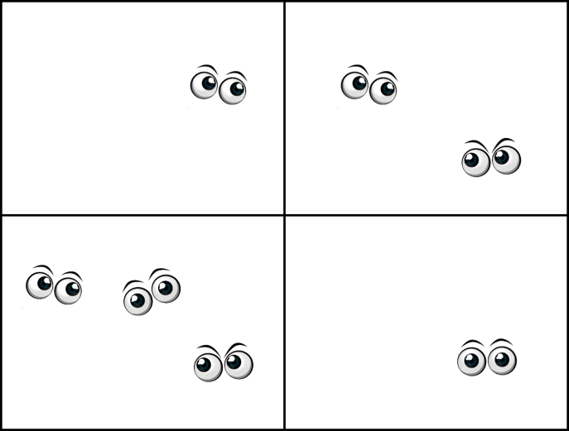

What did we understand?

* We took decisions on the eye
* We iterated through the four quadrants

Our life is amidst the repetitions and decisions. How do you think such human constructs inspire programming language design?

**Question to ponder on:**

We never say ‘My name is Prakash and Prakash is in characters.’ Then why do I need to tell a machine that ‘Prakash’ is in characters and not integer?

**Task 01: Given the age and current year, compute the birth year (work with this code on Collab and Python Tutor)**

# Given the age and current year, compute the birth year

age = int(input("Enter your age: "))

year = int(input("Enter the current year: "))

# Calculate birth year

birth_year = year - age

# Display result

print("Your birth year is")

print(birth_year)

Observation:

Observe how we have given int( ) as typecasting. What would happen if we had missed it? Does it mean I need to tell python that the data I am entering is an integer? Is there something to do with input()?

**Task 02: Exercise**

Write a program to initialize integer, float, string and boolean data types and print

Activity: Understand the mapping of ‘if’ and ‘otherwise’ to ‘if’ and ‘else’. What happens if we have multiple decision making? How do we map it in python? In python we use if-elif-else for decision branching.

**Task 03: Using conditions in programming.**

Block 01:

# accept the age input

age = int(input("Enter your age: "))

Block 02:

# validate the age

if age < 0:

  print("Your age cannot be negative ")

elif age == 0:

  print("Age cannot be 0 ")

else:

  print("Age is accepted ")

Block 03:

# compute birthyear

if age > 0:

  current_year = int(input("Enter the current year "))

  birth_year =  current_year - age

  print("Your birth year is: ", birth_year);

else:

  print("Nothing to compute")

**Task 04: Looping and conditions**

From the list of given numbers, identify if the numbers are positive or negative.

Elements: Usage of Python Tutor for visualization

# List of numbers

numbers = [10, -5, 20, -15, 30, -25, 40, -35, 50, -45]

# Loop through each number

for num in numbers:

if num >= 0:

print(num, "is Positive")

else:

print(num, "is Negative")

Practice more such simple programs. Explore with other syntax. Use prompting to understand different ways.