**IR Sensor**

**Objective:**

1. To draw a schematic diagram of receiver to receive specified pulse width IR signals from gantries using CAD tool (Eagle).
2. To design a printed circuit board layout of IR sensor module circuit using CAD tool (Eagle).

**Software Used:** Eagle Software **Component Used:**

|  |  |  |  |
| --- | --- | --- | --- |
| **Sr. No** | **Name of Components** | **Value** | **Specifications** |
| 1. | Resistor | 10 K | Carbon Resistor with 5% Tolerance |
| 2. | Resistor | 330 ohm | Carbon Resistor with 5% Tolerance |
| 3. | SFH482 |  | Infrared Emitters |
| 4. | BPX65 |  | Photodiode |
| 5. | LMV358mm |  | Voltage Comparator |
| 6. | LED3mm |  | LED |
| 7. | MTA02-100 |  |  |
| 8. | Potentiometer | PT – 10 | Potentiometer |

**Theory:**

1. **Resistor**:A resistor is a passive two-terminal electrical component that implements electrical resistance as a circuit element.

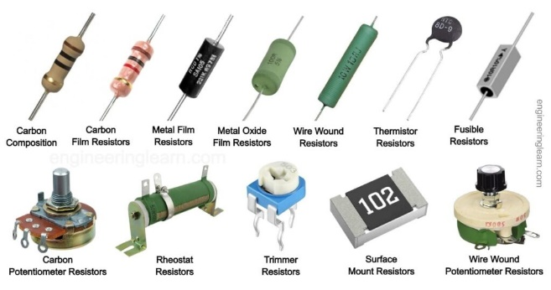

2. **SFH482:** Infrared Emitters - High Power GaAlAs 880nm MTL CAN HALF ANGLE +/-30DEG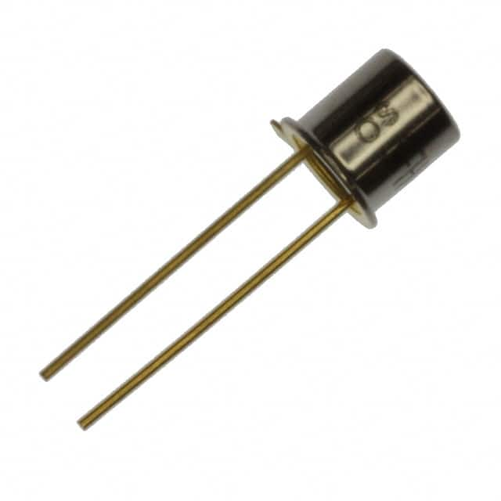 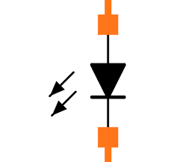

3. **BPX65:** The BPX65 family of detectors feature Centronics’s. 1mm2 high speed, high sensitivity chip already successful in a wide variety of applications.

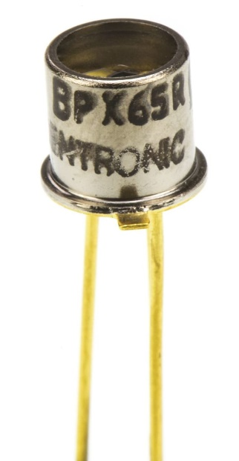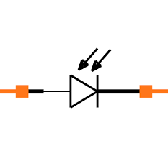

4. **BPW41N**: BPW41N is a PIN photodiode with high speed and high radiant sensitivity in a black, side view plastic package with daylight blocking filter.

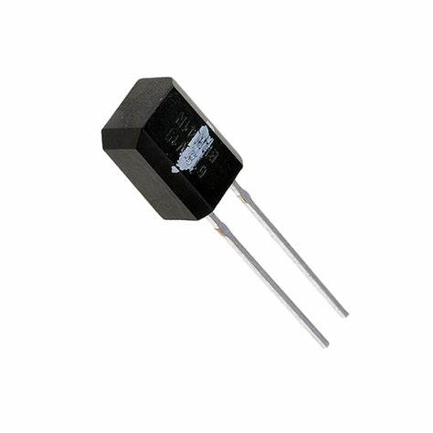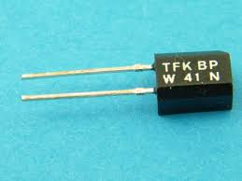

5. **LMV358mm:** The LMV358-N and LMV324-N are low-voltage (2.7 V to 5.5 V) versions of the dual and quad commodity op amps LM358 and LM324 (5 V to 30 V).

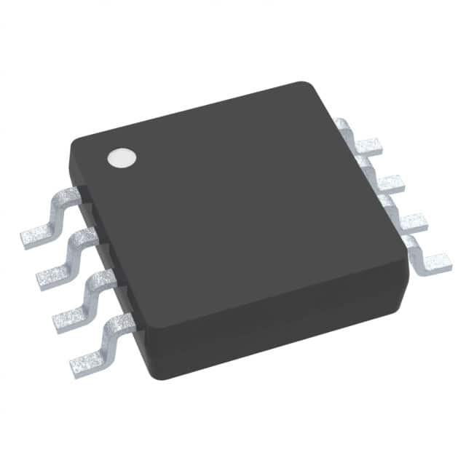 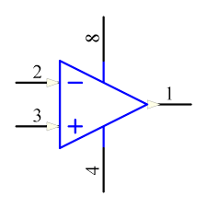

6. **LED3mm** A light-emitting diode (LED) is a [semiconductor](https://en.wikipedia.org/wiki/Semiconductor) [device](https://en.wikipedia.org/wiki/Electronics) that [emits light](https://en.wikipedia.org/wiki/Light#Light_sources) when [current](https://en.wikipedia.org/wiki/Electric_current) flows through it.

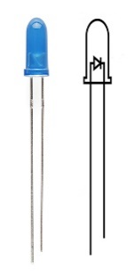 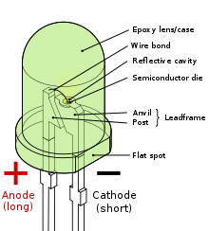

7. **MTA02-100 :** MTA-100 IDC connector system is a wire-to-board and wire-to-wire system with contacts in a single row on 100 in [2.54 mm] centreline.

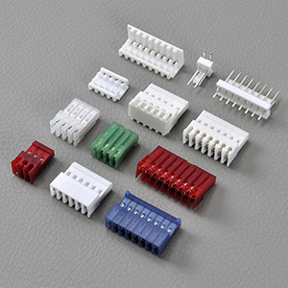

8. **Potentiometer (PT – 10):** The PT-10 potentiometers offer control where frequent adjustment is required.

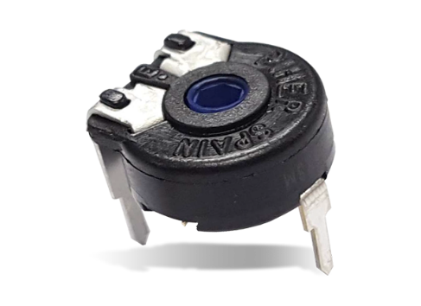

**Schematic diagram:**

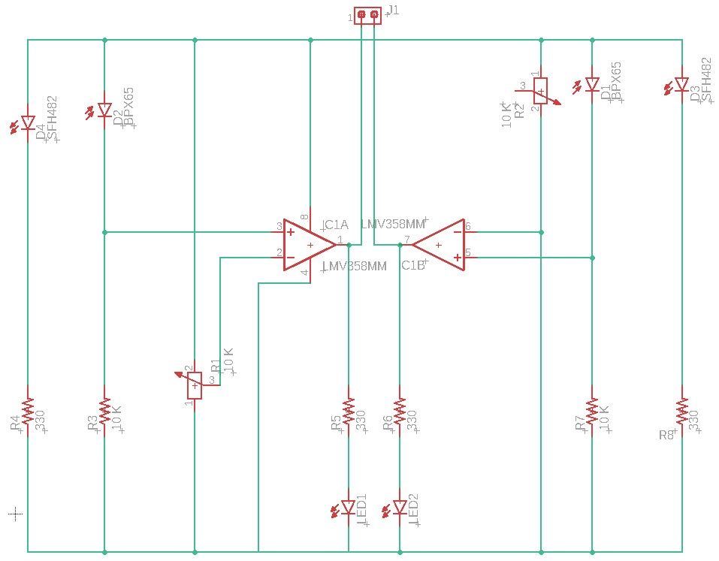

Schematic diagram of IR Sensor circuit

**Printed Circuit Board layout:**

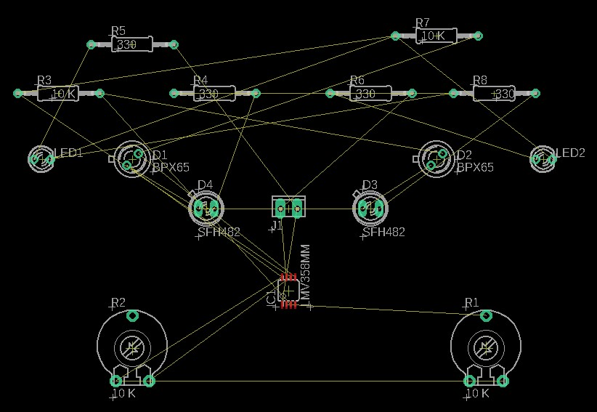

PCB layout of Receiver circuit

**Result / Discussion:**

In this experiment, we have learn using CAD tool (Eagle), how

1. We can draw a schematic diagram of receiver to receive specified pulse width IR signals from gantries.
2. We can design a printed circuit board layout of IR sensor module circuit.

**Reference:**

**[1] https://www.mouser.com/ProductDetail/ams-OSRAM/SFH-482?qs=nTDll3UaDK6II58RYiMx4g%3D%3D**

**[2] https://in.element14.com/centronic/bpx65/photodiode/dp/327451**

**[3] https://www.ti.com/product/LMV358-N/part-details/LMV358MM/NOPB**

**[4]** **https://learn.sparkfun.com/tutorials/resistors/all**

**[5]** **https://www.ultralibrarian.com/2022/07/21/factors-at-play-when-choosing-the-right-capacitor-for-your-design-ulc**