**Receiver Circuit**

**TABLE OF CONTENT**

|  |  |  |
| --- | --- | --- |
| **Sr. No.** | **Experiment no.** | **Objective** |
| **1** | **1 (a)** | To draw a schematic diagram of receiver to receive specified pulse width IR signals from gantries using CAD tool (Eagle). |
| **2** | **1 (b)** | To design a printed circuit board layout of receiver circuit using CAD tool (Eagle). |
| **3** | **2 (a)** | To draw a schematic diagram of IR sensor module circuit (required to move Buggy module on a predefined the path) using CAD tool (Eagle). |
| **4** | **2(b)** | To design a printed circuit board layout of IR sensor module circuit using CAD tool (Eagle). |
| **5** | **3 (a)** | To draw a schematic diagram of pulse width modulation (PWM) based transmitter for generating specified pulse width waveforms for gantries placed at different locations on the path using CAD tool (Eagle). |
| **6** | **3 (b)** | To design a printed circuit board layout of pulse width modulation (PWM) based transmitter circuit using CAD tool (Eagle). |
| **7** | **4** | To solder and test a pulse width modulation (PWM) based transmitter circuit (for gantries placed at different locations on the path to be followed by Buggy robot) on a printed circuit board (PCB). |
| **8** | **5** | To solder and test pulse width modulation (PWM) based receiver circuit (to receive IR signals from gantries connected to transmitter circuit) on a printed circuit board (PCB). |
| **9** | **6** | To solder and test an IR sensor module circuit (which helps Buggy robot to move on a predefined path) on a printed circuit board (PCB). |

**Experiment: 1**

**Objective:**

1. To draw a schematic diagram of receiver to receive specified pulse width IR signals from gantries using CAD tool (Eagle).
2. To design a printed circuit board layout of receiver circuit using CAD tool (Eagle).

**Software Used:** Eagle Software

**Component Used:**

|  |  |  |  |
| --- | --- | --- | --- |
| **Sr. No** | **Name of Components** | **Value** | **Specifications** |
| 1. | Resistor | 120k | Carbon Resistor with 5% Tolerance |
| 2. | Resistor | 100k | Carbon Resistor with 5% Tolerance |
| 3. | Resistor | 22k | Carbon Resistor with 5% Tolerance |
| 4. | Resistor | 1k | Carbon Resistor with 5% Tolerance |
| 5. | Capacitor | 100pf | Ceramic Capacitor |
| 6. | LM311N |  | Voltage Comparator |
| 7. | BPW41N |  | PIN Diode |
| 8. | 22-23-2031 |  | PCB Header |

**Theory:**

1. **Resistor**:A resistor is a passive two-terminal electrical component that implements electrical resistance as a circuit element.

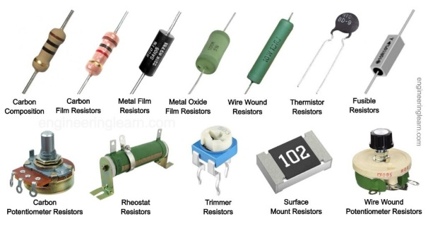

2. **Capacitor**: A capacitor is a device that stores electrical energy in an electric field by virtue of accumulating electric charges on two close surfaces insulated from each other.

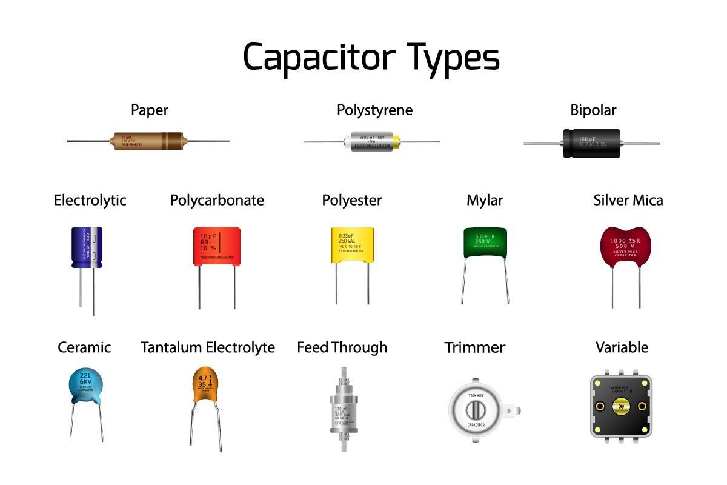

3. **LM311N**: The LM311N are voltage comparators that have input currents nearly a thousand times lower than devices

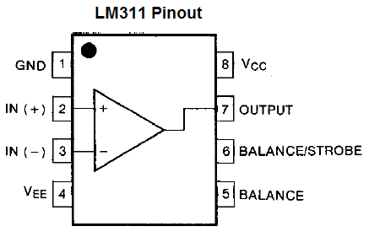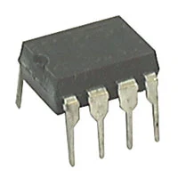

4. **BPW41N**: BPW41N is a PIN photodiode with high speed and high radiant sensitivity in a black, side view plastic package with daylight blocking filter

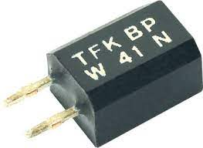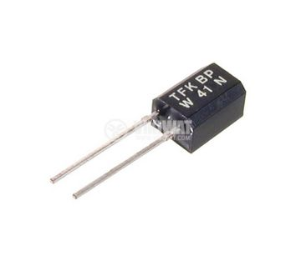

5. **22-23-2031**: 22-23-2031 is a 3 circuit KK 254 solid header with friction lock mates with mates with 2695, 6471, 7880, 4455, 7720.

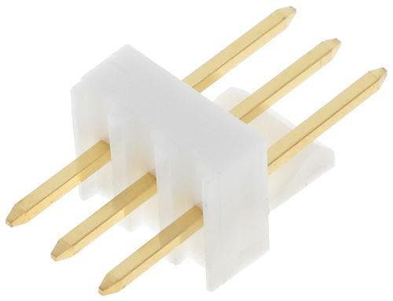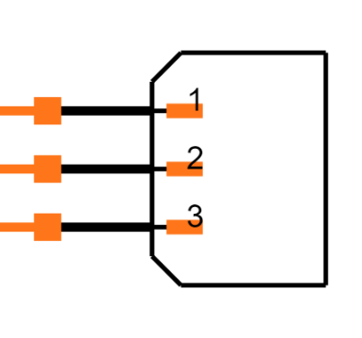

**Schematic diagram:**

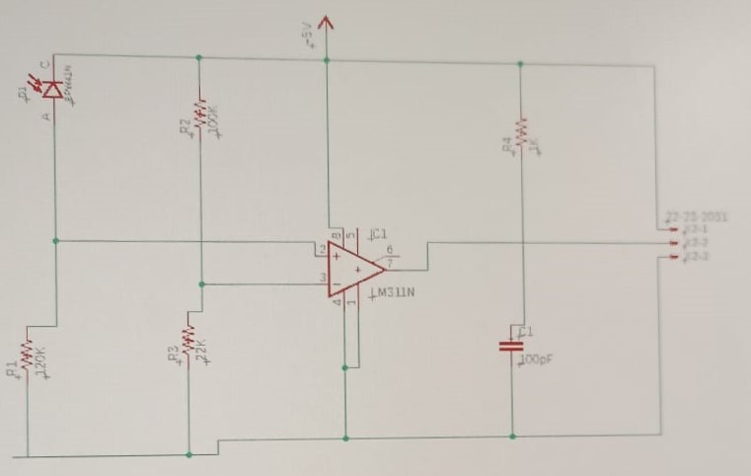

Schematic diagram of Receiver circuit

**Printed Circuit Board layout:**

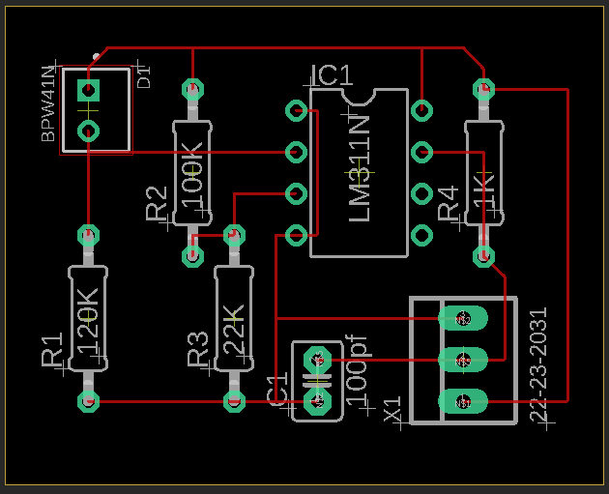

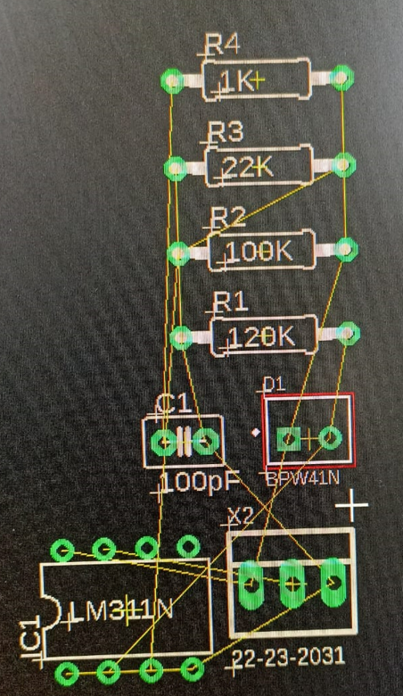

PCB layout of Receiver circuit

**Result / Discussion:**

In this experiment, we have learn using CAD tool (Eagle), how

(a) To draw a schematic diagram of receiver to receive specified pulse width IR signals from gantries.

(b) To design a printed circuit board layout of receiver circuit.

**Reference:**

**[1] https://www.snapeda.com/parts/22-23-2031/Molex/view-part/**

**[2] https://vikiwat.com/product/17136/photodiode-bpw41n.en.html**

**[3] http://www.learningaboutelectronics.com/Articles/LM311-voltage-comparator-circuit.php**

**[4] https://learn.sparkfun.com/tutorials/resistors/all**

**[5]** **https://www.ultralibrarian.com/2022/07/21/factors-at-play-when-choosing-the-right-capacitor-for-your-design-ulc**