**Transmitter Circuit**

**Objective:**

(a) To draw a schematic diagram of pulse width modulation (PWM) based transmitter for generating specified pulse width waveforms for gantries placed at different locations on the path using CAD tool (Eagle).

(b) To design a printed circuit board layout of pulse width modulation (PWM) based transmitter circuit using CAD tool (Eagle).

**Software Used:** Eagle Software

**Component Used:**

|  |  |  |  |
| --- | --- | --- | --- |
| **Sr. No** | **Name of Components** | **Value** | **Specifications** |
| 1. | Resistor | 330 ohm | Carbon Resistor with 5% Tolerance |
| 2. | DC Jack | DCJ0202 | DC power jack |
| 3. | Voltage Regulator IC | 7805TV | Integrated-Circuit Voltage Regulators |
| 4. | Capacitor | 1 uF | Ceramic Capacitor |
| 5. | Capacitor | 100 pF | Ceramic Capacitor |
| 6. | ATTINY85-20P |  |  |
| 7. | LED3mm |  | LED |
| 8. | 22-23-2031 |  | PCB Header |

**Theory:**

1. **Resistor**:A resistor is a passive two-terminal electrical component that implements electrical resistance as a circuit element.

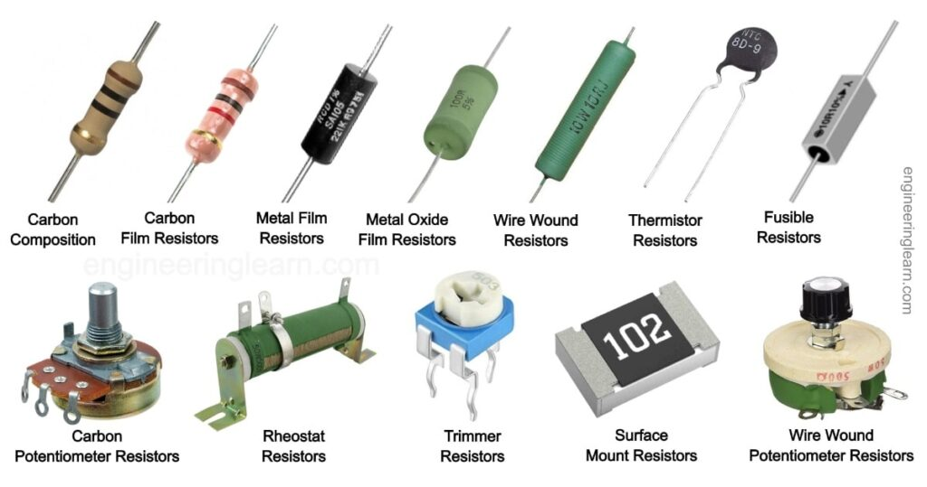

2. **DC Jack:** DCJ0202 dc power jack / DC Power Jack Connector For LED female dc jack. Quick Details: Specification: Low Voltage DC Power Connectors.

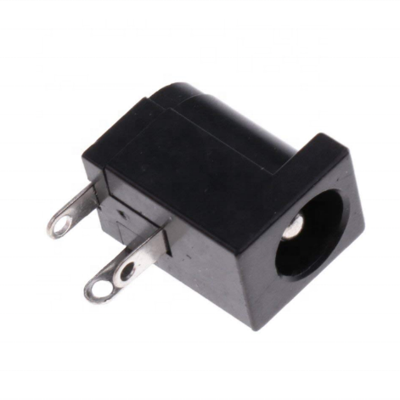

3. **Voltage Regulator IC:** The 7805TV Voltage Regulator IC is a commonly used voltage regulator. It provides a constant +5V output voltage for a variable input voltage supply.

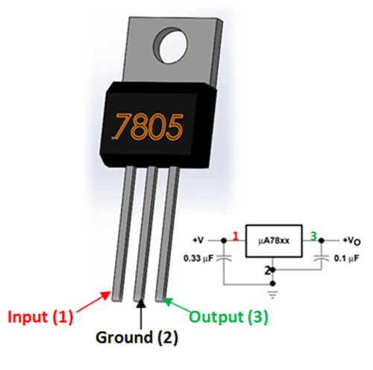

4. **Capacitor:** A capacitor is a device that stores electrical energy in an electric field by virtue of accumulating electric charges on two close surfaces insulated from each other. It is a passive electronic component with two terminals.

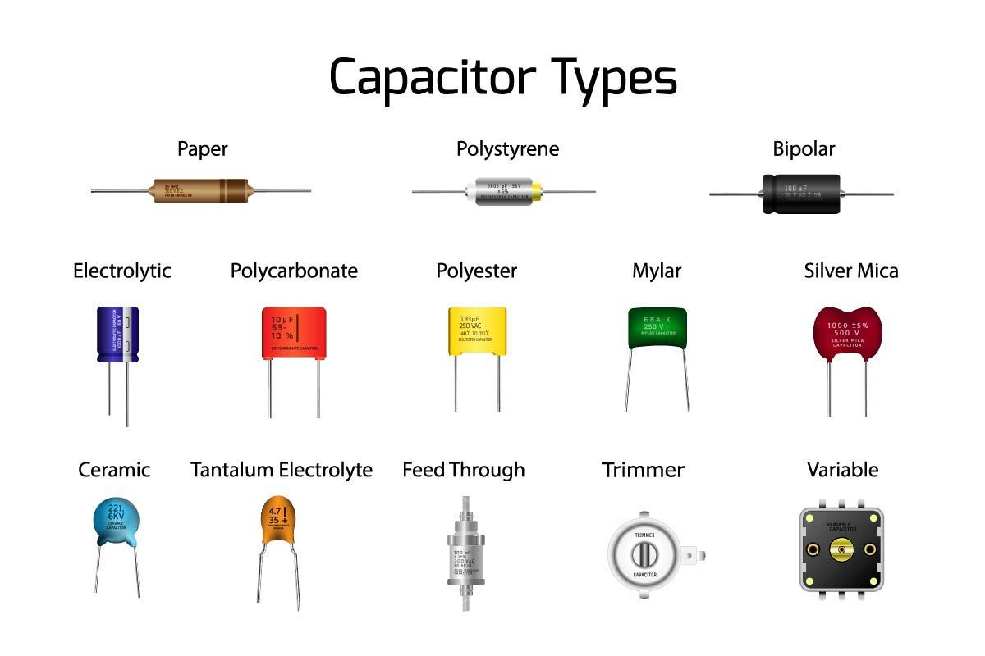

5. **ATTINY85-20P :** ATTINY45-20PU is a high performance and low power AVR 8bit microcontroller with 4K bytes of in-system programmable flash, alongside 256 bytes of EEPROM and 256 bytes of SRAM.

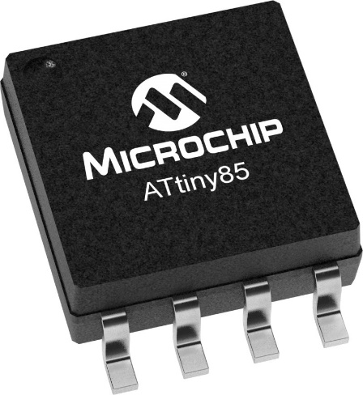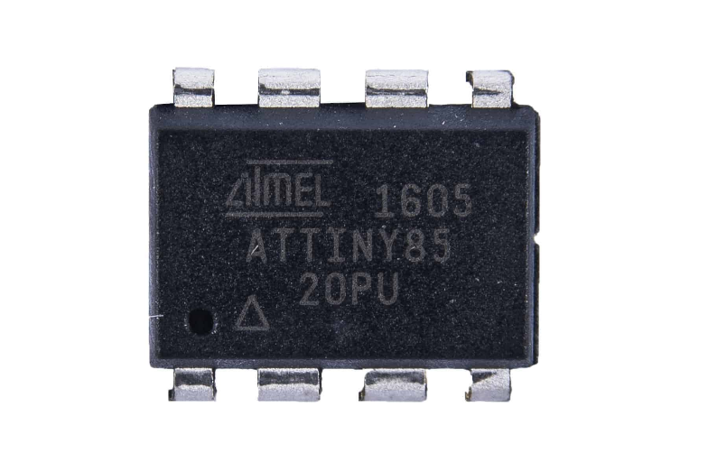

6. **LED3mm:** A light-emitting diode (LED) is a [semiconductor](https://en.wikipedia.org/wiki/Semiconductor) [device](https://en.wikipedia.org/wiki/Electronics) that [emits light](https://en.wikipedia.org/wiki/Light#Light_sources) when [current](https://en.wikipedia.org/wiki/Electric_current) flows through it.

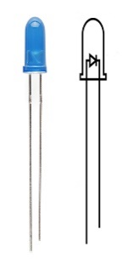 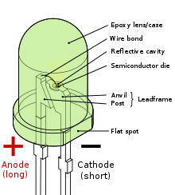

7. **22-23-2031**: 22-23-2031 is a 3 circuit KK 254 solid header with friction lock mates with mates with 2695, 6471, 7880, 4455, 7720.

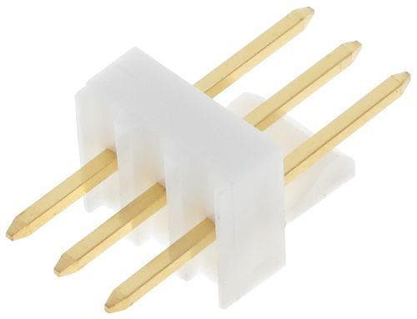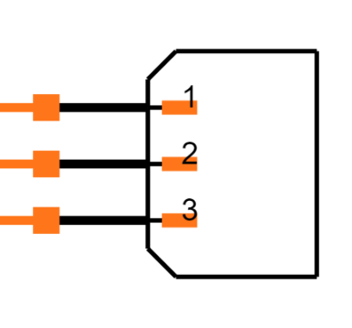

**Schematic diagram:**

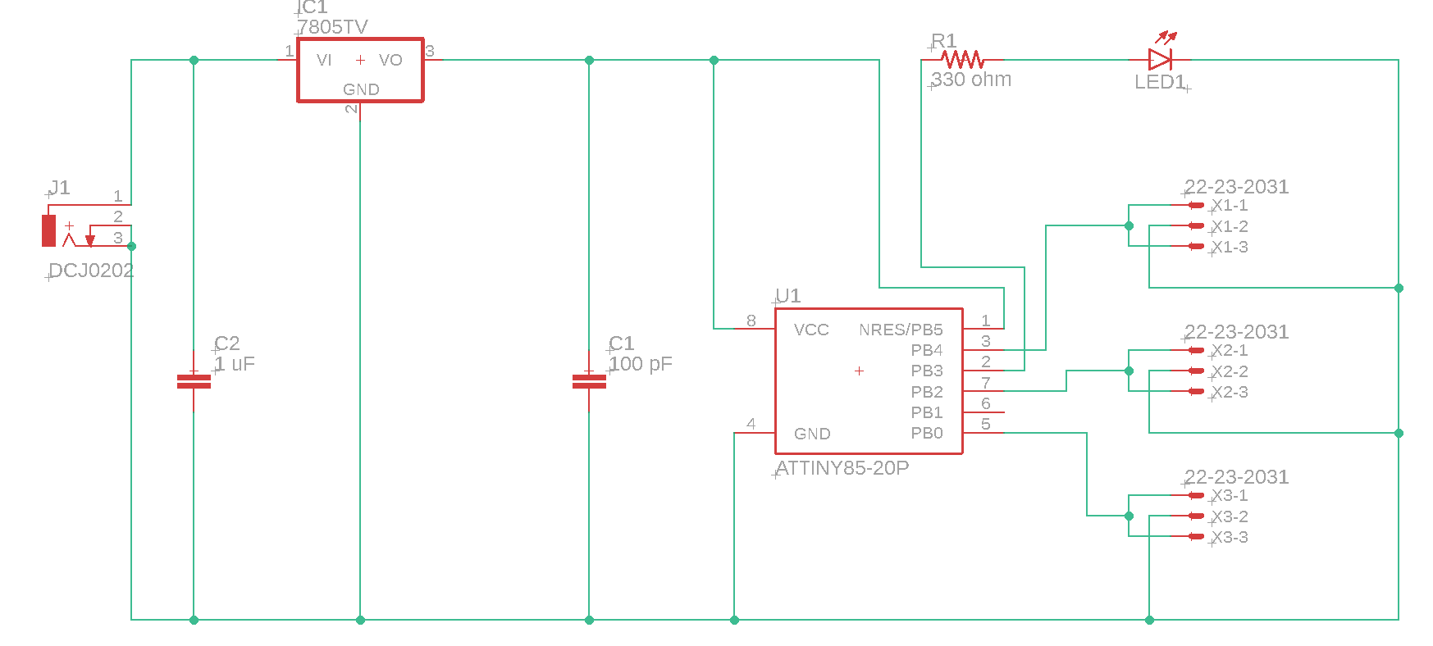

Schematic diagram of Transmitter circuit

**Printed Circuit Board layout:**

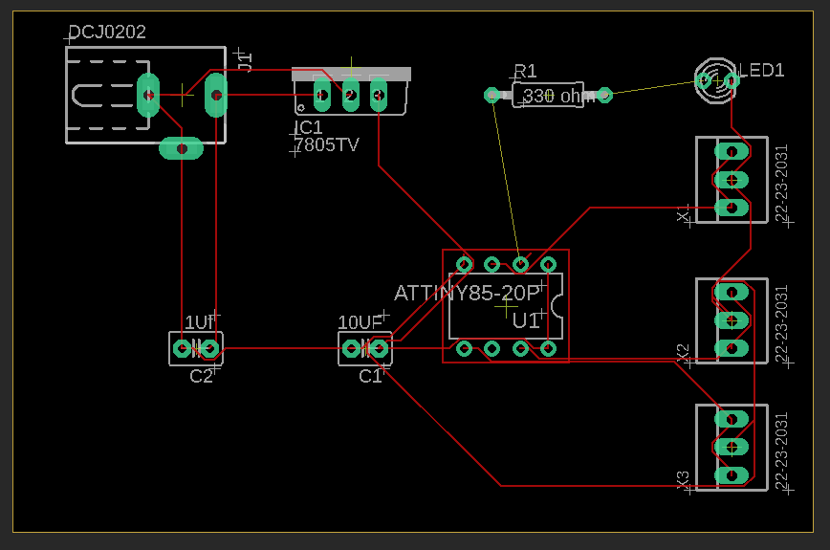

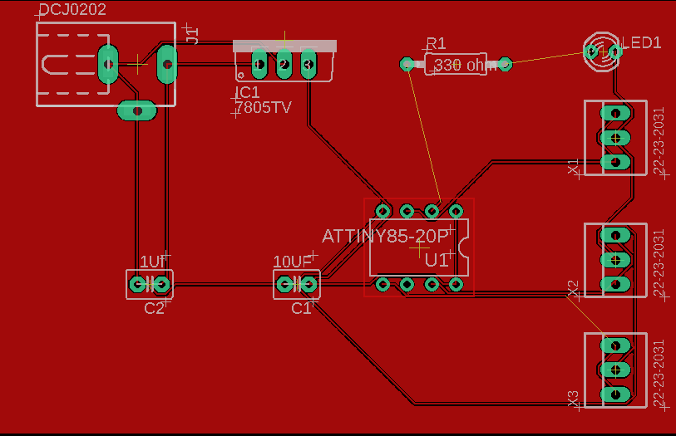

PCB layout of Transmitter circuit

**Result / Discussion:**

In this experiment, we have learnt using CAD tool (Eagle), how

(a) We can draw a schematic diagram of pulse width modulation (PWM) based transmitter for generating specified pulse width waveforms for gantries.

(b) We can design a printed circuit board layout of pulse width modulation (PWM) based transmitter circuit.

**Reference:**

**[1] https://components101.com/ics/7805-voltage-regulator-ic-pinout-datasheet**

**[2]** **https://www.studiopieters.nl/miniaturizing-attiny85/**

**[3]** **https://www.google.com/url?sa=i&url=https%3A%2F%2Fengineeringlearn.com%2Fwhat-are-resistors-types-of-resistors-and-their-uses-complete-details-with-pictures%2F&psig=AOvVaw212RzfCmK8OnwVtBLIWJUL&ust=1675517792640000&source=images&cd=vfe&ved=0CBEQjhxqFwoTCOixlKu8-fwCFQAAAAAdAAAAABAD**

**[4]** **https://www.ultralibrarian.com/2022/07/21/factors-at-play-when-choosing-the-right-capacitor-for-your-design-ulc**

**[5]** **https://www.ledsupply.com/blog/how-does-a-5mm-led-work/**