Case 1: Array Size is 15 and Number is present in array.

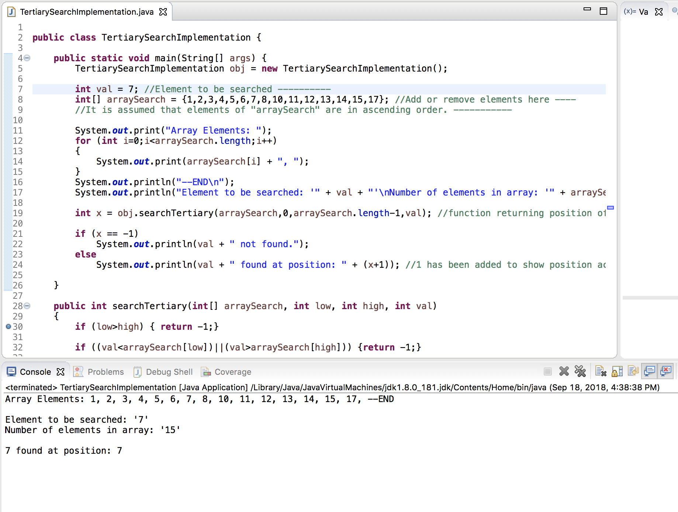

Case2: Array Size is 15 and Number is NOT present in array.

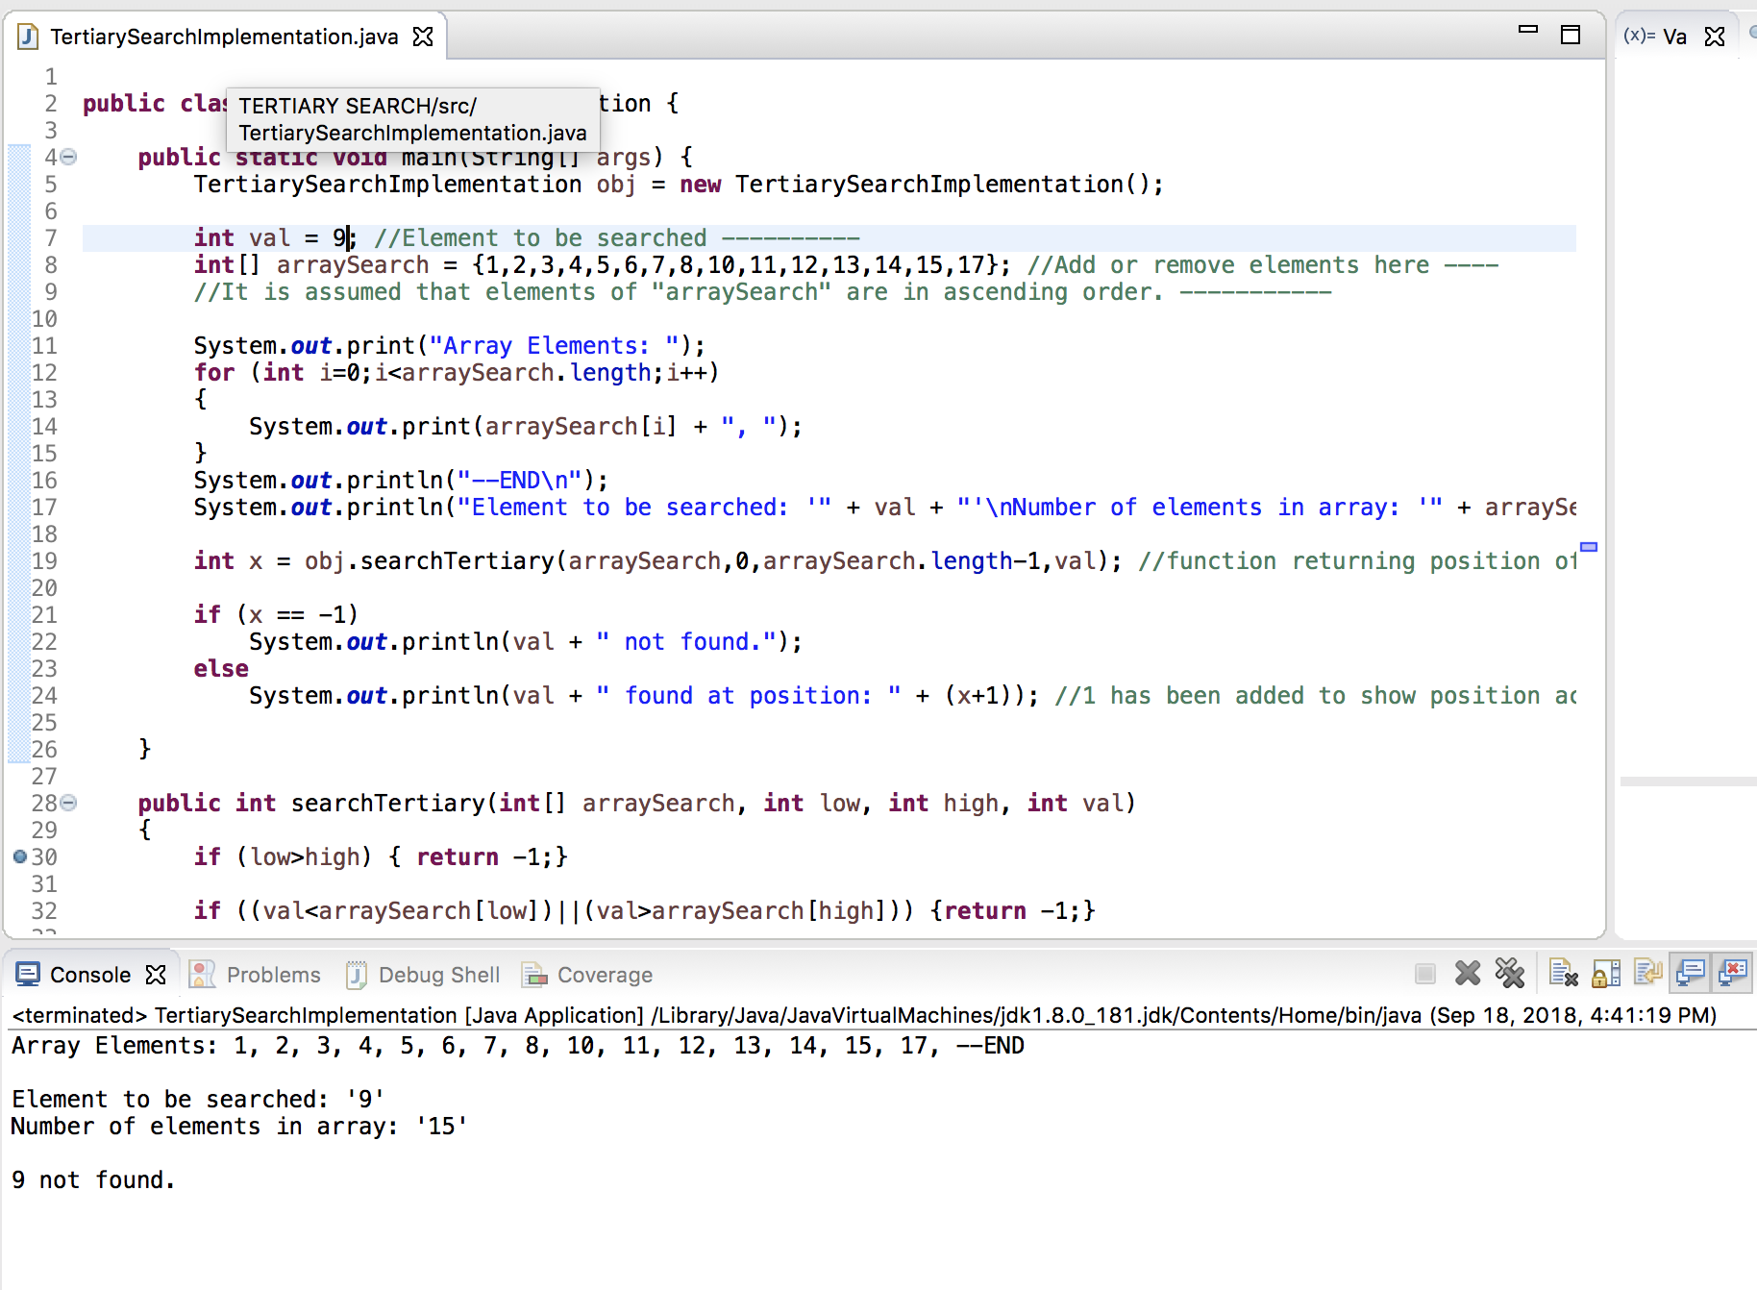

Case3: Array Size is 16 and Number is present in array.

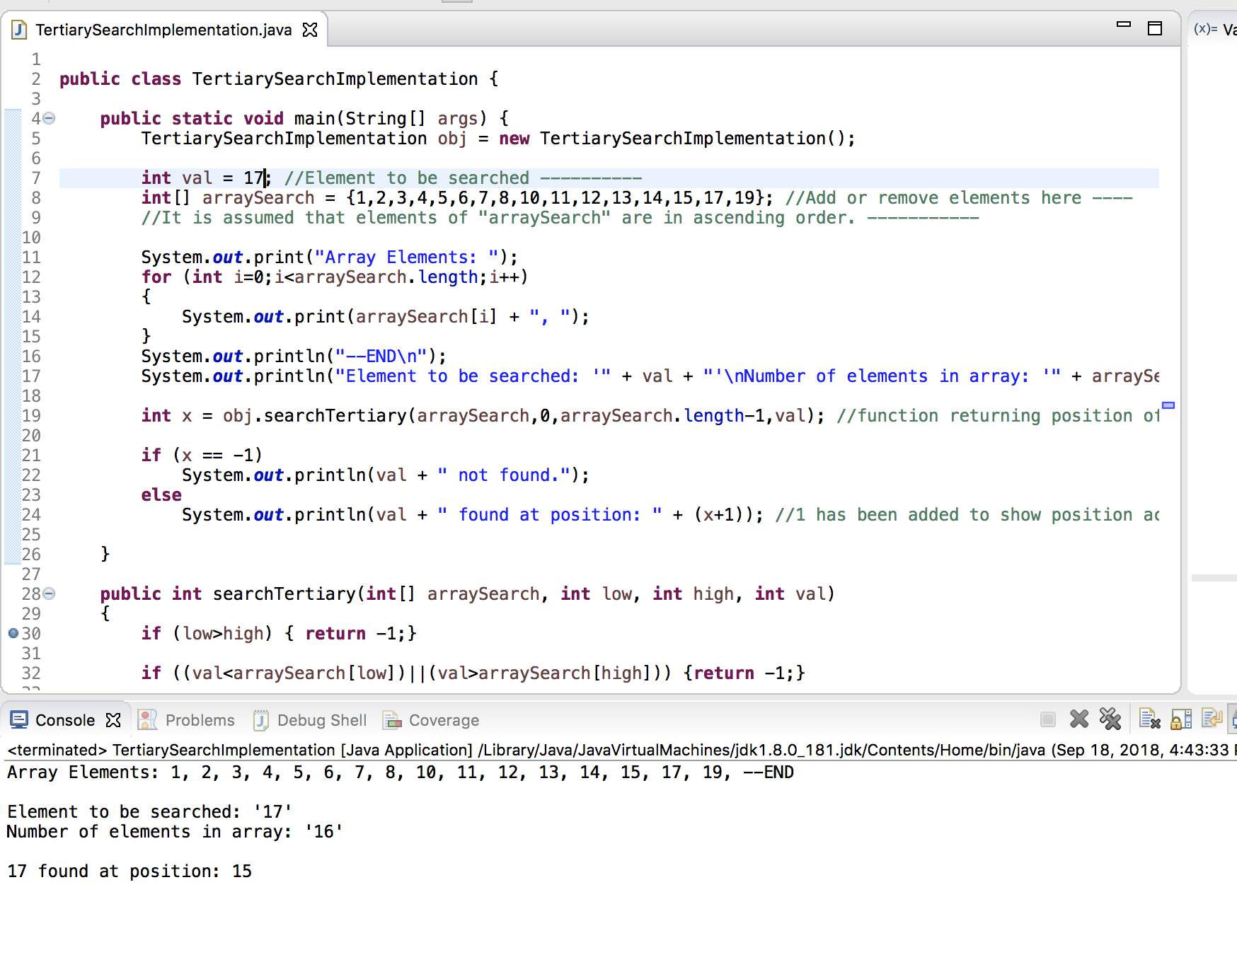

Case4: Array Size is 16 and Number is NOT present in array.

