JSP EXERCISE
1. Write a JSP to output the entire line, “Hello! The time is now …” but use a scriptlet for the complete string, including the HTML tags.
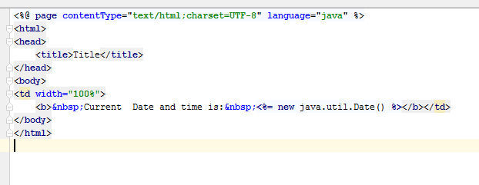
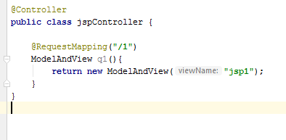
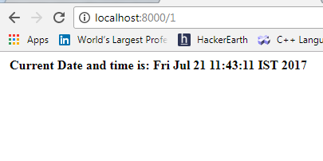

2. Accept the value of n and print numbers from 1 to n.
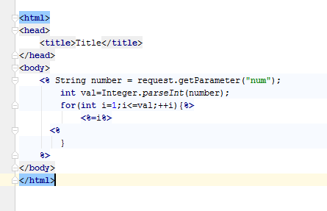
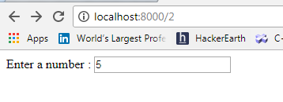
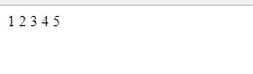
3. Create a dynamic web application with following features:
- Sign Up of user.
JSP
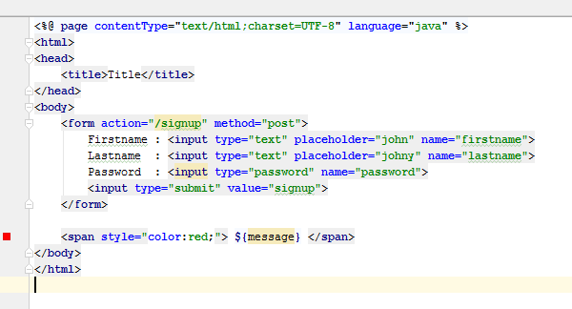
CONTROLLER
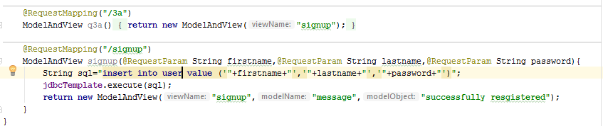
ON FORM SUBMIT
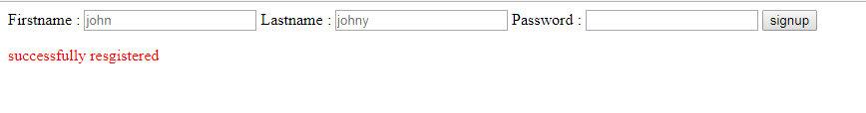
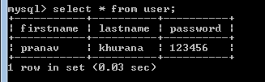
- Sign In of user.
Login form
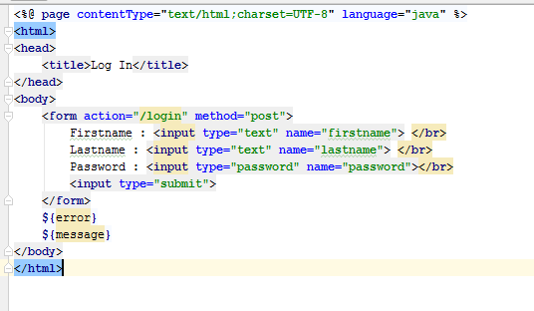
Incorrect password
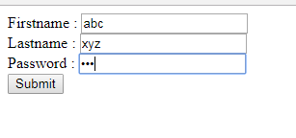
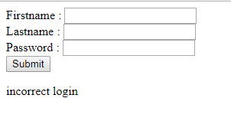
CORRECT LOGIN
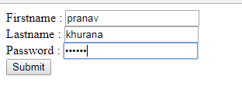
- Welcome page if login successful.
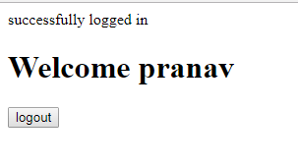
- Logout of user.
