PSG Institute of Technology and Applied Research

C Programming

Pranav Kiran S

715520104036



***CODING:***

#include<stdio.h>

#include<conio.h>

main()

{

int num1[5],num2[5];

int max = 0;

int i, j;

printf("Enter five integer values: \n");

for(i=0;i<5;i++)

{

Scanf("%d",&num2[i]);

num1[i] = num2[i];

if (num1[i] > max)

max = num1[i];

}

for(i=max;i>0;i--)

{

printf("%2d | ",i);

for(j=0;j<5;j++)

{

if (num1[j] == i)

{

printf(" x ");

num1[j] = num1[j]- 1;

}

Else

printf(" ");

}

printf("\n");

}

printf("_____________________\n");

printf(" ");

for(j=0;j<5;j++)

{

printf("%3d",num2[j]);

}

}

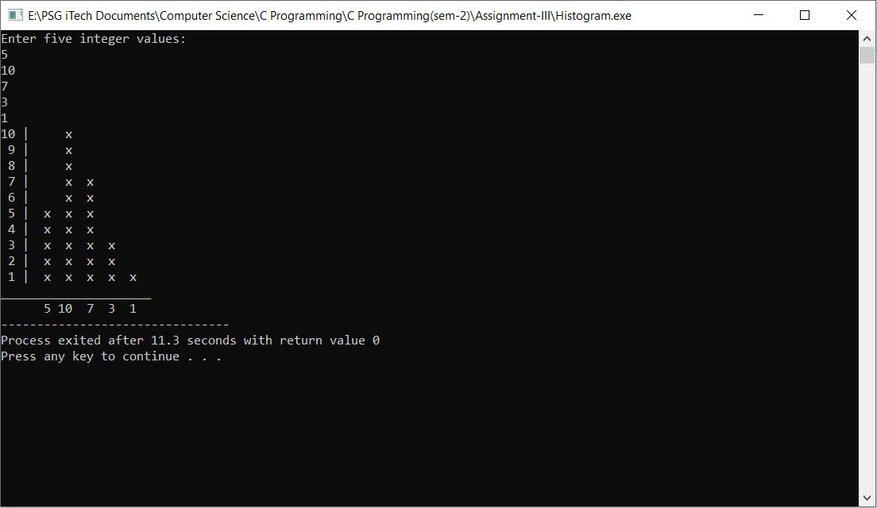



***CODING:***

#include<stdio.h>

#include<conio.h>

main()

{

int i,j;

for(i=1;i<=5;i++ )

{

for(j=0;j<5-i;j++)

printf(" ");

for(j=1;j<=i-1;j++)

printf("%d",j);

for(j=i;j>=1;j--)

printf("%d",j);

printf("\n");

}

}

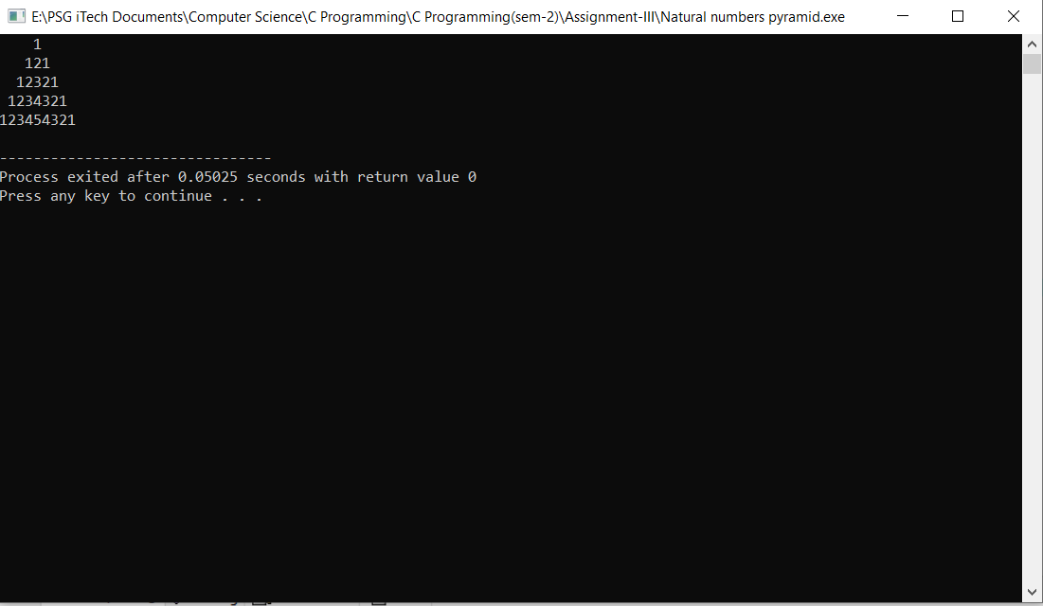

3. If the five digit number is input through the keyboard, write a program to calculate the sum of the its digits.

***CODING:***

#include<stdio.h>

#include<conio.h>

main()

{

int number,split,sum=0;

printf("Enter the number :");

scanf("%d",&number);

while(number>0)

{

split=number%10;

sum=sum+split;

number=number/10;

}

printf("The sum of digits of the number is :%d",sum);

}

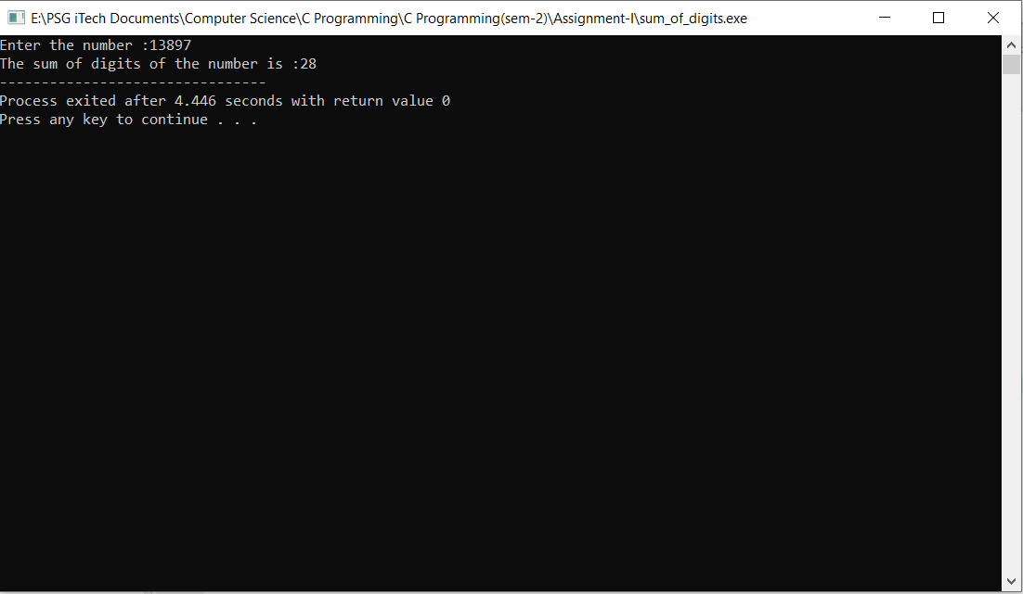

4. A five-digit number is entered through the keyboard. Write a program to obtain the reversed number and to determine whether the original and reversed numbers are equal or not.

***CODING:***

#include<stdio.h>

#include?<conio.h>

main()

{

int number,rev,temp;

number=temp

printf("enter the number :");

scanf("%d",&number);

while(number>0)

{

temp=number%10;

rev=rev*10+temp

number=number/10;

}

printf("The reverse of the number is :%d",rev"")

if(rev==number)

printf("\nThe number are same !");

else

printf("\nThe numbers are not same !");

}

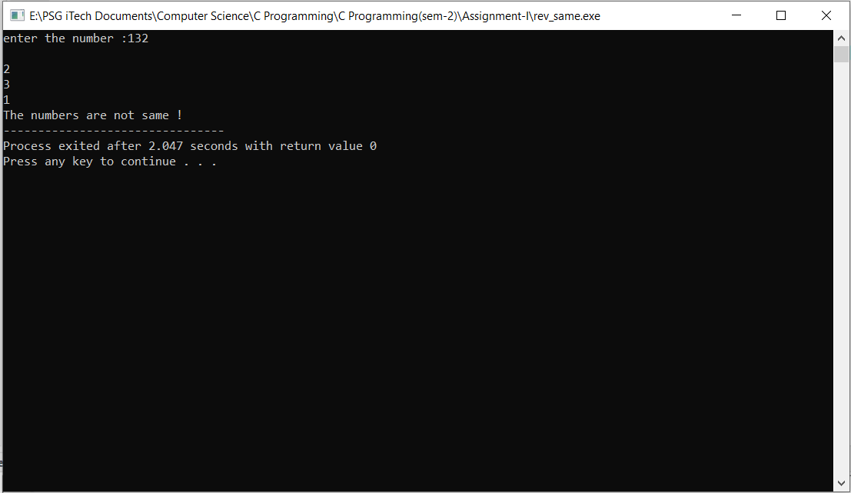

5.Write a program to calculate overtime pay of 10 employees. Overtime is paid at the rate of 12.00 per hour for every hour worked above 40 hours. Assume that employees do not work for fractional part of an hour.

***CODING:***

#include<stdio.h>

#include<conio.h>

main()

{

int hrs[10];

int overpay[10];

int i;

for(i=0;i<10;i++)

{

printf("\nEnter the hours of Employee# %d : ",i+1);

scanf("%d",&hrs[i]);

if (hrs[i] > 40)

overpay[i] = (hrs[i] - 40) * 12;

else

overpay[i] = 0;

}

for(i=0;i<10;i++)

{

printf("Overtime Pay of Employee%d is %d\n",i+1,overpay[i]);

}

}

