***Exercise 1: Electricity Bill***

Name: Pranav Kiran S

Reg. No: 715520104009

***Aim:***

To develop a Java application to generate Electricity bill. Create a class with the following members: Consumer no., consumer name, previous month reading, current month reading, type of EB connection (i.e., domestic or commercial). Compute the bill amount using the following tariff.  
  
If the type of the EB connection is domestic, calculate the amount to be paid as follows:  
  
First 100 units - Rs. 1 per unit  
101-200 units - Rs. 2.50 per unit  
201 -500 units - Rs. 4 per unit  
> 501 units - Rs. 6 per unit  
  
If the type of the EB connection is commercial, calculate the amount to be paid as follows:  
  
First 100 units - Rs. 2 per unit  
101-200 units - Rs. 4.50 per unit  
201 -500 units - Rs. 6 per unit  
> 501 units - Rs. 7 per unit

***Algorithm:***

1. To create a public static main function and then create object for the class.
2. Then create separate functions to get input, to calculate bill and to print them.
3. In input function using sc from java.util package get input from the user for the required details like customer number, customer name, type of connection and previous, current month readings.
4. In calculate function based on the type of connection, using if else and arithmetic operators do all the calculations to for bill.
5. Then finally, print the bill using a separate function (here display()).

***Code:***

**import** java.util.*;

**public** **class** Exercise_1

{

**int** con_no, prev, current, reading;

String con_name, type_eb;

**double** bill;

**void** input()

{

Scanner sc = **new** Scanner(System.***in***);

System.***out***.println("Enter consumer number : ");

con_no = sc.nextInt();

System.***out***.println("Enter consumer name: ");

con_name = sc.next();

System.***out***.println("Enter previous month reading : ");

prev = sc.nextInt();

System.***out***.println("Enter current month reading: ");

current = sc.nextInt();

System.***out***.println("Enter the type of connection(domestic/commercial): ");

type_eb = sc.next();

reading = current - prev;

}

**double** calculate()

{

**if** (type_eb.equals("domestic"))

{

**if** (reading >= 0 && reading <= 100)

{

bill = reading * 1;

}

**else** **if** (reading > 100 && reading <= 200)

{

bill = (100 * 1) + ((reading - 100) * 2.50);

}

**else** **if** (reading > 200 && reading <= 500)

{

bill = (100 * 1) + (200 * 2.50) + ((reading - 200) * 4);

}

**else** **if** (reading > 500)

{

bill = (100 * 1) + (100 * 2.50) + (300 * 4) + ((reading - 500) *6);

}

}

**else** **if** (type_eb.equals("commercial"))

{

**if** (reading >= 0 && reading <= 100)

{

bill = reading * 2;

}

**else** **if** (reading > 100 && reading <= 200)

{

bill = (100 * 2) + ((reading - 100) * 4.50);

}

**else** **if** (reading > 200 && reading <= 500)

{

bill = (100 * 2) + (200 * 4.50) + ((reading - 200) * 6);

}

**else** **if** (reading > 500)

{

bill = (100 * 2) + (100 * 4.50) + (300 * 6) + ((reading - 500) *7);

}

}

**return** bill;

}

**void** display()

{

System.***out***.println("----------ELECTRICITY BILL----------");

System.***out***.println("Consumer Number : " + con_no);

System.***out***.println("Consumer Name : " + con_name);

System.***out***.println("Previous month readings : " + prev);

System.***out***.println("Current month readings : " + current);

System.***out***.println("Type of EB Connection : " + type_eb);

System.***out***.println("Total Amount : Rs." + bill);

}

**public** **static** **void** main(String[] args)

{

Exercise_1 obj = **new** Exercise_1();

obj.input();

obj.calculate();

obj.display();

}

}

**Output:**

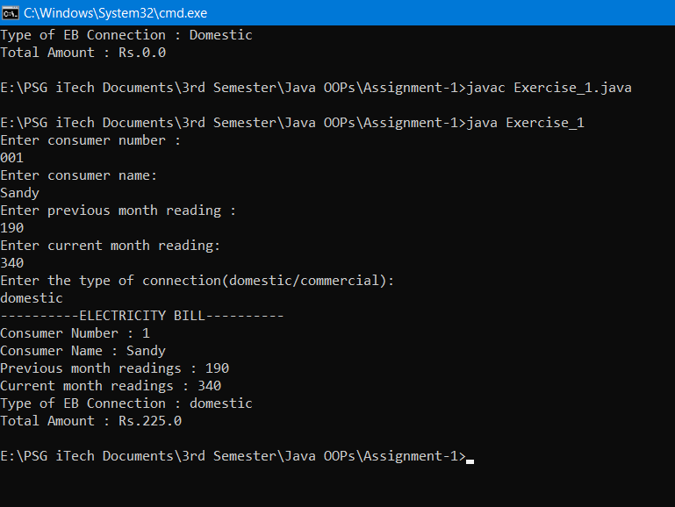

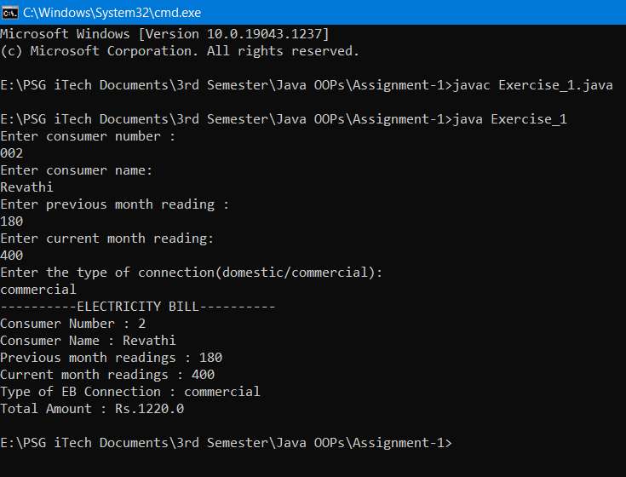

***Learning Outcome:***

1. If… else if…. else statements.
2. Arithmetic and relational operations used for calculating the bill.
3. Print using *system.out* and get input using *java.util library.*

***Result:***

The above java code for electricity bill generation is executed successfully.