***Exercise 2: Converters***

Name: Pranav Kiran S

Reg. No: 715520104009

***Aim:***

Develop a java application to implement currency converter (Dollar to INR, EURO to

INR, Yen to INR and vice versa), distance converter (meter to KM, miles to KM and vice

versa), time converter (hours to minutes, seconds and vice versa) using packages.

***Algorithm:***

1. To create a public static main function and then create object for the class .
2. Then print the menu for the converters available.
3. In input function using sc from java.util package get input from the user for the required details like what converter to be used and input for that converter.
4. Then include the package in the main file and do the operation.
5. Then finally, print the output to the user.

***Code:***

**Mainpack**

import newp.converter;

import java.util.Scanner;

class mainpack

{

public static void main(String args[])

{

int amount;

int choice;

int choice2;

Scanner sc=new Scanner(System.in);

converter obj=new converter();

System.out.println("1.Currency converter");

System.out.println("2.Distance converter");

System.out.println("3.Time converter");

System.out.print("Enter you choice: ");

choice=sc.nextInt();

if(choice == 1)

{

System.out.println("1.Dollar to INR");

System.out.println("2.EURO to INR");

System.out.println("3.Yen to INR");

System.out.println("4.INR to Dollar");

System.out.println("5.INR to EURO");

System.out.println("6.INR to Yen");

System.out.print("Enter you choice: ");

choice2=sc.nextInt();

if(choice2 == 1)

{

System.out.print("Enter Dollar: ");

amount=sc.nextInt();

System.out.print("INR for given dollar is : "+obj.dollar2inr(amount));

}

else if(choice2 == 2)

{

System.out.print("Enter EURO: ");

amount=sc.nextInt();

System.out.print("INR for given EURO is : "+obj.euro2inr(amount));

}

else if(choice2 == 3)

{

System.out.print("Enter Yen: ");

amount=sc.nextInt();

System.out.print("INR for given Yen is : "+obj.yen2inr(amount));

}

else if(choice2 == 4)

{

System.out.print("Enter INR: ");

amount=sc.nextInt();

System.out.print("Dollar for given INR is : "+obj.inr2dollar(amount));

}

else if(choice2 == 5)

{

System.out.print("Enter INR: ");

amount=sc.nextInt();

System.out.print("EURO for given INR is : "+obj.inr2euro(amount));

}

else if(choice2 == 6)

{

System.out.print("Enter INR: ");

amount=sc.nextInt();

System.out.print("Yen for given INR is : "+obj.inr2yen(amount));

}

}

else if(choice == 2)

{

System.out.println("1.meter to KM");

System.out.println("2.miles to KM");

System.out.println("3.KM to meter");

System.out.println("4.KM to miles");

System.out.print("Enter you choice: ");

choice2=sc.nextInt();

if(choice2 == 1)

{

System.out.print("Enter meter: ");

amount=sc.nextInt();

System.out.print("KM for given meter is :"+obj.meter2km(amount));

}

else if(choice2 == 2)

{

System.out.print("Enter miles: ");

amount=sc.nextInt();

System.out.print("KM for given miles is : "+obj.miles2km(amount));

}

else if(choice2 == 3)

{

System.out.print("Enter KM: ");

amount=sc.nextInt();

System.out.print("meter for given KM is :"+obj.km2meter(amount));

}

else if(choice2 == 4)

{

System.out.print("Enter KM: ");

amount=sc.nextInt();

System.out.print("miles for given KM is : "+obj.km2miles(amount));

}

}

else if(choice == 3)

{

System.out.println("1.hours to minutes");

System.out.println("2.hours to seconds");

System.out.println("3.minutes to hours");

System.out.println("4.seconds to hours");

System.out.print("Enter you choice: ");

choice2=sc.nextInt();

if(choice2 == 1)

{

System.out.print("Enter hours: ");

amount=sc.nextInt();

System.out.print("minutes for given hours "+obj.hrs2min(amount));

}

else if(choice2 == 2)

{

System.out.print("Enter hours: ");

amount=sc.nextInt();

System.out.print("seconds for given hours "+obj.hrs2min(amount));

}

else if(choice2 == 3)

{

System.out.print("Enter minutes: ");

amount=sc.nextInt();

System.out.print("hours for given minutes "+obj.min2hrs(amount));

}

else if(choice2 == 4)

{

System.out.print("Enter seconds: ");

amount=sc.nextInt();

System.out.print("hours for given seconds "+obj.sec2hrs(amount));

}

}

}

}

**Converter**

package newp;

public class converter

{

public static int dollar2inr(int a)

{

return a*73;

}

public static int euro2inr(int a)

{

return a*86;

}

public static double yen2inr(int a)

{

return a*0.67;

}

public static double inr2dollar(int a)

{

return a*0.014;

}

public static double inr2euro(int a)

{

return a*0.012;

}

public static double inr2yen(int a)

{

return a*1.5;

}

public static double meter2km(int a)

{

return a*0.001;

}

public static double miles2km(int a)

{

return a*1.60934;

}

public static double km2meter(int a)

{

return a*1000;

}

public static double km2miles(int a)

{

return a*0.621371;

}

public static double min2hrs(int a)

{

return a*0.0166667;

}

public static double sec2hrs(int a)

{

return a*0.0166667;

}

public static double hrs2min(int a)

{

return a*60;

}

public static double hrs2sec(int a)

{

return a*3600;

}

}

**Output:**

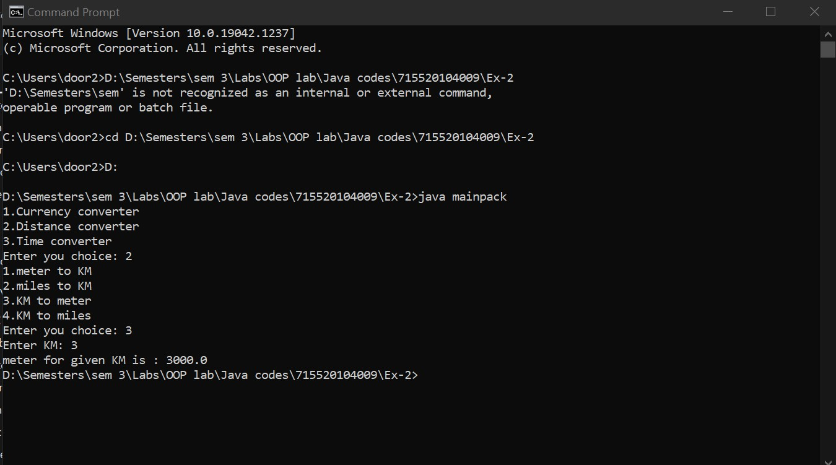

**Learning Outcome:**

1. Implementing packages in java

**Result:**

The above java code for converter using packages is executed successfully.