

**Software Requirements Specification**

**For**

**Football Match Prediction using Machine Learning**

Guided by: - Dr. Upendra Verma

Prepared by: Pranav Kolhe (B228)

Abhraneel Das (B211)

Dhairya Desai (B212)

Mukesh Patel School of Technology and Management Engineering

Session: 2022-2023

### **Certificate**

The SRS Report entitled **“Football Match Prediction Using Machine Learning”** being submitted by

“**Pranav Kolhe” (Roll No.: B228)”**

“**Abhraneel Das” (Roll No.: B211)”**

“**Dhairya Desai” (Roll No.: B212)”**

has been examined by us and is hereby approved for the award of degree **“Bachelor of Technology in Computer Engineering Discipline”**, for which it has been submitted. It is understood that by this approval the undersigned do not necessarily endorse or approve any statement made, opinion expressed or conclusion drawn therein, but approve the report only for the purpose for which it has been submitted.

**(Internal Examiner) (External Examiner)**

**Date: Date:**

**DEPARTMENT OF COMPUTER ENGINEERING**

**Mukesh Patel School of Technology Management & Engineering**

Table of Contents

1. Introduction

1.1 Purpose

1.2 Document Conventions

1.3 Intended Audience and Reading Suggestions

1.4 Product Scope

1.5 References

2. Overall Description

2.1 Product Perspective

2.2 Product Functions

2.3 User Classes and Characteristics

2.4 Operating Environment

2.5 Design and Implementation Constraints

2.6 Assumptions and Dependencies

3. External Interface Requirements

3.1 User Interfaces

3.2 Hardware Interfaces

3.3 Software Interfaces

3.4 Communications Interfaces

4. System Features

5. Other Nonfunctional Requirements

5.1 Performance Requirements

5.2 Safety Requirements

5.3 Security Requirements

5.4 Software Quality Attributes

5.5 Business Rules

1. **Introduction**
   1. **Purpose**

This is a Software Requirement Specification for the project Football Match Prediction Using Machine Learning. The purpose of our project is to successfully create a computer model that can successfully predict whether a football team would win, lose, or draw a match. By observing patterns, asking questions, and building a model, we will have a chance to push state-of-the-art technology farther.

* 1. **Document Conventions**

Entire document should be justified.

* Main Section Title
* Font face: Times New Roman
* Font style: Bold
* Font Size: 14
* Sub Section Title
  + Font face: Times New Roman
  + Font style: Bold
  + Font Size: 12
* Body Section
* Font face: Times New Roman
* Font Size: 12
  1. **Intended Audience and Reading Suggestions**

The document is intended for sports analysts and researchers. It is also intended for football club managers and staff members. This project is a prototype model for football match prediction. It will be very useful for these individuals and will assist them by saving their time by predicting the match results and adjusting their strategy accordingly.

* 1. **Product Scope**
* Preparing a perfect strategy for their own team in a important and also a tedious task in sports industry. This also involves predicting and analysing every possible scenario of the future matches.
* May researchers have attempted to predict football match outcome using the in-game match statistics.
* There is so much data available other than that. Hence, creating a computer model that can predict the outcome of a particular football match would be of a great help.
* Predicting the outcomes of a match can help the analysts of a football team simulate a few strategies and pick the best ones for each match.
  1. **References**
* [1] J. Almulla and T. Alam, “Machine Learning Models Reveal Key Performance Metrics of Football Players to Win Matches in Qatar Stars League,” *IEEE Access*, vol. 8, pp. 213695–213705, 2020, doi: 10.1109/ACCESS.2020.3038601.
* [2] S. K. Nivetha, M. Geetha, R. C. Suganthe, R. M. Prabakaran, S. Madhuvanan, and A. M. Sameer, “A Deep Learning Framework for Football Match Prediction,” *2022 International Conference on Computer Communication and Informatics, ICCCI 2022*, 2022, doi: 10.1109/ICCCI54379.2022.9740760.
* [3] S. Manish., V. Bhagat, and R. M. Pramila, “Prediction of football players performance using machine learning and deep learning algorithms,” *2021 2nd International Conference for Emerging Technology, INCET 2021*, May 2021, doi: 10.1109/INCET51464.2021.9456424.
* [4] A. A. Azeman, A. Mustapha, N. Razali, A. Nanthaamomphong, and M. H. Abd Wahab, “Prediction of football matches results: Decision forest against neural networks,” *ECTI-CON 2021 - 2021 18th International Conference on Electrical Engineering/Electronics, Computer, Telecommunications and Information Technology: Smart Electrical System and Technology, Proceedings*, pp. 1032–1035, May 2021, doi: 10.1109/ECTI-CON51831.2021.9454789.
* [5] D. Wang, “Clustering and Evolutionary System Analysis of Data Mining Algorithms in the Field of Football,” *2022 IEEE Asia-Pacific Conference on Image Processing, Electronics and Computers, IPEC 2022*, pp. 1341–1344, 2022, doi: 10.1109/IPEC54454.2022.9777487.
* [6] S. N. Maozad, S. Noor Asyikin Mohd Razali, A. Mustapha, A. Nanthaamornphong, M. H. Abdul Wahab, and N. Razali, “Comparative Analysis for Predicting Football Match Outcomes based on Poisson Models,” pp. 1–4, Jun. 2022, doi: 10.1109/ECTI-CON54298.2022.9795385.
* [7] Rahman, M.A. A deep learning framework for football match prediction. *SN Appl. Sci.* **2**, 165 (2020). https://doi.org/10.1007/s42452-019-1821-5
* [8] N. Danisik, P. Lacko and M. Farkas, "Football Match Prediction Using Players Attributes," 2018 World Symposium on Digital Intelligence for Systems and Machines (DISA), 2018, pp. 201-206, doi: 10.1109/DISA.2018.8490613.
* [9] Qiyun Zhang, Xuyun Zhang, Hongsheng Hu, Caizhong Li, Yinping Lin, Rui Ma, Sports match prediction model for training and exercise using attention-based LSTM network, Digital Communications and Networks, Volume 8, Issue 4, 2022, Pages 508-515, ISSN 2352-8648, https://doi.org/10.1016/j.dcan.2021.08.008.
* [10] N. Z. S. T. P. S. U. S. L. K. T., “Prediction of Football Match Score and Decision Making Process”, *IJRITCC*, vol. 6, no. 2, pp. 162–165, Feb. 2018.

1. **Overall Description**
   1. **Product Perspective**

Given in-depth data of various players and teams, build a machine learning model that can predict the football match result.

Input:

10 datasets are chosen by us to perform this project. Each dataset had the in-depth details and information of each match played in a particular season for the last ten years in English Premier League.

All the datasets have the same number of columns, i.e., 62 and 380 rows, each depicting one match played between two teams.

Output: A predicted metrics of win-loss-draw percent.

* 1. **Product Functions**

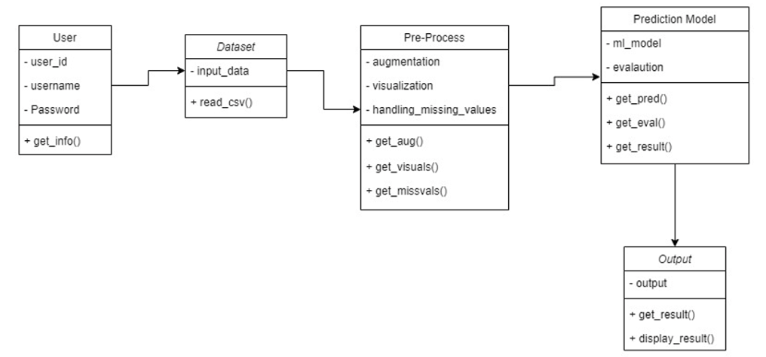

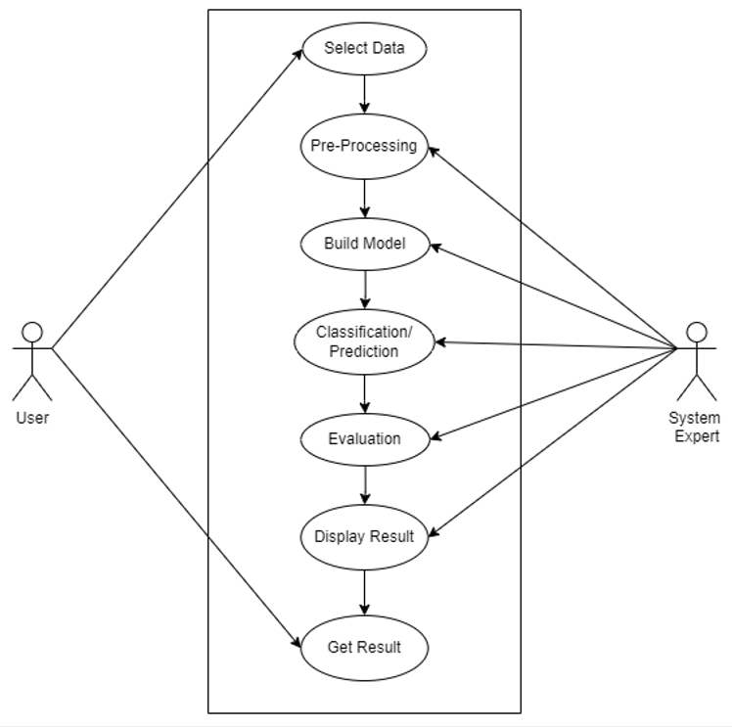

* 1. **User Classes and Characteristics**

|  |  |  |  |
| --- | --- | --- | --- |
| **User Type** | **User Characteristic** | **User Technical Expertise** | **How the User Characteristic affects system functionality** |
| Football team’s analysis and strategic team | They will be provided with the data of their team as well as their opponent, and using this model, they can simulate different strategies that can benefit their team. | The user must know how to operate a computer system and understand the predictions models. | The different data inputs provided by the user will ensure that the system is correctly able to predict the outcome with respect to the above situation. |

* 1. **Operating Environment**
* Operating System: Windows.
* Dataset Format : Text
* Platform: On Board Computers, Jupyter Notebook
  1. **Design and Implementation Constraints**
* Since the dataset consists of a lot of players, we are only considering the players that play regular football for their team.
* We cannot identify the emotional constraints such as Fatigue of a player.
* The output metrics may be difficult to understand. It may require prior knowledge to understand.
  1. **Assumptions and Dependencies**

Assumptions:

* Coding should be error free.
* The data provided should be correct.
* The dataset can be replaced to acquire more accurate predictions.

Dependencies:

* The end user must have a proper understanding of the model.
* Specific software and hardware must be used.

1. **External Interface Requirements**
   1. **User Interfaces**

* Back-end software: Python
  1. **Hardware Interfaces**
* Processor: The model requires a good computer processor (E.g. Intel I5)
* Memory: Minimum 8 GB RAM, 500 GB Disk Memory.
* Connection: Active Internet Connection.
* Environment: Solution can run on Windows Environment.
* Software version: Python version should be above 3.
  1. **Software Interfaces**
* Operating System: Windows
* Dataset Format: Text
* Programming Language: Python
  1. **Communication Modules**
* Various Python Modules

1. **System Features**

Mostly all functionality of the system can work offline. Internet connection is needed only to install various python libraries and modules.

1. **Other Non-functional Requirements**
   1. **Performance Requirements**

The proposed solution we are going to develop will be used as the chief performance system by football team analysts, pundits, researchers, and strategists.

* The performance of the system must be fast and accurate.
* This system shall handle expected and non-expected errors in ways that prevent loss in information and long downtime period.
* The system should be able to handle large amount of data.
  1. **Safety Requirements**
* The calculated columns like xG, xA, etc. should be accurate as they are crucial part of the prediction model.
  1. **Security Requirements**
* Data Integrity: All the data obtained of an individual is solely used for their personal model training and the integrity of data should not be compromised.
  1. **Software Quality Attributes**
* Quality: The quality of input data needed for pre-processing should not be compromised.
* Accuracy: Accuracy of the solution depends on the input data and the data on which the model is trained on, thus both supplement each other for obtaining accuracy.
* Application should be correct in terms of its functionality, calculations used internally and the navigation should be correct. This means application should adhere to functional requirements.
* Software reuse is a good cost efficient and time saving development way. Different code libraries classes should be generic enough to use easily in different application modules. Dividing application into different modules so that modules can be reused across the application.
* The system must be:
* Easy to use for input preparation, operation, and interpretation of output.
* Easy for new or infrequent users to learn to use the system.
  1. **Business Rules**

A business rule is anything that captures and implements business policies and practices. A rule can enforce business policy, make a decision, or infer new data from existing data. This includes the rules and regulations that the System users should abide by. This includes the cost of the project and the discount offers provided. The users should avoid illegal rules and protocols. Neither admin nor member should cross the rules and regulations.