**Experiment No.06**

PART A

(PART A: TO BE REFFERED BY STUDENTS)

**Experiment 6**

**A.1 Aim:** Design the appropriate user interface diagram for your project using three golden rules. Coding for your project according to the designs analyzed in Exp.4 & 5**.**

**A.2 Prerequisite:**

Requirement Engineering, DFD, CFD.

**A.3 Outcome:**

After completing this experiment, you will be able to:

* Design UID using Golden rules
* Implementation of the case study using previous design knowledge

**A.4 Theory:**

**User Interface design:**

While designing user interface, keep the three golden rules in mind.

* Place the user in control
* Reduce the user’s memory load
* Make the interface consistent

The goal of user interface design is to make the user's interaction as simple and efficient as possible, in terms of accomplishing user goals, what is often called as user-centered design.

**Coding:**

The coding depends on individual’s project. Any programming language can be used according to student’s interest.

**Coding:** The objective of the coding phase is to transform the design of a system into code in a high-level language and then to unit test this code. Good software development organizations normally require their programmers to adhere to some well-defined and standard style of coding called coding standards.

Coding Standards- A coding standard gives a uniform appearance to the codes written by different engineers. It enhances code understanding. It encourages good programming practices.

**Coding Standards and Guideline:**

Limiting the use of global data type. Contents of the headers preceding codes for different modules naming conventions for global variables, local variables, and constant identifiers. Error return conventions and exception handling mechanisms Representative Coding Standards. Do not use a coding style that is too clever or too difficult to understand. Avoid obscure side effects. Do not use an identifier for multiple purposes. The code should be well-documented.

**Code Review:**

Code review for a model is carried out after the module is successfully compiled and all the syntax errors have been eliminated. Normally, two types of reviews are carried out on the code of a module.

**Code Walk Through:** To discover the algorithm and logical errors in the code.

**Code Inspection:** The aim of code inspection is to discover some common types of errors caused due to oversight and improper programming.

Software Documentation: Good documents are very useful and serves the following purposes. Good documents enhance understandability and maintainability of a software product. It helps the users in effectively using the system. Helps in effectively handling the manpower turnover problem. Helps the manager in effectively tracking the progress of the project.

Software Documentation classified into the following: Internal documentation: These are provided in the source code itself

External documentation: These are the supporting documents that usually accompany a software product

Task to be completed:

1. Design UID for your project
2. You can code using any programming language of your interest
3. GUI(optional), Data retrieval from data base, processing must be implemented

***************************************************************************

**PART B**

(PART B: TO BE COMPLETED BY STUDENTS)

**(Students must submit the soft copy as per following segments within two hours of the practical. The soft copy must be uploaded on the Blackboard or emailed to the concerned lab in charge faculties at the end of the practical in case the there is no Black board access available)**

|  |  |
| --- | --- |
| Roll No. B228 | Name: Pranav Kolhe |
| Program: Btech | Division: CS |
| Batch: A | Date of Experiment: |
| Date of Submission: | Grade : |

**B.1 Tasks given in PART A to be completed here**

*(****Students must write the answers of the task(s) given in the PART A)***

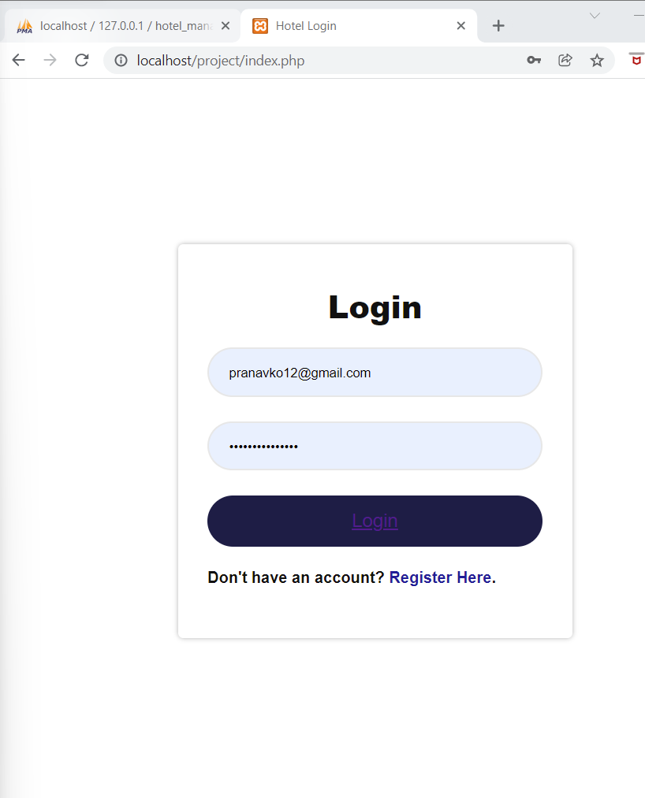

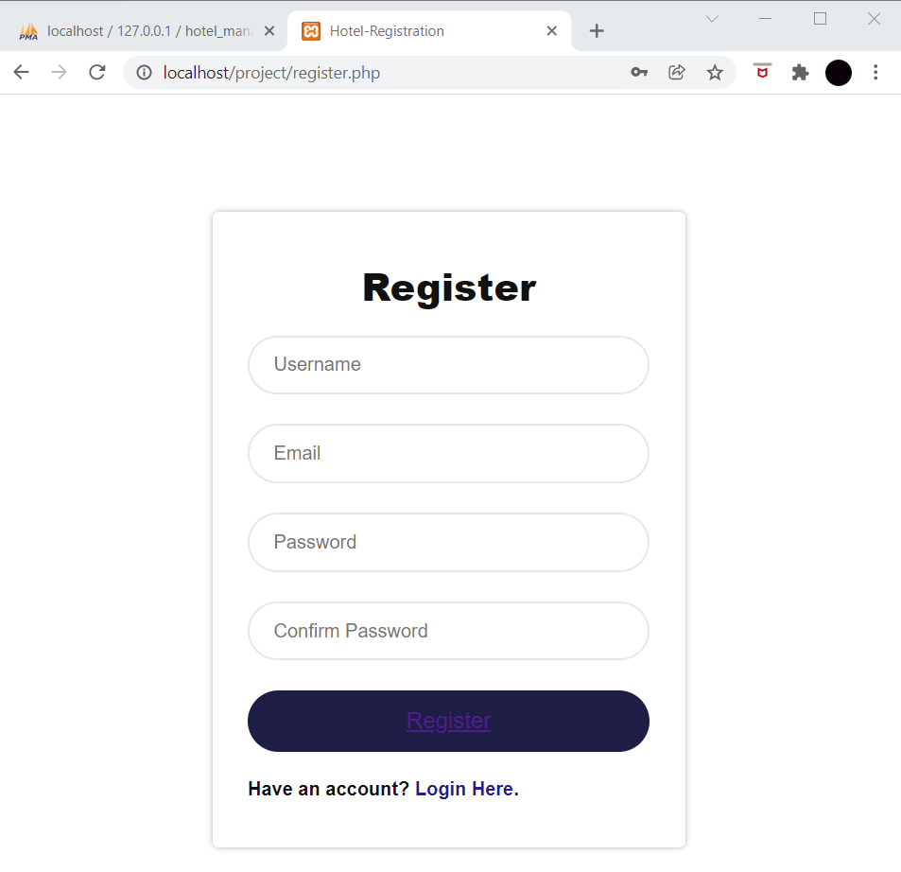

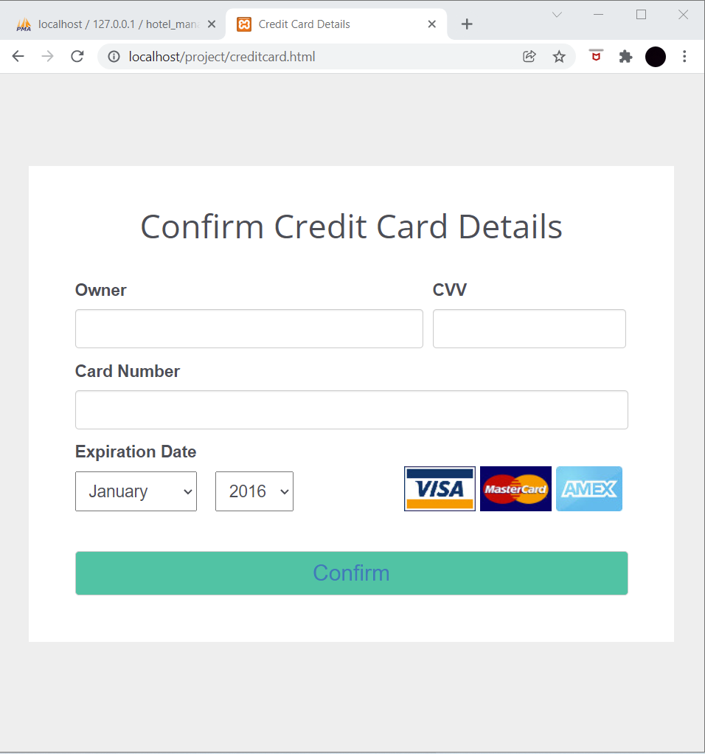

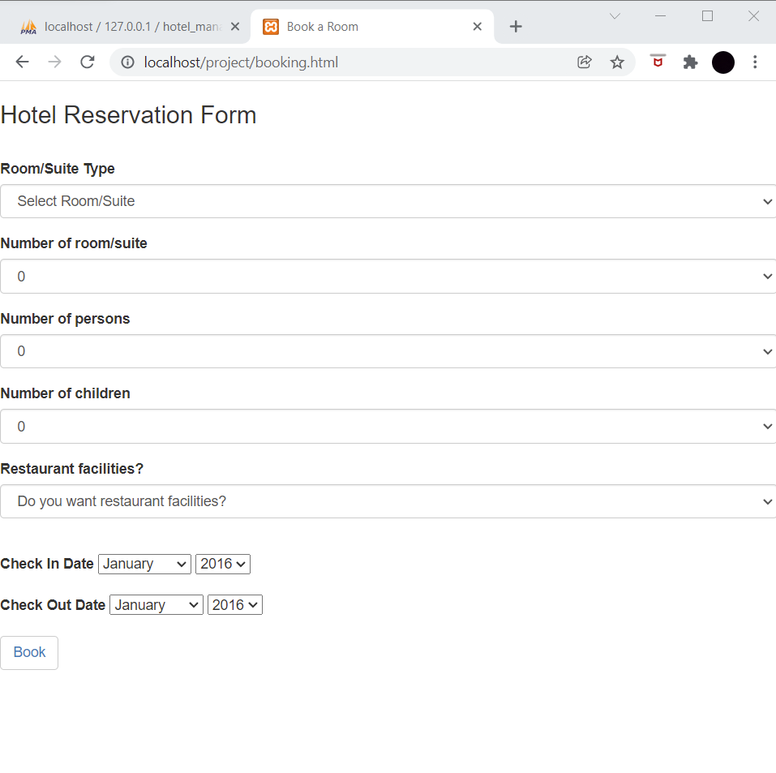

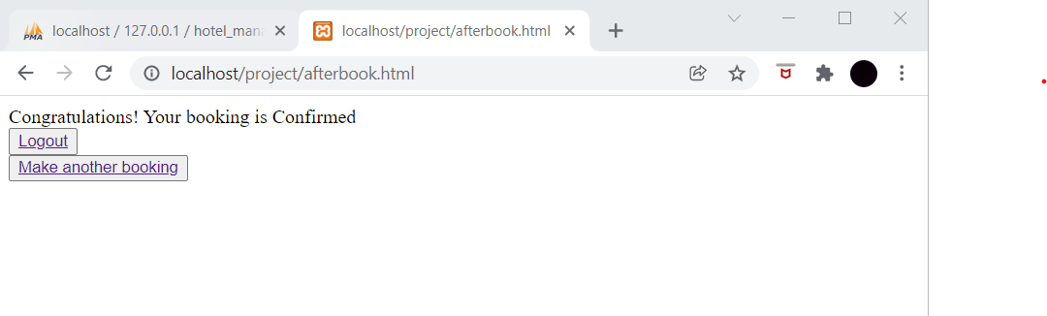

**B.2 Observations and Learning:**

*(****Students must write the observations and learning based on their understanding built about the subject matter and inferences drawn)***

We have created a UID using HTML and CSS for our project.

**B.3 Conclusion:**

*(****Students must write the conclusive statements as per the attainment of individual outcomes listed above and learning/observation noted in section B.2)***

The experiment was executed successfully.

**B.4 Question of curiosity:**

1. Which of the following is golden rule for interface design?  
a) Place the user in control  
b) Reduce the user’s memory load  
c) Make the interface consistent  
d) All of the mentioned

2. Which of the following is not a design principle that allow the user to maintain control?  
a) Provide for flexible interaction  
b) Allow user interaction to be interrupt-able and undo-able  
c) Show technical internals from the casual user  
d) Design for direct interaction with objects that appear on the screen

3. Which of the following is not a user interface design process?  
a) User, task, and environment analysis and modeling  
b) Interface design  
c) Knowledgeable, frequent users  
d) Interface validation

4. When users are involved in complex tasks, the demand on __________ can be significant.  
a) short-term memory  
b) shortcuts  
c) objects that appear on the screen  
d) all of the mentioned

5. Which of the following option is not considered by the Interface design?  
a) the design of interfaces between software components  
b) the design of interfaces between the software and human producers and consumers of information  
c) the design of the interface between two computers  
d) all of the mentioned

6. A software might allow a user to interact via  
a) keyboard commands  
b) mouse movement  
c) voice recognition commands  
d) all of the mentioned

7. A software engineer designs the user interface by applying an iterative process that draws on predefined design principles.  
a) True  
b) False

8. What establishes the profile of end-users of the system?  
a) design model  
b) user’s model  
c) mental image  
d) system image

******************************************************************