COGNIFYZ TECHNOLOGIES

Data Science Internship
TASK 2: DESCRIPTIVE ANALYSIS
Intern: Pranav KS
Role: Data Science Intern
Level: Level 1
Task: Descriptive Analysis

Objective

The objective of this task is to perform descriptive analysis on the restaurant dataset. The analysis calculates basic statistical measures for numerical variables, explores the distribution of categorical variables such as Country Code, City, and Cuisines, and identifies the cities and cuisine entries with the highest number of restaurant records

Dataset Overview

The dataset contains 9,551 restaurant records and 21 columns. The variables include restaurant identification details, country and city information, location coordinates, cuisines, average cost, service-related attributes, price range, aggregate rating, rating information, and votes

Numerical Statical Analysis

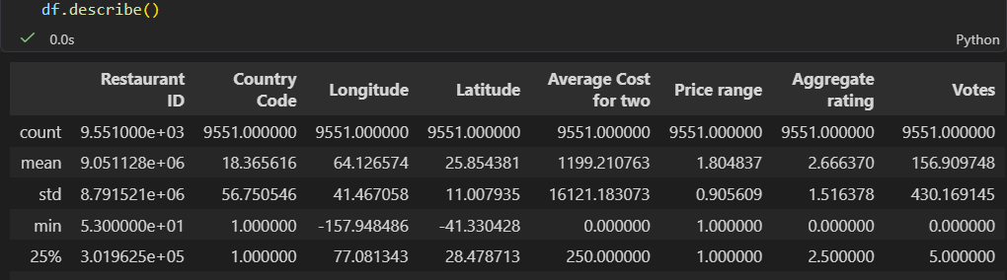

The mean Aggregate rating is 2.67, while the median is 3.20. The standard deviation of Aggregate rating is 1.52. The mean number of votes is 156.91, while the median is 31, indicating substantial variation in votes. Average Cost for two has a mean of 1,199.21 and a median of 400, with a maximum of 800,000, showing a very wide range in the recorded cost values.

Categorical Variable Distribution

Cuisines

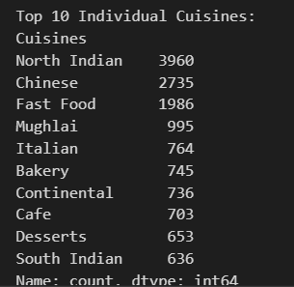

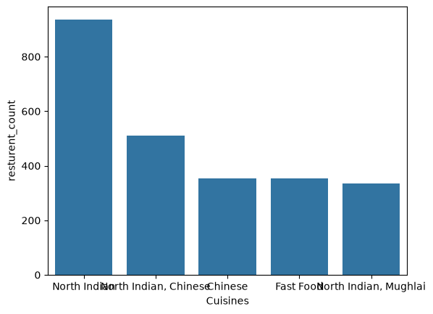

North Indian is the most frequent cuisine entry, with 936 restaurant records. It is followed by the North Indian, Chinese combination with 511. Chinese and Fast Food each have 354 records, followed by North Indian, Mughlai with 334.

Country code

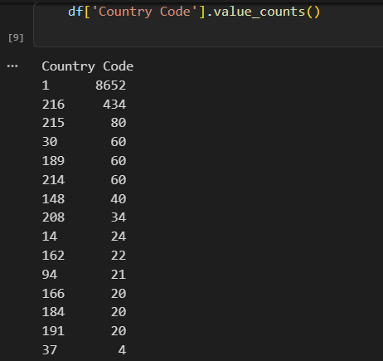

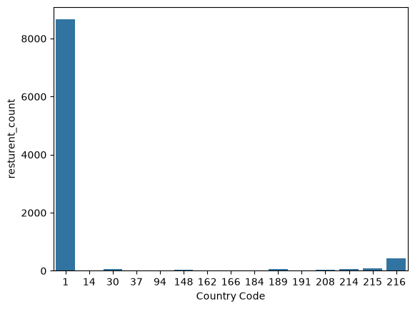

Country Code 1 has the highest number of restaurant records, with 8,652, followed by Country Code 216 with 434. The remaining country codes have substantially fewer records. This indicates that the dataset is concentrated in a small number of country codes

City

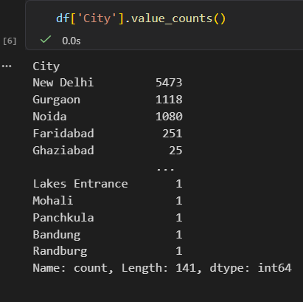

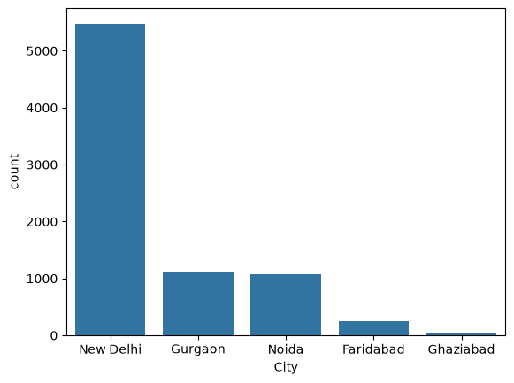

New Delhi has the highest number of restaurant records, with 5,473. Gurgaon and Noida follow with 1,118 and 1,080 respectively. Faridabad has 251 records, while the other cities in the top 10 have 25 or fewer records.

5. Key Findings
- The dataset contains 9,551 restaurant records across 21 columns.
- The mean Aggregate rating is 2.67 and the median is 3.20.
- The mean number of votes is 156.91, while the median is 31.
- Average Cost for two has a mean of 1,199.21 and a median of 400.
- Country Code 1 contains the largest number of restaurant records.
- New Delhi has the highest number of restaurants, followed by Gurgaon and Noida.
- North Indian is the most frequent cuisine entry in the top-10 cuisine results.
- Cuisine combinations are present, so cuisine-entry counts should be distinguished from individual-cuisine counts

Conclusion
The descriptive analysis provided an overview of the restaurant dataset through numerical statistics and categorical frequency analysis. The numerical analysis summarized central tendency, spread, and range, while the categorical analysis identified the distribution of country codes, cities, and cuisine entries. New Delhi was the city with the highest number of restaurant records, and North Indian was the most frequent cuisine entry. These findings provide a foundation for the remaining internship tasks, including geospatial analysis and feature engineering.

