COGNIFYZ TECHNOLOGIES

Data Science Internship
TASK 2: DESCRIPTIVE ANALYSIS
Intern: Pranav KS
Role: Data Science Intern
Level: Level 1
Task: Descriptive Analysis

1. Objective
The objective of this task is to analyze restaurant services related to table booking and online delivery. The analysis focuses on three areas: determining the percentage of restaurants that offer table booking and online delivery, comparing restaurant ratings based on table-booking availability, and examining online delivery availability across different price ranges.

2. Task Requirements
- Determine the percentage of restaurants that offer table booking and online delivery.
- Compare the average ratings of restaurants with table booking and those without.
- Analyze the availability of online delivery among restaurants with different price ranges.

3. Methodology
The restaurant dataset was loaded into a Pandas DataFrame. The columns used for this task were "Has Table booking", "Has Online delivery", "Aggregate rating", and "Price range". The Yes/No service fields were converted to lowercase before comparison so that the analysis was case-insensitive.
restaurant_percentage = (
(df['Has Table booking'].str.lower() == 'yes').mean() * 100
)
online_percentage = (
(df['Has Online delivery'].str.lower() == 'yes').mean() * 100
)

4. Percentage of Restaurants Offering Services
Service | Percentage | Interpretation
Table booking | 12.12% | A relatively small proportion of restaurants offer table booking.
Online delivery | 25.66% | Online delivery is available at a larger proportion than table booking.
According to the executed notebook, 12.12% of restaurants offer table booking, while 25.66% offer online delivery. Therefore, online delivery is more widely available than table booking in the analyzed dataset.

5. Average Rating: Table Booking vs. No Table Booking
The submitted notebook calculated the average Aggregate rating for restaurants that offer table booking. The resulting average was 3.4419689119170984, approximately 3.44.
Table Booking Status | Average Rating | Status
Yes | 3.44 | Calculated in submitted notebook
No | Not calculated in submitted notebook | Run the code below
Important: The submitted notebook did not contain the executed result for the average rating of restaurants without table booking. To avoid inventing a value, this report leaves that result open. The following code completes the required comparison when the original dataset is available:
with_booking = df[df['Has Table booking'].str.lower() == 'yes']
without_booking = df[df['Has Table booking'].str.lower() == 'no']
avg_with = with_booking['Aggregate rating'].mean()
avg_without = without_booking['Aggregate rating'].mean()
print("Average rating with table booking:", avg_with)
print("Average rating without table booking:", avg_without)

6. Online Delivery Availability by Price Range
The notebook grouped restaurants by Price range and calculated the percentage offering online delivery within each price range.
Price Range | Online Delivery Available (%)
1 | 15.77%
2 | 41.31%
3 | 29.19%
4 | 9.04%
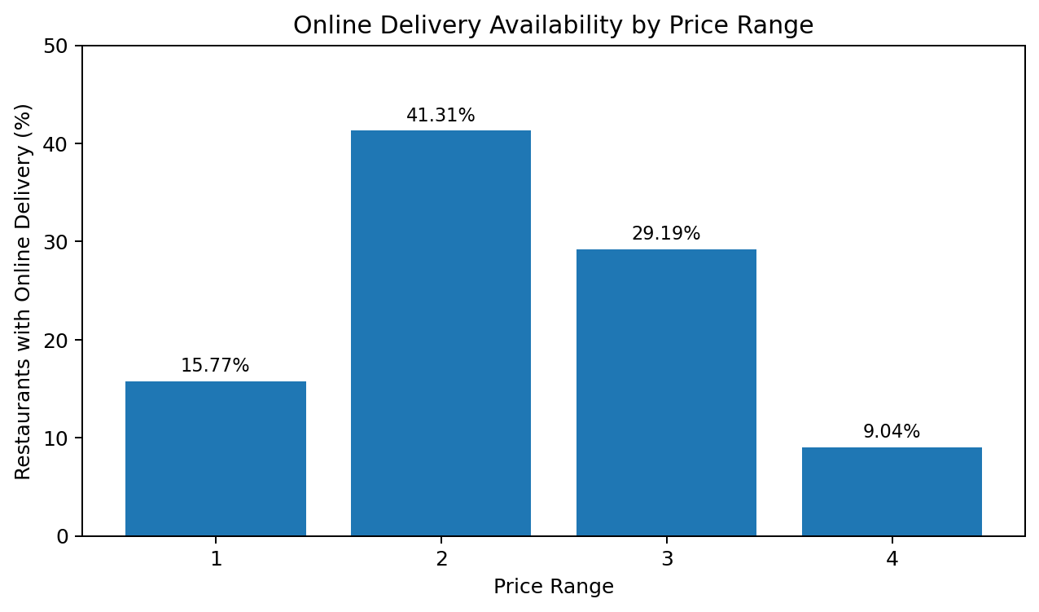
Figure 1. Online delivery availability by price range
Price Range 2 has the highest online-delivery availability at approximately 41.31%. It is followed by Price Range 3 at 29.19%, Price Range 1 at 15.77%, and Price Range 4 at 9.04%. Thus, the availability of online delivery is not simply increasing with price range; it varies across the categories.

7. Key Findings
- 12.12% of restaurants offer table booking.
- 25.66% of restaurants offer online delivery.
- The average rating of restaurants with table booking is approximately 3.44.
- The submitted notebook does not contain the executed average rating for restaurants without table booking; the comparison should be completed by running the provided code.
- Price Range 2 has the highest online-delivery availability at 41.31%.
- Price Range 4 has the lowest online-delivery availability at 9.04%.

8. Conclusion
The analysis shows that online delivery is more common than table booking in the restaurant dataset. Table booking is available at 12.12% of restaurants, whereas online delivery is available at 25.66%. Among the different price ranges, Price Range 2 has the highest percentage of restaurants offering online delivery, while Price Range 4 has the lowest. The average rating for restaurants with table booking is approximately 3.44. A complete comparison with restaurants without table booking requires the missing calculation to be executed on the dataset.
print(online)

