KESHAV MEMORIAL INSTITUTE OF TECHNOLOGY
Department of Computer Science & Engineering (Data Science)
Major Project Report
Provenance-Grounded Drug Repurposing via Agentic Evidence Adjudication
Section: CSD A | Team No: 14
Academic Year 2026–27
Roll No | Student Name
23BD1A6722 | J Pranav Kumar
23BD1A6758 | V Sri Teja
23BD1A6751 | Shishir Gella
23BD1A6710 | C Girish

Faculty Supervisor  _____________________  (Signature & Date) | Project Coordinator  _____________________  (Signature & Date)

Abstract
Drug repurposing offers a faster, cheaper route to treatment than de-novo discovery, but assessing a candidate requires evidence fragmented across mechanistic knowledge graphs, curated association repositories, and primary literature, making manual triage slow and inconsistent. Recent multi-agent frameworks such as PharmaSwarm show that specialised large-language-model (LLM) agents can be orchestrated to generate novel drug-discovery hypotheses, yet they target novel discovery, rely on proprietary or omics-scale resources, and defer rigorous validation to future work.
We present a cost-tiered multi-agent system that reframes repurposing as ranked in-silico triage: given a disease, it screens the entire approved-drug space and returns a small set of audited candidates that narrow the search space for experimental testing. The pipeline is a precision-recall cascade in which computational cost rises as the candidate set narrows. A relational graph neural network, trained on a public biomedical knowledge graph under time-split link prediction, scores every approved compound against the query disease in milliseconds; because scoring is exhaustive rather than retrieved, the first stage incurs no retrieval loss. Deterministic filters then prune on indication overlap, contraindication, and delivery feasibility, and audit each surviving score by metapath composition to flag candidates whose ranking derives from chemical similarity rather than mechanism.
Only the shortlist reaches the agentic layer, where a LangGraph-orchestrated Proponent and Falsifier argue the candidate under separate retrieval budgets and a constrained Referee adjudicates without introducing claims of its own; every claim is gated by a natural-language-inference verifier against its cited source, so provenance is enforced rather than prompted. A final arbitration stage addresses a failure mode of independent adjudication: because biomedical evidence is heavily shared across candidates, per-candidate briefs over-count correlated support. A shared evidence ledger propagates invalidations across the shortlist and rescores candidates by effective independent support, and a calibrator fitted on approved and failed indications converts these features into a confidence estimate reported with reliability diagrams rather than asserted.
Built entirely on public, redistributable resources (Hetionet/PrimeKG, CTD, Reactome, ChEMBL, repoDB, DrugCentral, PubMed) and evaluated against a gold standard containing true clinical negatives, the system is designed to return an empty recommendation set when no candidate clears threshold. The primary contribution is not the ranking model, which is pluggable, but the adjudication, invalidation, and calibration layers above it, which make agentic biomedical reasoning transparent and auditable.

Keywords
Drug repurposing; multi-agent systems; LangGraph; graph neural networks; knowledge graph embedding; retrieval-augmented generation; adversarial verification; evidence provenance; confidence calibration; in-silico screening.

Introduction & Problem Statement
Repurposing an already-approved drug for a new indication is, in principle, far faster and cheaper than de-novo drug discovery, because the compound's safety and pharmacokinetic profile is already established. In practice, deciding whether a given drug is a plausible candidate for a given disease requires pulling together evidence that is scattered across mechanistic knowledge graphs, curated association databases, and thousands of primary-literature papers — a task that today is done largely by hand, which makes it slow, inconsistent across reviewers, and difficult to audit after the fact.
Existing computational approaches only partly close this gap. Pure ranking models (knowledge-graph embeddings, graph neural networks such as TxGNN) can score candidates quickly but give no human-readable justification a reviewer can check. Newer agentic, LLM-based frameworks such as PharmaSwarm can generate plausible-sounding hypotheses, but are aimed at proposing genuinely novel candidates on proprietary data, not at systematically triaging the already-approved drug space, and they explicitly leave rigorous validation to future work. This leaves an open problem: how to screen the full space of approved drugs against a disease query cheaply, while still producing a per-candidate justification that is cited, adversarially stress-tested, and calibrated rather than merely asserted.
This project addresses that problem directly. Rather than trying to out-predict existing scorers, we treat scoring as a solved, pluggable component and build the missing layer above it: cost-tiered triage, adversarial adjudication, correlated-evidence-aware arbitration, and calibrated confidence — evaluated against true clinical negatives rather than positives alone.

Literature Survey
This section consolidates the systems, datasets and modelling techniques the team has reviewed, and records where each one is used or deliberately not used in our own design.

Competing / related systems
PharmaSwarm is a multi-agent large-language-model framework aimed at generating novel drug-repurposing hypotheses. It targets genuinely new discovery rather than triage of the already-approved drug space, relies on proprietary and omics-scale data that is not generally available to an academic team, and explicitly defers rigorous quantitative validation to future work. We treat it as inspiration for the multi-agent pattern, not as a system we are benchmarking against on equal footing, since its goals differ from ours.
TxGNN is a graph foundation model that performs zero-shot drug repurposing across roughly 17,080 diseases and is widely cited as a state-of-the-art ranking baseline, reporting around a 49% improvement in zero-shot indication prediction over prior methods. Because TxGNN only produces a ranked score with no human-readable justification, we treat it in our own pipeline as a pluggable wide scorer rather than as a competitor to beat outright — our contribution is the adjudication and audit layer built on top of a scorer like it.

Knowledge graphs and gold-standard benchmarks
Hetionet (from the Rephetio project) is a heterogeneous biomedical knowledge graph purpose-built for drug repurposing. It ships with a published gold standard of disease-modifying indications and metapath semantics that connect graph structure directly to pharmacological mechanism, which makes it a natural source of both training signal and structured filtering rules.
PrimeKG is a larger precision-medicine knowledge graph, integrating on the order of 130,000 entities from more than 20 biomedical resources. We use it to widen coverage beyond what Hetionet alone provides, particularly for target, pathway and adverse-event relations.
repoDB is a benchmark of both approved and failed drug-indication pairs. The failed pairs are the true clinical negatives that most repurposing papers lack, and are essential for an honest, falsifiable evaluation — a system that is only ever shown positives cannot be shown to discriminate.

Modelling and orchestration techniques
Relational Graph Neural Networks (R-GCNs) perform typed message passing over heterogeneous knowledge-graph edges and are the standard approach for exhaustive, millisecond-scale candidate scoring across thousands of drug-disease pairs. This is the technique behind our Stage-1 wide scorer.
Retrieval-augmented generation and natural-language-inference (NLI) claim verification are techniques for grounding language-model-generated claims against the literature they cite, rather than trusting free-form generation. We use an NLI verifier to gate every claim our adjudication agents produce against its cited source.
Multi-agent LLM debate, with adversarial role separation, is a pattern in which generation and criticism are deliberately assigned to separate agents. The literature shows this reduces the over-optimistic bias that appears when a single model both proposes and judges its own output — this is the basis for our Proponent / Falsifier / Referee design in Stage 3.

Existing System and its Limitations

Existing System
Drug-repurposing candidate identification today is handled by three broad approaches, each covered in the literature survey above:
- Manual literature review and expert triage — a domain expert cross-references mechanistic knowledge graphs, curated association databases and primary literature by hand for each candidate drug-disease pair.
- Pure ranking / scoring models (e.g. TxGNN and other knowledge-graph-embedding baselines) — a trained model outputs a ranked score for how plausible a drug-disease link is, with no accompanying justification.
- Agentic hypothesis-generation frameworks (e.g. PharmaSwarm) — multiple LLM agents are orchestrated to propose genuinely novel candidates, typically on proprietary or omics-scale data, aimed at discovery rather than triage of the already-approved drug space.

Limitations of Existing System
- Manual triage does not scale to the full approved-drug space and is inconsistent across reviewers, since it depends on which papers and databases a given expert happens to check.
- Ranking-only models give no human-readable, source-traceable justification a reviewer or clinician can audit — a candidate is simply a number.
- Agentic discovery frameworks explicitly defer rigorous, falsifiable validation to future work, and rely on data that is not generally available outside well-resourced industry or omics labs.
- Where a single model or a single evaluator sits over the generation step, the system is systematically over-optimistic, because the generation and the judgment of it share the same underlying prior.
- None of the existing approaches detects when several “independent” candidates secretly rely on the same shared piece of evidence, which causes systematic over-confidence if that evidence turns out to be weak or wrong.
- Confidence, where reported at all, is a model's self-reported score rather than a calibrated, reliability-checked figure (no ECE or Brier score is computed).
- Evaluation is almost always done only against known-positive indications, never against confirmed failed trials, so none of these systems can be shown to actually discriminate good candidates from bad ones.

Proposed System
The system proposed in this project is designed against each limitation above: a pluggable wide scorer for exhaustive coverage, deterministic structured filters for a cheap audit pass, an adversarial Proponent/Falsifier/Referee adjudication layer with NLI-gated claims for auditable justification, a shared evidence ledger to correct for correlated evidence, and a fitted calibrator evaluated against true clinical negatives for honest, checked confidence. The full design is detailed in the Proposed Methodology, System Architecture and Module Design sections that follow.

Research Gap Identification
Reading the systems above against each other surfaces six concrete gaps that existing work leaves open, and that our proposed system is designed to close.
- Gap 1 — No evaluable, reproducible triage system: agentic frameworks such as PharmaSwarm target novel discovery on proprietary or omics-scale data and defer validation; nothing currently screens the full approved-drug space against a disease query with a falsifiable evaluation protocol.
- Gap 2 — Ranking without provenance: scoring-only models such as TxGNN and other knowledge-graph-embedding baselines rank candidates but give no human-readable, source-traceable justification that a reviewer or clinician could actually audit.
- Gap 3 — Fan-out agents are not genuinely multi-agent: designs where a single evaluator sits over several parallel generation agents are systematically over-optimistic, because the generation and the criticism ultimately share the same model prior.
- Gap 4 — Correlated evidence is unhandled: no existing system detects that several “independent” candidate briefs secretly rest on the same shared — and possibly weak — piece of evidence, which causes systematic over-confidence when that evidence turns out to be wrong.
- Gap 5 — Confidence is asserted, not calibrated: most systems report a language model's self-reported confidence with no reliability diagram, expected calibration error (ECE), or Brier score behind it, so the numbers cannot be trusted at face value.
- Gap 6 — No evaluation against true clinical negatives: repurposing systems are rarely tested on failed-trial pairs, so false enthusiasm about a candidate goes undetected until much later and at much higher cost.
Taken together, these gaps motivate a system that is cheap enough to screen the whole approved-drug space, that produces an auditable, cited case for every surviving candidate, that treats generation and criticism as adversarial rather than cooperative, that explicitly tracks shared evidence across candidates, and that reports a calibrated — not merely asserted — confidence score, evaluated against real clinical negatives.

Objectives
Directly addressing the six gaps identified above, the project's objectives are to:
- Build a knowledge-graph-based wide scorer (an R-GCN trained under time-split link prediction) capable of exhaustively ranking the entire approved-drug space against a disease query in milliseconds, with no retrieval loss.
- Design deterministic structured filters that prune on indication overlap, contraindication and delivery feasibility, and that flag candidates whose score is driven by chemical similarity rather than mechanism, before any expensive review happens.
- Develop a LangGraph-orchestrated adversarial adjudication layer (Proponent / Falsifier / Referee) in which every claim is gated by a natural-language-inference verifier against its cited source, so provenance is enforced rather than merely prompted for.
- Build a cross-candidate arbitration and calibration layer that uses a shared evidence ledger to correct for correlated evidence across candidates, and that reports a fitted, reliability-checked confidence score instead of an asserted one.
- Evaluate the end-to-end pipeline against the repoDB / DrugCentral gold standard — which includes true clinical negatives, not just positives — using an ablation ladder across stages and Recall@K, MAP, nDCG, ECE and Brier score as metrics.
- Build entirely on public, redistributable data and tooling, so the system and its evaluation are reproducible outside the team's own environment.

Scope of the Project
In scope for this project: knowledge-graph construction and preprocessing over public biomedical resources; a trained, time-split-evaluated wide-scoring model; deterministic structured filtering and degeneracy flagging; a prototype LangGraph-based adversarial adjudication layer with NLI-gated claim verification; a cross-candidate evidence ledger and fitted calibrator; and an offline benchmark against repoDB/DrugCentral, demonstrated through a FastAPI backend and a React audit UI on a pilot set of disease queries.
Explicitly out of scope: wet-lab or clinical validation of any candidate the system surfaces, regulatory submission or clinical decision-making, and discovery of genuinely novel (non-approved) compounds. The system is a computational triage and evidence-audit tool intended to narrow a search space for human experts, not a replacement for clinical trials or a clinical decision-support system in the regulated sense.

Feasibility Study

Technical feasibility
Every component relies on established, publicly documented techniques — R-GCN link prediction, deterministic rule-based filtering, LLM-agent orchestration via LangGraph, and NLI-based claim verification — each of which has open-source implementations (PyTorch Geometric/DGL, LangGraph, HuggingFace Transformers) that the team can build on rather than implement from scratch. The main technical risk is integration and latency across four stages rather than any single stage being infeasible.

Data feasibility
All required datasets (Hetionet, PrimeKG, repoDB, DrugCentral, CTD, Reactome, ChEMBL, PubMed, OpenFDA FAERS) are public and already identified with clear access paths, so data availability is not a blocking risk. Data-cleaning and ID-crosswalking effort (M1) is real but bounded and scoped into the timeline.

Time feasibility
The remaining Stage-1 work is bounded to run through December 2026 (see the project timeline), with the knowledge-graph pipeline, wide scorer, structured filters, and an adjudication-agent prototype sequenced to allow overlap rather than strict dependency, so a delay in one stream does not immediately block the others.

Economic feasibility
Dataset and tooling costs are zero, since everything used is public and open-source. The one recurring cost is LLM API usage in Stage 3; the cost-tiered design keeps this bounded by construction, since the language-model-driven stages only ever run on the already-narrowed shortlist (~20 candidates per query) rather than the full approved-drug space (~3,000 candidates).
Honestly stated risk: the adjudication and calibration stages are the least proven part of the design and the most likely to need iteration once real disease queries are run end to end — the evaluation plan and timeline are built to surface that early rather than at the final review.

Proposed Methodology
Our proposed system is a cost-tiered precision–recall cascade: computational and financial cost rises only as the candidate set narrows. Given a single disease query, the pipeline runs four stages of increasing cost and decreasing candidate count, so that the most expensive step — language-model-driven adjudication — is only ever run on a small, already-pruned shortlist.

Stage 1 — Wide Scorer (no LLM, milliseconds)
A Relational Graph Neural Network (R-GCN), trained under a time-split link-prediction protocol so that evaluation never leaks future knowledge into training, scores every approved drug in the knowledge graph exhaustively against the query disease. This stage touches roughly 3,000 candidate drugs and produces a ranked top-200 shortlist with no retrieval loss — nothing is filtered by a lossy nearest-neighbour search.

Stage 2 — Structured Filters (deterministic rules, milliseconds)
A deterministic rule engine prunes drugs that are already indicated for the disease or that fail basic safety constraints, then annotates the survivors with their metapath profile, target and pathway data, and prior trial history. It also flags candidates whose score looks similarity-driven rather than mechanism-driven, a form of degeneracy that would otherwise slip through unnoticed. This stage narrows the top-200 down to an audited top-20.

Stage 3 — Adversarial Adjudication (agentic, minutes)
For each of the roughly 20 surviving candidates, a LangGraph-orchestrated set of agents builds and stress-tests the case. A Proponent agent builds the cited case for the candidate; a Falsifier agent builds the cited case against it, working under a separate retrieval budget so it cannot simply echo the Proponent's sources; and a Referee agent adjudicates between them under a fixed rubric, adding no new claims of its own. Every claim any agent makes is gated by a natural-language-inference verifier against the literature it cites, so an unsupported assertion cannot pass silently into the final brief.

Stage 4 — Cross-Candidate Arbitration & Calibration (hybrid)
A shared evidence ledger tracks which pieces of evidence were used to support which candidates. When a piece of evidence is later invalidated — for instance if the Falsifier or a downstream check discredits a source — that invalidation propagates across every candidate that relied on it, and each candidate is rescored by its effective independent support rather than its raw evidence count. A calibrator, fitted with logistic regression or gradient-boosted trees, then converts these evidence features into a final confidence estimate, reported alongside reliability diagrams so the confidence number is checked rather than merely asserted.

Output
The system's output is a ranked, tiered list of fully-sourced candidate briefs — never a single verdict — and, when nothing in the candidate pool clears the calibrated confidence threshold, an explicit empty list rather than a forced recommendation. This is a deliberate design choice: a system that always returns a top candidate cannot be trusted when the true answer is that none of the reviewed candidates hold up.

System Architecture
The diagram below traces a single disease query through the full cascade described in the methodology section. Teal-coloured stages run with no language model involved, at millisecond latency and fully deterministic behaviour; purple-coloured stages are language-model-driven, more expensive, and are run only on the narrowed shortlist that survives the teal stages. Referee verdicts from Stage 3 feed back over time to reweight the metapath priors used in Stage 1, so the wide scorer improves as more diseases are reviewed.
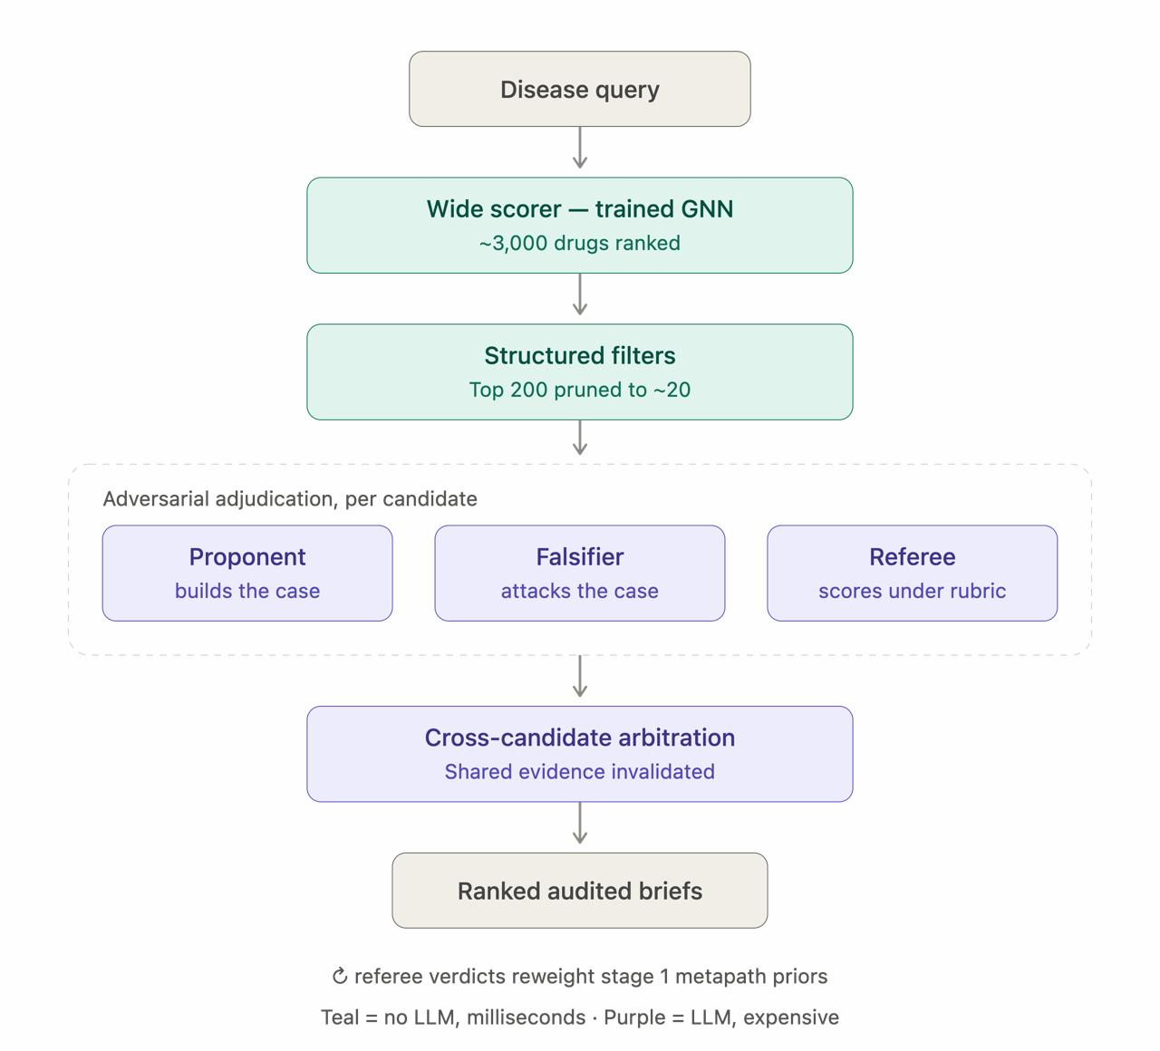
Disease query → Wide Scorer (trained GNN, ~3,000 drugs ranked) → Structured Filters (top 200 pruned to ~20) → Adversarial Adjudication per candidate (Proponent builds the case, Falsifier attacks it, Referee scores under a rubric) → Cross-Candidate Arbitration (shared evidence invalidated and rescored) → Ranked, audited briefs.

Module Design
The system decomposes into seven modules, each corresponding to one stage of the cascade plus the evaluation and serving layers that surround it.
Module | Name | Description
M1 | KG Construction & Preprocessing | As built: ingests Hetionet v1.0 + PharmacotherapyDB into a single versioned, typed graph (47,031 nodes, 2.25M edges). Planned: PrimeKG, repoDB, DrugCentral and ID crosswalks to MONDO/UniProt/InChIKey.
M2 | Wide Scorer (Stage 1) | As built: an inductive R-GCN ensembled with a popularity prior and gene-overlap count (weights fitted on validation diseases), trained with disease-holdout link prediction; a true time-split is supported once drug approval dates are supplied. Scores every approved drug; outputs the top-200 shortlist.
M3 | Structured Filter (Stage 2) | A deterministic rule engine performing pruning, metapath annotation and degeneracy flagging; outputs the audited top-20 shortlist.
M4 | Adversarial Adjudication (Stage 3) | A LangGraph orchestrator running the Proponent / Falsifier / Referee agents, each with tool access to PubMed, knowledge-graph path queries and FAERS/clinical-trial data, gated by an NLI claim-verification step.
M5 | Arbitration & Calibration (Stage 4) | Maintains the shared evidence ledger, propagates invalidations, computes effective-independent-support scores, and applies the fitted calibrator to produce a final confidence estimate.
M6 | Evaluation Harness | Runs the repoDB / DrugCentral benchmark, executes the ablation ladder across pipeline stages, and reports Recall@K, MAP, nDCG, ECE and Brier score.
M7 | Serving & Audit UI | A FastAPI backend and React frontend that exposes ranked briefs, the full evidence-provenance trace for each one, and the invalidation history from the shared ledger.

Dataset & Technology Stack

Datasets
Dataset | Role in the pipeline
Hetionet / PrimeKG | Base heterogeneous knowledge graph (entities, drug-disease-gene-pathway relations)
CTD, Reactome, ChEMBL | Mechanistic and pathway annotation
repoDB | Approved and failed drug-indication pairs — the gold standard with true clinical negatives
DrugCentral | Drug and safety metadata
PubMed | Literature retrieval for the adjudication agents
OpenFDA FAERS | Adverse-event signal

Technology stack
Layer | Tools
Modelling | Python, PyTorch, PyTorch Geometric / DGL (R-GCN link prediction)
Agentic layer | LangGraph for multi-agent orchestration; an LLM API (Claude / GPT-class model) for the Proponent, Falsifier and Referee agents
Verification & calibration | HuggingFace Transformers (an off-the-shelf NLI checkpoint, e.g. a SciFact/HealthVer-trained DeBERTa); scikit-learn for the calibrator and metrics
Serving | FastAPI backend, React audit-UI frontend
Tooling | Git / GitHub for version control; Docker for reproducible environments
All datasets used are public and freely redistributable — no proprietary or licensing-restricted resources such as DrugBank or KEGG are used, which keeps the whole pipeline reproducible outside our own environment.

Gantt Chart / Project Timeline
The timeline below covers the remainder of Stage 1, bounded to run only through December 2026. The literature survey and research-gap analysis are already complete; the remaining five workstreams are planned sequentially with deliberate overlap so that data-pipeline and modelling work is not blocked on documentation.
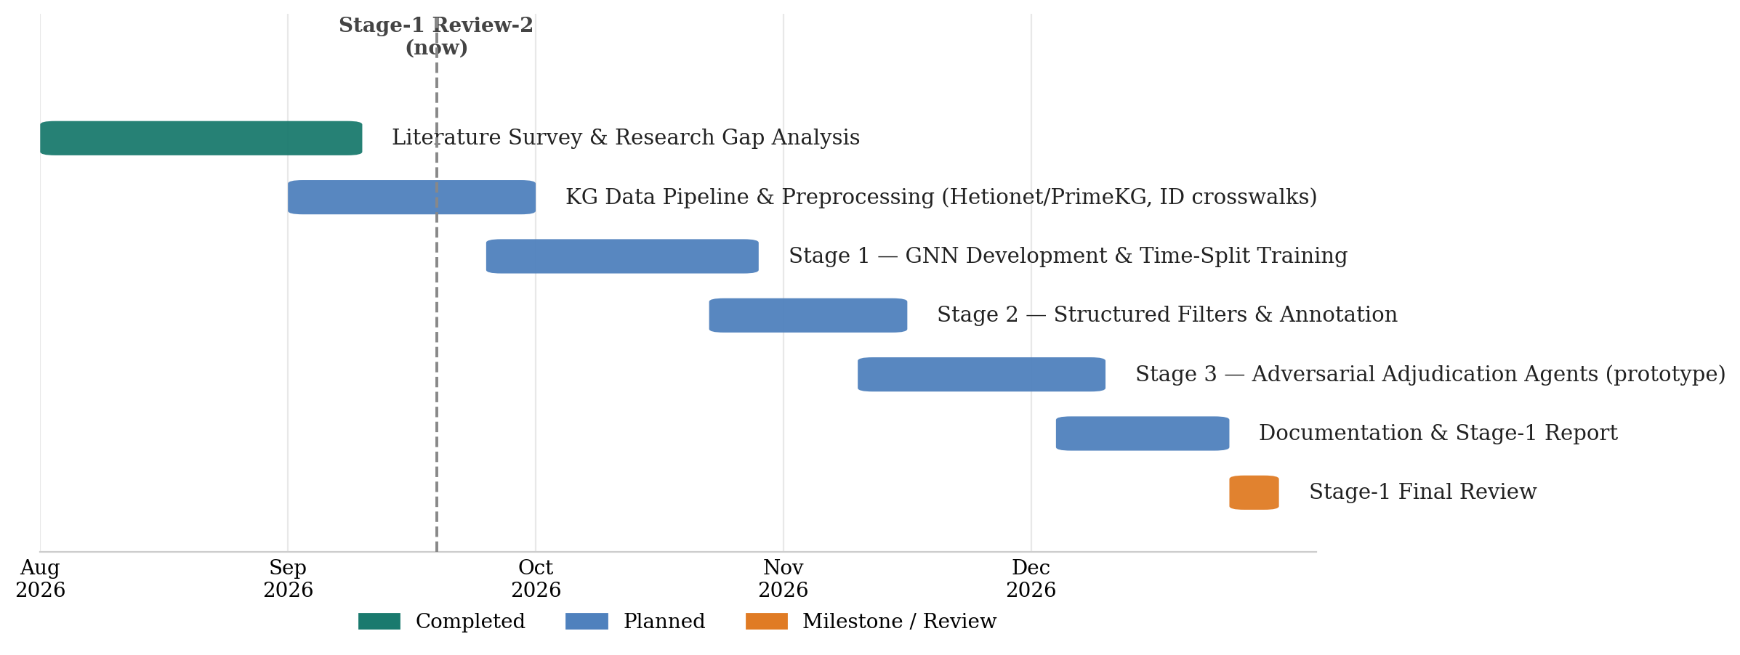
Workstream | Window & status
Literature Survey & Research Gap Analysis | Aug 2026 – mid Sep 2026 — Completed
KG Data Pipeline & Preprocessing (Hetionet/PrimeKG, ID crosswalks) | Mid Sep 2026 – early Oct 2026 — Planned
Stage 1 — GNN Development & Time-Split Training | Late Sep 2026 – early Nov 2026 — Planned
Stage 2 — Structured Filters & Annotation | Late Oct 2026 – mid Nov 2026 — Planned
Stage 3 — Adversarial Adjudication Agents (prototype) | Mid Nov 2026 – mid Dec 2026 — Planned
Documentation & Stage-1 Report | Mid Dec 2026 – late Dec 2026 — Planned
Stage-1 Final Review | Late Dec 2026 — Milestone

Advantages & Novelty
- Auditable, cited justification per candidate — the output is a sourced brief a reviewer can check line by line, not just a bare score, closing Gap 2 from the literature survey.
- Genuinely adversarial verification — the Proponent and Falsifier work under separate retrieval budgets and a constrained Referee adjudicates without introducing new claims, avoiding the over-optimism of single-evaluator-over-parallel-agents designs (Gap 3).
- Correlated-evidence awareness — the shared evidence ledger is, to the team's knowledge, the first component in this space to explicitly detect and correct for candidates that secretly share the same underlying evidence (Gap 4).
- Calibrated, not asserted, confidence — a fitted calibrator plus reliability diagrams (ECE, Brier score) replace an LLM's self-reported confidence with a number that has actually been checked (Gap 5).
- Honest evaluation — benchmarking against repoDB's true clinical negatives, not just approved positives, means the system can be shown to discriminate rather than just to rank (Gap 6).
- Reproducibility — every dataset and tool in the stack is public and redistributable, so the pipeline and its evaluation can be rerun outside the team's own environment.
- Cost control — because the expensive LLM-driven stages only ever run on an already-narrowed shortlist (~20 candidates), the design keeps API and compute cost bounded regardless of how large the underlying drug space grows.

Expected Outcomes & Deliverables
- A working end-to-end prototype — FastAPI backend plus a React audit UI — that takes a disease query and returns ranked, calibrated, fully-sourced candidate briefs.
- A trained and time-split-evaluated R-GCN wide scorer over Hetionet/PrimeKG, exposed as a pluggable scoring module.
- A LangGraph adjudication pipeline (Proponent/Falsifier/Referee) with an NLI claim-verification gate, demonstrated on a pilot set of disease queries.
- A shared evidence ledger and fitted calibrator, with reliability diagrams reported for the pilot evaluation.
- A benchmark report against repoDB/DrugCentral, including an ablation ladder showing what each pipeline stage (wide scorer alone, plus filters, plus adjudication, plus arbitration/calibration) adds over the previous one.

Evaluation Criteria
The system is evaluated in two dimensions, both against the repoDB / DrugCentral gold standard, which — unlike most repurposing benchmarks — includes confirmed failed indications as true negatives, not only approved positives:
- Ranking quality: Recall@K, Mean Average Precision (MAP) and normalized Discounted Cumulative Gain (nDCG), computed at each pipeline stage so the ablation ladder shows the marginal value of structured filtering and adjudication over the wide scorer alone.
- Calibration quality: Expected Calibration Error (ECE) and Brier score on the final confidence estimate, together with reliability diagrams, so the confidence number is checked rather than asserted.
Success for Stage 1 is defined as a working, time-split-evaluated wide scorer and a demonstrated adjudication-plus-calibration pipeline on a pilot set of diseases, with the full benchmark run against repoDB reserved for the later evaluation stage described in the project timeline.

Key Datasets, Systems & Literature Referenced
- Hetionet (Rephetio project) — heterogeneous biomedical knowledge graph with a published gold standard of disease-modifying indications and metapath semantics.
- PrimeKG — large-scale precision-medicine knowledge graph (~130,000 entities) integrating 20+ biomedical resources.
- TxGNN — graph foundation model for zero-shot drug repurposing across ~17,080 diseases; used here as a reference ranking baseline, not a competitor.
- PharmaSwarm — multi-agent LLM framework for novel drug-discovery hypothesis generation; motivates the multi-agent pattern used in Stage 3.
- repoDB — benchmark of approved and failed drug-indication pairs, the source of true clinical negatives for evaluation.
- DrugCentral — drug and safety metadata.
- CTD, Reactome, ChEMBL — mechanistic and pathway annotation sources.
- PubMed and OpenFDA FAERS — literature retrieval and adverse-event signal respectively.
- Relational Graph Convolutional Networks (R-GCN) — the typed message-passing architecture underlying the Stage-1 wide scorer.
- LangGraph — the multi-agent orchestration framework used to implement the Proponent / Falsifier / Referee adjudication layer.

Conclusion & Future Scope
Stage 1 of this project establishes the case for treating drug repurposing as auditable, cost-tiered triage rather than either a black-box ranking problem or an unconstrained hypothesis-generation problem. The literature survey and gap analysis motivate a specific architecture — wide scoring, structured filtering, adversarial adjudication, and correlated-evidence-aware calibration — and the module design, dataset/technology stack and timeline in this document lay out how that architecture will be built and evaluated through the remainder of Stage 1.
Looking beyond Stage 1, the natural next steps are to complete the adjudication-agent prototype, run the full benchmark against repoDB and DrugCentral with the ablation ladder described above, and — time permitting — pilot the audit UI on a small set of disease queries chosen with faculty input, so that Stage 2 can focus on refining calibration and expanding evaluation coverage rather than on first getting a pipeline to run end to end.

Closing note for the team
This document is the team's complete study reference for the project — from the initial problem statement, scope and feasibility through the updated literature survey, research gaps, proposed methodology, system architecture, module design, dataset/technology stack and project timeline, and closing with the advantages, expected outcomes, evaluation criteria and key references. It is meant to stand on its own behind the accompanying slide deck, covering everything presented and developed so far rather than just the material for a single review. Each team member should be able to speak to any section, but especially their own area: the KG pipeline and dataset stack, the R-GCN wide scorer, the adjudication agents, and the evaluation/serving layer.

Implementation Status and Results (as built)
This section records what was actually implemented and the measured results, as a factual counterpart to the proposal above. The full pipeline (all seven modules) is implemented and covered by 44 automated tests. It was trained and evaluated on the complete Hetionet v1.0 knowledge graph (47,031 nodes, 2.25 million edges) using a GPU.

Evaluation setup
Split: disease-holdout (zero-shot). The 15 test diseases have every one of their known treatments hidden during training, a stricter test than a time-split. Negatives are PharmacotherapyDB non-indications, a proxy for repoDB's failed trials. Because unlabelled drug-disease pairs count as negatives, the reported precision is a lower bound.

Headline results
On the 15 held-out test diseases, the full system outperforms every non-learned baseline. The largest gain is in recall@10, the share of true treatments landing in the top ten a reviewer reads, which more than doubles over the best baseline. Confidence is well calibrated after Stage 4: expected calibration error (ECE) falls from 0.67 on the raw score to 0.063.
Method (test diseases, zero-shot) | MAP | recall@10 | ECE
Popularity baseline | 0.127 | 0.172 | —
Gene-overlap baseline | 0.054 | 0.103 | —
Stage 1 — R-GCN alone | 0.136 | 0.152 | —
Stage 1 — ensemble | 0.126 | 0.176 | —
Stage 2 — + filters & audit | 0.225 | 0.360 | —
Stage 4 — full system | 0.231 | 0.418 | 0.063
Macro-averaged over test diseases; ECE on the shortlist candidates. The ablation ladder shows most of the gain comes from the Stage-2 audit (MAP 0.13 → 0.23) and Stage-4 calibration, not from Stage 1 alone.

Worked example — rheumatoid arthritis (held-out)
None of this disease's known drugs were visible in training, yet 8 of the system's top 10 are real known treatments (dexamethasone, prednisone, cyclosporine, betamethasone, methotrexate, leflunomide, triamcinolone, hydrocortisone), and the remaining two include mycophenolate, used off-label for the condition. For migraine it recovers topiramate and valproate and also surfaces zonisamide, pregabalin and lamotrigine, all studied for migraine prevention.

Differences from the original plan
- Data: Hetionet v1.0 + PharmacotherapyDB are used. PrimeKG, repoDB, DrugCentral, OpenFDA FAERS and PubMed retrieval are designed-in but not yet wired up.
- Split: disease-holdout is used because Hetionet carries no dates; a true time-split is implemented and runs once drug approval years are supplied.
- Stage 1 is an ensemble (R-GCN + popularity + gene-overlap), because the R-GCN alone under-performed a popularity prior on held-out diseases.
- Stage 3 agents ran on an offline rule-based stand-in with a lexical verifier, not a live LLM or a trained NLI model. The reported L3/L4 numbers therefore measure the pipeline's evidence handling, not LLM reasoning; the code switches to Claude agents with one setting and an API key.
- Delivered interface: a FastAPI service with a React audit page (search a disease; see ranked drugs with calibrated confidence, verified evidence and the referee verdict).

