**Abstract**

The chatbot made in this video is a retrieval based chatbot. This bot uses simple neural network to recognize what was the intention behind a users comment and fetch the output for the particular comment’s intent from a set of predefined outputs. Since it’s a “Library chatbot” therefore a retrieval based chatbot will be more efficient with its work. Apart from answering the queries, our chatbot is also able to connect to the database and fetch data regarding author, no of books available in shelf, etc.

**Introduction**

Many organizations these days have started implementing artificial intelligence for its various applications. Chatbots are becoming more and more popular as it has the capacity to answer queries to different type of users and will not complain about their frequency. Some libraries cannot afford much staff members due to the high work toll. In such situation a chatbot will be a perfect solution to answer to same queries which are frequently. Our chatbot is able to answer the basic issues such as membership, issue, overdue charges, library timings, etc.

**Literature review**

I was able to get a good intuition regarding following:

* Natural language processing and the steps included in it which are stemming, lemmatizing, tokenizing, bag of words, tf-idf algorithm.
* The use of **pickling** to skip the preprocessing part each and every time.
* The process involved in neural network to perform effective classification.
* All about “**one hot encoding**” and its application.
* What **activation functions** are. I learned about two of them which are “**sigmoid**” and “**softmax**”.

**Proposed methodology**

1. **Data:** The first step is to get the dataset. For this we created a json file which contains different tags which contains possible patterns that the user can input and their responses as the output. We have to add various patterns and tag which were suitable for our purpose i.e. library.
2. **Data preprocessing:** in this step the patterns from json file is passed through various phase which are stemming(where the words are converted to their root words), tokenizing(created list of words), conversion into lowercase and removal of punctuations and finally bag of words which contains the count of every word present and its frequency.
3. **Network training:** once the preprocessing step is completed, the data is now sent into a neural network with three layers(1 input, hidden and output) with 8 neurons in each except the output layer. “Softmax” is used as the activation function which returns the probability from 0-100 for each and every output neuron.
4. **Prediction:** After the training part, we give an input pattern for which the network returns a list of probabilities of all the tags for the input. We will select the tag which has the highest probability among the others and consider this tag as the output result.
5. **Output:** Once we have successfully predicted our output. We can fetch the response from a set a predefined responses presented in the json file we loaded. This output is then shown as the final output to the user.

**Result and declaration**

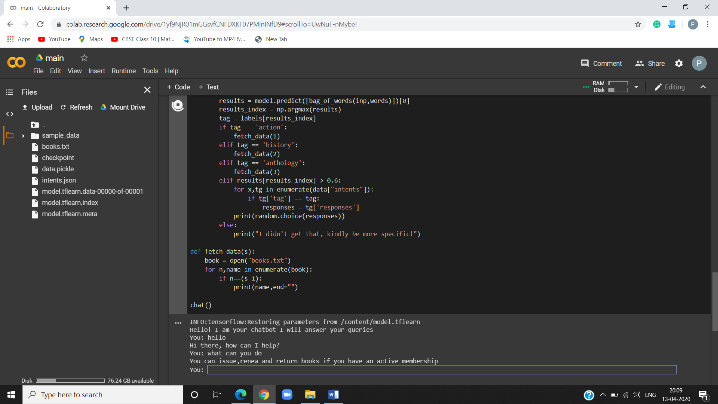

The chatbot was successful and was able to answer queries related to library.

**Conclusion**

We were able to successfully implement chatbot which answered questions asked about various services in a book library. The chatbot is an efficient one as it applies learning to predict a particular output from a set of predefined patterns rather than generating the a whole pattern using its intelligent. The only downside it can face is regarding the limitation to the types of responses it can fetch as all are predefined on the contrary a generative based chatbot applies its learning algorithm to generate an actual response on the spot but with far less efficiency than a retrieval based chatbot. Since our purpose of the project was very much focused on a single purpose application(Library) therefore the later option of retrieval based chatbot becomes an ideal decision for the project.

**References**

* <https://towardsdatascience.com/stemming-lemmatization-what-ba782b7c0bd8>
* <https://missinglink.ai/guides/neural-network-concepts/7-types-neural-network-activation-functions-right/>
* <https://pathmind.com/wiki/neural-network>
* <https://www.geeksforgeeks.org/understanding-python-pickling-example/>
* <https://machinelearningmastery.com/how-to-one-hot-encode-sequence-data-in-python/>
* <https://www.pythonforbeginners.com/error-handling/exception-handling-in-python>
* <https://www.geeksforgeeks.org/bag-of-words-bow-model-in-nlp/>
* <https://algorithmia.com/blog/introduction-natural-language-processing-nlp>