50 -
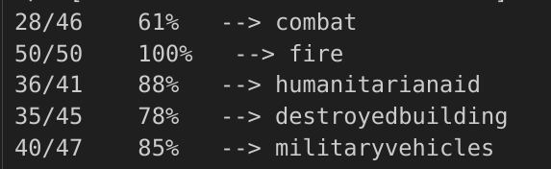

20-
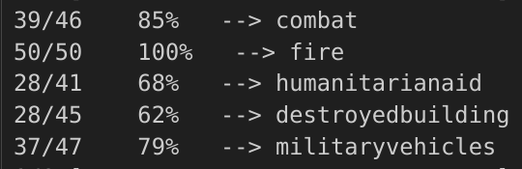

20- with prep

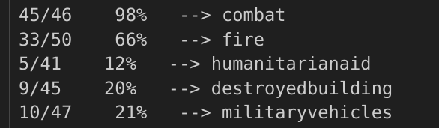

20- with prep

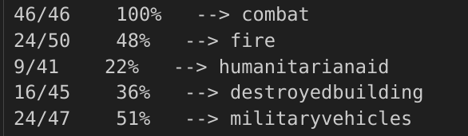

20- no prep

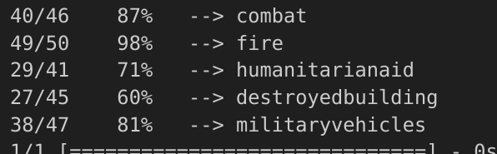

30
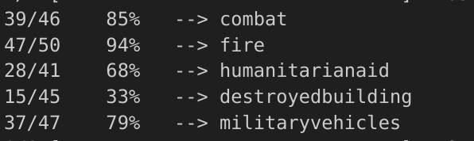

20 eps (added db ds)

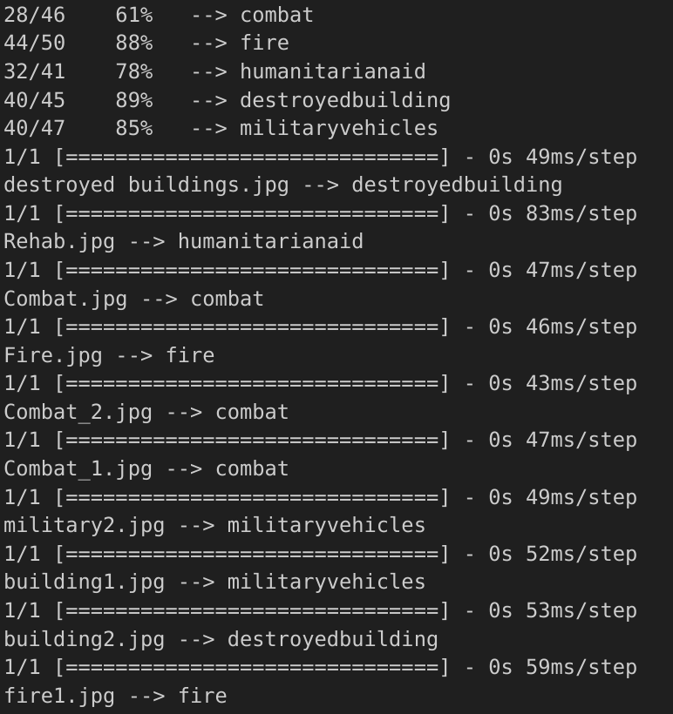

20 updated test set-
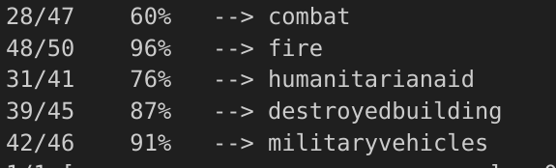

20, lr = 0.0003-
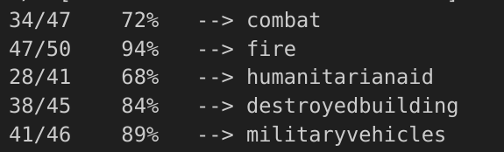

30 -
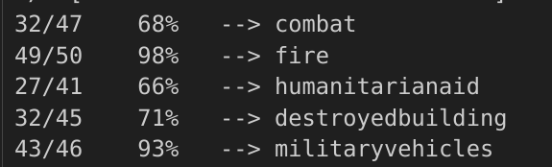

50, 0.0002lr -

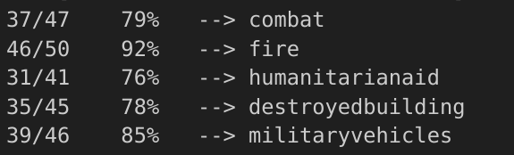

20, 0.0001lr -
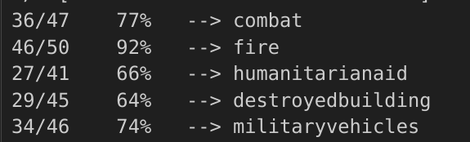

40 -

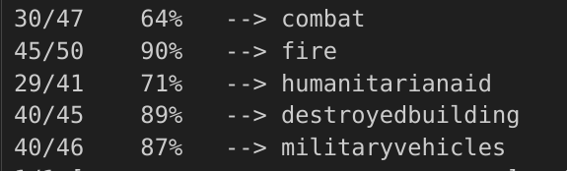

60 -
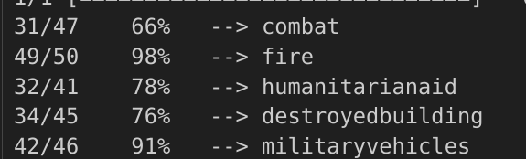

20 with pp -

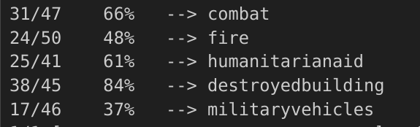

40 with pp -

