**“DAILY ONLINE ACTIVITIES SUMMARY”**

|  |  |  |  |  |  |
| --- | --- | --- | --- | --- | --- |
| **Date:** | **24-06-2020** | | | **Name:** | **Pranav L M** |
| **Sem & Sec** | **6th - B** | | | **USN:** | **4AL17CS062** |
| **PRE-PLACEMENT TRAINING** | | | | | |
| **Subject** | **JAVA AND DATA STRUCTURES** | | | | |
| **Max. Marks** | **--** | Score | | | **--** |
| **JAVA**  **DATA STRUCTURES** | Ms. SHILPA  Mr. VENKATESH BHAT | | | | |
| **Coding Challenges** | | | | | |
| **Problem Statemen:**  **JAVA PROGRAM** | | | | | |
| **Status: executed** | | | | | |
| **Uploaded the report in Github** | | | **yes** | | |
| **If yes Repository name** | | | <https://github.com/pranavlm/DAILY-STATUS/tree/master/online-coding-report> | | |
| **Uploaded the report in slack** | | | **Yes** | | |

ONLINE CODING

Create a class named 'Shape' with a method to print "This is This is shape". Then create two other classes named 'Rectangle', 'Circle' inheriting the Shape class, both having a method to print "This is rectangular shape" and "This is circular shape" respectively. Create a subclass 'Square' of 'Rectangle' having a method to print "Square is a rectangle". Now call the method of 'Shape' and 'Rectangle' class by the object of 'Square' class.

class Shape{

public void print_shape(){

System.out.println("This is shape");

}

}

class Rectangle extends Shape{

public void print_rect(){

System.out.println("This is rectangular shape");

}

}

class Circle extends Shape{

public void print_circle(){

System.out.println("This is circular shape");

}

}

class Square extends Rectangle{

public void print_square(){

System.out.println("Square is a rectangle");

}

}

public class Test{

public static void main(String[] args){

Square sq = new Square();

sq.print_shape();

sq.print_rect();

}

}

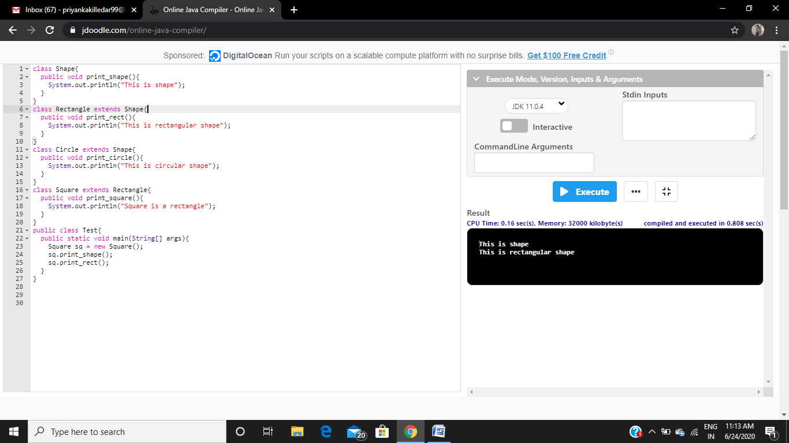

TRAINING:

