**DAILY ONLINE ACTIVITIES SUMMARY**

|  |  |  |  |  |  |  |  |  |
| --- | --- | --- | --- | --- | --- | --- | --- | --- |
| **Date:** | **08-07-2020** | | | | | **Name:** | **Pranav L M** | |
| **Sem & Sec** | **6th -B** | | | | | **USN:** | **4al17cs062** | |
| **Online Test Summary** | | | | | | | | |
| **Subject** | | **-** | | | | | | |
| **Max. Marks** | | **-** | | **Score** | | | **-** | |
| **Certification Course Summary** | | | | | | | | |
| **Course** | Cloud Infrastructure and Service Management | | | | | | | |
| **Certificate Provider** | | | **-** | | **Duration** | | | **1.5hours** |
| **Coding Challenges** | | | | | | | | |
| **Problem Statement:** **Python Program to Reverse a linked list** | | | | | | | | |
| **Status: Solved** | | | | | | | | |
| **Uploaded the report in Github** | | | | | **yes** | | | |
| **If yes Repository name** | | | | | <https://github.com/pranavlm/DAILY-STATUS/tree/master/Daily-Report> | | | |
| **Uploaded the report in slack** | | | | | **yes** | | | |

**ONLINE COURSE**

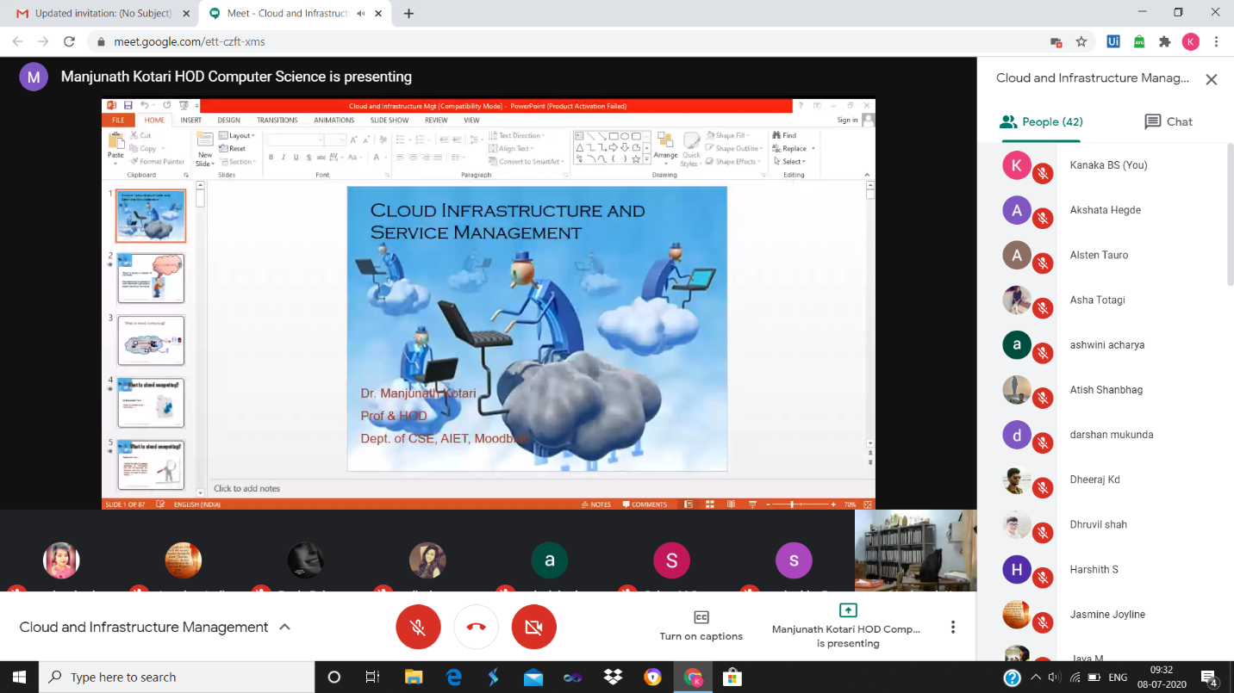

**ONLINE CODING**

**Python Program to Reverse a linked list**

class Node:

def __init__(self, data):

self.data = data

self.next = None

class LinkedList:

def __init__(self):

self.head = None

def reverse(self):

prev = None

current = self.head

while(current is not None):

next = current.next

current.next = prev

prev = current

current = next

self.head = prev

def push(self, new_data):

new_node = Node(new_data)

new_node.next = self.head

self.head = new_node

def printList(self):

temp = self.head

while(temp):

print(temp.data),

temp = temp.next

llist = LinkedList()

llist.push(5)

llist.push(25)

llist.push(9)

llist.push(56)

print("Given Linked List")

llist.printList()

llist.reverse()

print("\nReversed Linked List")

llist.printList()

