**DAILY ONLINE ACTIVITIES SUMMARY**

|  |  |  |  |  |  |  |  |  |
| --- | --- | --- | --- | --- | --- | --- | --- | --- |
| **Date:** | **12-06-2020** | | | | | **Name:** | **Pranav L M** | |
| **Sem & Sec** | **6th - B** | | | | | **USN:** | **4AL17CS062** | |
| **Online Test Summary** | | | | | | | | |
| **Subject** | | **--** | | | | | | |
| **Max. Marks** | | **30** | | **Score** | | |  | |
| **Certification Course Summary** | | | | | | | | |
| **Course** | **Introduction to Cloud** | | | | | | | |
| **Certificate Provider** | | | **IBM** | | **Duration** | | | **15** |
| **Coding Challenges** | | | | | | | | |
| **Problem Statemen:**   1. **A magic square of order n is an arrangement of n^2 numbers, usually distinct integers, in a square, such that the n numbers in all rows, all columns, and both diagonals sum to the same constant. A magic square contains the integers from 1 to n^2.** 2. **Python program to print the pattern.** 3. **Java program to find maximum width of a binary tree** | | | | | | | | |
| **Status: executed** | | | | | | | | |
| **Uploaded the report in Github** | | | | | **yes** | | | |
| **If yes Repository name** | | | | | <https://github.com/pranavlm/DAILY-STATUS/tree/master/online-coding-report> | | | |
| **Uploaded the report in slack** | | | | | **Yes** | | | |

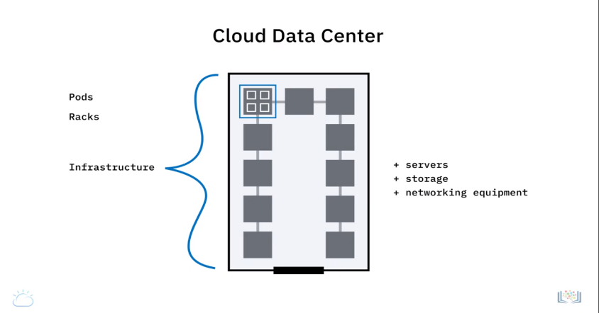CERTIFICATION DETAIL

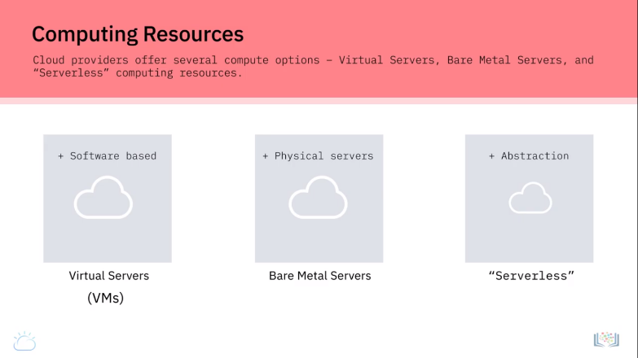

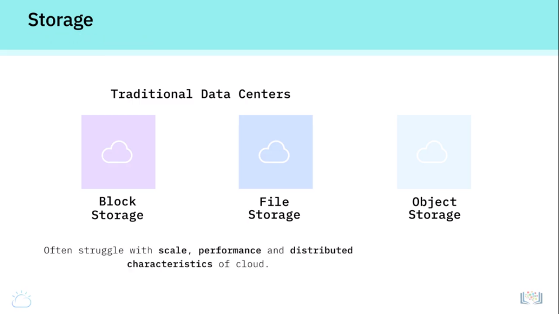

ONLINE PROGRAMING

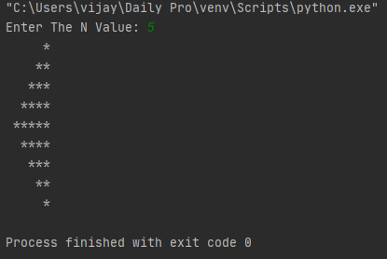 P-1 P-2

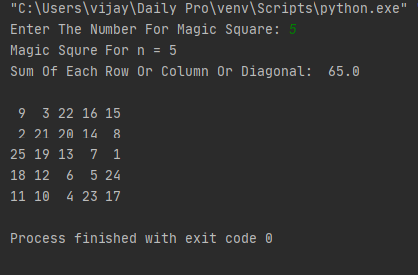

P-3

