**DAILY ONLINE ACTIVITIES SUMMARY**

|  |  |  |  |  |  |  |  |  |
| --- | --- | --- | --- | --- | --- | --- | --- | --- |
| **Date:** | **13-06-2020** | | | | | **Name:** | **Pranav L M** | |
| **Sem & Sec** | **6th - B** | | | | | **USN:** | **4AL17CS062** | |
| **Online Test Summary** | | | | | | | | |
| **Subject** | | **PAP-IV** | | | | | | |
| **Max. Marks** | | **30** | | **Score** | | | **27** | |
| **Certification Course Summary** | | | | | | | | |
| **Course** | **Introduction to Cloud** | | | | | | | |
| **Certificate Provider** | | | **IBM** | | **Duration** | | | **15** |
| **Coding Challenges** | | | | | | | | |
| **Problem Statemen:**  **1.C Program to calculate Electricity Bill**  **2.How to find the first non repeated character of a given String**  **3.Write a Java Program to determine whether a given matrix is a sparse matrix**  **4.Python Program to print the pattern.** | | | | | | | | |
| **Status: executed** | | | | | | | | |
| **Uploaded the report in Github** | | | | | **yes** | | | |
| **If yes Repository name** | | | | | <https://github.com/pranavlm/DAILY-STATUS/tree/master/online-coding-report> | | | |
| **Uploaded the report in slack** | | | | | **Yes** | | | |

CERTIFICATION DETAIL

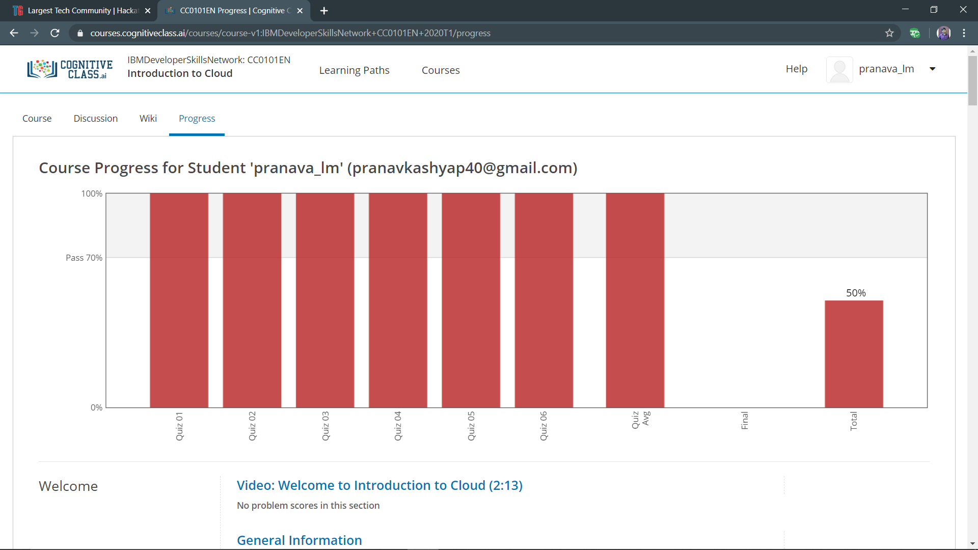

ONLINE TEST DETAILS

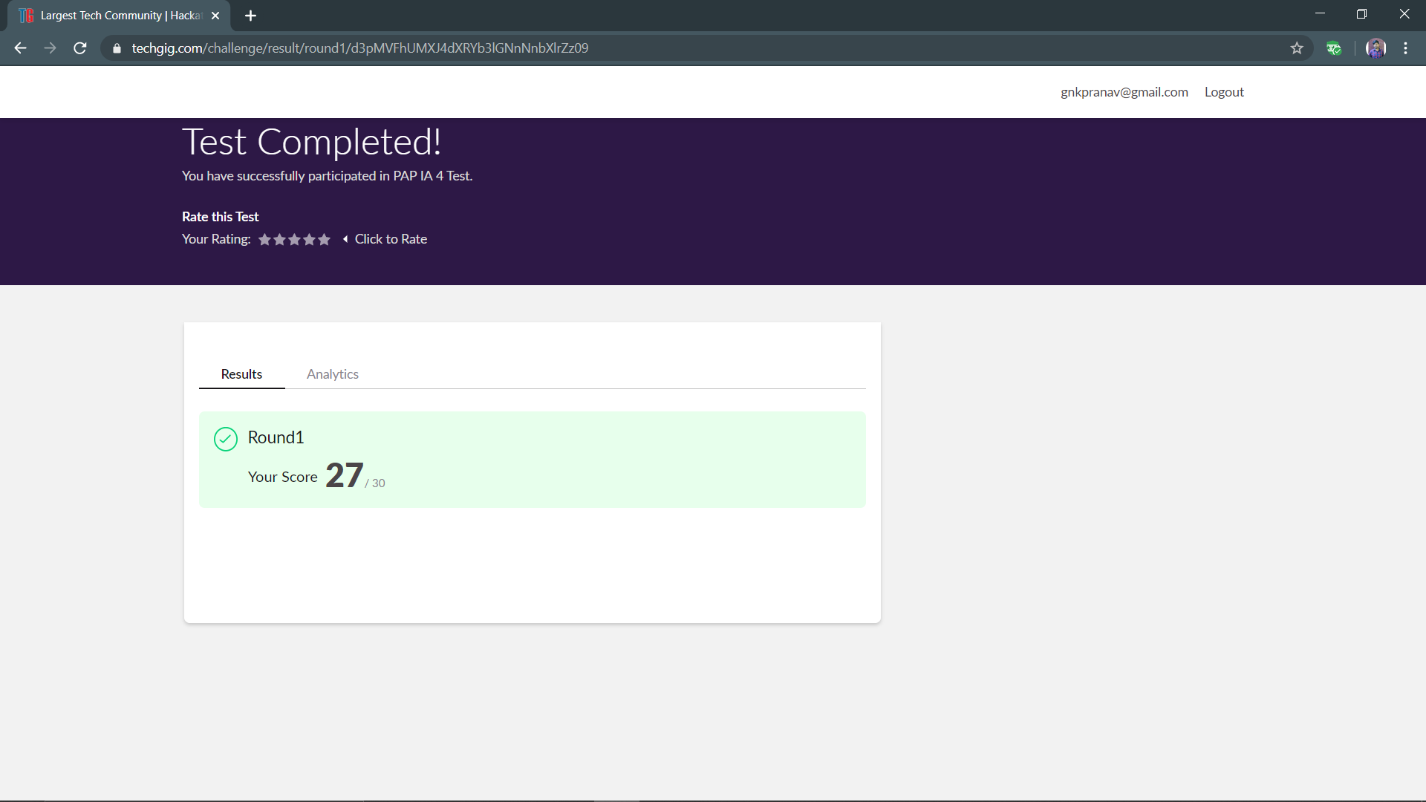

ONLINE PROGRAMING

P-1

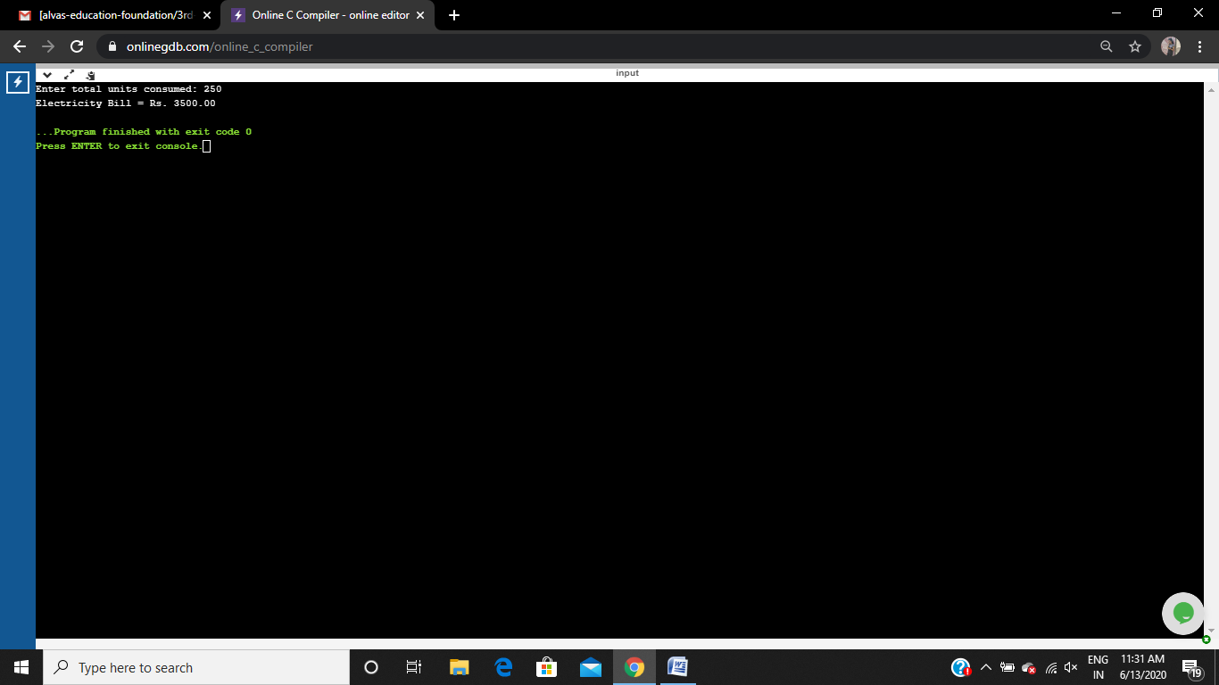

P-2

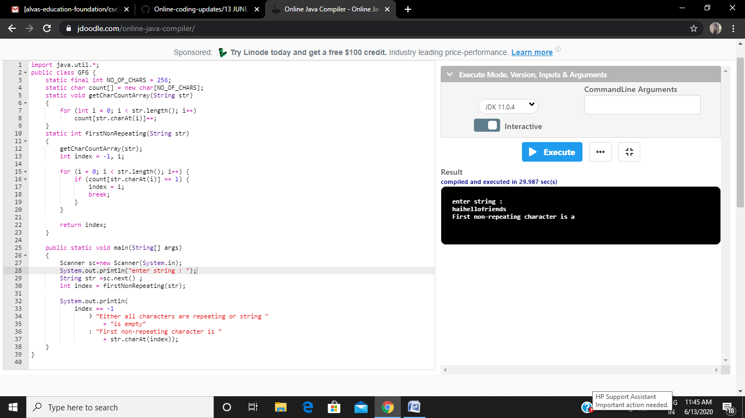

P-3

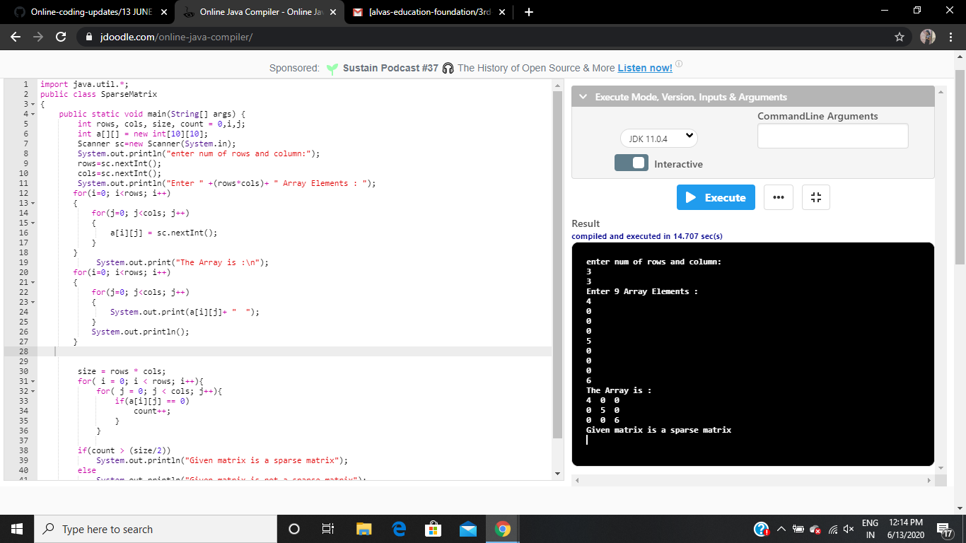

P-4

