**DAILY ONLINE ACTIVITIES SUMMARY**

|  |  |  |  |  |  |
| --- | --- | --- | --- | --- | --- |
| **Date:** | **15-06-2020** | | | **Name:** | **Pranav L M** |
| **Sem & Sec** | **6th - B** | | | **USN:** | **4AL17CS062** |
| **PRE-PLACEMENT TRAINING** | | | | | |
| **Subject** | **C-Programing and Python workshop** | | | | |
| **Max. Marks** | **--** | **Score** | | | **--** |
| **C-Structures**  **Python workshop** | 9:00 to 10:30 Mr. Vivek Sharma  10:00 to 1:00 Dr. Mohideen Badhusha | | | | |
| **Coding Challenges** | | | | | |
| **Problem Statemen:**  **1.C program to count distinct elements in an array.**  **2.Java Program to Find the Middle Node of a Linked list in a Single-pass** | | | | | |
| **Status: executed** | | | | | |
| **Uploaded the report in Github** | | | **yes** | | |
| **If yes Repository name** | | | <https://github.com/pranavlm/DAILY-STATUS/tree/master/online-coding-report> | | |
| **Uploaded the report in slack** | | | **Yes** | | |

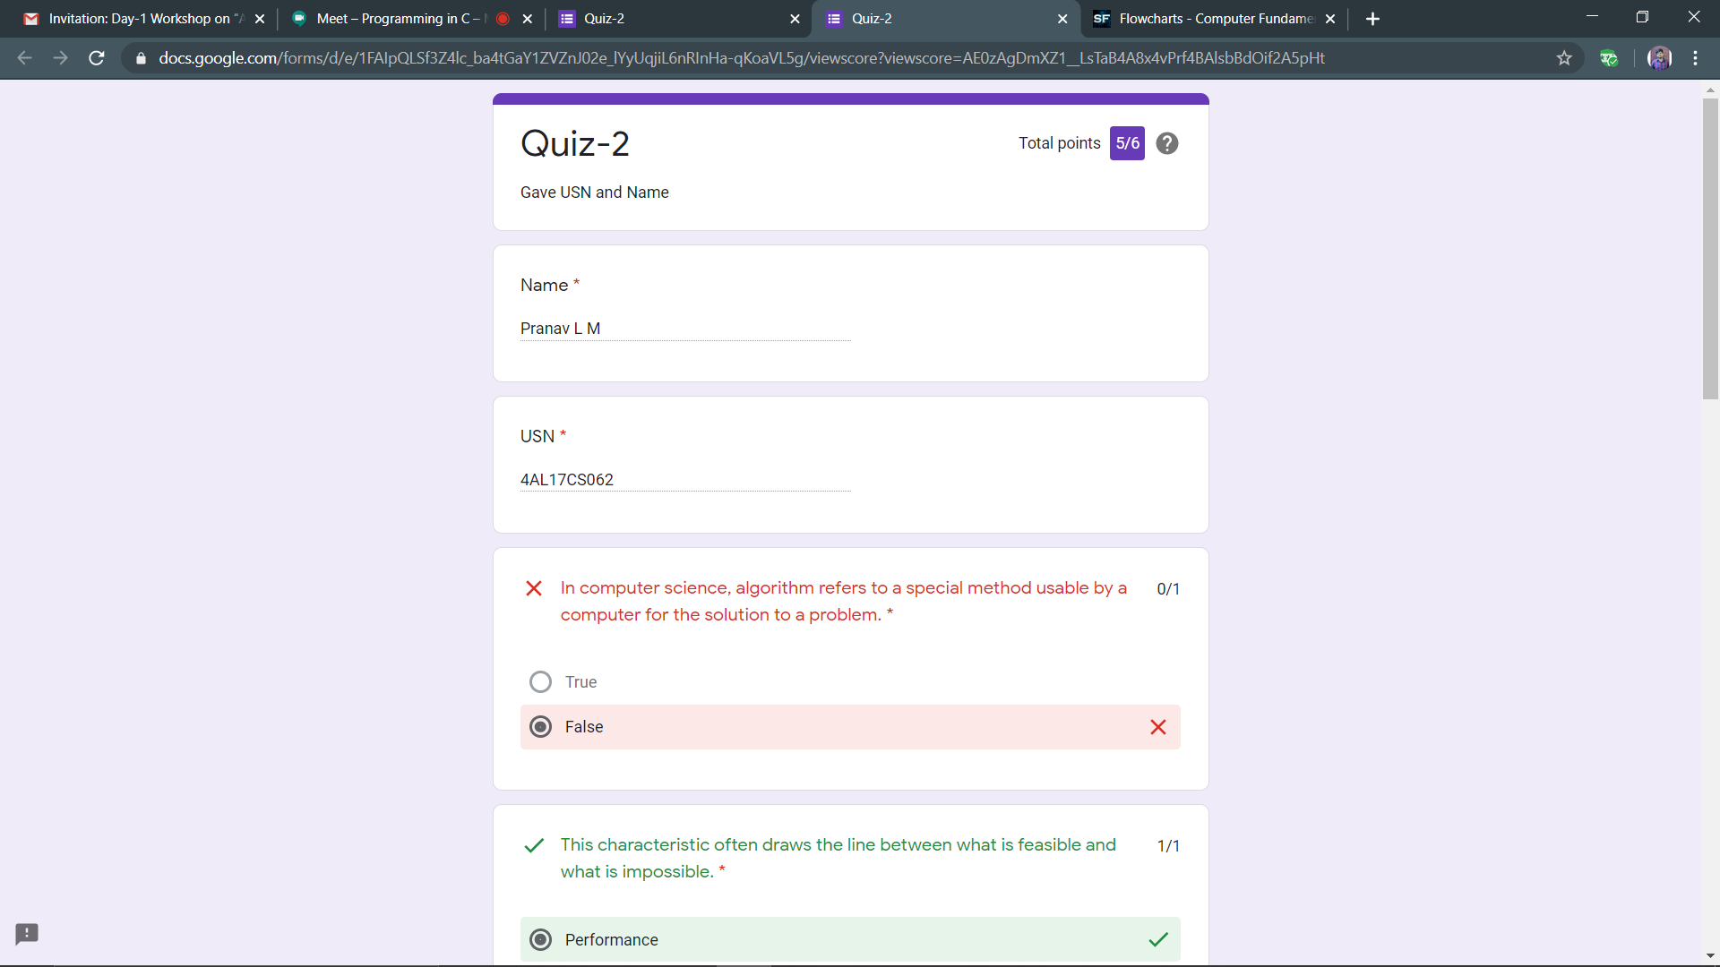ONLINE TEST DETAILS

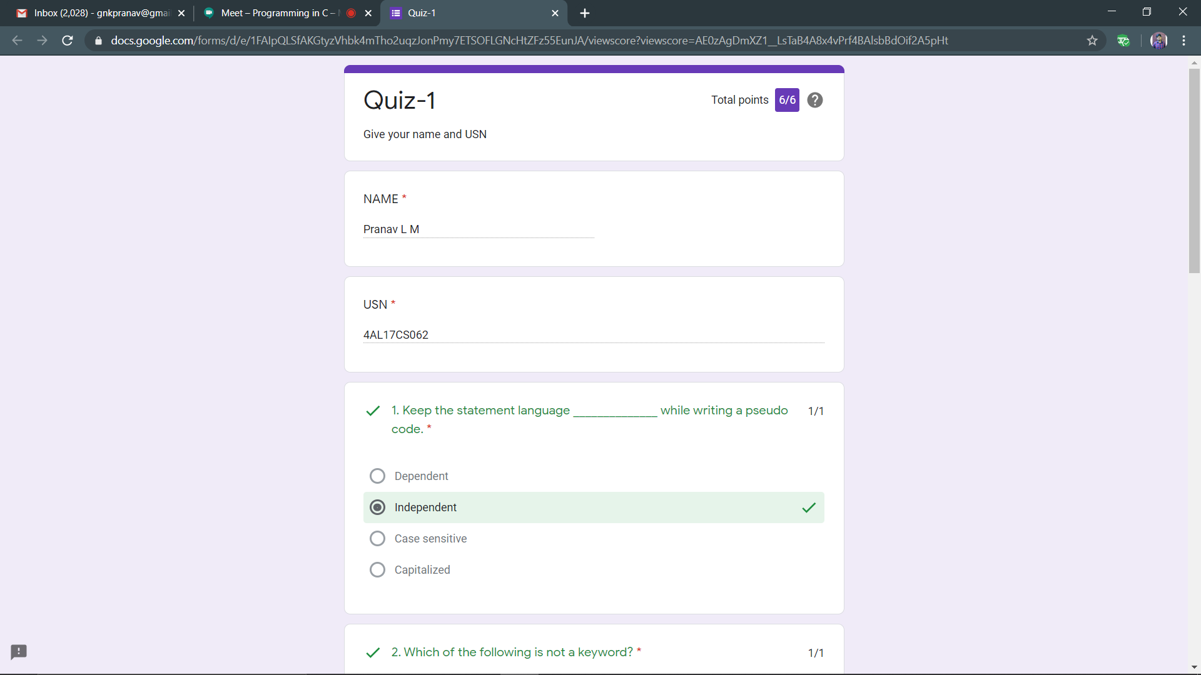

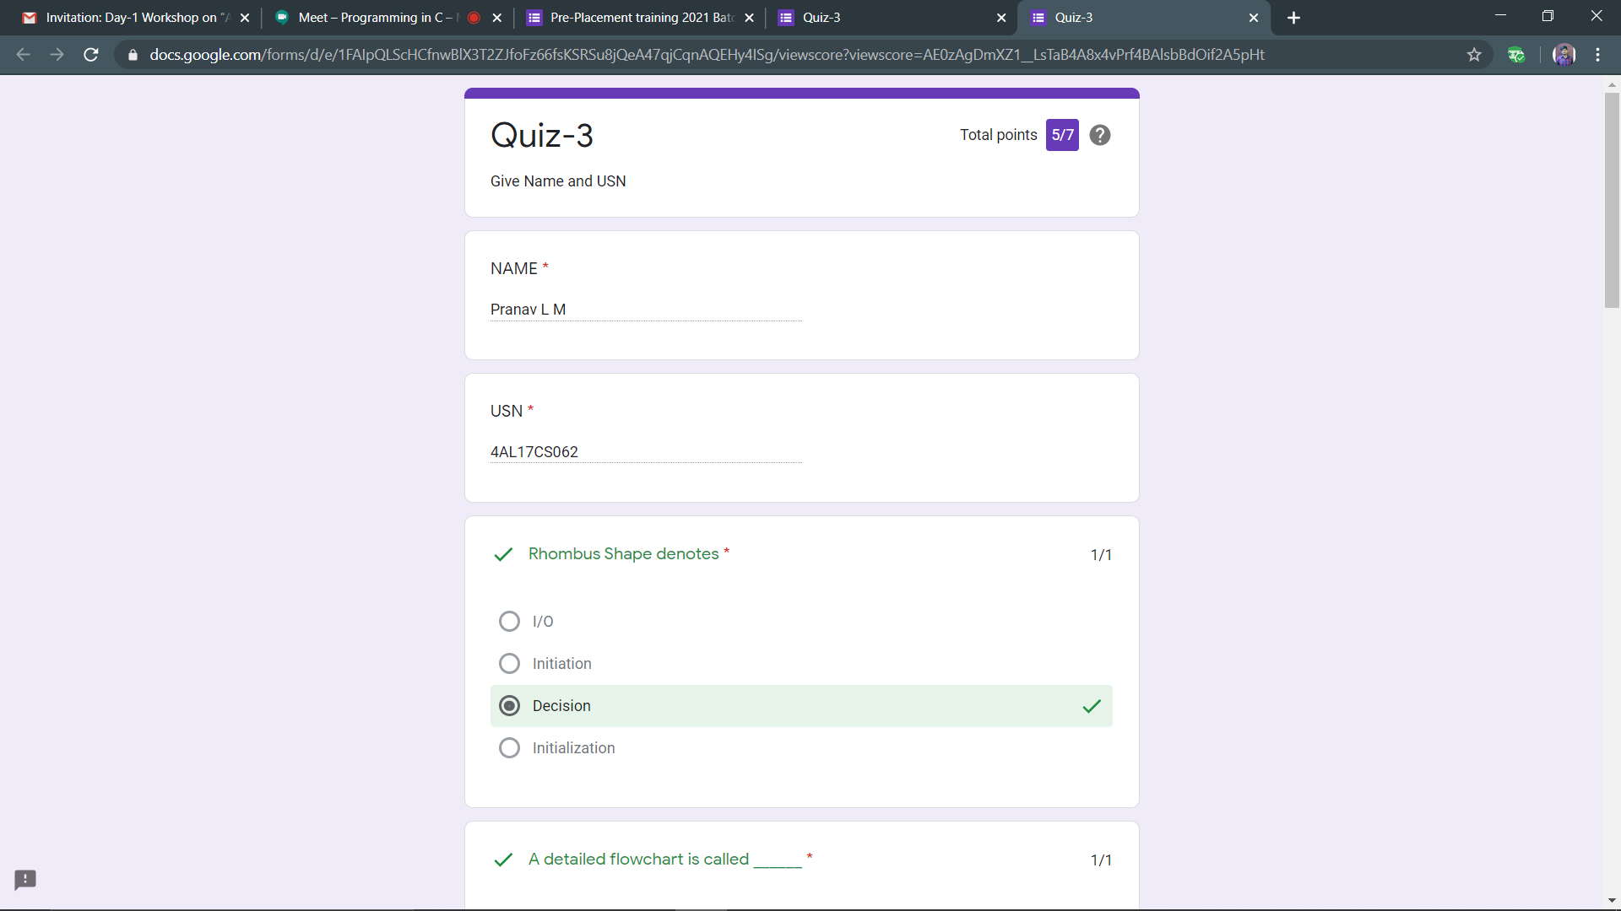 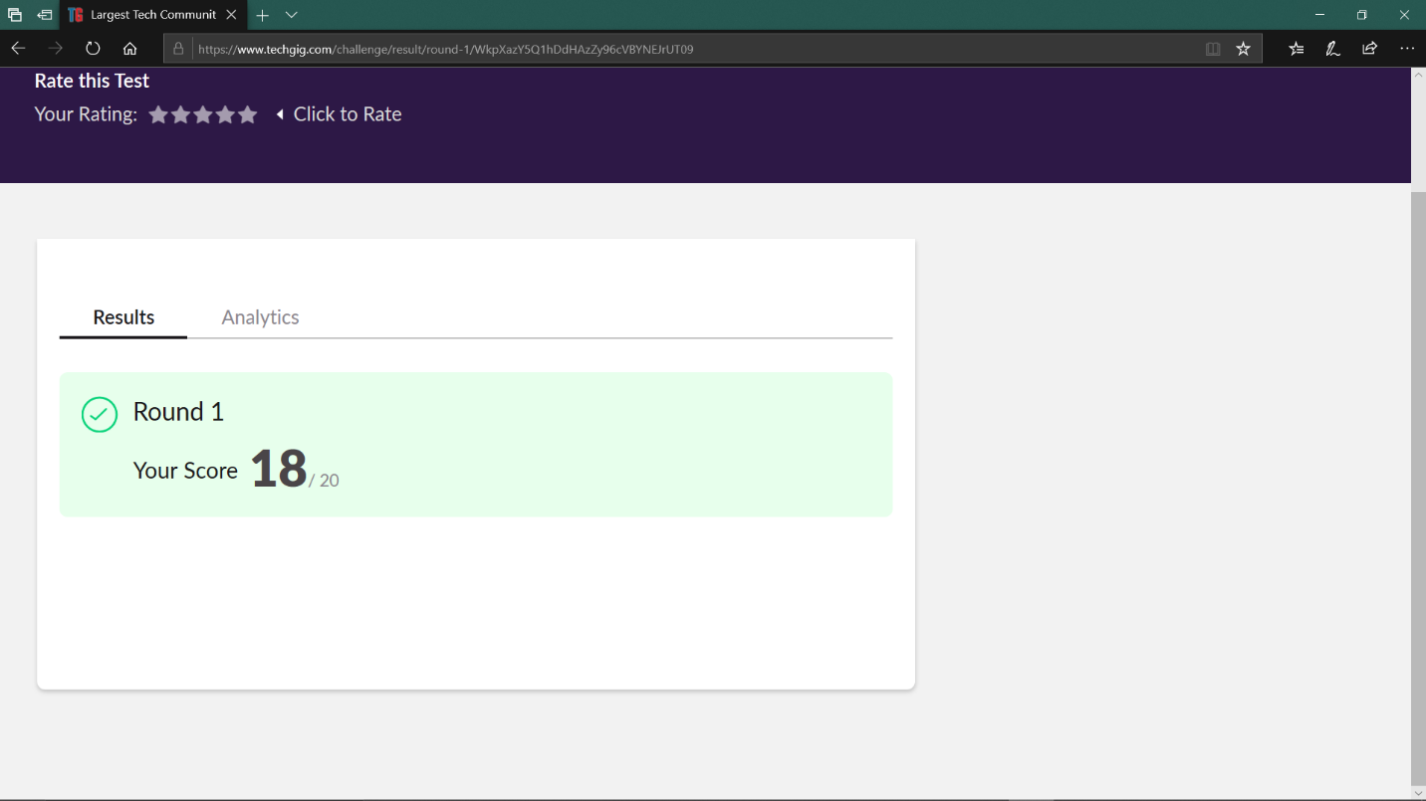

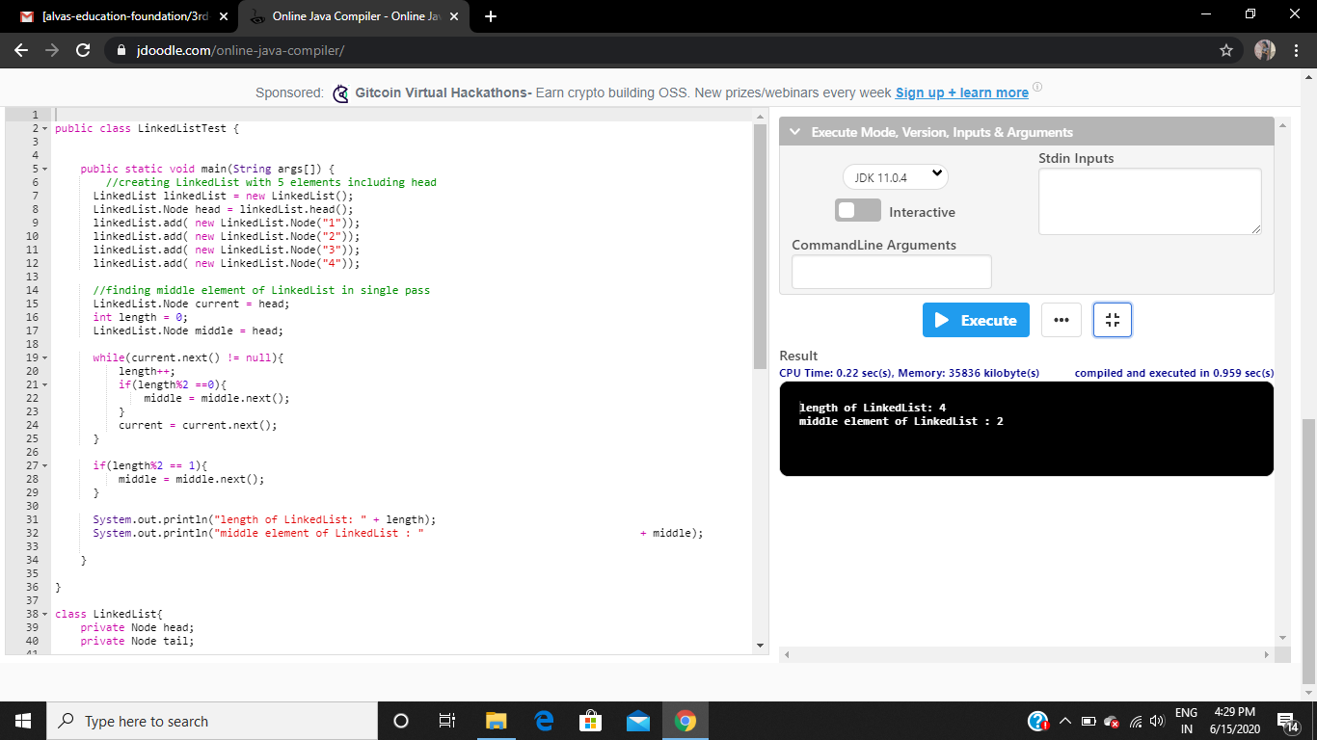 ONLINE PROGRAMS:

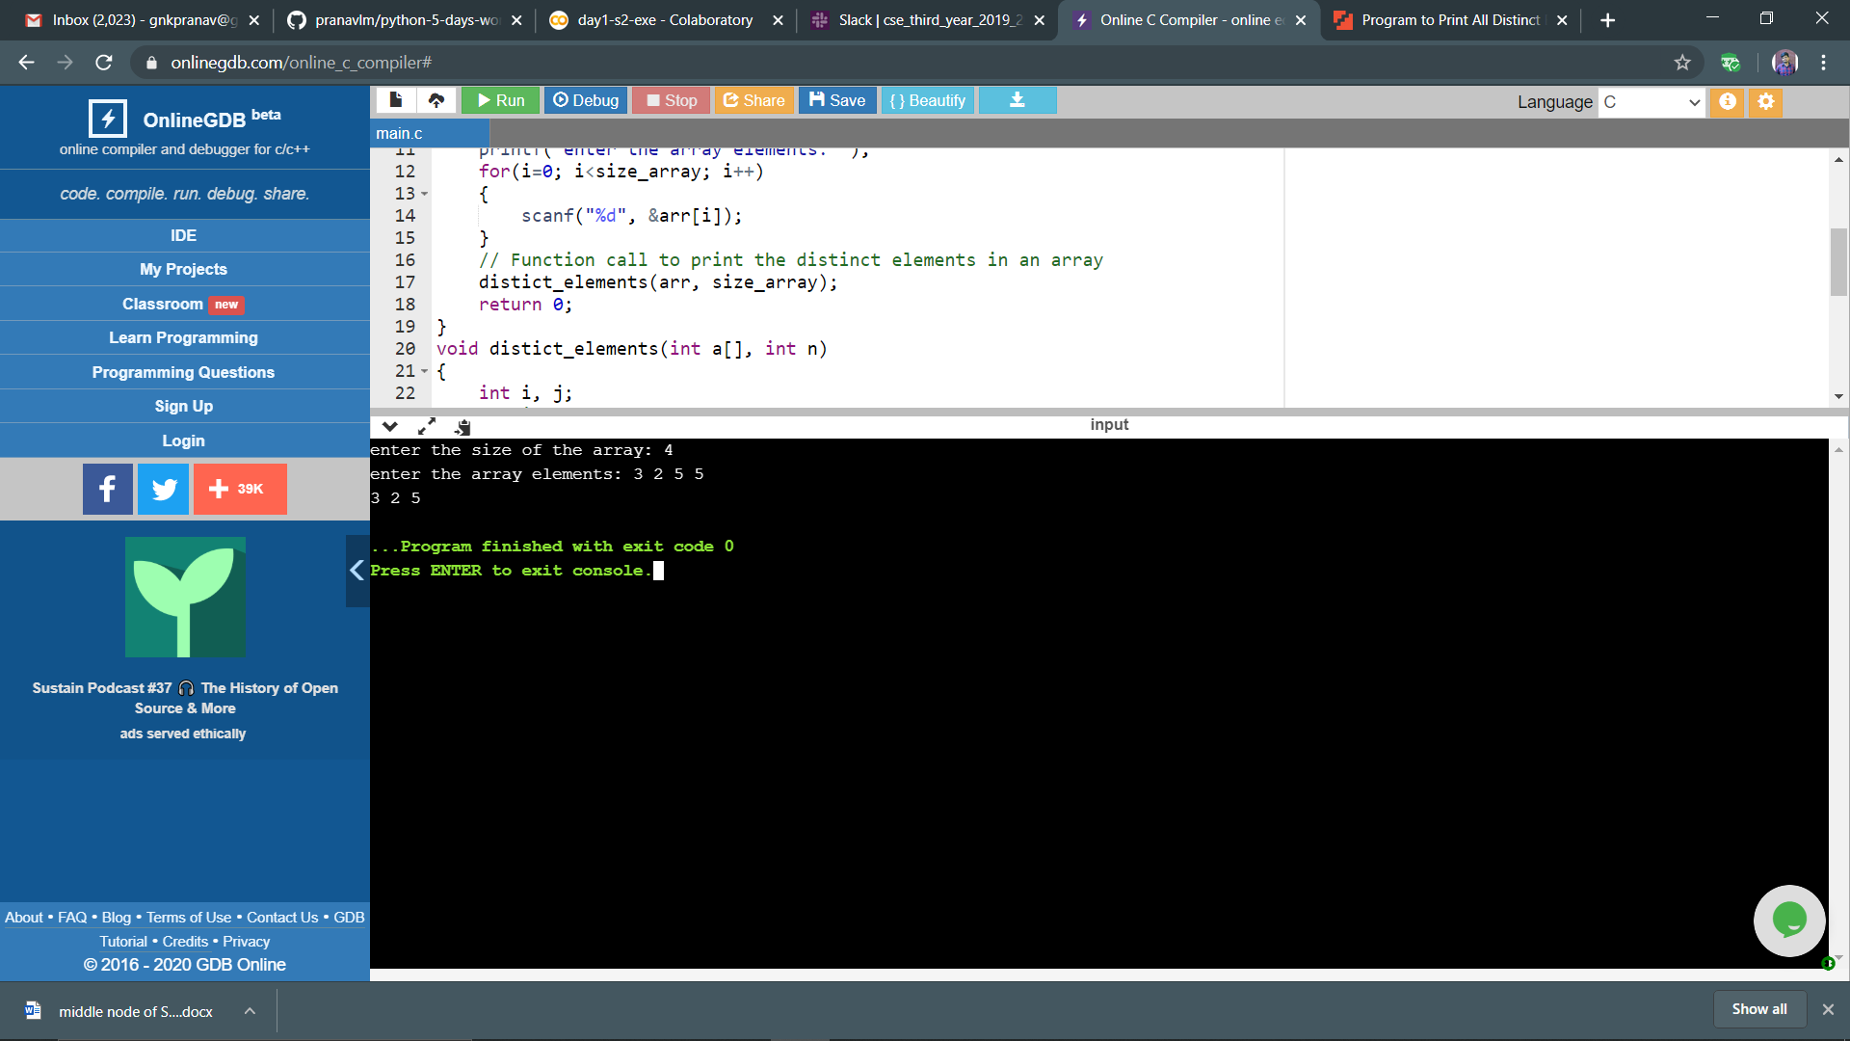

ONLINE TRAINING:

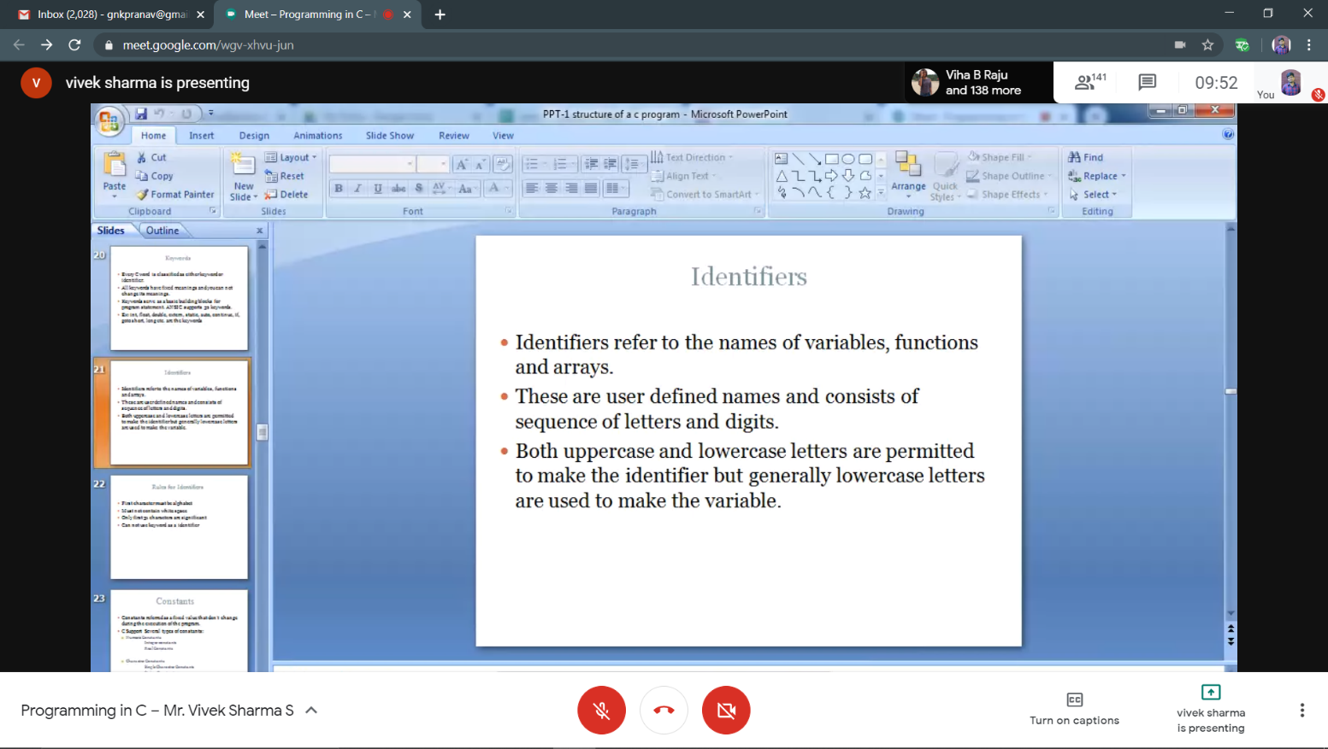

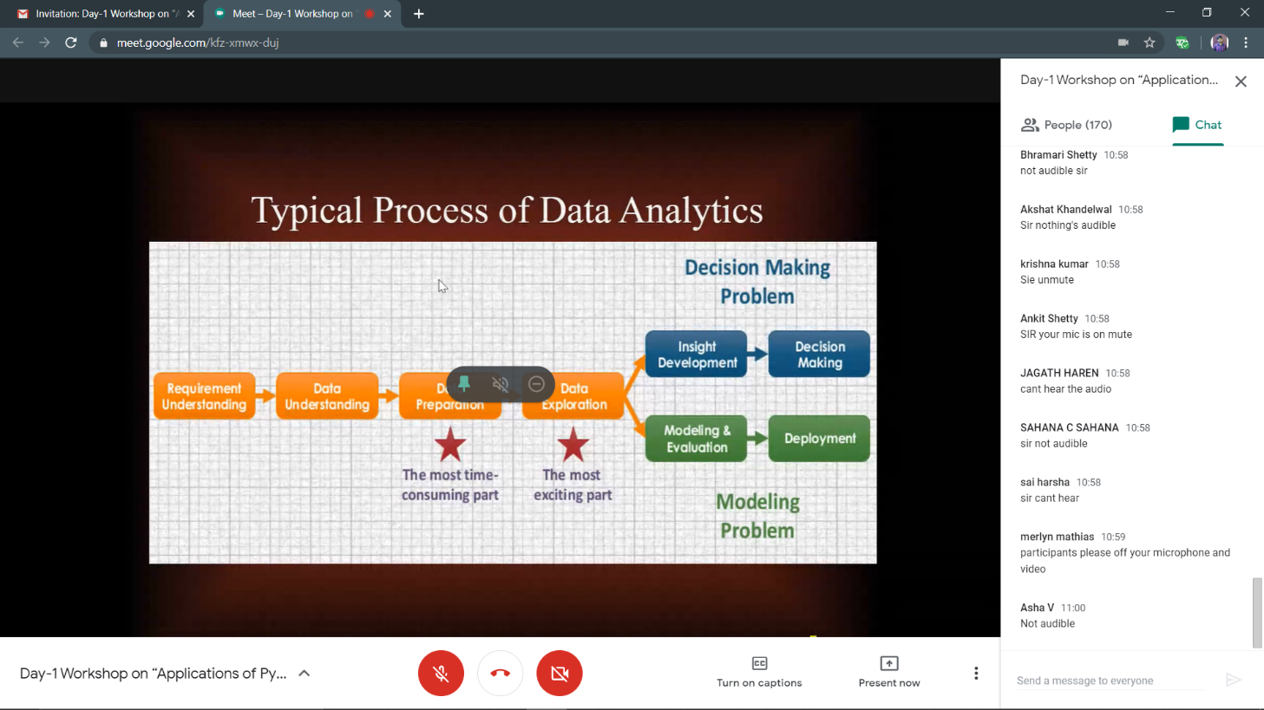

Python workshop : <https://github.com/pranavlm/python-5-days-workshop>