**“DAILY ONLINE ACTIVITIES SUMMARY”**__________

|  |  |  |  |  |  |
| --- | --- | --- | --- | --- | --- |
| **Date:** | **18-06-2020** | | | **Name:** | **Pranav L M** |
| **Sem & Sec** | **6th - B** | | | **USN:** | **4AL17CS062** |
| **PRE-PLACEMENT TRAINING** | | | | | |
| **Subject** | **C-Programing(Arrays) and Python workshop(day-4)** | | | | |
| **Max. Marks** | **--** | **Score** | | | **--** |
| **C-Programing**  **Python workshop** | 9:15 to 11:00 Mr. Vivek Sharma  11:00 to 1:40 Dr. Mohideen Badhusha | | | | |
| **Coding Challenges** | | | | | |
| **Problem Statemen:**   1. **Java program to check BST or NOT** 2. **C program to get n magic number** | | | | | |
| **Status: executed** | | | | | |
| **Uploaded the report in Github** | | | **yes** | | |
| **If yes Repository name** | | | <https://github.com/pranavlm/DAILY-STATUS/tree/master/online-coding-report> | | |
| **Uploaded the report in slack** | | | **Yes** | | |

Python workshop exercise : <https://github.com/pranavlm/python-5-days-workshop>

ONLINE PROGRAMS:

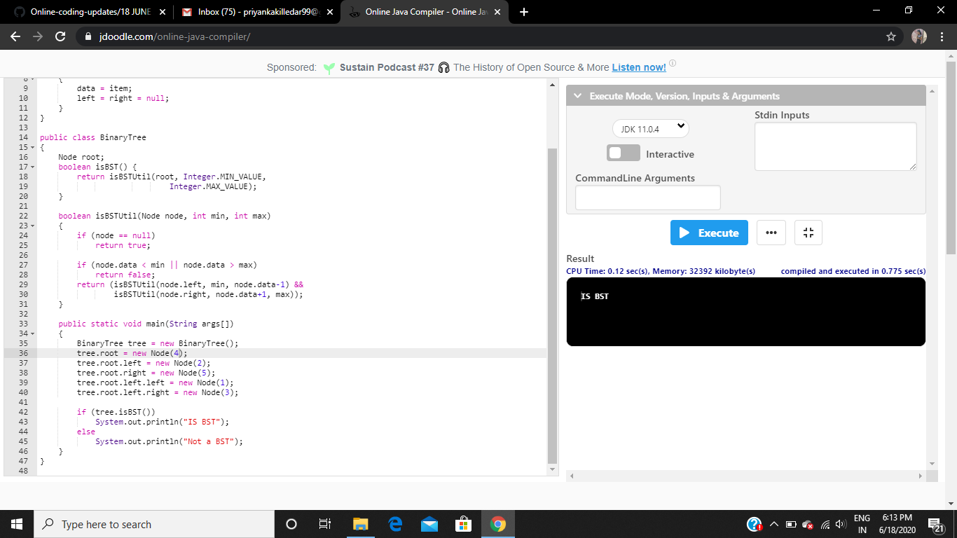

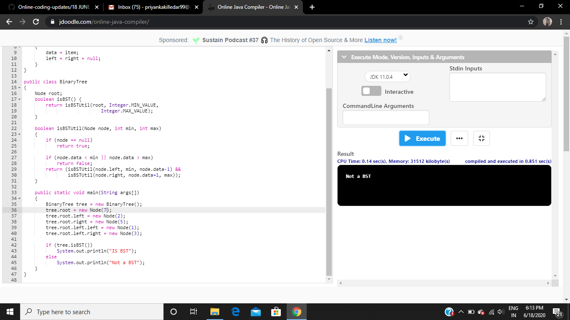

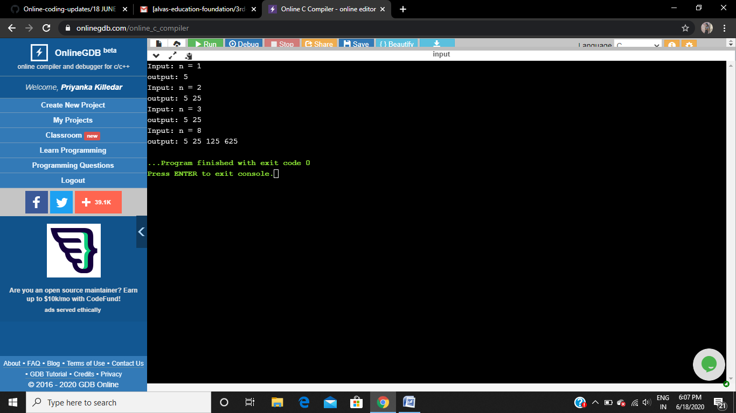

Training:

