**“DAILY ONLINE ACTIVITIES SUMMARY”**

|  |  |  |  |  |  |
| --- | --- | --- | --- | --- | --- |
| **Date:** | **20-06-2020** | | | **Name:** | **Pranav L M** |
| **Sem & Sec** | **6th - B** | | | **USN:** | **4AL17CS062** |
| **PRE-PLACEMENT TRAINING** | | | | | |
| **Subject** | **Basics of C++** | | | | |
| **Max. Marks** | **--** | **Score** | | | **--** |
| **C-Programing**  **Python workshop** | 9:15 to 11:00 Ms. Ankitha Shetty  11:00 to 1:40 Mr. Pradeep Nayak | | | | |
| **Coding Challenges** | | | | | |
| **Problem Statemen:**  **1.Write a Java Program to find area of Square, Rectangle and Circle using Method Overloading**  **2.Write a C Program to rotate an array by K positions.** | | | | | |
| **Status: executed** | | | | | |
| **Uploaded the report in Github** | | | **yes** | | |
| **If yes Repository name** | | | <https://github.com/pranavlm/DAILY-STATUS/tree/master/online-coding-report> | | |
| **Uploaded the report in slack** | | | **Yes** | | |

ONLINE PROGRAMS:

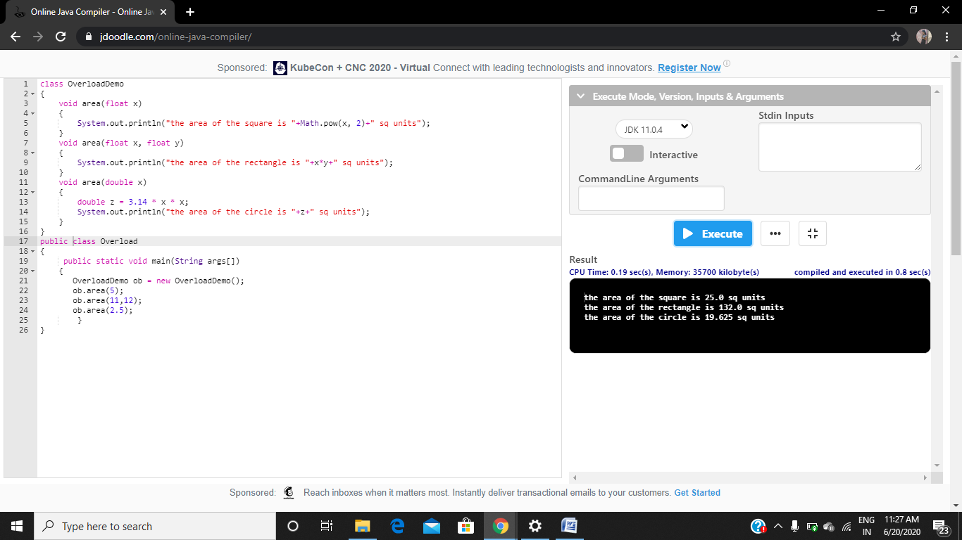

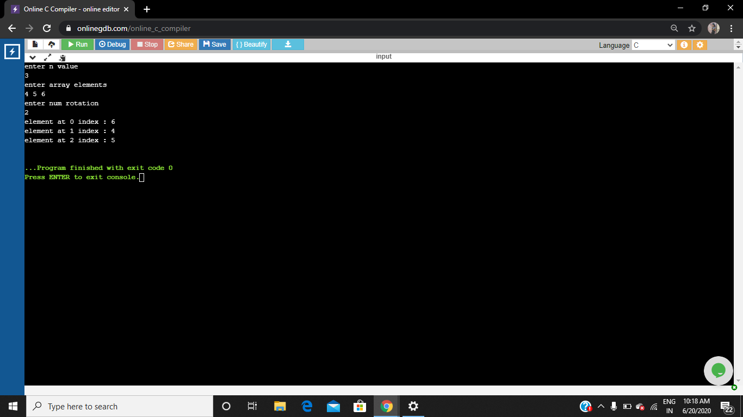

Training:

