**DAILY ONLINE ACTIVITIES SUMMARY**

|  |  |  |  |  |  |
| --- | --- | --- | --- | --- | --- |
| **Date:** | **23-05-2020** | | **Name:** | **Pranav L M** | |
| **Sem & Sec** | **6th - B** | | **USN:** | **4AL17CS062** | |
| **Online Test Summary** | | | | | |
| **Subject** | **PAP** | | | | |
| **Max. Marks** | **30** | **Score** | | **18** | |
| **Certification Course Summary** | | | | | |
| **Course** | **Machine learning with python** | | | | |
| **Certificate Provider** | **Cognitiviclass.ai (IBM)** | **Duration** | | | **10 of 10** |
| **Coding Challenges** | | | | | |
| **Problem Statemen:**  **1.**C Program to Generate First N Triangular Numbers (Where N is read from the Keyboard). | | | | | |
| **Status: executed** | | | | | |
| **Uploaded the report in GitHub** | | **yes** | | | |
| **If yes Repository name** | | <https://github.com/pranavlm/DAILY-STATUS/tree/master/online-coding-report> | | | |
| **Uploaded the report in slack** | | **Yes** | | | |

Online Test Details:

First I A of PAP

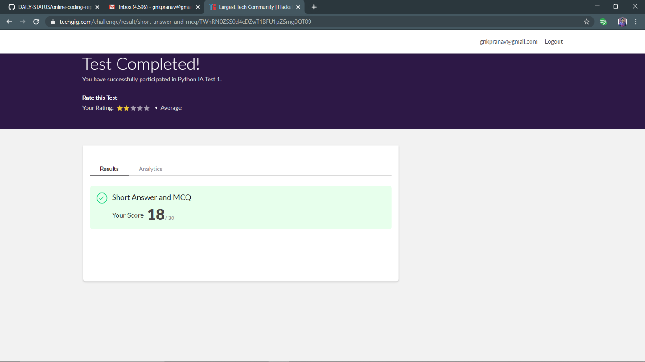

Certification Course Details:

Exam Report

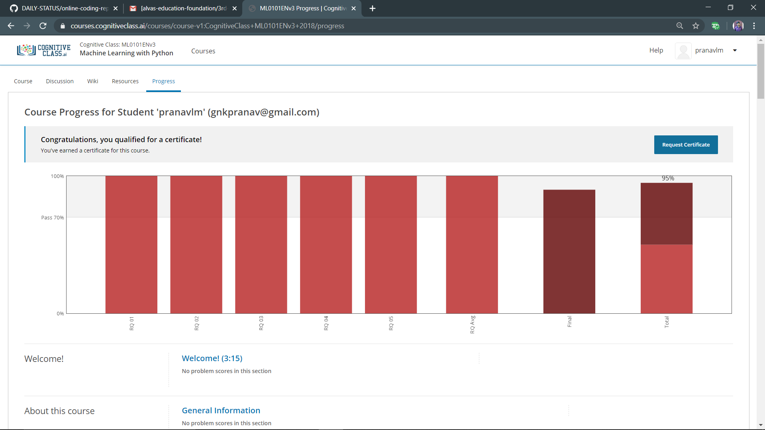

Certificate

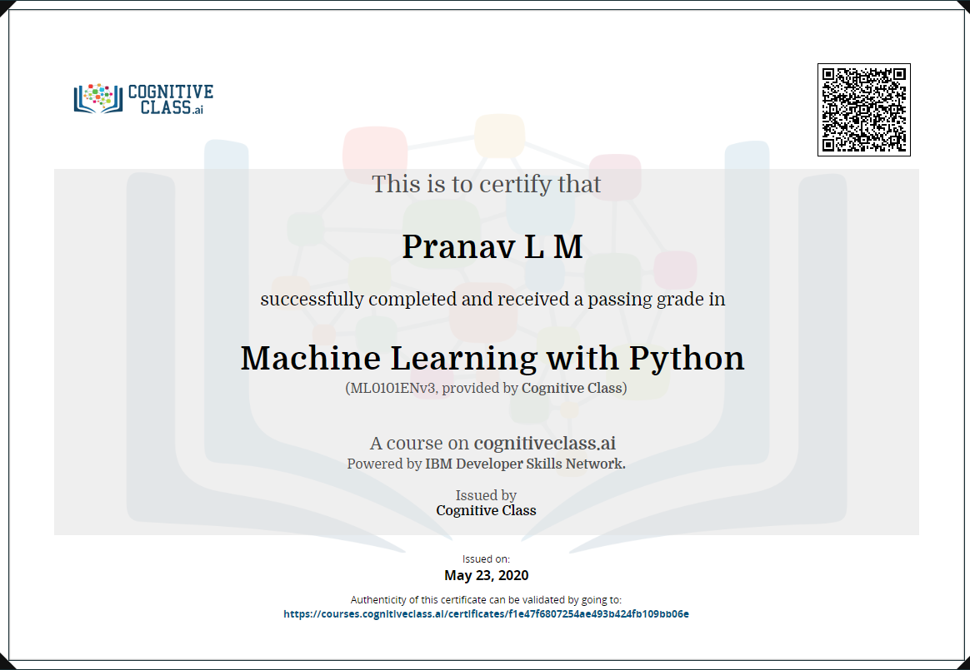

Badge



Coding Challenges Details:

The below gitHub link for details

<https://github.com/pranavlm/DAILY-STATUS/tree/master/online-coding-report>

P-1

