**DAILY ONLINE ACTIVITIES SUMMARY**

|  |  |  |  |  |  |  |
| --- | --- | --- | --- | --- | --- | --- |
| **Date:** | **27-05-2020** | | | **Name:** | **Pranav L M** | |
| **Sem & Sec** | **6th - B** | | | **USN:** | **4AL17CS062** | |
| **Online Test Summary** | | | | | | |
| **Subject** | | **SSCD-II** | | | | |
| **Max. Marks** | | **30** | **Score** | | **18** | |
| **Certification Course Summary** | | | | | | |
| **Course** | **Blockchain Essentials** | | | | | |
| **Certificate Provider** | **IBM** | | **Duration** | | | **4 of 10** |
| **Coding Challenges** | | | | | | |
| **Problem Statemen:**1.Java program to find the largest element on the left side of each index which is smaller than the element present at that index.  2.java program to implement Binary Tree using the Linked List  3. C Program to sort an array of integers in ascending order and display the sorted array  and Number of passes performed for sorting. | | | | | | |
| **Status: executed** | | | | | | |
| **Uploaded the report in Github** | | | **yes** | | | |
| **If yes Repository name** | | | <https://github.com/pranavlm/DAILY-STATUS/tree/master/online-coding-report/27-05-20> | | | |
| **Uploaded the report in slack** | | | **Yes** | | | |

Online Test Details:

second I A of SSCD

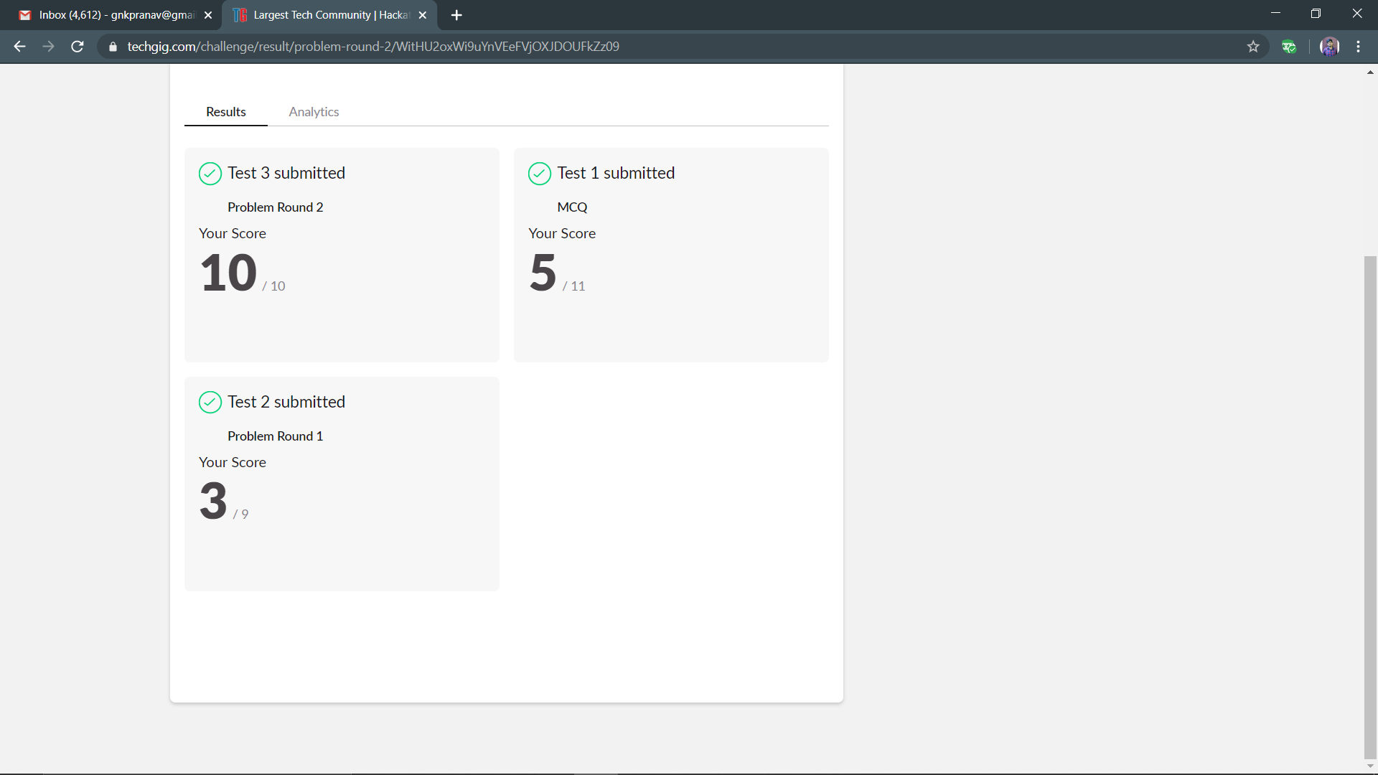

Certification Course Details:

Progress of 27-05-20

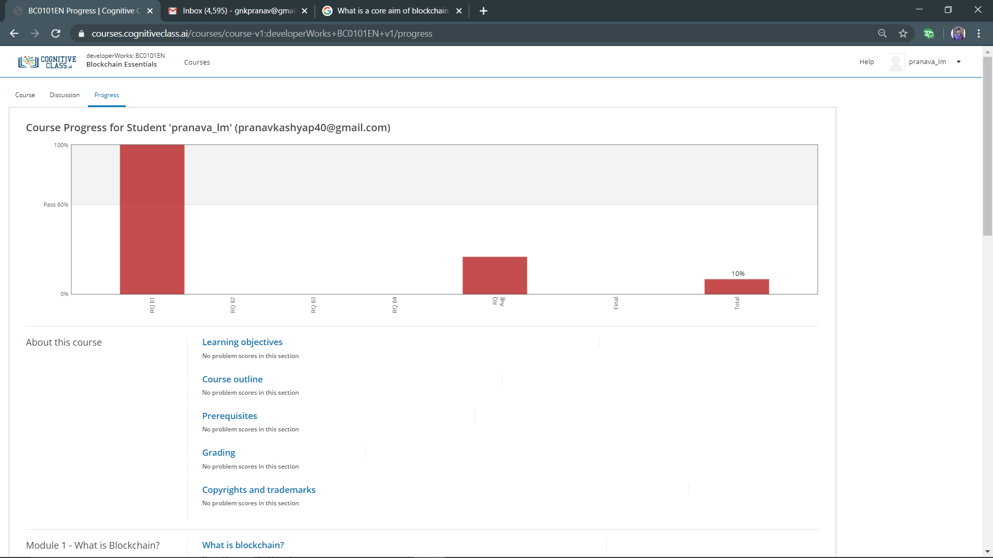

Coding Challenges Details:

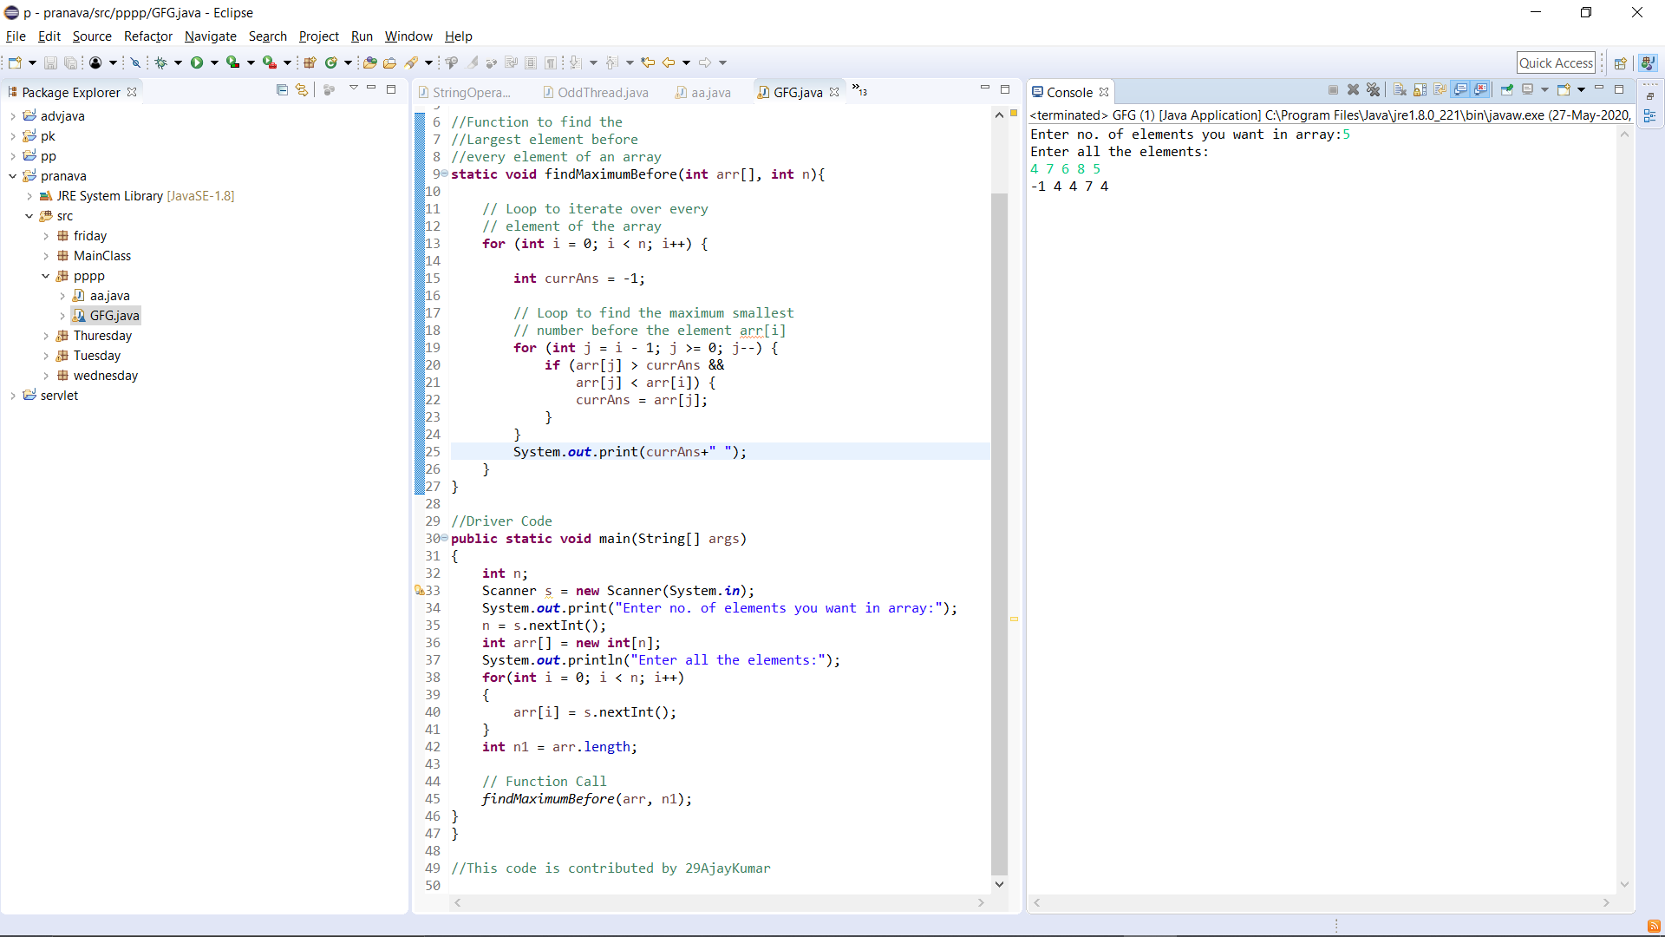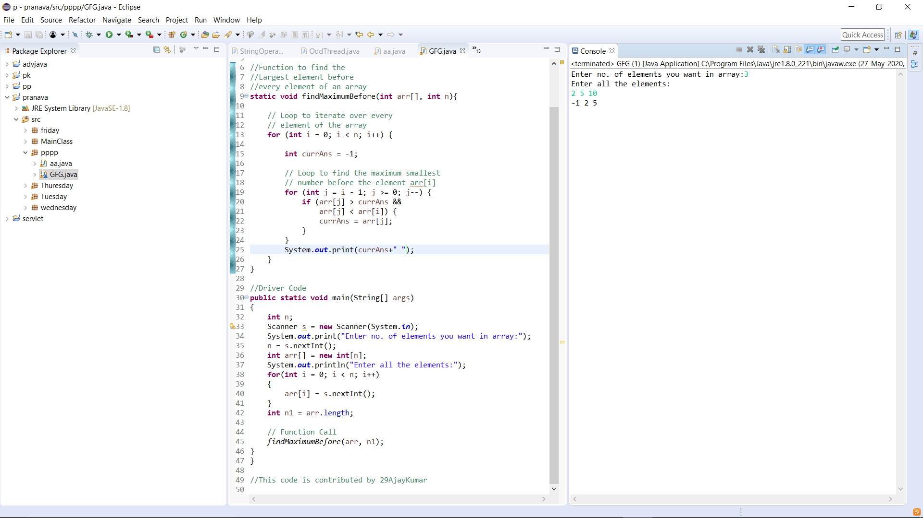**p-1**

P-2

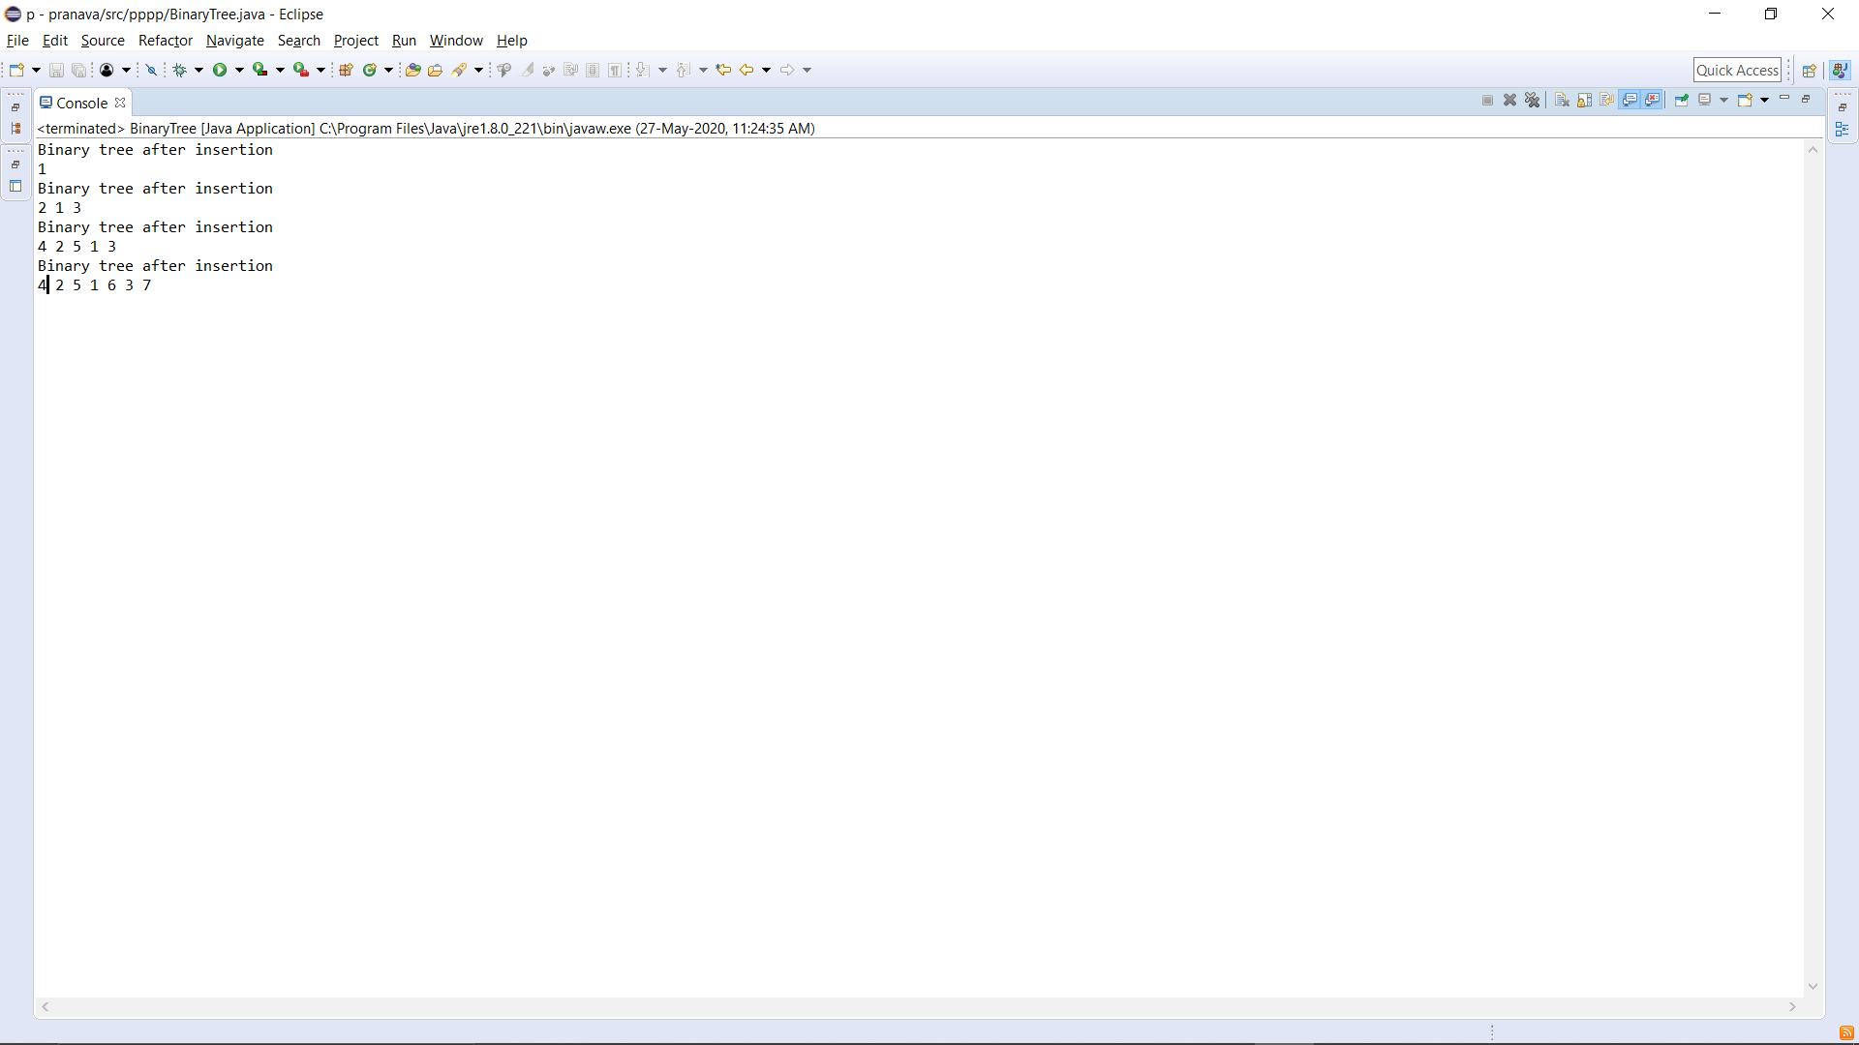

p-3

