**DAILY ONLINE ACTIVITIES SUMMARY**

|  |  |  |  |  |  |  |  |  |
| --- | --- | --- | --- | --- | --- | --- | --- | --- |
| **Date:** | | **27-06-2020** | | | | **Name:** | **Pranav L M** | |
| **Sem & Sec** | | **6th -B** | | | | **USN:** | **4AL17CS062** | |
| **Online Test Summary** | | | | | | | | |
| **Subject** | | | **DBMS and JDBC** | | | | | |
| **Max. Marks** | | | **-** | **Score** | | | **-** | |
| **Pre-placement Training Summary** | | | | | | | | |
| **Topic** | **DBMS,**  **JDBC** | | | | | | | |
| **Faculty** | Mr. Hemanth Kumar  Mr. Sayeesh | | | | **Duration** | | | **4hours** |
| **Coding Challenges** | | | | | | | | |
| **Problem Statement**:  **1. Python Program to Find the Area of a Rectangle Using Classes**  2. DBMS assignment | | | | | | | | |
| **Status: Solved** | | | | | | | | |
| **Uploaded the report in Github** | | | | | **yes** | | | |
| **If yes Repository name** | | | | | <https://github.com/pranavlm/DAILY-STATUS/tree/master/Daily-Report> | | | |
| **Uploaded the report in slack** | | | | | **yes** | | | |

**SNAPSHOTS**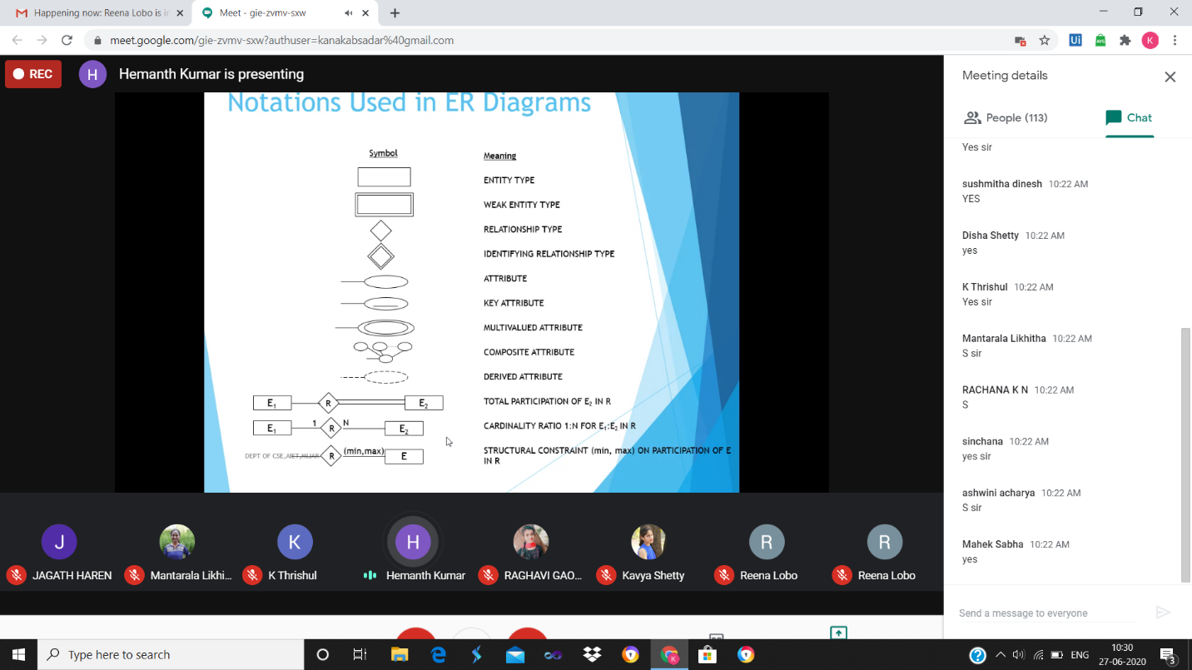

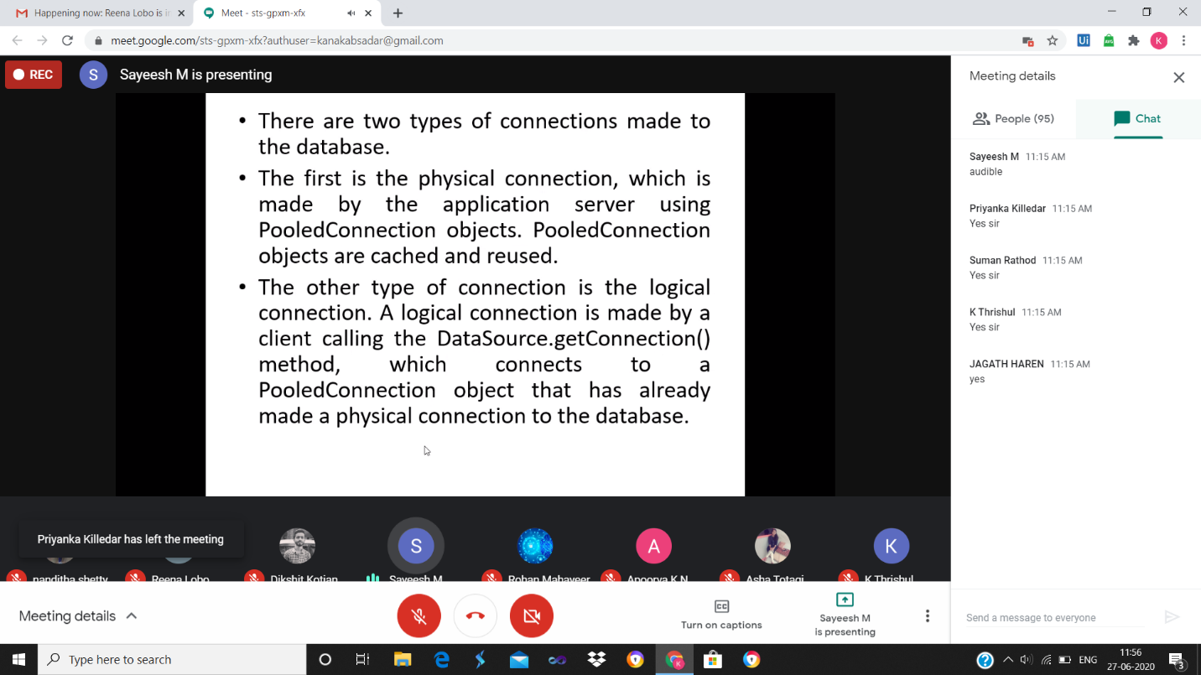

**ONLINE CODING**

**1. Python Program to Find the Area of a Rectangle Using Classes**

class rectangle():

def __init__(self,b,l):

self.b=b

self.l=l

def area(self):

return self.b*self.l

x=int(input("Enter length of rectangle: "))

y=int(input("Enter breadth of rectangle: "))

obj=rectangle(x,y)

print("Area of rectangle:",obj.area())

print()

OUTPUT:

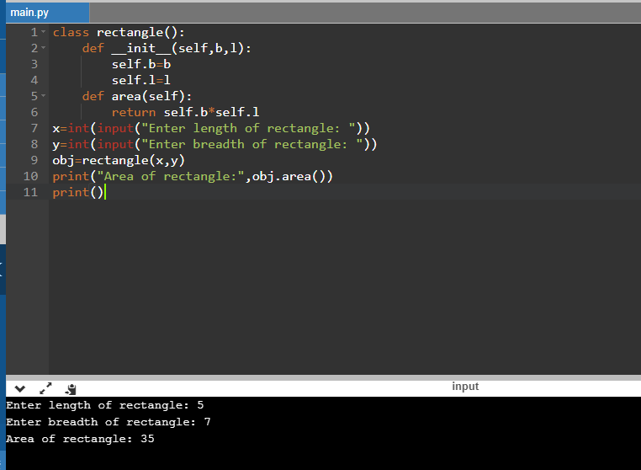

**1. Consider the following relations**

**Student (snum: integer, sname: string, major: string, level: string,age: integer)  
Class (name: string, meets at: string, room: string, d: integer)  
Enrolled (snum: integer, cname: string)  
Faculty (fid: integer, fname: string, deptid: integer)**

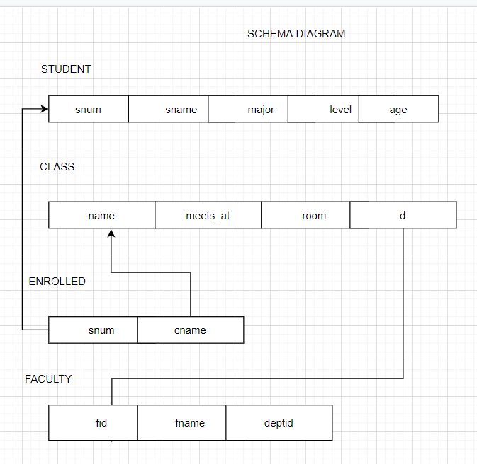

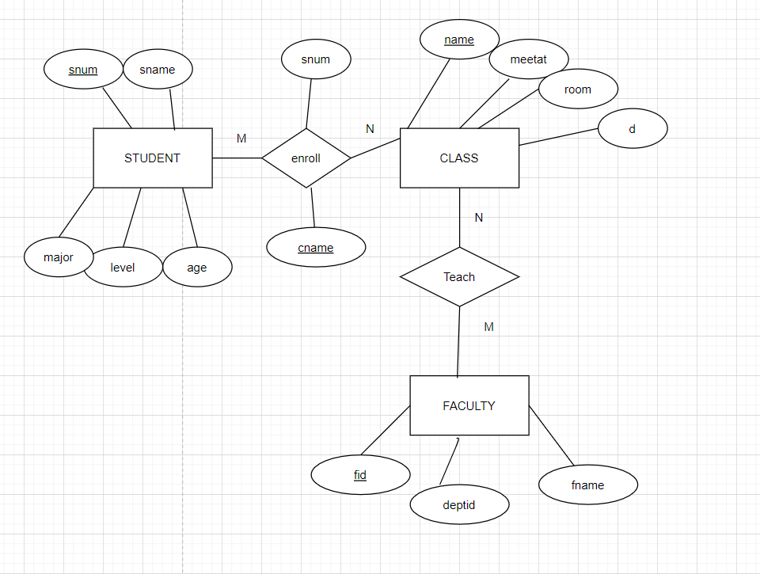

**2. Consider the following database for a banking enterprise**

**BRANCH(branch-name:string,branch-city:string,assets:real)  
ACCOUNT(accno:int,branch-name:string,balance:real)  
DEPOSITOR(customer-name:string,accno:int)  
CUSTOMER(customer-name:string,customer-street:string,city:string)**

