**DAILY ONLINE ACTIVITIES SUMMARY**

|  |  |  |  |  |  |  |  |  |
| --- | --- | --- | --- | --- | --- | --- | --- | --- |
| **Date:** | **29-05-2020** | | | | | **Name:** | **Pranav L M** | |
| **Sem & Sec** | **6th - B** | | | | | **USN:** | **4AL17CS062** | |
| **Online Test Summary** | | | | | | | | |
| **Subject** | | **OR-II** | | | | | | |
| **Max. Marks** | | **30** | | **Score** | | | **30** | |
| **Certification Course Summary** | | | | | | | | |
| **Course** | **BLOCKCHAIN ESSENTIALS** | | | | | | | |
| **Certificate Provider** | | | **IBM** | | **Duration** | | | **6 of 10** |
| **Coding Challenges** | | | | | | | | |
| **Problem Statemen:**  **1.Python program to calculate the number of lowercase and uppercase letters in a string**  **2. We are given 3 strings: str1, str2, and str3. Str3 is said to be a shuffle of str1 and str2 if it can be formed by interleaving the characters of str1 and str2 in a way that maintains the left to right ordering of the characters from each string. For example, given str1="abc" and str2="def", str3="dabecf" is a valid shuffle since it preserves the character ordering of the two strings. So, given these 3 strings write a function that detects whether str3 is a valid shuffle of str1 and str2.**  **3. c program to solve a system of linear congruences by applying the Chinese Remainder Theorem**  **4. Java Program to check whether the given number is Armstrong number or not**  **5. Java Program to find longest substring without repeating characters in a string** | | | | | | | | |
| **Status: executed** | | | | | | | | |
| **Uploaded the report in Github** | | | | | **yes** | | | |
| **If yes Repository name** | | | | | <https://github.com/pranavlm/DAILY-STATUS/tree/master/online-coding-report> | | | |
| **Uploaded the report in slack** | | | | | **Yes** | | | |

Online Test Details:

SECOND I A of OR

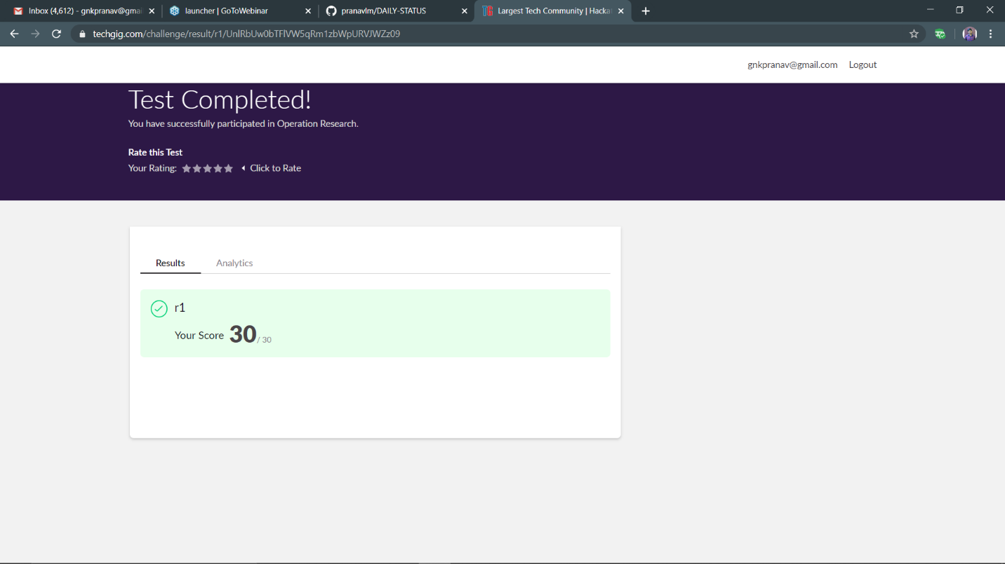

Certification Course Details:

Module-II

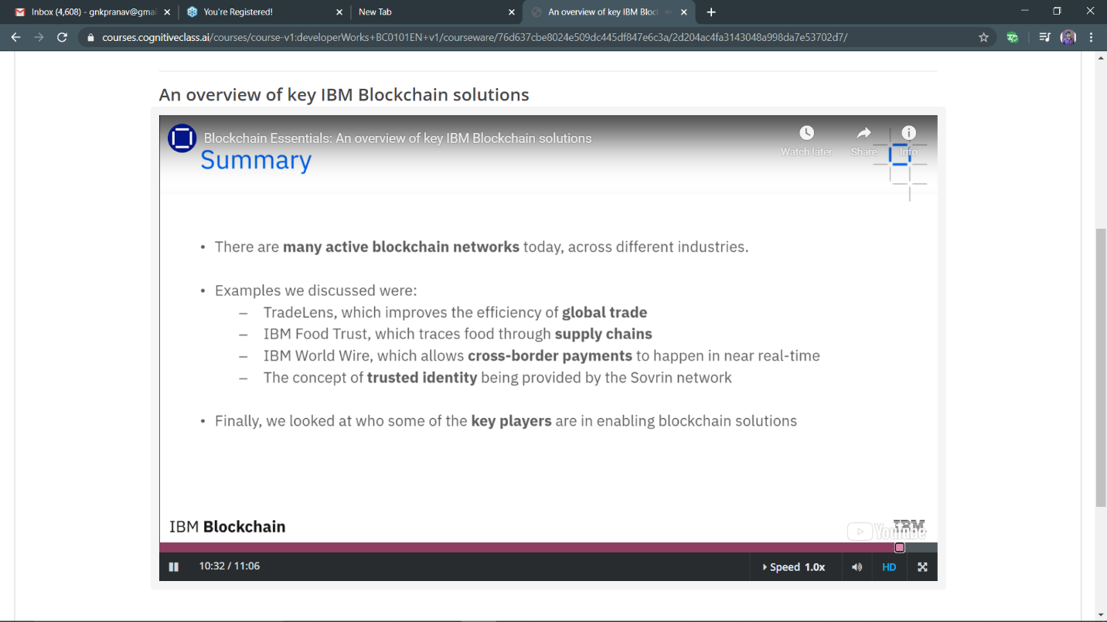

Progress:

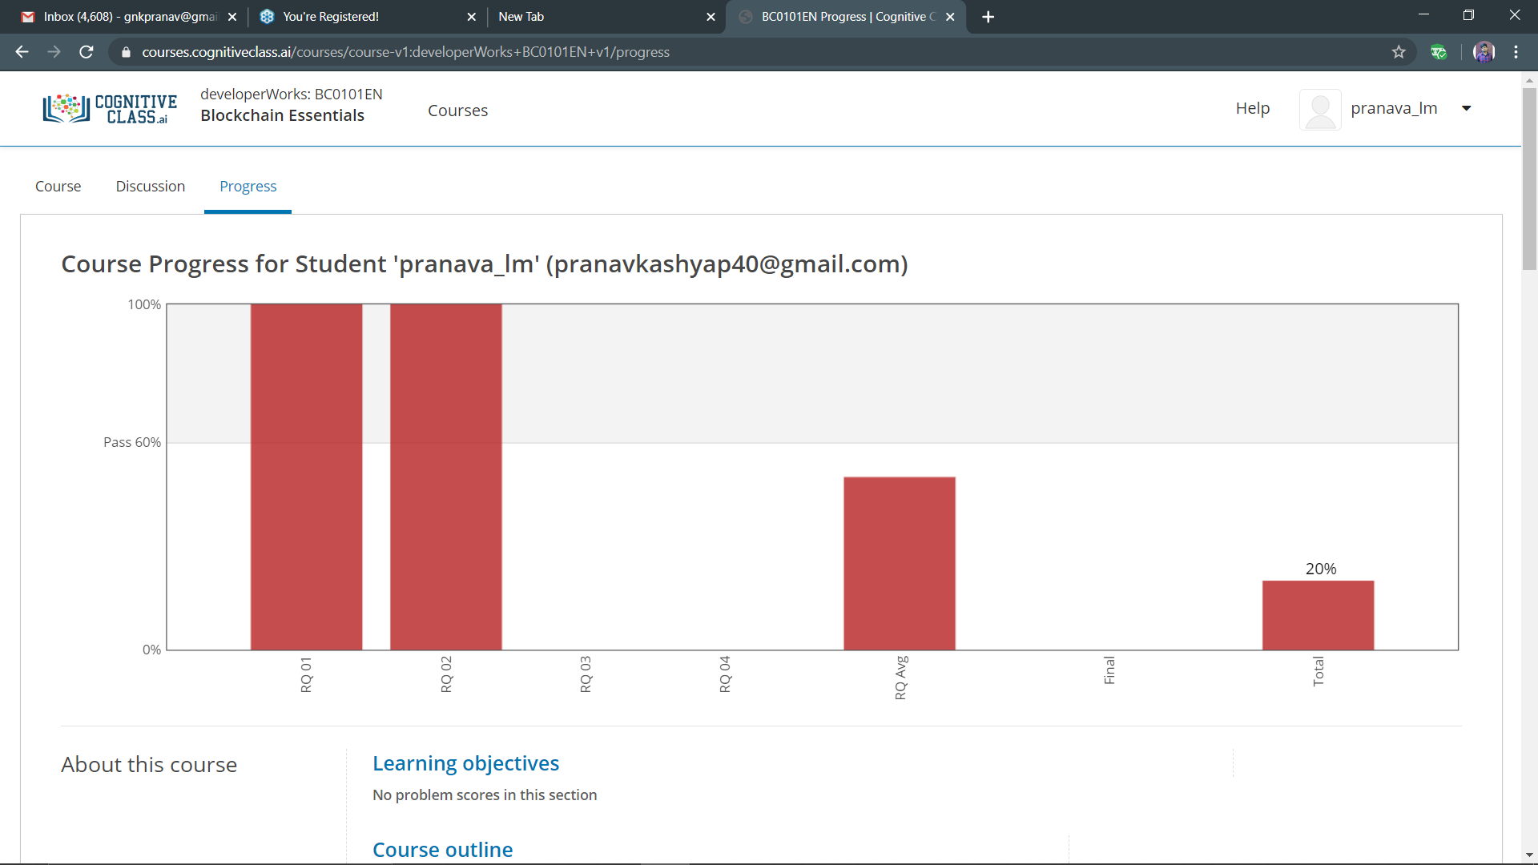

Coding Challenges Details:

**P-1**

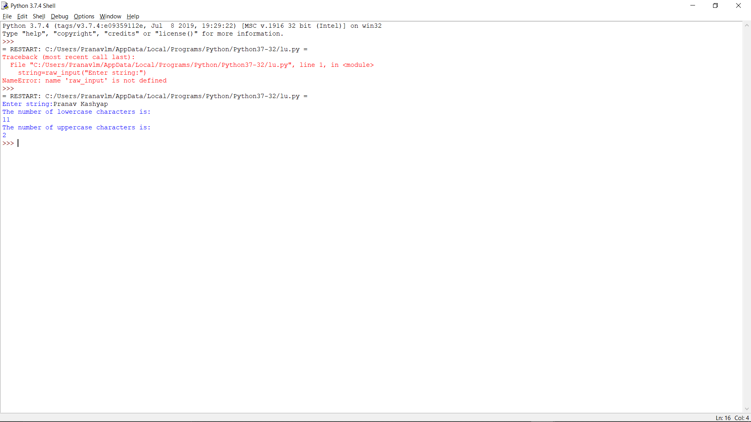

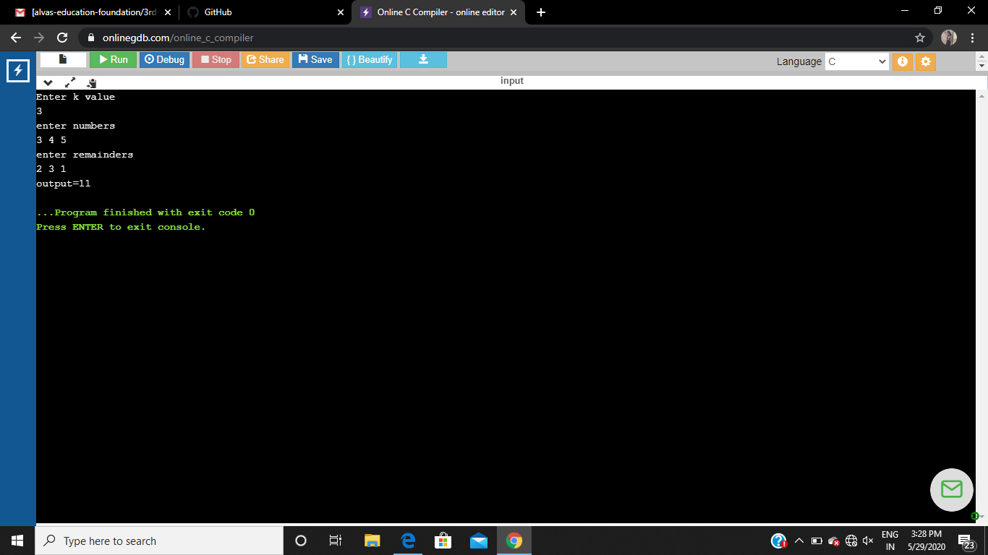P-2 P-3

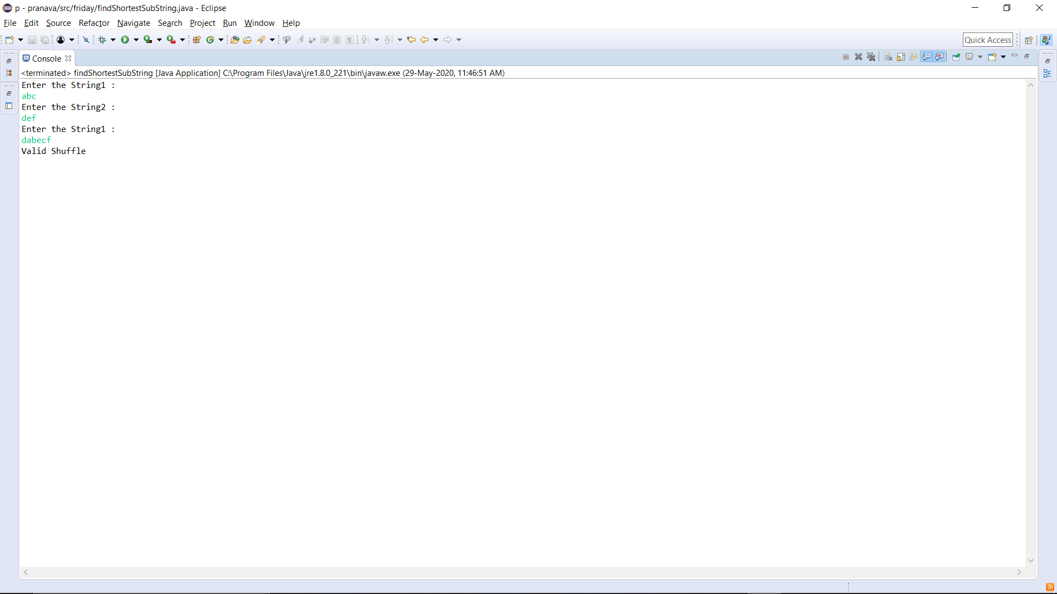

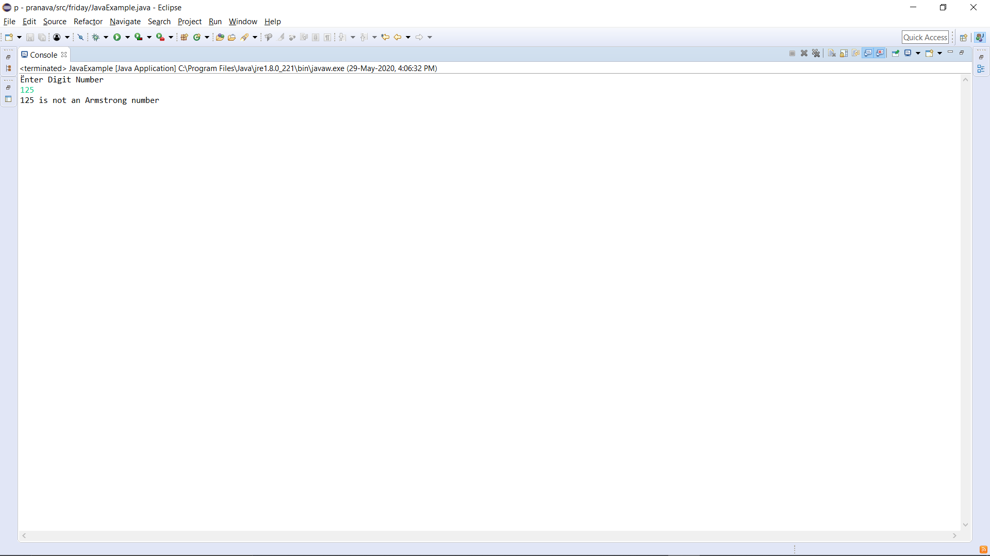P-4

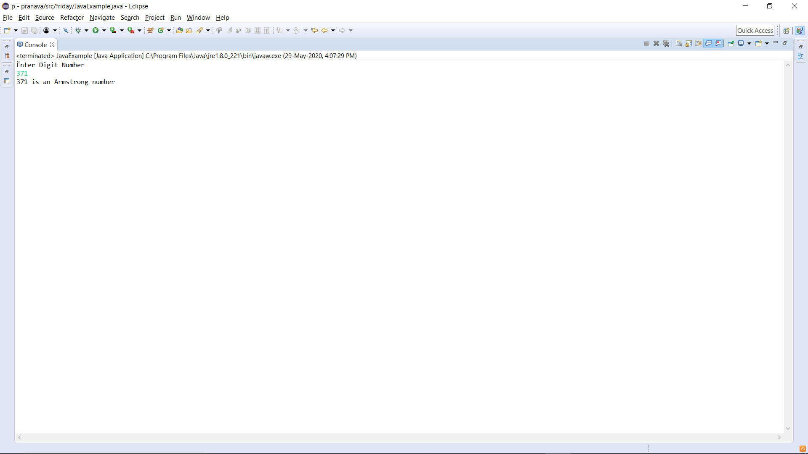

P-5

