**DAILY ONLINE ACTIVITIES SUMMARY**

|  |  |  |  |  |  |  |  |  |
| --- | --- | --- | --- | --- | --- | --- | --- | --- |
| **Date:** | **30-05-2020** | | | | | **Name:** | **Pranav L M** | |
| **Sem & Sec** | **6th - B** | | | | | **USN:** | **4AL17CS062** | |
| **Online Test Summary** | | | | | | | | |
| **Subject** | | **PAP-II** | | | | | | |
| **Max. Marks** | | **30** | | **Score** | | | **16** | |
| **Certification Course Summary** | | | | | | | | |
| **Course** | **Machine learning with python** | | | | | | | |
| **Certificate Provider** | | | **IBM** | | **Duration** | | | **8 of 10** |
| **Coding Challenges** | | | | | | | | |
| **Problem Statemen:**  **1.** Python program to read a number and print the pattern  **2.** java program to Count number of trailing zeros in product of array | | | | | | | | |
| **Status: executed** | | | | | | | | |
| **Uploaded the report in Github** | | | | | **yes** | | | |
| **If yes Repository name** | | | | | <https://github.com/pranavlm/DAILY-STATUS/tree/master/online-coding-report> | | | |
| **Uploaded the report in slack** | | | | | **Yes** | | | |

Online Test Details:

SECOND I A of PAP

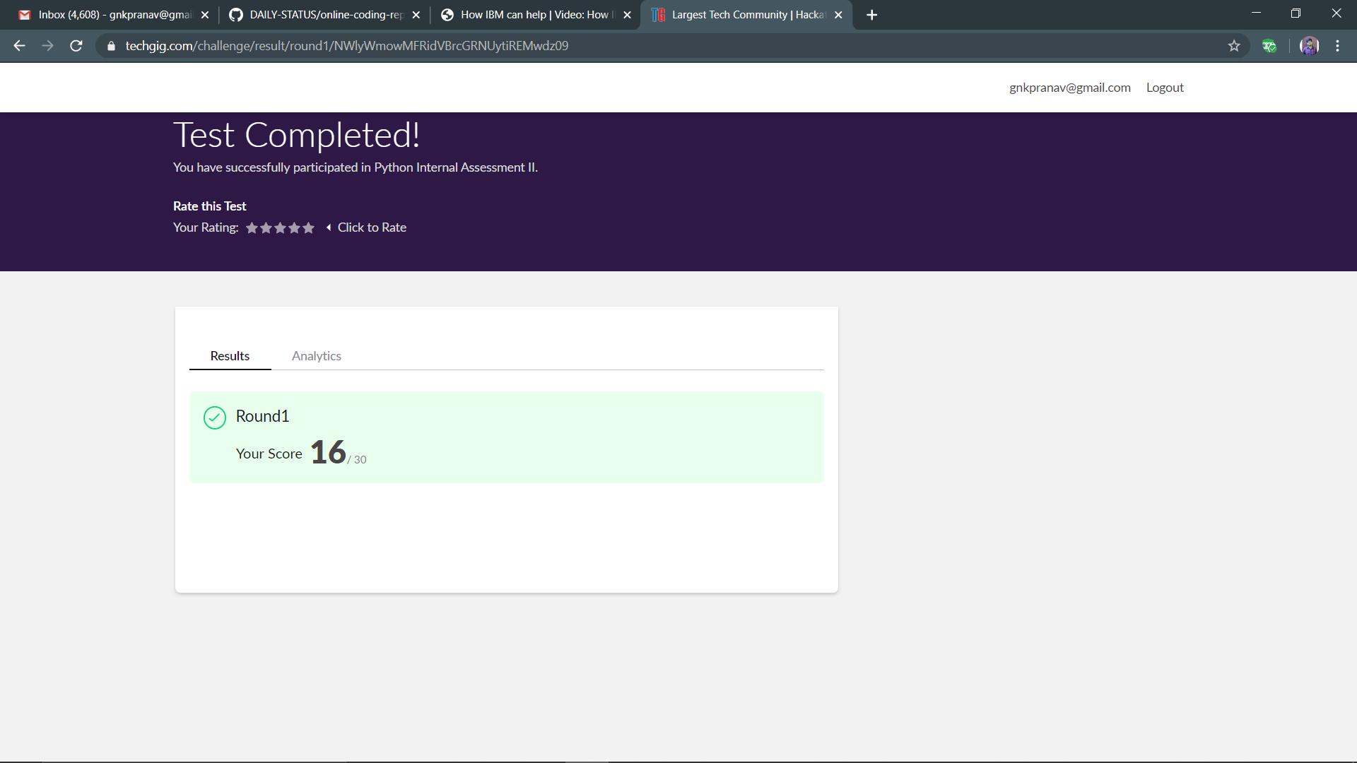

Certification Course Details:

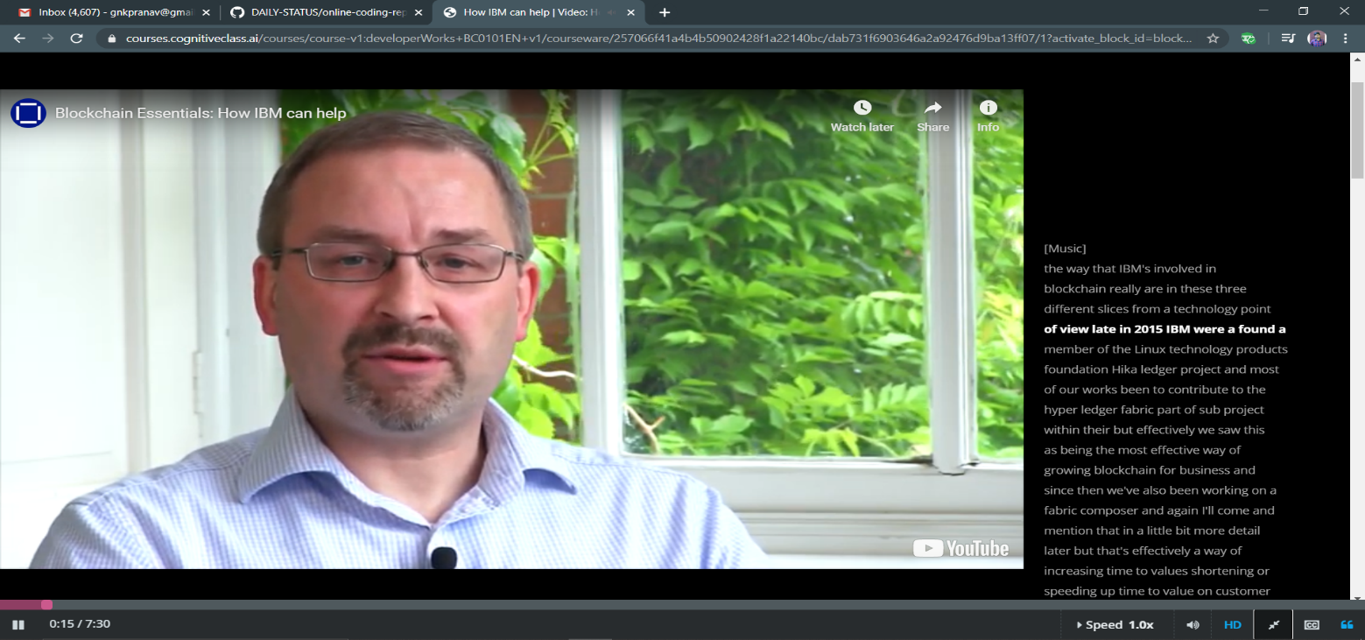

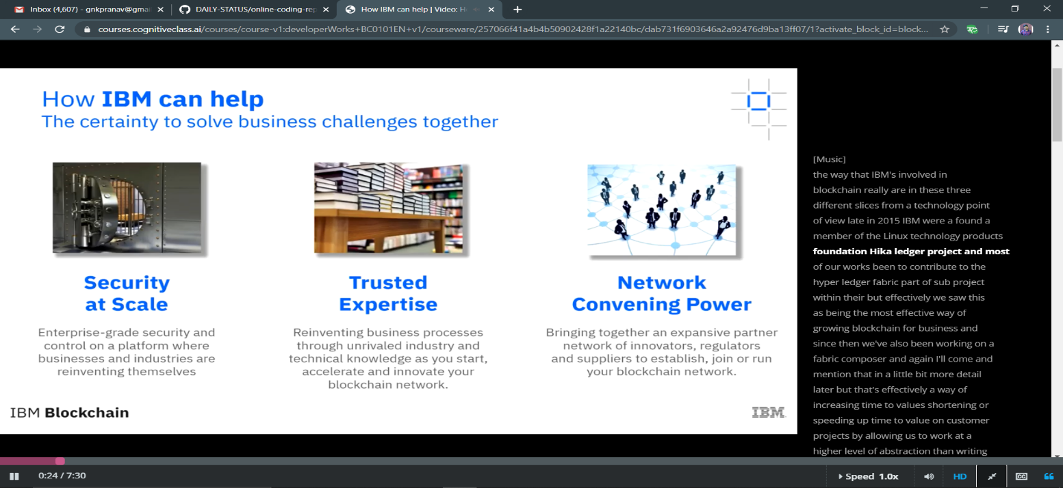

Coding Challenges Details:

P-1

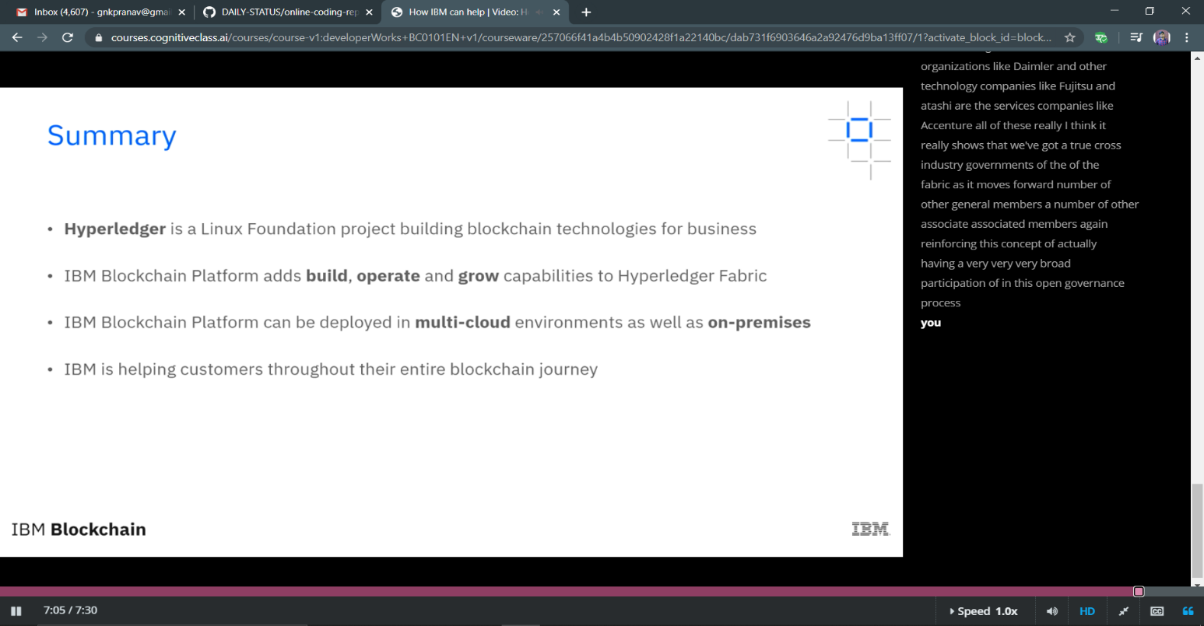

P-1

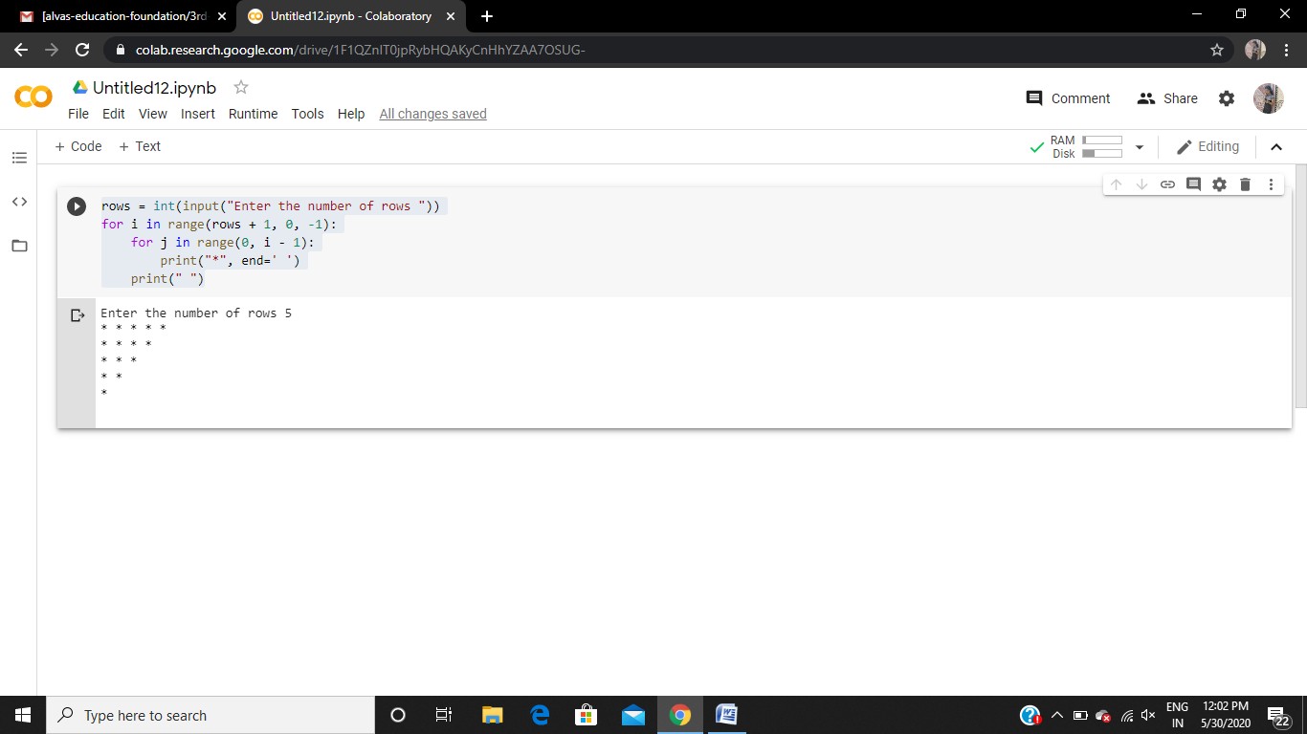

P-2

