**DAILY ONLINE ACTIVITIES SUMMARY**

|  |  |  |  |  |  |  |  |  |
| --- | --- | --- | --- | --- | --- | --- | --- | --- |
| **Date:** | | **30-06-2020** | | | | **Name:** | **Pranav L M** | |
| **Sem & Sec** | | **6th -B** | | | | **USN:** | **4AL17CS062** | |
| **Online Test Summary** | | | | | | | | |
| **Subject** | | | **9:20 am to 11:10 am - Java** | | | | | |
| **Max. Marks** | | | **-** | **Score** | | | **-** | |
| **Pre-placement Training Summary** | | | | | | | | |
| **Topic** | **Java** | | | | | | | |
| **Faculty** | Mr. SHARAN PAIS | | | | **Duration** | | | **2hours** |
| **Coding Challenges** | | | | | | | | |
| **Problem Statement**:  Write a C Program to generate first n Ugly Numbers  Write a Java Program to determine whether one string is a rotation of another. | | | | | | | | |
| **Status: Solved** | | | | | | | | |
| **Uploaded the report in Github** | | | | | **yes** | | | |
| **If yes Repository name** | | | | | <https://github.com/pranavlm/DAILY-STATUS/tree/master/Daily-Report> | | | |
| **Uploaded the report in slack** | | | | | **yes** | | | |

**SNAPSHOTS**

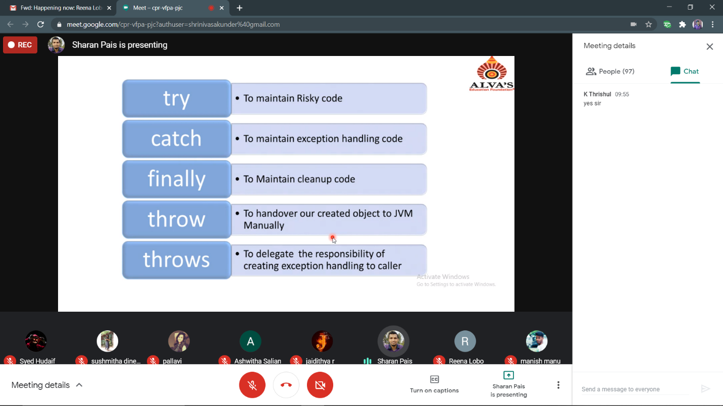

**PROGRAMS**

1)

# include <stdio.h>

# include <string.h>

int main()

{

int n,x=0;

printf("Input an integer number: ");

scanf("%d",&n);

if (n <= 0) {

printf("Input a correct number.");

}

while (n != 1)

{

if (n % 5 == 0)

{

n /= 5;

}

else if (n % 3 == 0)

{

n /= 3;

}

else if (n % 2 == 0)

{

n /= 2;

}

else

{

printf("It is not an ugly number.\n");

x = 1;

break;

}

}

if (x==0)

{

printf("It is an ugly number.\n");

}

}

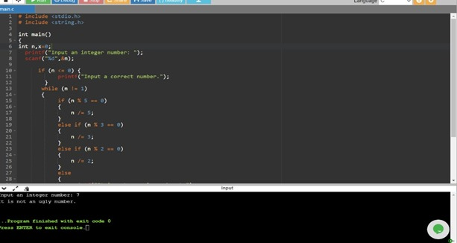

2)

public class Main {

public static boolean checkRotation(String st1, String st2) {

if (st1.length() != st2.length()) {

return false;

}

String st3 = st1 + st1;

if (st3.contains(st2))

return true;

else

return false;

}

public static void main(String[] args) {

String str1 = "avajava";

String str2 = "javaava";

System.out.println("Checking if a string is rotation of another");

if (checkRotation(str1, str2)) {

System.out.println("Yes " + str2 + " is rotation of " + str1);

} else {

System.out.println("No " + str2 + " is not rotation of " + str1);

}

}

}

