**PROGRAM:**

#include <stdio.h>

void distict_elements(int a[], int n);

int main()

{

int size_array, i, arr[20];

// Get the array size

printf("enter the size of the array: ");

scanf("%d", &size_array);

// Get the array elements

printf("enter the array elements: ");

for(i=0; i<size_array; i++)

{

scanf("%d", &arr[i]);

}

// Function call to print the distinct elements in an array

distict_elements(arr, size_array);

return 0;

}

void distict_elements(int a[], int n)

{

int i, j;

// Pick all elements one by one

for (i=0; i<n; i++)

{

// Check if the picked element is already printed

for (j=0; j<i; j++)

{

if (a[i] == a[j])

break;

}

// If not printed earlier, then print it

if (i == j)

printf("%d ",a[i]);

}

}

OUTPUT:

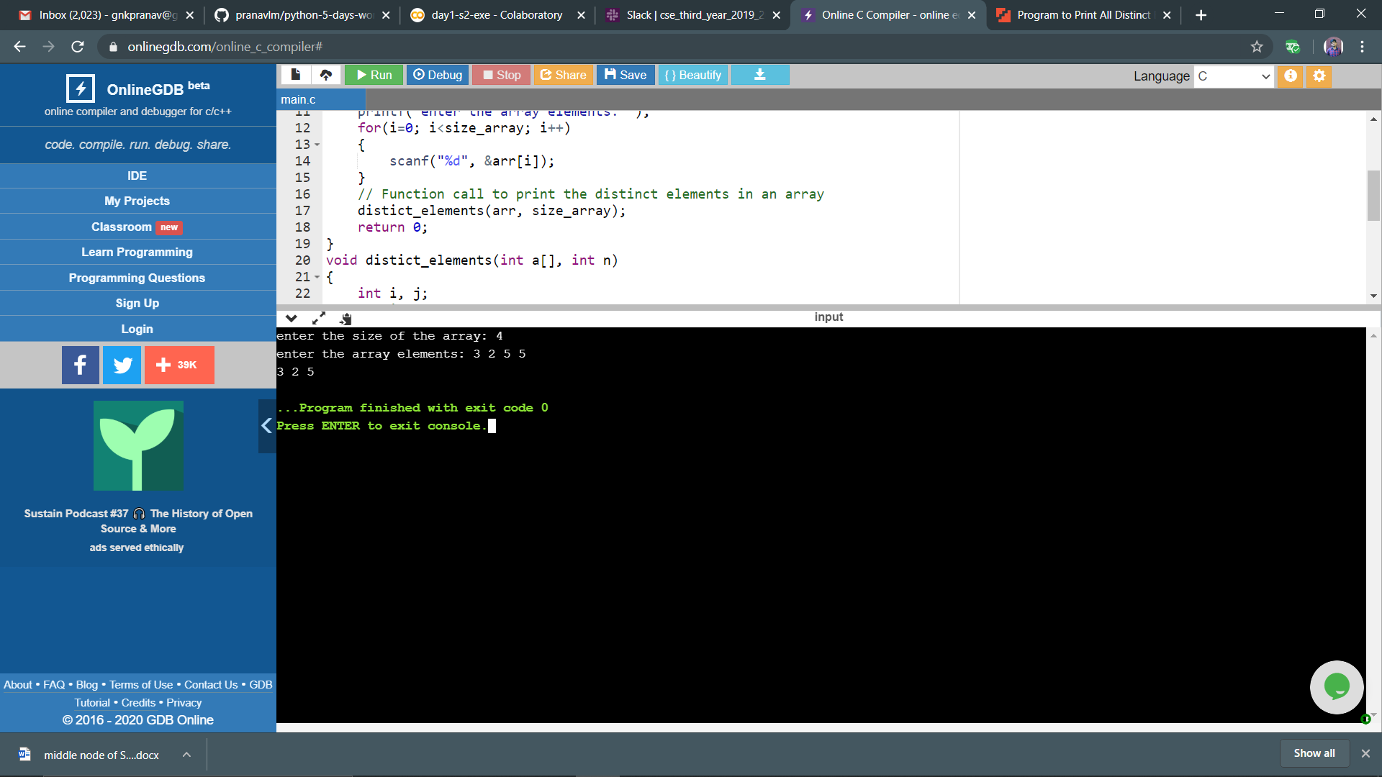

**ALGORITH:**

1.Declare and input the array elements.

2.Traverse the array from the beginning.

3.Check if the current element is found in the array again.

4.If it is found, then do not print that element.

5.Else, print that element and continue.

**FLOWCHART:**

