**KUBERNETES**

* A Kubernetes cluster consists of a control plane plus a set of worker machines, called nodes, that run containerized applications.
* The control plane manages the worker nodes and the Pods in the cluster.
* the control plane usually runs across multiple computers and a cluster usually runs multiple nodes, **providing fault-tolerance and high availability.**

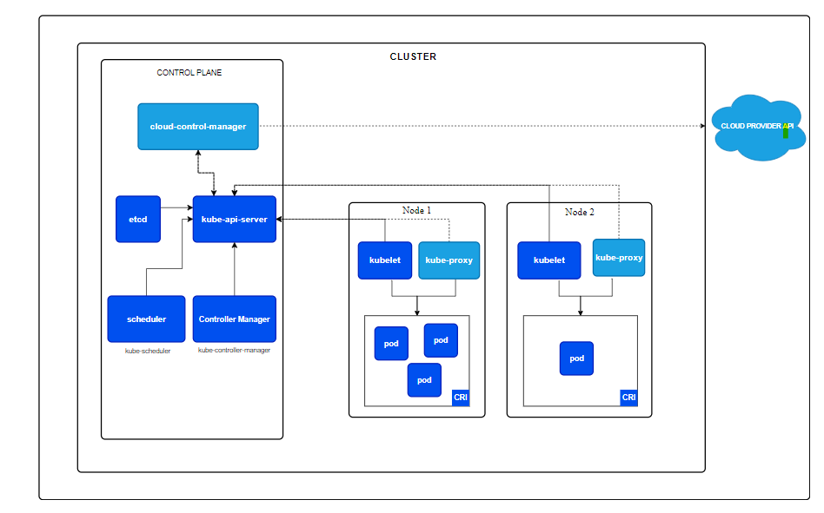

* **Kube-apiserver****:** 
  + **The API server is a component of the Kubernetes control plane that exposes the Kubernetes API.**
  + **kube-apiserver is designed to scale horizontally that is, it scales by deploying more instances.**