Valuing off-ball runs with StatsBomb 360
A possession-value model for the movement that happens away from the ball, and a player metric built on top of it.
Pranav Mohan · Data Scientist assessment, Parts 1 & 2 · July 2026 · Code: github.com/pranavm28/statsbomb-off-ball
Headline. Event data records the pass; it never records the run that made the pass possible. Using 360 freeze-frames I reconstruct 61,823 off-ball runs and value them by how much they raise the chance of a shot within five seconds. Seeing the players — not just the ball — is worth +0.0212 AUC over event-only features on identical rows and folds. The applied finding is a profile, not just a ranking: Victor Boniface ranks second per 90 on a fifth of Mbappé's minutes, while receiving in the most crowded space of anyone near the top.

1 What "possession value" means here
Unit: the game state at one instant, attached to one player. Target: a binary label — did the possession produce a shot within the next 5 seconds. Model: V(state) = P(shot ≤ 5s | ball location, that player's location, the defensive structure around him), fitted as a supervised classifier on 185,967 states with a base rate of 3.3%.
This is a state-value function in the same family as xT and VAEP: it scores a state of the possession, and the value of a move is the change in that score between two states. The difference is what defines the state. xT keys value to where the ball is; this keys it to where the players are. Two identical ball positions with different defensive shapes are one cell in xT and two states here. An xT surface is still used as a context feature, so the model knows the geographic prior it adds to.
2 How it works
The reconstruction does the real work. A Ball Receipt event carries its own freeze-frame with the receiver tagged actor, which fixes where the run ended and who made it. The preceding pass's frame fixes where everyone stood when the ball was struck — but frames are anonymous, so the run's origin must be inferred: the nearest teammate in the release frame, accepted only if the implied sprint is physically possible (≤ 9.5 m/s over the pass duration). That gate is why 66% of 93,202 receipts survive, and it is the biggest assumption in the project.
3 Scope, and why
Four full competition-seasons with 360 coverage — La Liga 2020/21, Ligue 1 2021/22 and 2022/23, Bundesliga 2023/24: 123 matches, 264,814 player-minutes. I pooled seasons rather than use the World Cup because off-ball running needs volume per player and the metric is a rate: a tournament gives seven matches, a season thirty-plus. The honest cost is that open-data 360 covers one focus club per competition, so the pool is effectively three clubs and the ranking is within-sample, not cross-league.
4 The metric, and the ranking
Run Value per 90. One number per player, built in four steps: (i) for each run, take the out-of-fold gain in predicted shot probability when the model can see how the player moved, on top of a context model that already knows where the ball and the receipt were; (ii) keep only runs received in the final third, because outside it "predictive" and "valuable" come apart — a centre-back dropping into space is reliably informative and is not creating anything; (iii) sum per player; (iv) divide by 90s played, with a 600-minute floor. That leaves 59 qualifying players.
It is an information gain, not a probability. It answers "how much of the outcome is explained by the manner of the movement rather than its geography", so it does not sum to goals. Two scouts watch the same possession, one seeing only the ball, one seeing the runner: Run Value is what the second knew that the first did not.
# | Player | Team | Position | 90s | Runs /90 | F3 runs /90 | In behind /90 | Enclosed share | Run Value /90
1 | K. Mbappé | Paris Saint-Germain | Forward | 50.6 | 23.3 | 13.7 | 2.03 | 0.40 | 0.616
2 | V. Boniface | Bayer Leverkusen | Forward | 17.8 | 13.2 | 7.5 | 1.23 | 0.52 | 0.590
3 | F. Wirtz | Bayer Leverkusen | Left Att Mid | 27.3 | 29.7 | 13.0 | 1.39 | 0.44 | 0.563
4 | F. Trincão | Barcelona | Right Wing | 8.2 | 26.8 | 15.7 | 1.71 | 0.30 | 0.552
5 | M. Braithwaite | Barcelona | Forward | 11.8 | 12.2 | 8.0 | 1.11 | 0.46 | 0.519
6 | J. Hofmann | Bayer Leverkusen | Right Att Mid | 25.2 | 25.3 | 10.8 | 0.75 | 0.40 | 0.499
7 | Neymar | Paris Saint-Germain | Left Wing | 31.7 | 33.2 | 13.5 | 1.55 | 0.40 | 0.469
8 | P. Schick | Bayer Leverkusen | Forward | 12.5 | 9.8 | 6.2 | 0.80 | 0.59 | 0.459
9 | H. Ekitike | Paris Saint-Germain | Forward | 11.4 | 12.5 | 6.9 | 0.79 | 0.52 | 0.454
10 | N. Tella | Bayer Leverkusen | RWB | 10.1 | 11.2 | 6.4 | 1.09 | 0.19 | 0.343

Enclosed share = mean angular encirclement on receipt (1 = defenders on all sides, 0 = a completely clear side). F3 = final third.
5 One run, in detail
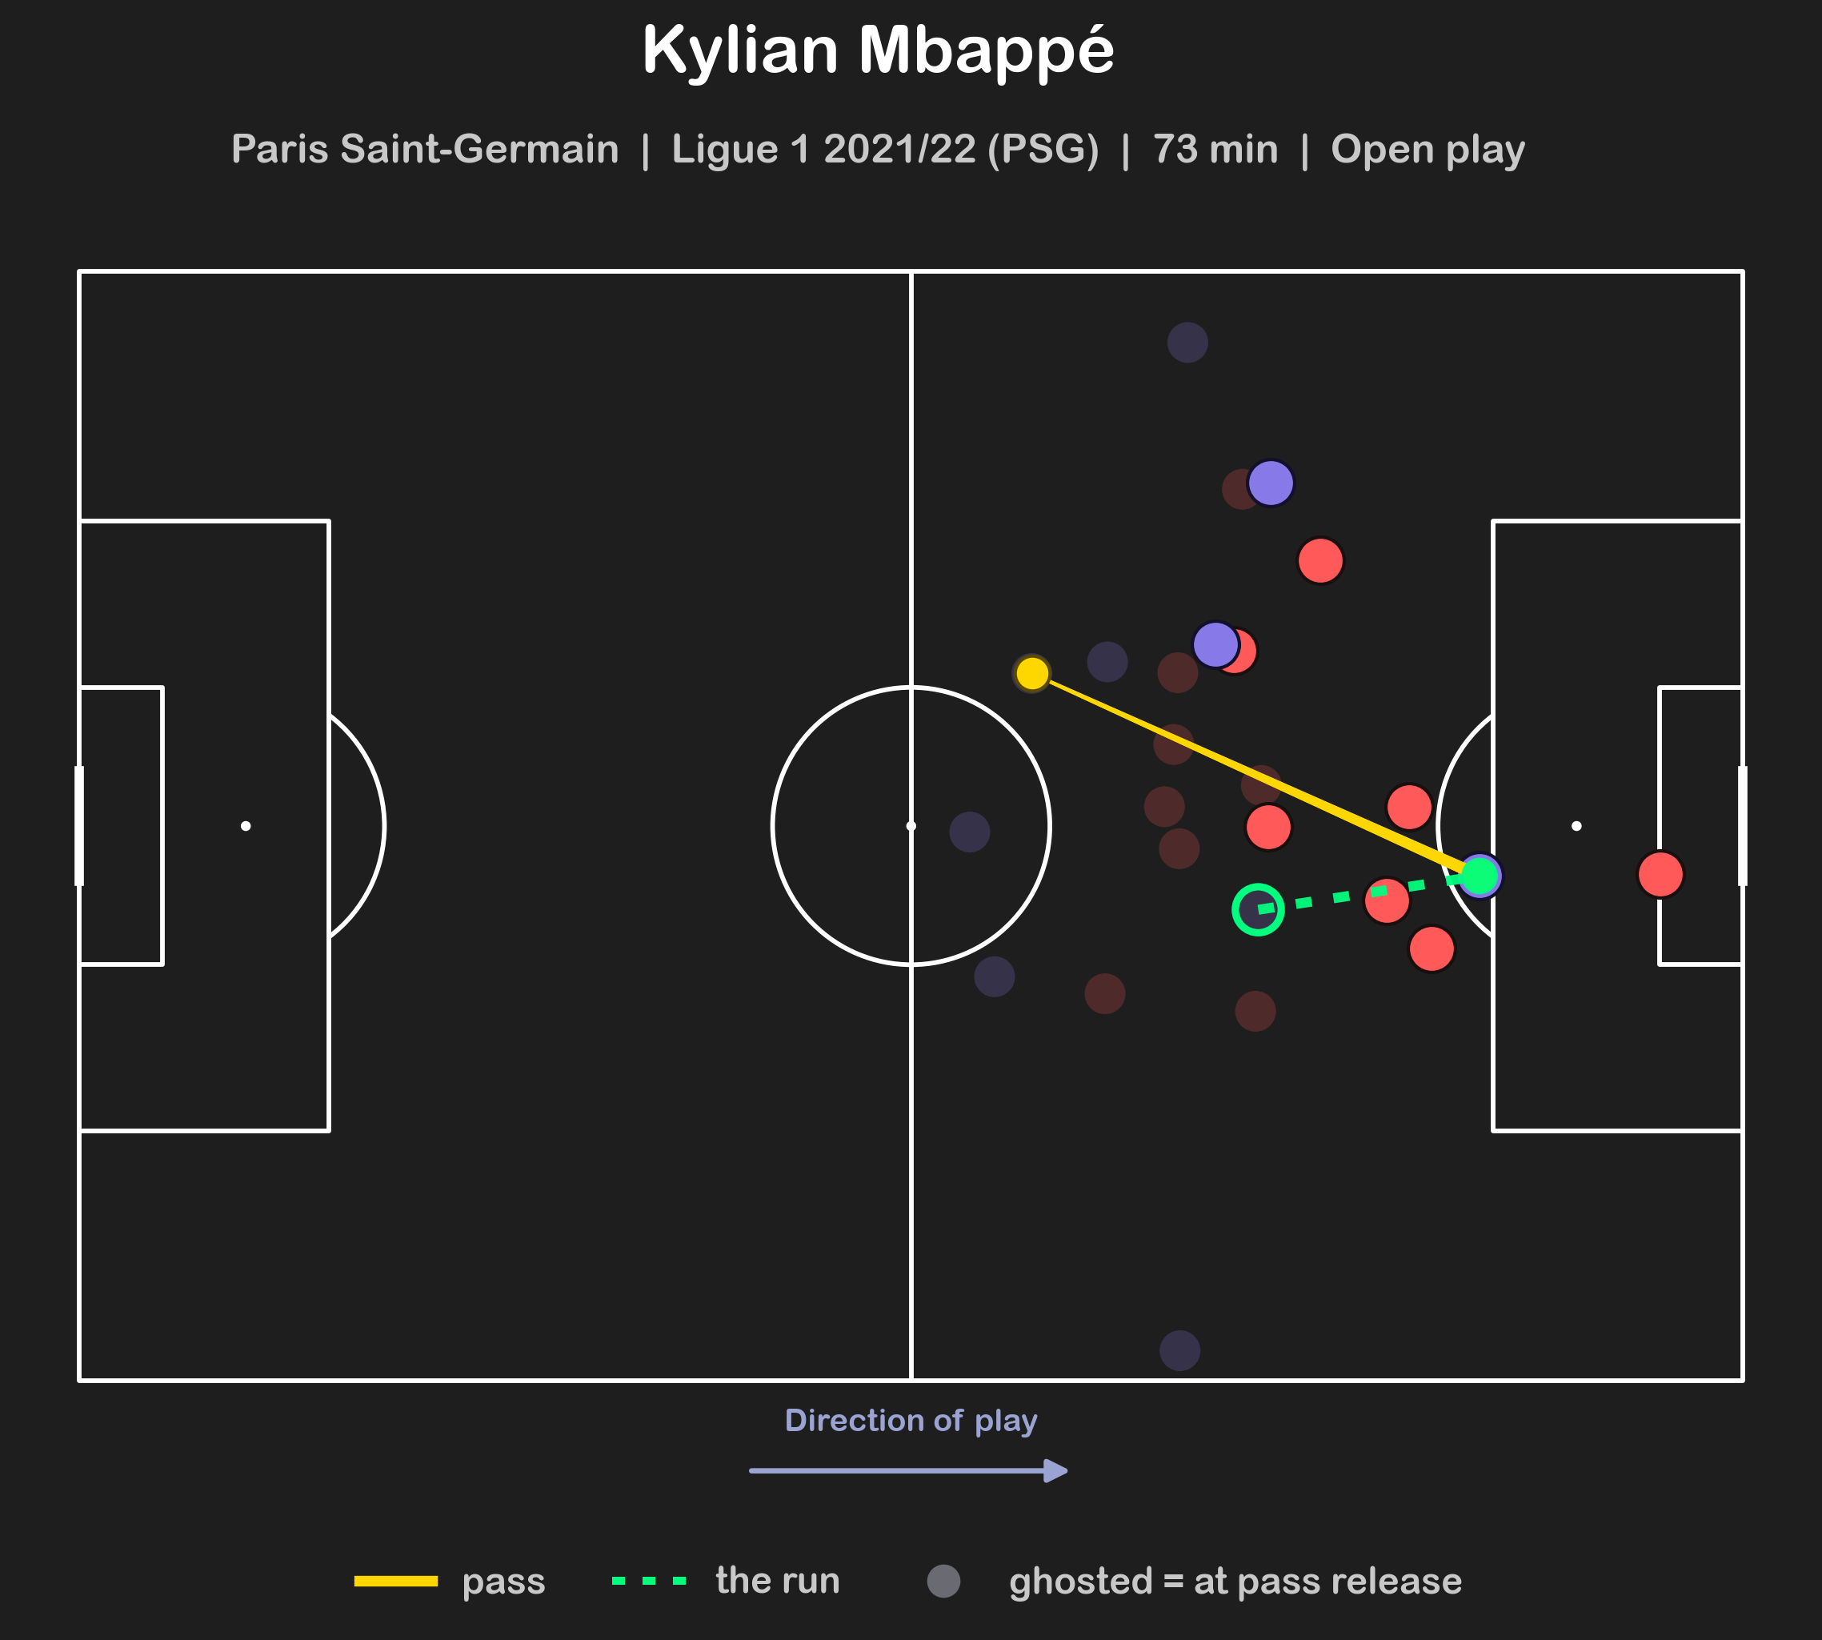 | Ghosted dots are where everyone stood when the pass was struck; solid dots where they stood when it arrived. Gold is the ball, green dotted is the run.  Mbappé starts outside the box at the moment of release and arrives on the penalty spot 16.2 m later, with four defenders around him — encirclement 0.63, i.e. almost no clear side. The possession produces 0.70 xG within five seconds.  This is what event data cannot see. A model given only the ball's start and end sees a 16 m pass into a crowd; a model given the freeze-frames sees a striker manufacturing the one gap that made it a chance.
6 Validation
Nested structure. Events sit inside possessions inside matches, so a random split leaks — two events from one possession are near-duplicates. All folds are GroupKFold on match_id; every number quoted is out-of-fold.
Does 360 earn its keep? The honest test is not "with vs without 360" — the runner's own position is a 360 feature, so a naive baseline smuggles it in. Instead, four nested tiers on identical rows and folds:
Feature tier | n | AUC | Brier | Gain | What it adds
1. Event data only | 3 | 0.9238 | 0.0260 | — | what event data alone can see
2. + where the runner is | 7 | 0.9375 | 0.0244 | +0.0137 | the runner's own position, from 360
3. + defensive structure | 12 | 0.9444 | 0.0238 | +0.0069 | where the defenders are
4. + compactness / encirclement | 16 | 0.9450 | 0.0238 | +0.0006 | shape of the block (negligible)

Tier 1→3 is the real 360 contribution: +0.0212 AUC. Tier 4 is +0.0006 — a null result, reported rather than dropped. Separately, the run features add +0.0197 AUC over context alone (0.7806 → 0.8002) on the progression target. Calibration: out-of-fold Brier 0.0238 against a 3.3% base rate, and predicted vs observed track closely across all ten deciles (figures in the repo).
7 Say it two ways
To a sporting director (~200 words)  We can now put a number on something we could previously only describe: what a player's running without the ball is worth.  For every pass in our sample we can see where all twenty-two players stood when the ball was struck, and again when it arrived. That lets us rebuild the run the receiver made to get there and ask one question: how much more likely did a shot become because of the way he moved, rather than simply because of where the ball ended up?  Mbappé finishes top, which tells you the method isn't broken but doesn't tell you anything you'd pay for. The name worth your time is Victor Boniface. He is second on this list on roughly a fifth of Mbappé's minutes, and he does it while receiving in the most crowded areas of anyone near the top — more than half his receptions come with defenders closing him from most sides. That is a specific and buyable habit: a forward who will still move into a packed box, and whose movement makes the pass playable.  How much would I bet? Enough to put him on a shortlist and watch him properly. Not enough to price a bid on this alone — the sample is three clubs, and below the leading names the order shifts depending on which outcome we ask about. | To the data team (2–3 sentences)  Run Value is an ablation quantity: the out-of-fold gain in P(shot ≤ 5s) once the model can see how the player moved, on top of a context model that already has ball location, receipt location and defensive structure — so it is information gain about the manner of movement, not a probability, and it will not sum to goals.  Folds are GroupKFold on match_id; the 360 tiers are worth +0.0212 AUC over event-only features on identical rows and folds, and out-of-fold predictions are calibrated (Brier 0.0238 on a 3.3% base rate).  What would make me trust it more: a counterfactual attribution that holds the ball and the defenders fixed and moves only the runner, because the current quantity is target-sensitive — three of four target definitions I tested reorder the leaderboard, which is a property of information-gain metrics rather than a bug, but it needs pinning down before anyone scouts off it.

8 What I used, and what I rejected
Kept  - Ball Receipt freeze-frames. The receiver is tagged actor — the only route to the runner's identity.  - Nearest-teammate origin with a speed gate. Frames are anonymous; the gate keeps physically impossible matches out.  - LightGBM. Tabular, non-linear, handles the mixed feature scales; the relationships here (distance, angle, congestion) are not linear.  - Angular encirclement over defender counts — where the defenders are beats how many.  - Final-third restriction to stop rewarding informative-but-harmless movement. | Rejected, and why  - socceraction / VAEP off the shelf. The point was to define the target myself; using it as a black box is the failure mode named in the brief.  - Defender counts within 10 m. Collinear with the geometry features, no incremental lift.  - Compactness tier. +0.0006 AUC — kept in the report as a null, not in the metric.  - Plain ΔV as the player metric. It is joint with the pass; corr(ΔV, ball forward) exceeded corr(ΔV, run forward), so it partly ranked passers.  - Pitch control / velocity models. Freeze-frames have positions but no velocities.  - World Cup 2022. Too few matches per player for a rate metric.

9 What breaks it
The one that matters. The metric is target-sensitive: of four target definitions tested, three reorder the leaderboard and two produce football-nonsense orderings (defenders and deep midfielders on top). That is inherent to an information-gain quantity — changing the outcome changes what counts as position-explained versus movement-explained — but the ordering below the leading names is not settled. The specified-but-unbuilt fix: a counterfactual attribution holding ball and defenders fixed and moving only the player, isolating his contribution instead of inferring it from a model comparison.
- Who it treats unfairly. Target men and deep-lying creators. It rewards movement that raises shot probability quickly, so a striker who occupies two centre-backs to open space for someone else scores nothing for it. Fixing that needs off-ball value attributed to the space created for teammates, not just the receiving player.
- Small samples. The 600-minute floor is ~6.7 × 90, so F. Trincão ranks 4th on 8.2 × 90. Bootstrap intervals per player are the fix; they are not in this version.
- Three clubs. Open-data 360 is club-focused, so this is within-sample. No cross-league claim is made.
- Inferred origins. 34% of receipts are discarded, and the kept ones rest on a nearest-teammate assumption that will occasionally pick the wrong player in a crowded box.
10 AI usage, in short
Full log with representative prompts, accepted/modified/rejected detail and the errors I caught is in AI_USAGE.md in the repo. Summary:
Area | What the assistant did | What I did
Framing & metric | Sketched options once I set the direction | Mine: model off-ball runs as a supervised, xG-style problem rather than a grid
Model family | Recommended LightGBM + GroupKFold | Accepted after checking the leakage argument held for nested events
Features | Drafted the geometry (encirclement, block spread) | Rejected the density counters; required the ablation before believing any of it
Verification | Produced the first, flattering comparison | Caught the mislabelled 360 baseline (the "no-360" model contained a 360 feature) — true gain +0.0212, not +0.0069
Football sense | Proposed reading block spread as "stretched = valuable" | Caught the sign: the data says the opposite by 7.6×; it is a depth proxy
Plotting & prose | First drafts | Restyled to my own conventions; fixed runs drawn off-pitch (360 frames are not clamped)

Data: StatsBomb Open Data, accessed via statsbombpy, used under the StatsBomb open-data user agreement for non-commercial research. Data provided by StatsBomb — with thanks. · Reproduce: pip install -r requirements.txt then streamlit run app/streamlit_app.py; full pipeline via requirements-pipeline.txt and build_runs.py.

