|  |  |  |  |
| --- | --- | --- | --- |
| **Class: FYMCA Div: A**  **Semester: 2** | **Course Code:**  **MCA01555**  **Course Name: Database Systems Laboratory** | | **Batch: F2** |
| **Name: Pranav Raju Malwatkar** | | **Roll No: 51037** | |
| **CO No: CO516.3** | | **Assignment No:10** | |

**PRACTICAL SUBMISSION RECORD- A.Y. 2024-25**

**Query 10: Application using database triggers – Create a transparent audit system for a table Client_master. The system must keep track of the records that are being deleted or updated. When the record is deleted or modified the original record details date of operation are stored in the audit table then the delete update is allowed to go.**

**Ans:**

**Query:**

**Query 1: Create Client_master table:**

CREATE TABLE Client_master (

client_id NUMBER PRIMARY KEY,

client_name VARCHAR2(100),

city VARCHAR2(50),

phone VARCHAR2(20)

);

**Output:**

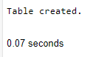

**Query 2: Create Client_audit table:**

CREATE TABLE Client_audit (

audit_id NUMBER GENERATED BY DEFAULT AS IDENTITY PRIMARY KEY,

client_id NUMBER,

client_name VARCHAR2(100),

city VARCHAR2(50),

phone VARCHAR2(20),

operation VARCHAR2(10),

operation_date DATE

);

**Output:**



**Query 3: Create Trigger**

CREATE OR REPLACE TRIGGER trg_audit_client_master

BEFORE DELETE OR UPDATE ON Client_master

FOR EACH ROW

BEGIN

INSERT INTO Client_audit (

client_id, client_name, city, phone,

operation, operation_date

) VALUES (

:OLD.client_id, :OLD.client_name, :OLD.city, :OLD.phone,

CASE

WHEN DELETING THEN 'DELETE'

WHEN UPDATING THEN 'UPDATE'

END,

SYSDATE

);

END;

/

**Output:**



**Query 4: Insert data and check audit log:**

INSERT INTO Client_master (client_id, client_name, city, phone)

VALUES (1, 'Alice Smith', 'Delhi', '9123456780');

**Output:**

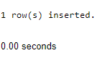

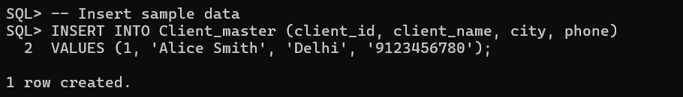

**Query 5: Update data and check trigger audit log:**

UPDATE Client_master

SET city = 'Chennai'

WHERE client_id = 1;

COMMIT;

**Output:**

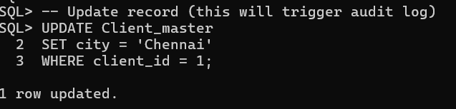

**Query 6: Delet data and check trigger audit log:**

DELETE FROM Client_master

WHERE client_id = 1;

COMMIT;

/

**Output:**

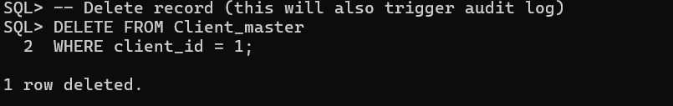

**Query 7: View trigger audit log:**

SELECT * FROM Client_audit;

**Output:**

