|  |  |  |  |
| --- | --- | --- | --- |
| **Class: FYMCA Div:A**  **Semester: 2** | **Course Code:**  **MCA01555**  **Course Name:Database Systems Laboratory** | | **Batch: F2** |
| **Name: Pranav Raju Malwatkar** | | **Roll No: 51037** | |
| **CO No: CO516.2** | | **Assignment No:3** | |

**PRACTICAL SUBMISSION RECORD- A.Y. 2024-25**

**Title: Create the following tables. Insert the appropriate data in these tables and solve the queries**

**1.Client_master (client_no, name, address1, address2, city,pincode,state,bal_due)**

**Constraints:Client_master( Client_no is PK & first letter must start with ‘C’ , Name Not NULL)**

**Query(create table):**

CREATE TABLE Client_master (

client_no CHAR(5) PRIMARY KEY CHECK (client_no LIKE 'C%'),

name VARCHAR(100) NOT NULL,

address1 VARCHAR(255),

address2 VARCHAR(255),

city VARCHAR(100),

pincode CHAR(6),

state VARCHAR(50),

bal_due DECIMAL(10, 2)

);

**Output:**

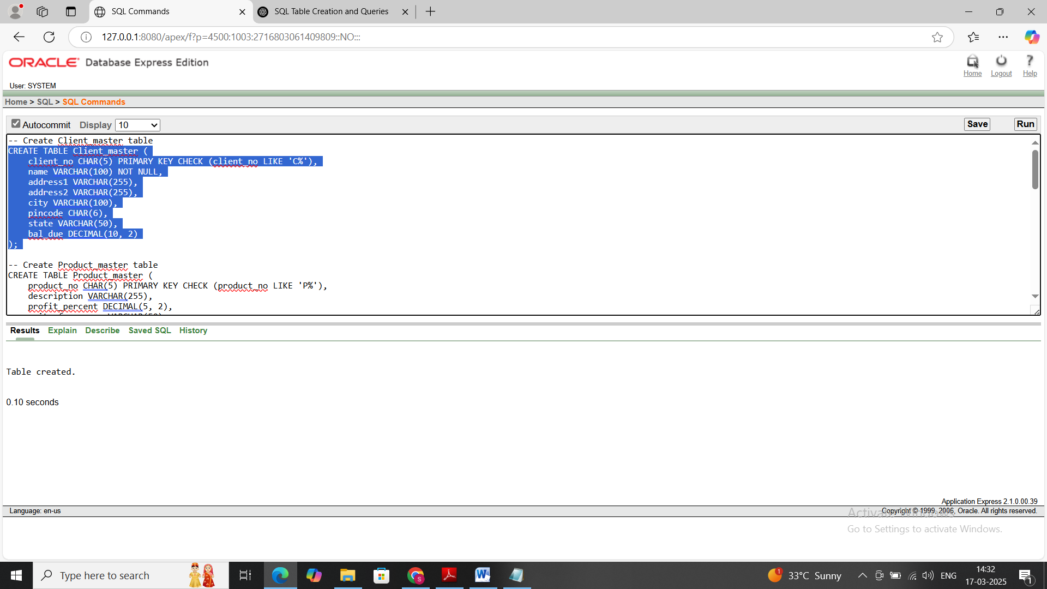

**Query(desc table):**

DESC Client_master

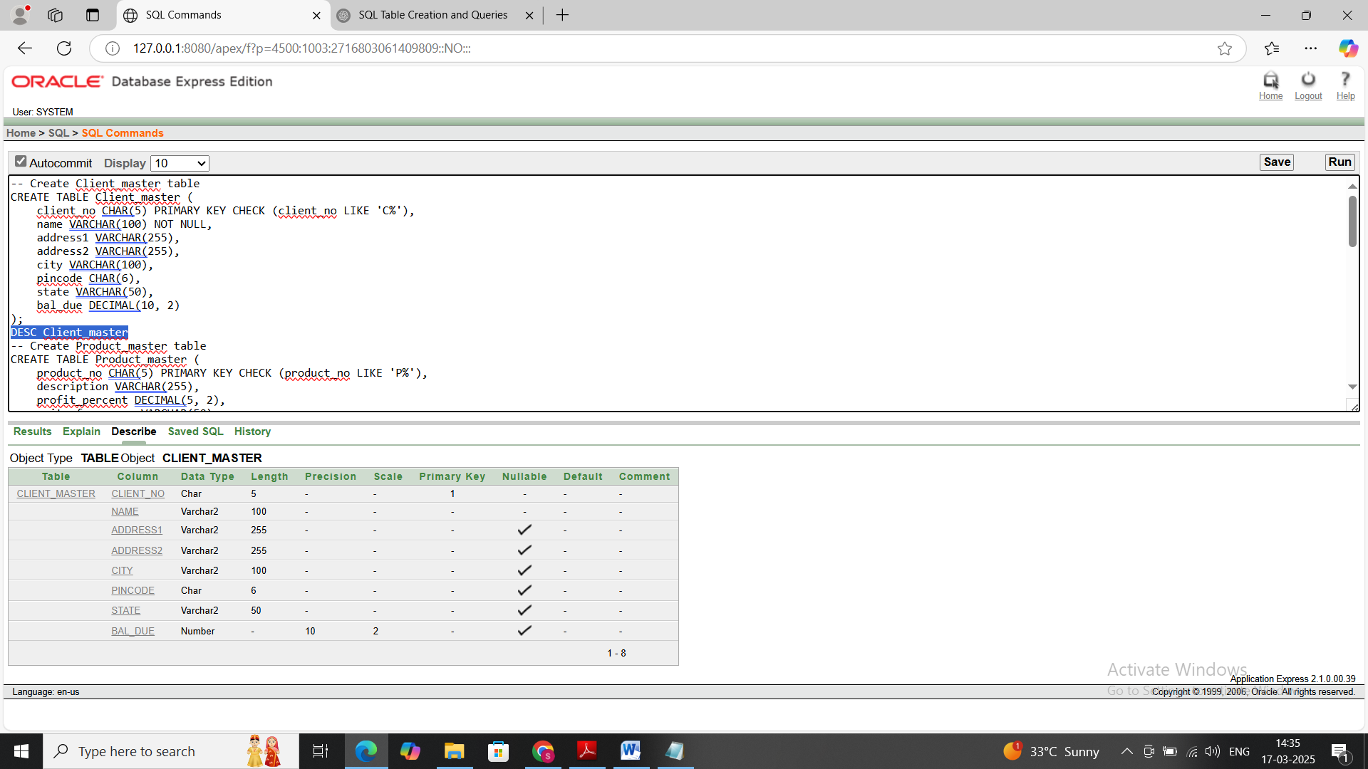

**Query(insert into table):**

INSERT INTO Client_master

VALUES

('C001', 'Sumedh Khedekar', 'h47 health camp', 'Apt 4B', 'Pune', '411013', 'Maharashtra', 100.50);

('C002', 'Dhananjay Khedekar', 'Pandav Nagar', NULL, 'Nashik', '541101', 'Maharashtra', 150.75);

('C003', 'Sanjana Khedekar', 'Beturkar Pada', 'House no.54', 'Mumbai', '310014', 'Maharashtra', 175.85);

('C004', 'Gaurav Khedekar', 'Mohar Pratima ', NULL, 'Mumbai', '310014', 'Maharashtra', 145.44);  
**Output:**

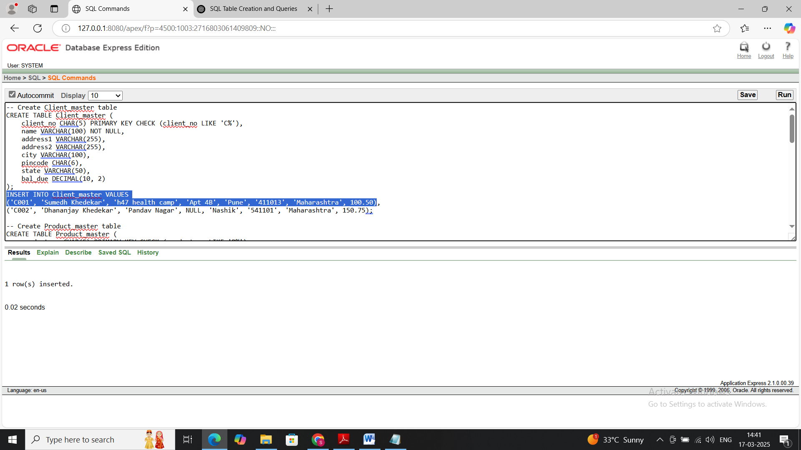

**Query(select ): select * from client_master**

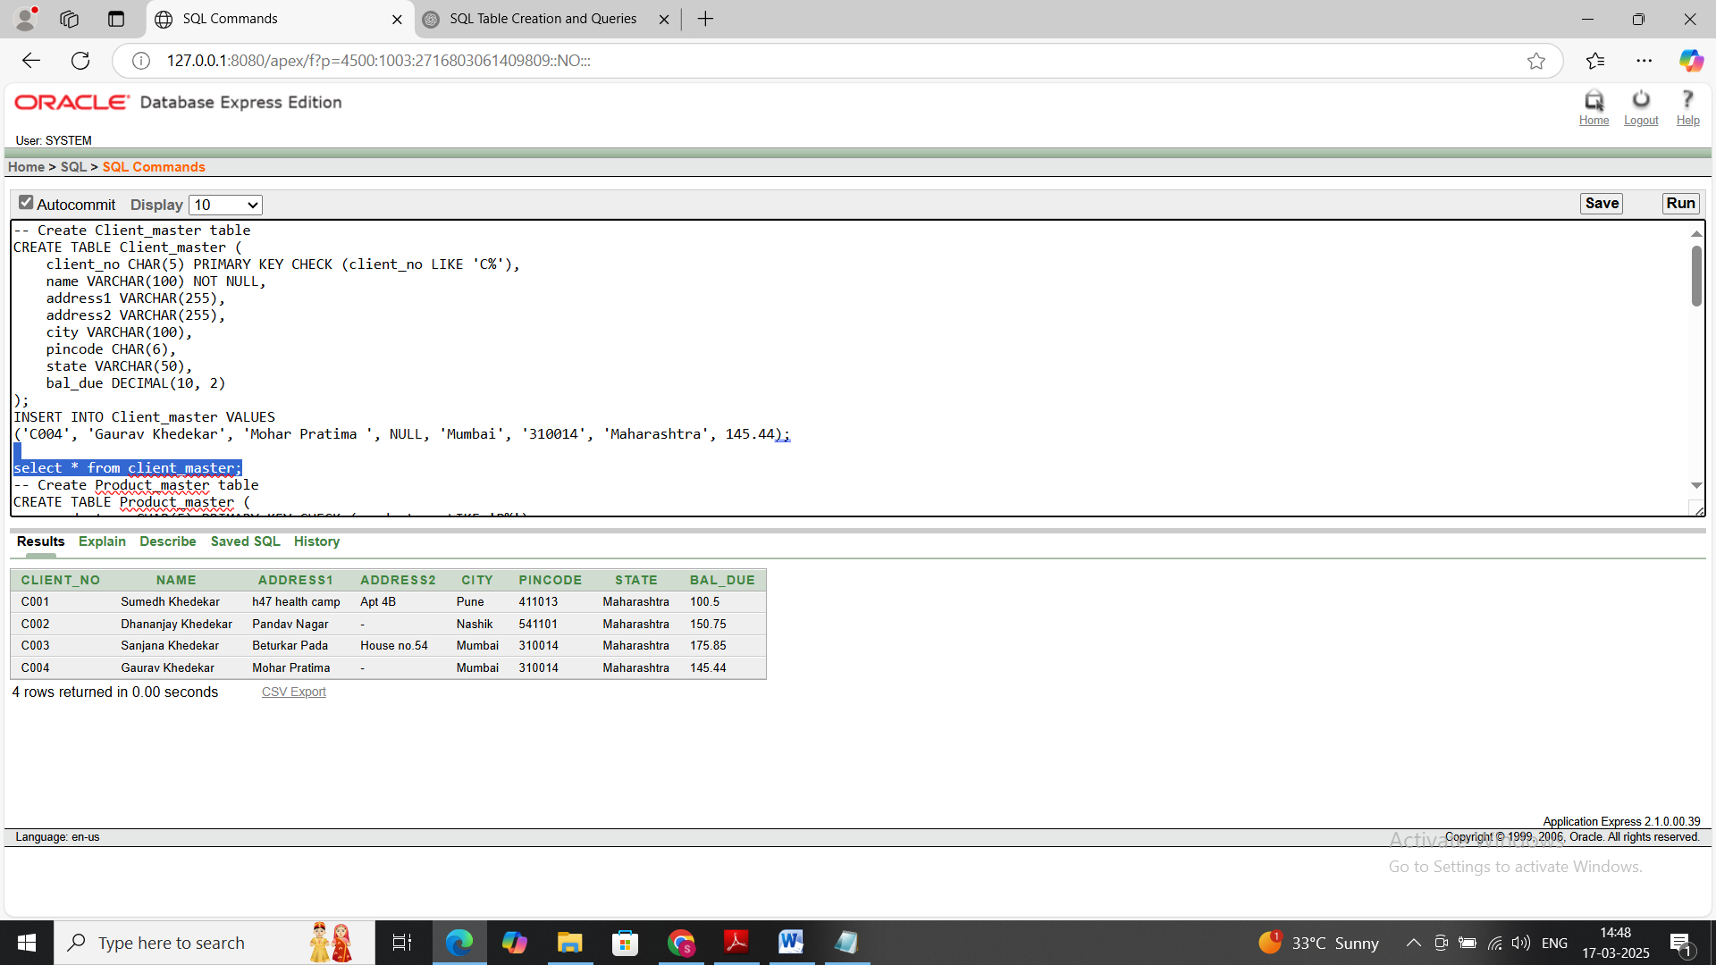

**2.Product_master(product_no, description, profit_percent, unit_ measure, qty_on_hand ,**

**reorder_lvl, sell_price, cost_price)**

**Constraints: Product_master(product_no is PK & first letter must start with ‘P’)**

**Query(create table):**

CREATE TABLE Product_master (

product_no CHAR(5) PRIMARY KEY CHECK (product_no LIKE 'P%'),

description VARCHAR(255),

profit_percent DECIMAL(5, 2),

unit_of_measure VARCHAR(50),

qty_on_hand INT,

reorder_lvl INT,

sell_price DECIMAL(10, 2),

cost_price DECIMAL(10, 2)

);

**Output:**



**Query(desc table):**

desc product_master;

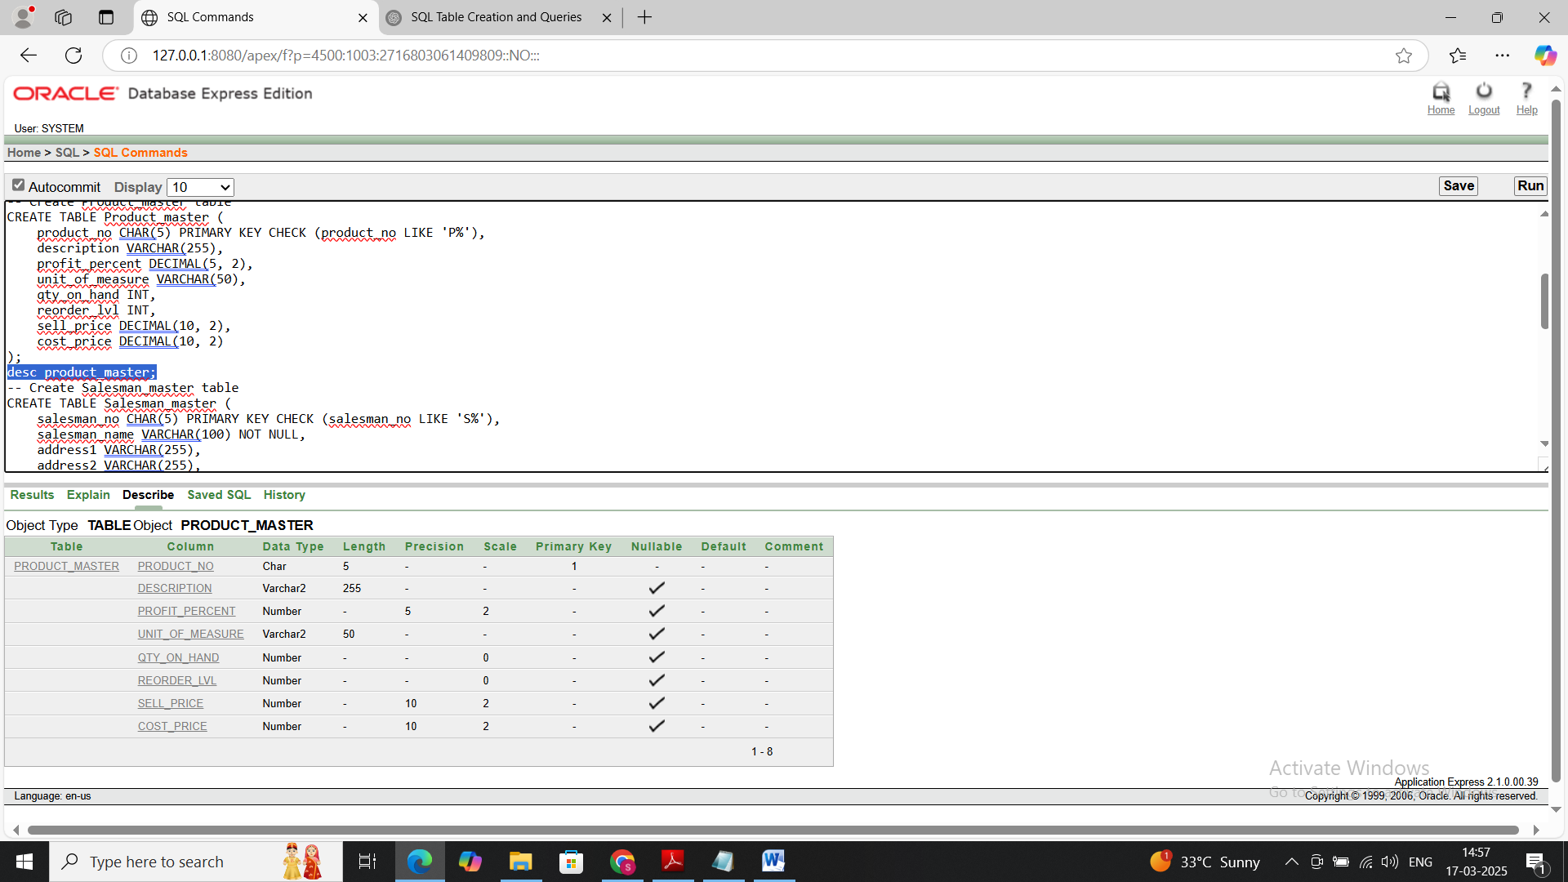

**Query(insert table):**

INSERT INTO TABLE Product_master VALUES

('P001', 'Laptop', 20.00, 'Unit', 50, 10, 1000.00, 800.00),

('P002', 'Smartphone', 15.00, 'Unit', 100, 15, 500.00, 400.00)

('P003', 'Headset', 20.00, 'Unit', 100, 20, 300.00, 50.00)

('P004', 'Earpods', 25.00, 'Unit', 100, 30, 1200.00, 500.00)Output:

**Output:**



**Query(select):** select * from Product_master;

**Output:**

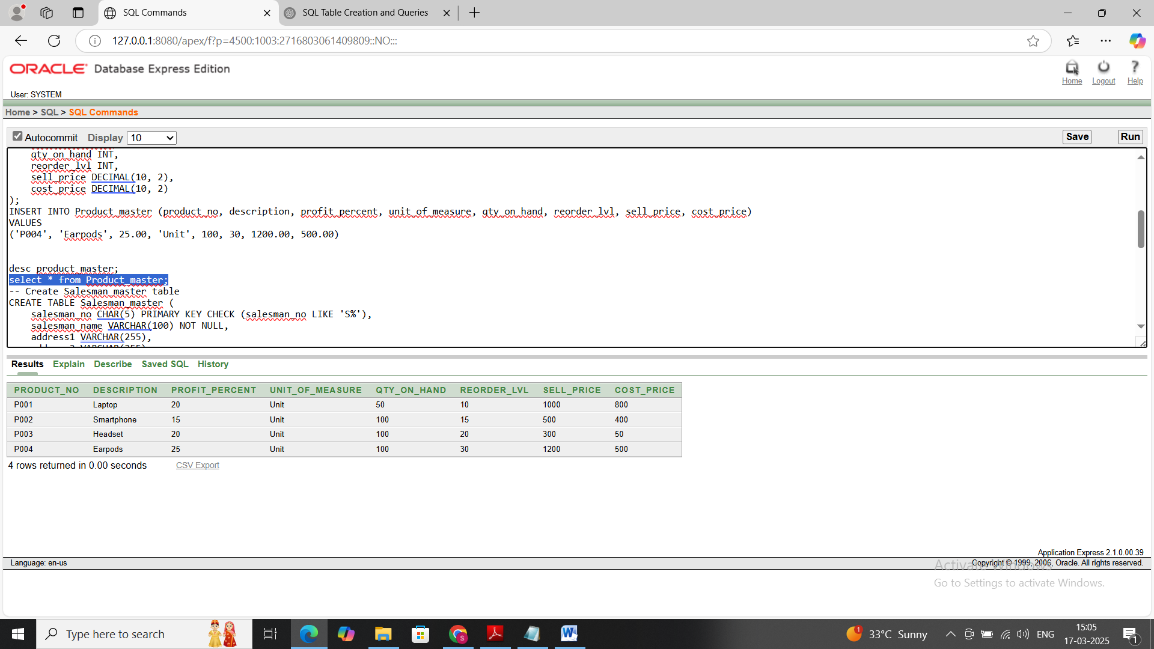

**3. Salesman_master(salesman_name, address1, address2, city, pincode, state, sal_amt,**

**tgt_to_get,ytd_sales,remarks)**

**Constraints:** **Salesman_master(salesman_no is PK & first letter must start with ‘S’ Name not NULL)**

**Query(Create):**

CREATE TABLE Salesman_master (

salesman_no CHAR(5) PRIMARY KEY CHECK (salesman_no LIKE 'S%'),

salesman_name VARCHAR(100) NOT NULL,

address1 VARCHAR(255),

address2 VARCHAR(255),

city VARCHAR(100),

pincode CHAR(6),

state VARCHAR(50),

sal_amt DECIMAL(10, 2),

tgt_to_get DECIMAL(10, 2),

ytd_sales DECIMAL(10, 2),

remarks VARCHAR(255) -- changed from TEXT to VARCHAR(255)

);

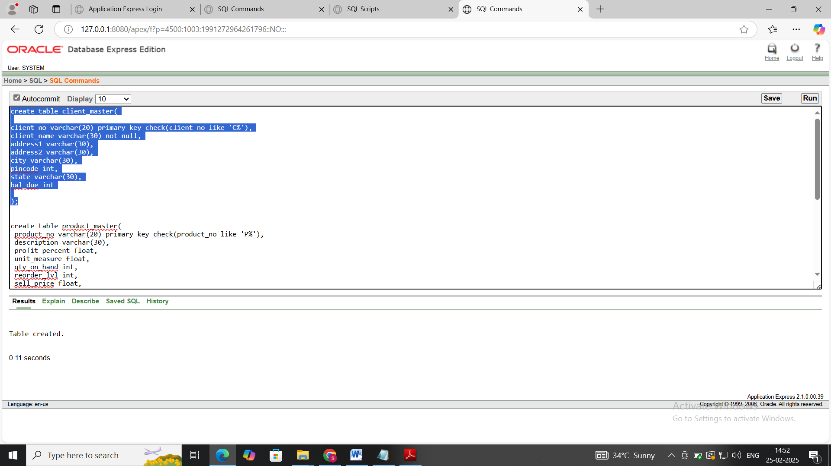

**Query(Desc):**

desc Salesman_master

**Ouput:**

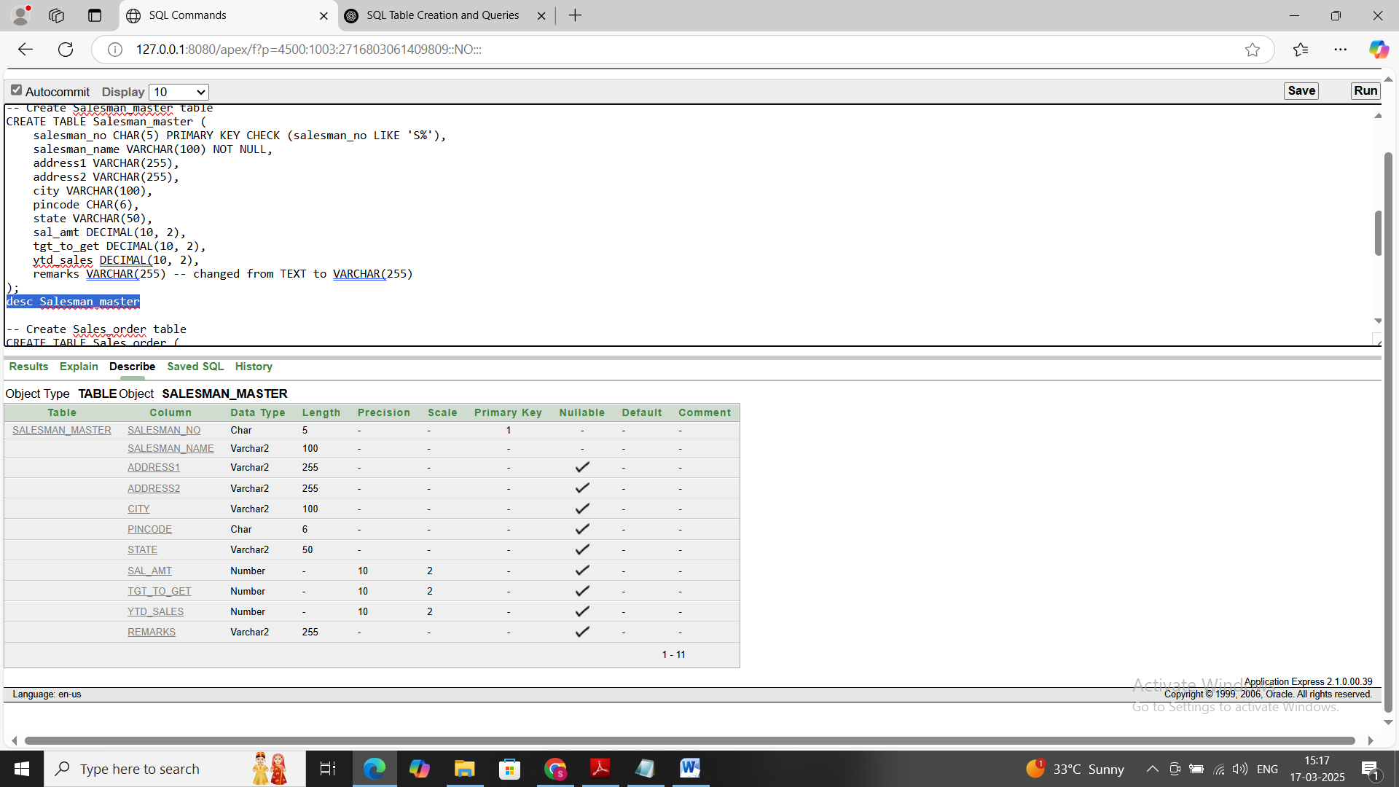

**Query(insert):**

INSERT INTO Salesman_master VALUES

('S001', 'Kapil Aru, 'Navi peth ', 'Laxmi Road', 'Pune', '411012', 'Maharashtra', 2000.00, 50000.00, 12000.00, 'Excellent performance'),

('S002', 'Ramesh Chaudhary', 'Juna bazar near Shaniwar Wada', 'near old factory1', 'Pune', '411012', 'Maharashtra', 1800.00, 45000.00, 15000.00, 'Needs improvement');

**Ouput:**



**Query(select):**

Select * from Salesman_master

**Output:**

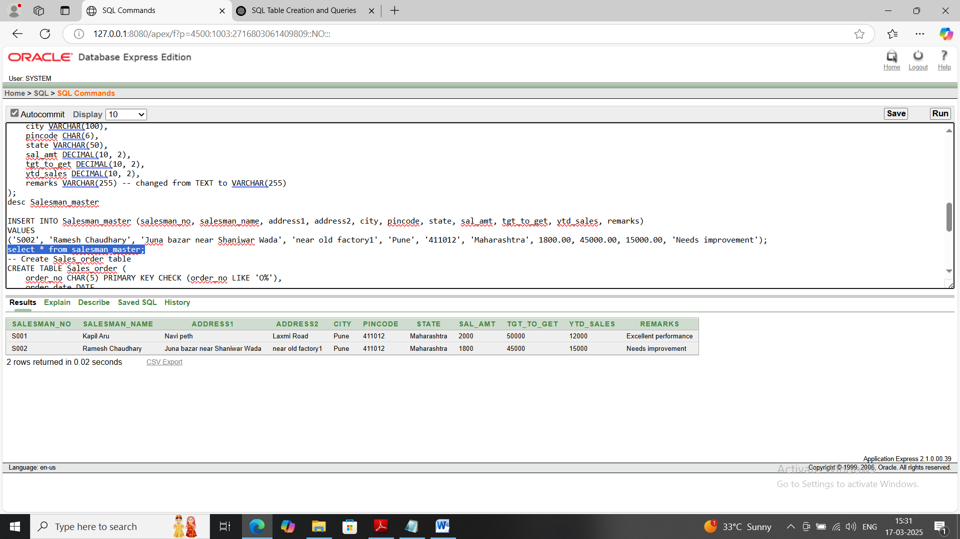

**3. Sales_order(order_no,order_date,client_no,dely_addr,salesman_no, dely_type,billed_yn,**

**dely_date, order_status)**

**Constraints:** **Sales_Order(order_no is PK & first letter must start with ‘O’,dely_type(Delivery:**

**part(P)/full(f) Default (F), dely_date cannot be less than order_date, order_status values (‘In**

**Process’, ‘Fulfilled’ ‘BackOrder’,’Cancelled’).**

**Query(Create):**

CREATE TABLE Sales_order (

order_no CHAR(5) PRIMARY KEY CHECK (order_no LIKE 'O%'),

order_date DATE,

client_no CHAR(5) ,

dely_addr VARCHAR(255),

salesman_no CHAR(5) ,

dely_type CHAR(1) DEFAULT 'F' CHECK (dely_type IN ('P', 'F')), -- Default to Full delivery

billed_yn CHAR(1),

dely_date DATE , -- Ensure dely_date >= order_date

order_status VARCHAR(20) CHECK (order_status IN ('In Process', 'Fulfilled', 'Cancelled')),

FOREIGN KEY (client_no) REFERENCES Client_master(client_no),

FOREIGN KEY (salesman_no) REFERENCES Salesman_master(salesman_no),

CHECK (dely_date >= order_date));

Output:

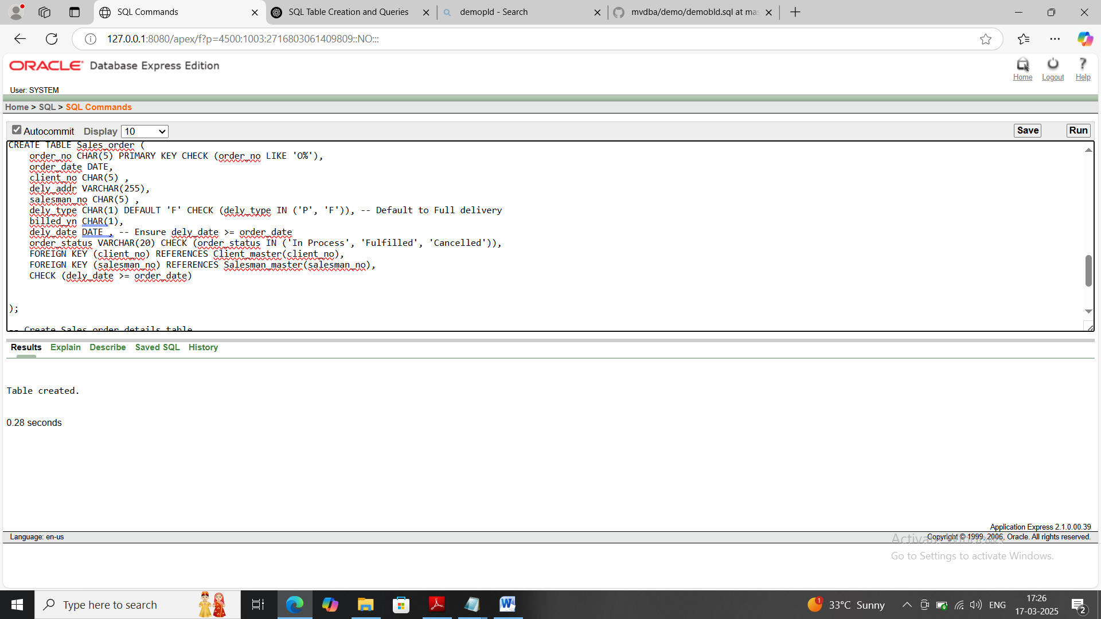

Query(Desc):DESC Sales_order

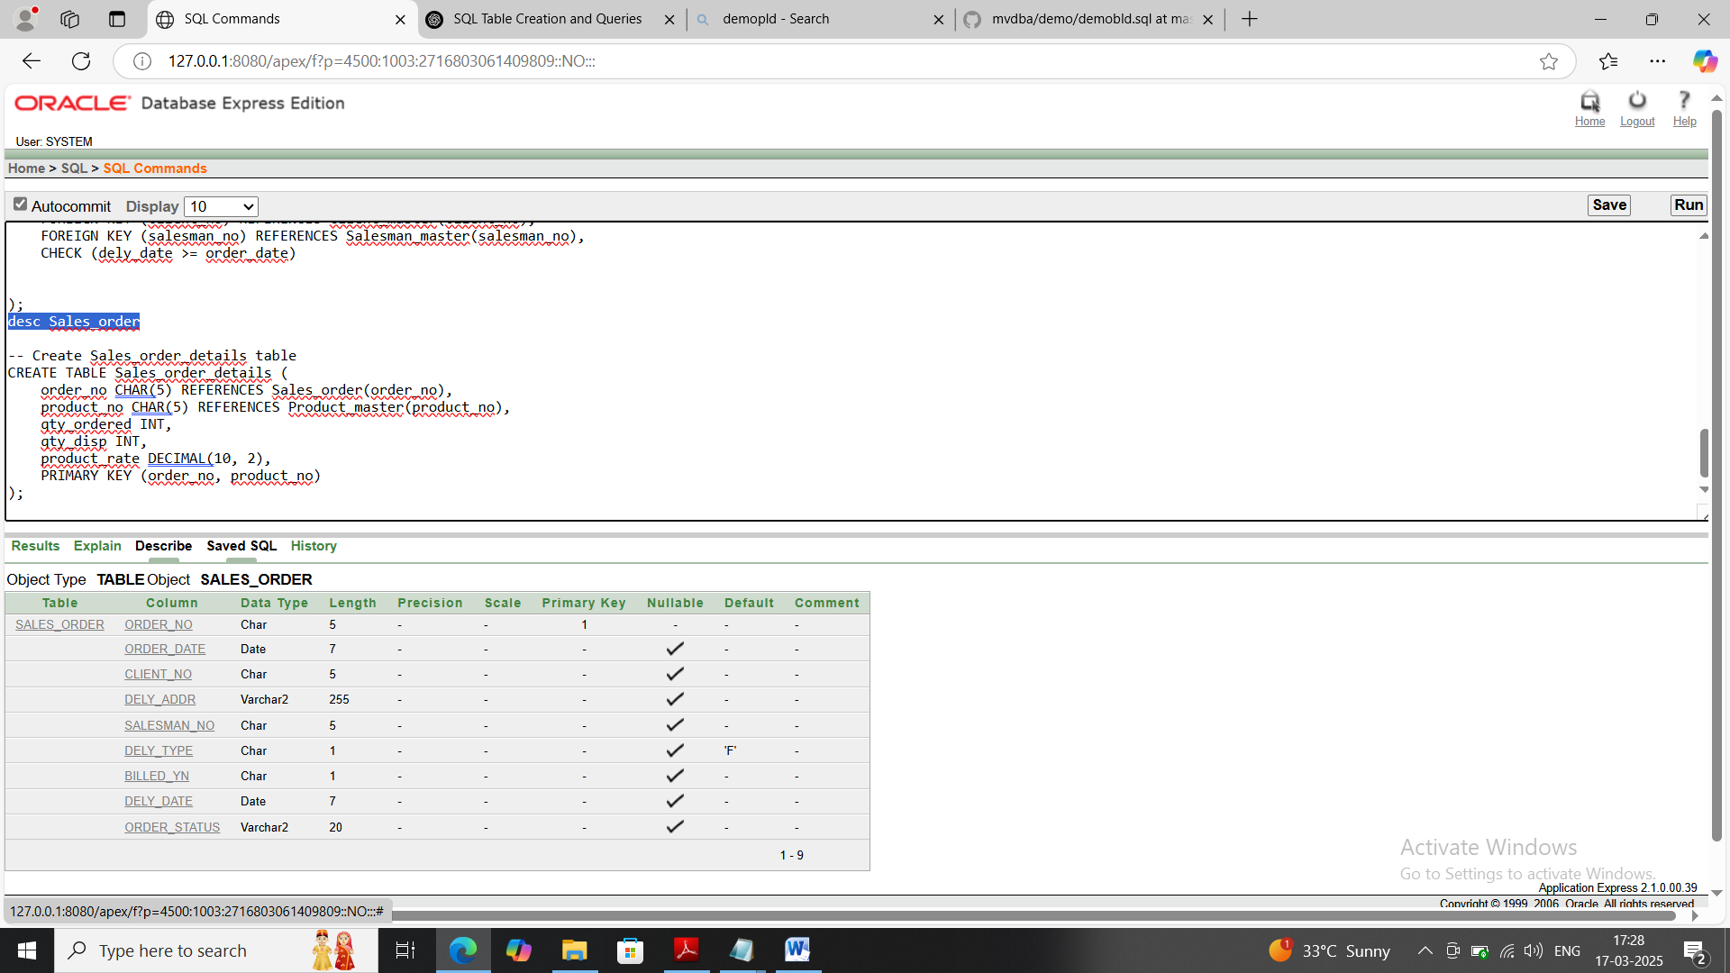

**Query(Insert):**

INSERT INTO Sales_order (order_no, order_date, client_no, dely_addr, salesman_no, dely_type, billed_yn, dely_date, order_status)

VALUES

('O001', TO_DATE('2025-03-15','YYYY-MM-DD'), 'C001', 'h47 health camp', 'S001', 'F', 'Y', TO_DATE('2025-03-17','YYYY-MM-DD'), 'In Process'),

('O002', TO_DATE('2025-03-16','YYYY-MM-DD'), 'C002', 'Pandav Nagar', 'S001', 'P', 'N', TO_DATE('2025-03-18','YYYY-MM-DD'), 'In Process');

('O003', TO_DATE('2025-03-17','YYYY-MM-DD'), 'C003', 'Beturkar Pada', 'S002', 'P', 'N', TO_DATE('2025-03-18','YYYY-MM-DD'), 'Cancelled');

('O004', TO_DATE('2025-03-16','YYYY-MM-DD'), 'C004', 'Mohar Pratima', 'S002', 'F', 'N', TO_DATE('2025-03-16','YYYY-MM-DD'), 'Fulfilled');

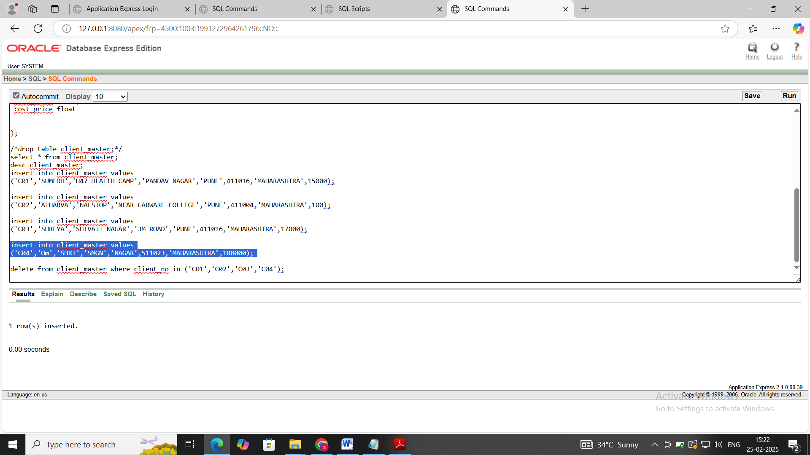

**Query(Select)**:Select * from sales_order

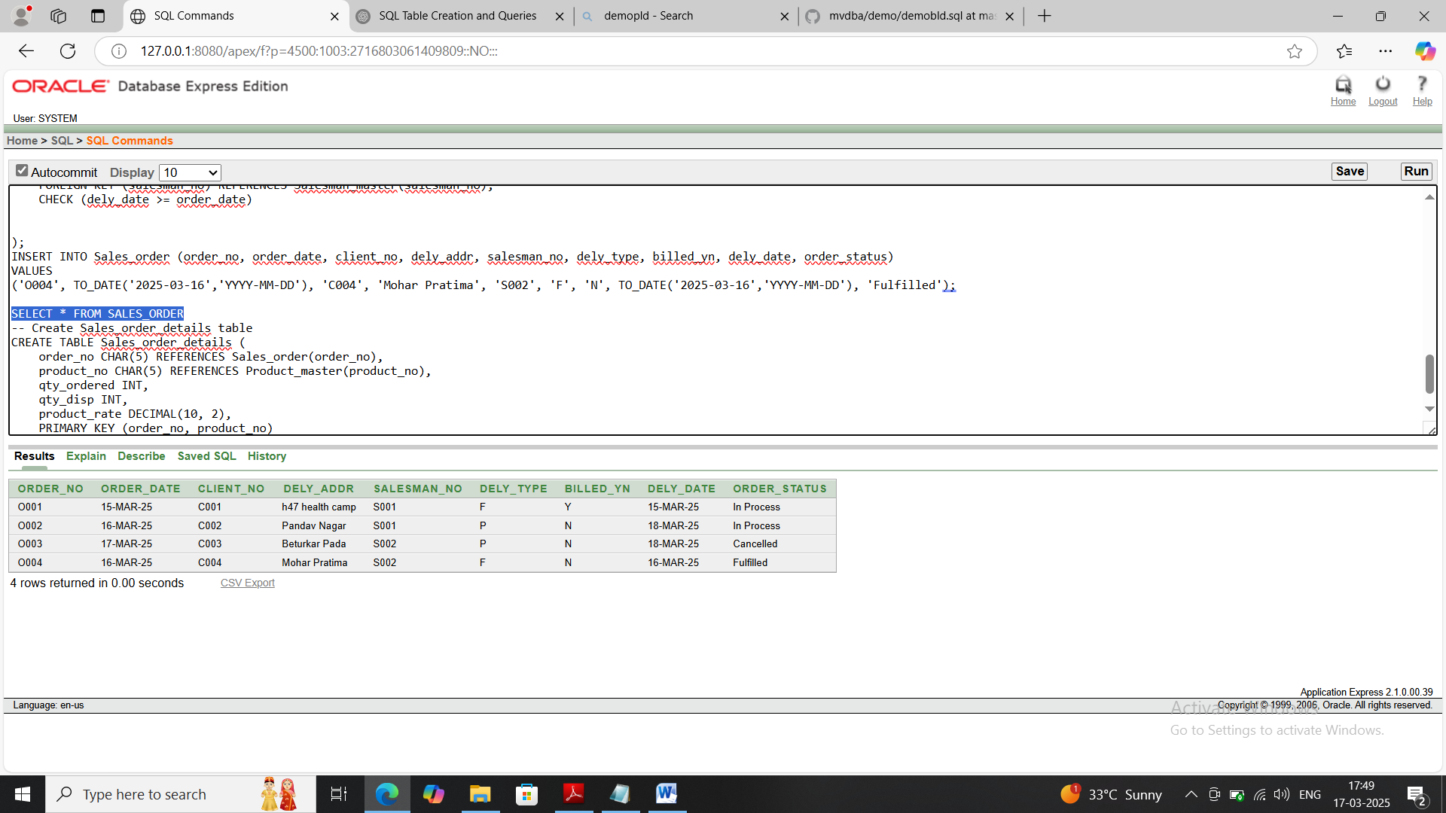

**5)Sales_order_details(order_no, product_no,qty_ordered,qty_disp,product_rate)**

**Query(Create):**

CREATE TABLE Sales_order_details (

order_no CHAR(5) REFERENCES Sales_order(order_no),

product_no CHAR(5) REFERENCES Product_master(product_no),

qty_ordered INT,

qty_disp INT,

product_rate DECIMAL(10, 2),

PRIMARY KEY (order_no, product_no)

);



**Query(desc table):**

desc Sales_order_details

**Output:**

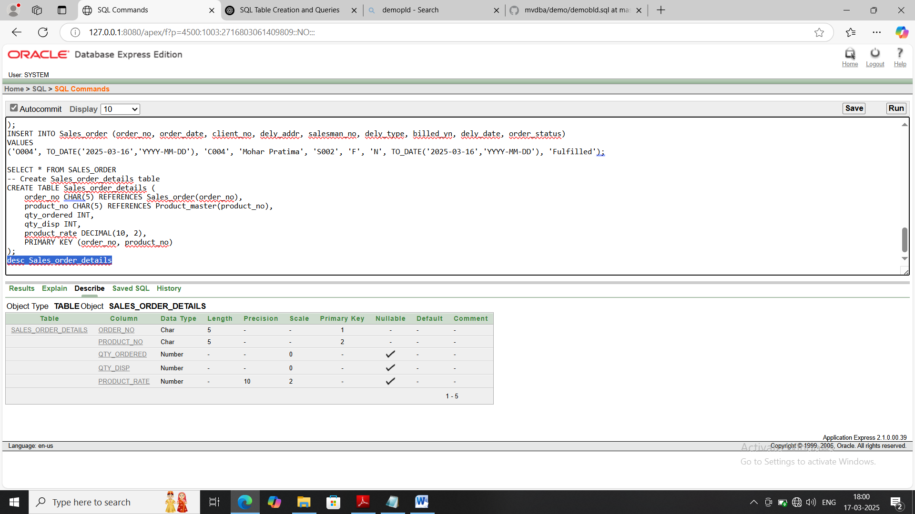

**Query(insert):**

INSERT INTO Sales_order_details (order_no, product_no, qty_ordered, qty_disp, product_rate)

VALUES

('O001', 'P001', 2, 1, 1000.00),

('O001', 'P002', 3, 2, 500.00),

('O002','P003',2,2,300);

**Output:**



**Query(Select):**Select * from Sales_order_details

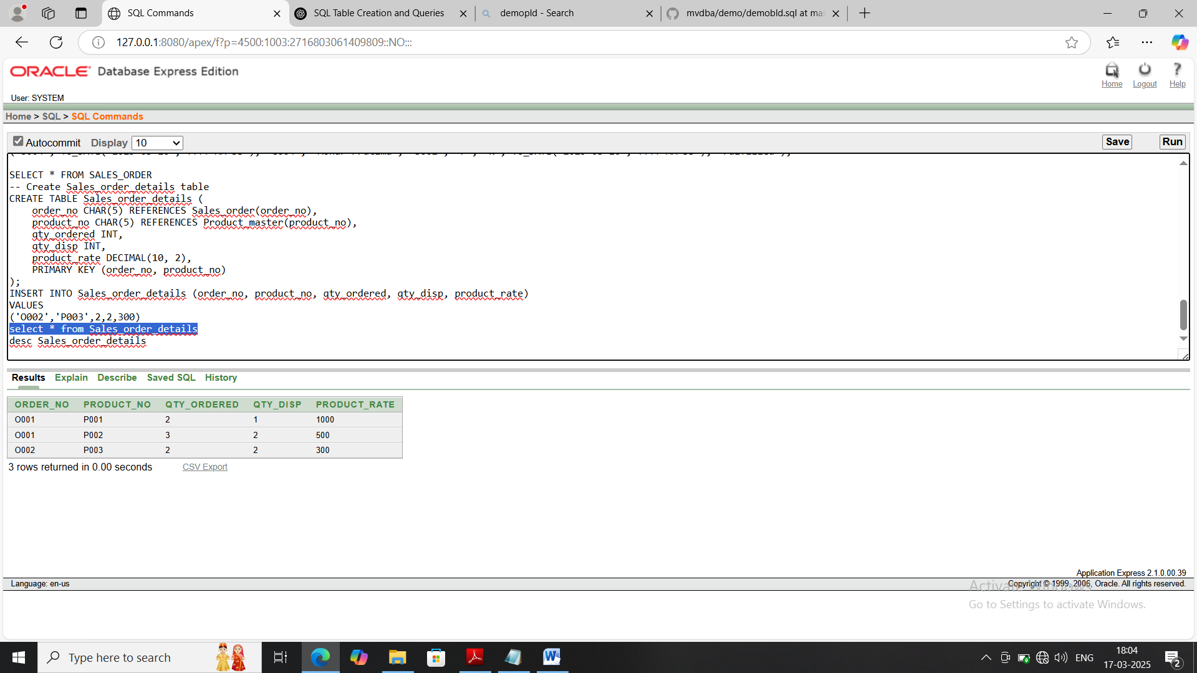**Output**: