|  |  |  |  |
| --- | --- | --- | --- |
| **Class: FYMCA Div:A**  **Semester: 2** | **Course Code:**  **MCA01555**  **Course Name:Database Systems Laboratory** | | **Batch: F2** |
| **Name: Pranav Raju Malwatkar** | | **Roll No: 51037** | |
| **CO No: CO516.2** | | **Assignment No:4** | |

**PRACTICAL SUBMISSION RECORD- A.Y. 2024-25**

**QUE.** Based on the below mentioned schema/tables apply the SQL queries EMP (Empno, Ename, Job, Mgr, Hiredate, Sal, Comm, Dept no) DEPT (Deptno,Dname,Loc)

1. Add a record to the department table with values (50,’PERSONNEL’,’BOSTON’).

**ANS=**

INSERT INTO Dept VALUES (50,'PERSONNEL','BOSTON');

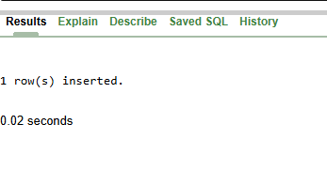

SELECT * FROM Dept where LOC='BOSTON';

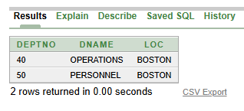

**QUE.** b) If a new person HERALD joins the organization in place of TURNER on the 5th of September 1992 with employee number 7999, make the required changes.

**ANS=**

UPDATE Emp SET Ename = 'HERALD', Hiredate = '05-SEP-92' WHERE Ename = 'TURNER';

UPDATE Emp SET Empno = 7999 WHERE Ename = 'HERALD';

**QUE.** c) Delete all the records of the employees whose job is ‘Computer Programmar’.

**ANS=**

INSERT INTO Emp VALUES (7370,'Komal','CmpPrm', 7901 , '12-JAN-81' , 40000 , 10 , 50);

INSERT INTO Emp VALUES (7371,'TANISHKA','CmpPrm', 7900 , '11-JAN-71' , 60000 , 0 , 12);



select * from Emp;

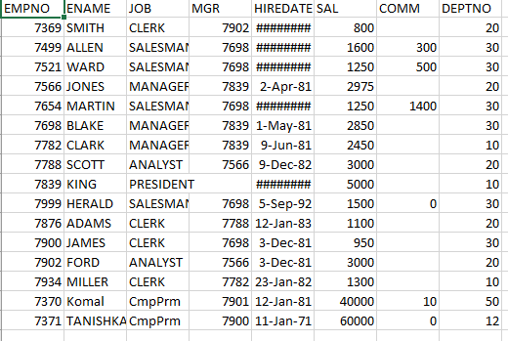

select * from Emp where Job= 'CmpPrm';

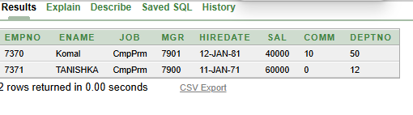

DELETE FROM Emp WHERE Job = 'CmpPrm';

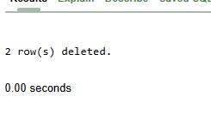

**QUE.** d) Convert the hire date of the employees to the number of years.

**ANS=**

select Ename, Hiredate,

ROUND(MONTHS_BETWEEN(SYSDATE,Hiredate)/12,2)AS Years_of_Services from Emp;

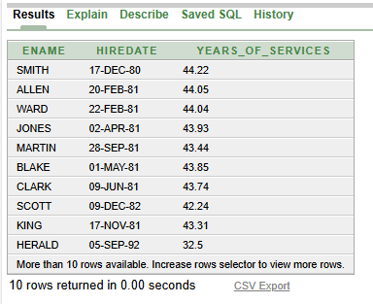

**QUE.** e) Display details of all employees who were hired earliest and latest.

**ANS=**

SELECT * FROM EMP WHERE Hiredate = (SELECT MIN(Hiredate) FROM EMP);

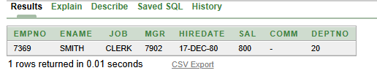

SELECT * FROM EMP WHERE Hiredate = (SELECT MAX(Hiredate) FROM EMP);

