|  |  |  |  |
| --- | --- | --- | --- |
| **Class: FYMCA Div:A**  **Semester: 2** | **Course Code:**  **MCA01555**  **Course Name:Database Systems Laboratory** | | **Batch: F2** |
| **Name: Pranav Raju Malwatkar** | | **Roll No: 51037** | |
| **CO No: CO516.2** | | **Assignment No:5** | |

**PRACTICAL SUBMISSION RECORD- A.Y. 2024-25**

**Tile: Based on the below mentioned schema/tables**

**apply the SQL queries**

**EMP (Empno, Ename, Job, Mgr, Hiredate, Sal,**

**Comm, Dept no)**

**DEPT (Deptno,Dname,Loc)**

**QUE.** f) Find out the department in which the maximum number of employees works.

**ANS=**

SELECT Deptno

FROM (SELECT Deptno, COUNT(*) AS Num_Employees

FROM EMP

GROUP BY Deptno

ORDER BY COUNT(*) DESC)

WHERE ROWNUM = 1;

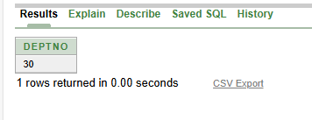

**QUE.** g) Select names of all employees whose names start with ‘S’.

**ANS=**

SELECT Ename FROM EMP WHERE Ename LIKE 'S%';

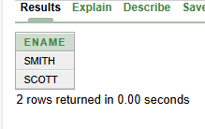

**QUE.** h) Find the day of the week, time of the day, month and century on which SMITH joined.

**ANS=**

SELECT Ename, TO_CHAR(Hiredate, 'Day') AS Day_Of_Week,

TO_CHAR(Hiredate, 'HH24:MI:SS') AS Time_Of_Day,

TO_CHAR(Hiredate, 'Month') AS Month,

TO_CHAR(Hiredate, 'YYYY') AS Century

FROM EMP WHERE Ename = 'SMITH';

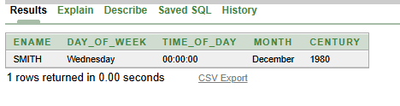

**QUE.** i) Find out details of employees where commission is greater than 7% of salary.

**ANS=**

SELECT * FROM EMP WHERE Comm > (0.07 * Sal);

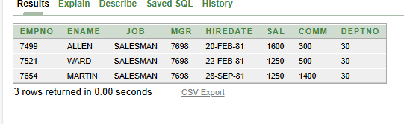

**QUE.** j) Display the names of people and their departments working in either the Sales or Research department

**ANS=**

SELECT Ename, Dname

FROM EMP

INNER JOIN DEPT ON EMP.Deptno = DEPT.Deptno

WHERE UPPER(Dname) IN ('SALES', 'RESEARCH');

