|  |  |  |  |
| --- | --- | --- | --- |
| **Class: FYMCA Div:A**  **Semester: 2** | **Course Code:**  **MCA01555**  **Course Name:Database Systems Laboratory** | | **Batch: F2** |
| **Name: Pranav Raju Malwatkar** | | **Roll No: 51037** | |
| **CO No: CO516.2** | | **Assignment No:6** | |

**PRACTICAL SUBMISSION RECORD- A.Y. 2024-25**

**Que.** Based on the below mentioned schema/tables apply the SQL queries EMP (Empno, Ename, Job, Mgr, Hiredate, Sal, Comm, Dept no) DEPT (Deptno,Dname,Loc)

**a) Display the department name which has more than 3 employees in it**

**Ans.**

SELECT dept.dname, count(emp.empno) AS ecount

from dept

INNER JOIN emp

ON dept.deptno=emp.deptno

GROUP BY dept.dname

HAVING count(emp.empno)>3;

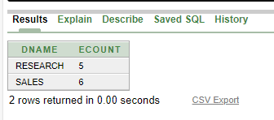

**b) Write a query which concatenates the employee number, his name and manager number. Display the output with spaces in between the columns.**

**Ans.**

SELECT E.Empno|| ' '|| E.Ename|| ' '|| E.Mgr AS Employee_Info

FROM EMP E;

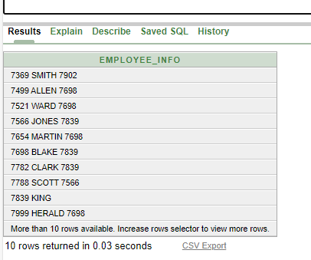

**c) Display the locations of the employees.**

**Ans.**

SELECT E.Ename, E.Sal, D.Loc

FROM EMP E

JOIN DEPT D ON E.Deptno = D.Deptno

WHERE D.Loc = 'CHICAGO';

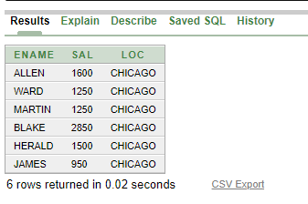

**d) Display name, salary and location of employees who stay in CHICAGO.**

**Ans.**

SELECT E.Ename, E.Sal, D.Loc

FROM EMP E

JOIN DEPT D ON E.Deptno = D.Deptno

WHERE D.Loc = 'CHICAGO';

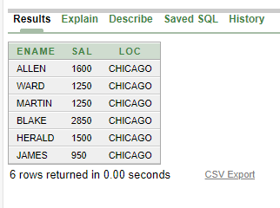

**e) List number, name, job, manager number and manager job of each employee**

**Ans.**

SELECT E.Empno, E.Ename, E.Job, E.Mgr, M.Job AS Manager_Job

FROM EMP E

LEFT JOIN EMP M ON E.Mgr = M.Empno;

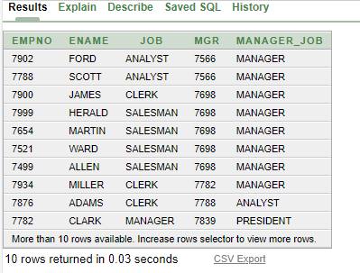

**f) Display information about employees who have the maximum number of employees reporting to him.**

**Ans.**

SELECT E.Empno, E.Ename, E.Job, E.Mgr

FROM EMP E

WHERE E.Empno = (

SELECT M.Mgr

FROM EMP M

GROUP BY M.Mgr

HAVING COUNT(M.Empno) = (

SELECT MAX(NumEmployees)

FROM (

SELECT M.Mgr, COUNT(M.Empno) AS NumEmployees

FROM EMP M

GROUP BY M.Mgr

) AS Subquery

)

);