|  |  |  |  |
| --- | --- | --- | --- |
| **Class: FYMCA Div:A**  **Semester: 2** | **Course Code:**  **MCA01555**  **Course Name:Database Systems Laboratory** | | **Batch: F2** |
| **Name: Pranav Raju Malwatkar** | | **Roll No: 51037** | |
| **CO No: CO516.3** | | **Assignment No:7** | |

**PRACTICAL SUBMISSION RECORD- A.Y. 2024-25**

**Program Title: 7)** **Write a PL/SQL which will accept age of the person if age is more than 18 display message as “Eligible for voting” else display message as “Not eligible for voting”**

**Ans:**

**Case 1:**

**Program Code:**

DECLARE

v_age NUMBER;

BEGIN

v_age := 17;

IF v_age >= 18 THEN

DBMS_OUTPUT.PUT_LINE('Eligible for voting');

ELSE

DBMS_OUTPUT.PUT_LINE('Not eligible for voting');

END IF;

END;

/

**Output:**

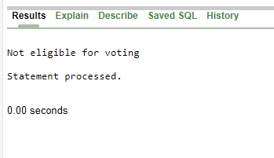

**Case 2:**

DECLARE

v_age NUMBER;

BEGIN

v_age := 20;

IF v_age >= 18 THEN

DBMS_OUTPUT.PUT_LINE('Eligible for voting');

ELSE

DBMS_OUTPUT.PUT_LINE('Not eligible for voting');

END IF;

END;

/

**Output:**

