|  |  |  |  |
| --- | --- | --- | --- |
| **Class: FYMCA Div: A**  **Semester: 2** | **Course Code:**  **MCA01555**  **Course Name: Database Systems Laboratory** | | **Batch: F2** |
| **Name: Pranav Raju Malwatkar** | | **Roll No: 51037** | |
| **CO No: CO516.3** | | **Assignment No:8** | |

**PRACTICAL SUBMISSION RECORD- A.Y. 2024-25**

**Query 8 :** **Perform the following operations with the help of cursors i. Increase salary of each customer by 5000. ii. Retrieve the customer name and address.**

**Ans:**

**Query: create table**

CREATE TABLE customers(

customer_id NUMBER PRIMARY KEY,

customer_name VARCHAR(100),

address VARCHAR(255),

salary NUMBER);

**Query: Insert Values**

INSERT INTO customers VALUES( 1, 'Alice Johnson','123 street, NY', 50000);

INSERT INTO customers VALUES( 2, 'Bob Smith','456 Road,CA', 60000);

INSERT INTO customers VALUES( 3, 'Charlie Brown','789 Avenue, TX', 70000);

**PL/SQL**

DECLARE

CURSOR cust_cursor IS

SELECT customer_id, customer_name, address, salary

FROM customers;

v_customer_id customers.customer_id%TYPE;

v_customer_name customers.customer_name%TYPE;

v_address customers.address%TYPE;

v_salary customers.salary%TYPE;

BEGIN

OPEN cust_cursor;

LOOP

FETCH cust_cursor INTO v_customer_id, v_customer_name, v_address, v_salary;

-- Exit the loop when there are no more rows

EXIT WHEN cust_cursor%NOTFOUND;

-- Update the salary

UPDATE customers

SET salary = salary + 5000

WHERE customer_id = v_customer_id;

-- Output the customer name and address

DBMS_OUTPUT.PUT_LINE('Customer Name: ' || v_customer_name || ' Address: ' || v_address);

END LOOP;

CLOSE cust_cursor;

END;

/

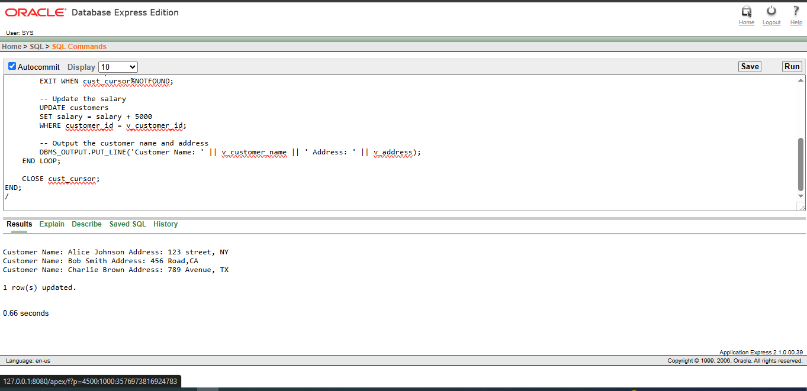

**Results:**

