|  |  |  |  |
| --- | --- | --- | --- |
| **Class: FYMCA Div:A**  **Semester: 2** | **Course Code:**  **MCA01555**  **Course Name:Database Systems Laboratory** | | **Batch: F2** |
| **Name: Pranav Raju Malwatkar** | | **Roll No: 51037** | |
| **CO No: CO516.3** | | **Assignment No:9** | |

**PRACTICAL SUBMISSION RECORD- A.Y. 2024-25**

**Query:** **Create a stored function to perform item_id check operation. Which accepts item_id returns a flag as per the id exist or not.**

**Ans:**

**Query: Create table**

**Create table items (if not created beforehand)**

CREATE TABLE items (

id NUMBER PRIMARY KEY,

name VARCHAR(100)

);

**Query: Insert data**

INSERT INTO items (id,name) VALUES (101,'Laptop');

INSERT INTO items (id,name) VALUES (102,'Phone');

**Query: Create Stored Function**

CREATE OR REPLACE FUNCTION

check_item_exists (p_item_id NUMBER)

RETURN NUMBER

IS

v_count NUMBER;

BEGIN

SELECT COUNT(*) INTO v_count

FROM items WHERE id=p_item_id;

IF v_count >0 THEN

RETURN 1;

ELSE

RETURN 0;

END IF;

END;

/

**Output:**

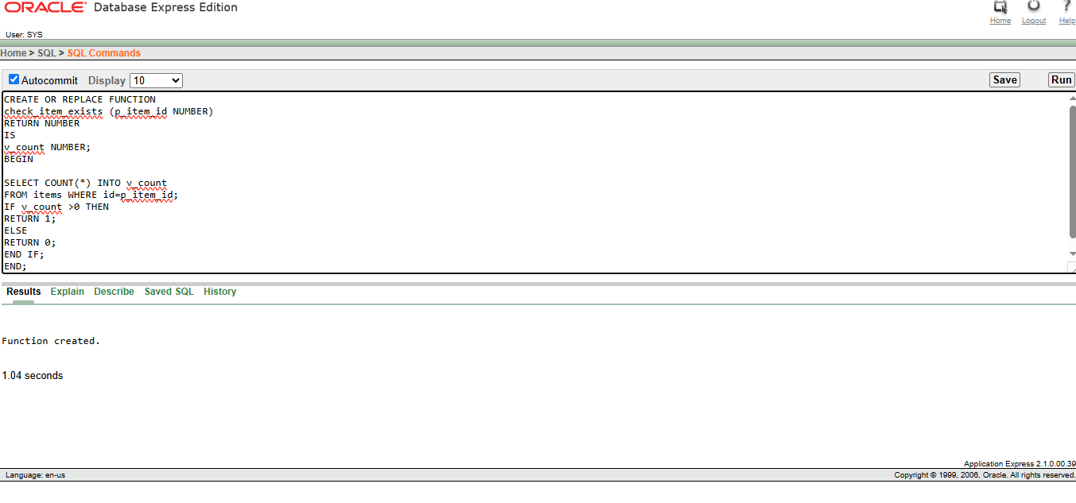

**Query: To check if the item exists**

SELECT check_item_exists(101) FROM

dual;

SELECR check_item_exists(200) FROM

dual;

**Output:**

