PRACTICAL SUBMISSION RECORD- A.Y. 2024-25

Class: FYMCA Div: A  Semester: 3 | Course Code: MCA01602  Course Name: Laboratory Practice - 3 |  | Batch:S2
Name: Pranav Raju Malwatkar |  | Roll No: 51037
CO No: CO607B.4 |  | Assignment No: 8

Title: Set Up Load Balancer - Test traffic distribution by accessing the public IP of the Load Balancer.
Code:
Server1.py
from flask import Flask
app = Flask(__name__)

@app.route('/')
def home():
return "Hello from SERVER 1"

if __name__ == '__main__':
app.run(port=5001)
server2.py
from flask import Flask
app = Flask(__name__)

@app.route('/')
def home():
return "Hello from SERVER 2"

if __name__ == '__main__':
app.run(port=5002)
load_balancer.py
import http.server
import socketserver
import requests
import threading

PORT = 8080
servers = ["http://127.0.0.1:5001", "http://127.0.0.1:5002"]
lock = threading.Lock()
index = 0

class LoadBalancerHandler(http.server.SimpleHTTPRequestHandler):
def do_GET(self):
global index
with lock: # ensure round-robin is thread-safe
target = servers[index % len(servers)]
index += 1

# forward the original request path to the backend and avoid connection reuse

url = target + self.path
try:
response = requests.get(url, timeout=5, headers={"Connection": "close"})
self.send_response(response.status_code)
# copy simple headers
content_type = response.headers.get("Content-Type", "text/html")
self.send_header('Content-type', content_type)
self.end_headers()
self.wfile.write(response.content)
print(f"Forwarded to {target}") # for debugging: shows round-robin sequence
except Exception as e:
self.send_response(500)
self.end_headers()
self.wfile.write(f"Server error: {e}".encode())

if __name__ == "__main__":
print(f"Load Balancer running on http://127.0.0.1:{PORT}")
with socketserver.ThreadingTCPServer(("", PORT), LoadBalancerHandler) as httpd:
httpd.serve_forever()
Output:
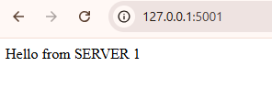
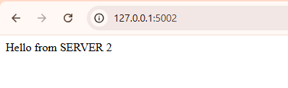
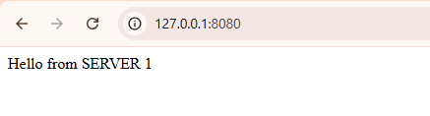
After reference
