**PRACTICAL SUBMISSION RECORD- A.Y. 2024-25**

|  |  |  |  |
| --- | --- | --- | --- |
| **Class: FYMCA Div: A**  **Semester: II** | **Course Code: MCA01554**  **Course Name: Java Programming Laboratory** | | **Batch:F2** |
| **Name: Pranav Raju Malwatkar** | | **Roll No: 51037** | |
| **CO No: CO515.4** | | **Assignment No: 11** | |

**Title:**

**Write JDBC backend class, which establishes a connection with the database having a table “STUDENT” with structure – roll no, name, class, DOB. Using the above backend class WAP to accept roll_no from command line and display the details with proper error messages. Display all the records from table with proper formatting.**

**Code:**

**SQL Description**

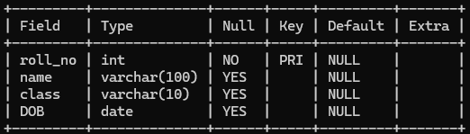

**Records**

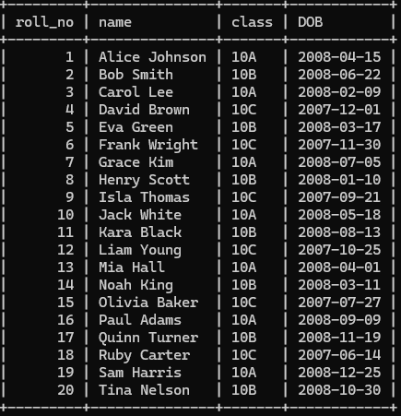

DatabaseManager

package practice_java; import java.sql.*;

public class DatabaseManager {

private static final String ***URL*** = "jdbc:mysql://localhost:3306/java_practice"; private static final String ***USER*** = "root";

private static final String ***PASSWORD*** = ""; private Connection connection;

public DatabaseManager() throws SQLException, ClassNotFoundException { Class.*forName*("com.mysql.cj.jdbc.Driver");

connection = DriverManager.*getConnection*(***URL***, ***USER***, ***PASSWORD***);

}

public Connection getConnection() { return connection;

}

public void close() { try {

if (connection != null) connection.close();

} catch (SQLException e) {

System.***err***.println("Error closing connection: " + e.getMessage());

}

}

}

Main

package practice_java; import java.sql.*; import java.util.Scanner;

public class Assignment_No_11 {

public static void main(String[] args) { Scanner scanner = new Scanner(System.***in***);

try {

DatabaseManager dbManager = new DatabaseManager(); Connection conn = dbManager.getConnection();

System.***out***.print("Enter Roll Number to search: "); int rollNo = scanner.nextInt();

String query = "SELECT * FROM STUDENT WHERE roll_no = ?"; PreparedStatement pstmt = conn.prepareStatement(query);

pstmt.setInt(1, rollNo);

ResultSet rs = pstmt.executeQuery();

if (rs.next()) { System.***out***.println("\nStudent Details:");

System.***out***.printf("Roll No : %d\n", rs.getInt("roll_no")); System.***out***.printf("Name : %s\n", rs.getString("name")); System.***out***.printf("Class : %s\n", rs.getString("class")); System.***out***.printf("DOB : %s\n", rs.getDate("DOB"));

} else {

System.***out***.println("No student found with roll number " + rollNo);

}

System.***out***.println("\nAll Students:"); Statement stmt = conn.createStatement();

ResultSet allRs = stmt.executeQuery("SELECT * FROM STUDENT");

System.***out***.printf("%-10s %-20s %-10s %-15s\n", "Roll No", "Name", "Class", "DOB"); System.***out***.println(" ");

while (allRs.next()) {

System.***out***.printf("%-10d %-20s %-10s %-15s\n", allRs.getInt("roll_no"), allRs.getString("name"), allRs.getString("class"), allRs.getDate("DOB").toString());

}

dbManager.close();

} catch (ClassNotFoundException e) {

System.***err***.println("MySQL JDBC Driver not found. Add the driver to your classpath.");

} catch (SQLException e) {

System.***err***.println("Database error: " + e.getMessage());

}

}

}

**Output:**

