**PRACTICAL SUBMISSION RECORD- A.Y. 2024-25**

|  |  |  |  |
| --- | --- | --- | --- |
| **Class: FYMCA Div: A**  **Semester: II** | **Course Code: MCA01554**  **Course Name: Java Programming Laboratory** | | **Batch:**  **F2** |
| **Name: Pranav Raju Malwatkar** | | **Roll No: 51037** | |
| **CO No: CO515.4** | | **Assignment No: 12** | |

**Title**:

Write a Java program to display the employee id, age, Date of joining, first name and last name using JDBC connectivity. (Assume suitable table structure)

**Table Description**

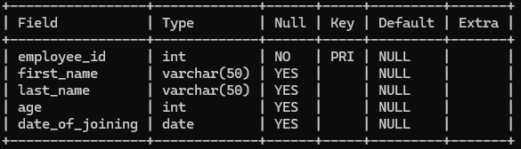

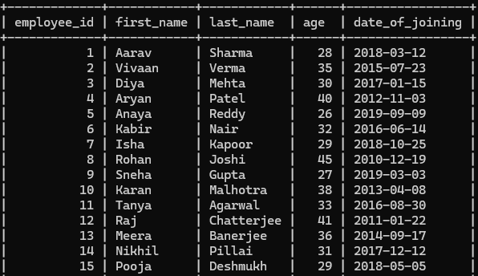**Table Records**

**Code:**

package practice_java; import java.sql.*;

public class Assignment_No_12 {

public static void main(String[] args) {

String url = "jdbc:mysql://localhost:3306/java_practice";

String user = "root"; String password = "";

try {

Class.*forName*("com.mysql.cj.jdbc.Driver");

Connection conn = DriverManager.*getConnection*(url, user, password);

String query = "SELECT employee_id, age, date_of_joining, first_name, last_name FROM EMPLOYEE";

Statement stmt = conn.createStatement(); ResultSet rs = stmt.executeQuery(query); System.***out***.println("\n");

System.***out***.printf("%-12s %-5s %-15s %-15s %-15s\n", "Employee ID", "Age", "Date Joined", "First Name", "Last Name");

System.***out***.println(" ");

while (rs.next()) {

int id = rs.getInt("employee_id"); int age = rs.getInt("age");

Date doj = rs.getDate("date_of_joining"); String first = rs.getString("first_name"); String last = rs.getString("last_name");

System.***out***.printf("%-12d %-5d %-15s %-15s %-15s\n", id, age, doj.toString(), first, last);

}

rs.close();

stmt.close();

conn.close();

} catch (ClassNotFoundException e) { System.***err***.println("JDBC Driver not found.");

} catch (SQLException e) {

System.***err***.println("Database error: " + e.getMessage());

}

}

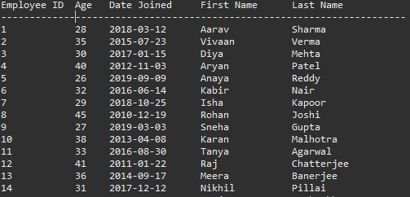}

**Output:**