|  |  |  |  |
| --- | --- | --- | --- |
| **Class: FYMCA Div:A**  **Semester: 2** | **Course Code: MCA01554**  **Course Name: Java Programming Laboratory** | | **Batch: F2** |
| **Name: Pranav Raju Malwatkar** | | **Roll No: 51037** | |
| **CO No: CO515.6** | | **Assignment No:15** | |

**PRACTICAL SUBMISSION RECORD- A.Y. 2024-25**

# Title: Create a CRUD application using Spring MVC. Code:

Student.java

package org.websparrow.model;

public class Student {

// Generate Getter and Setters... private int id;

private String name; private String email; private String course; public int getId() {

return id;

}

public void setId(int id) { this.id = id;

}

public String getName() { return name;

}

public void setName(String name) { this.name = name;

}

public String getEmail() {

return email;

}

public void setEmail(String email) { this.email = email;

}

public String getCourse() { return course;

}

public void setCourse(String course) { this.course = course;

}

}

**CreateController**

import org.springframework.web.servlet.ModelAndView; import org.websparrow.dao.StudentDao;

import org.websparrow.model.Student; @Controller

public class CreateController { @Autowired

private StudentDao studentDao;

@RequestMapping(value = "/create", method = RequestMethod.POST)

public ModelAndView createStudent(@RequestParam("name") String name, @RequestParam("email") String email,

@RequestParam("course") String course, ModelAndView mv) { Student student = new Student();

student.setName(name); student.setEmail(email); student.setCourse(course);

int counter = studentDao.create(student); if (counter > 0) {

mv.addObject("msg", "Student registration successful.");

} else {

mv.addObject("msg", "Error- check the console log.");

}

mv.setViewName("create"); return mv;

}

}

@Controller

public class DeleteController @Autowired

private StudentDao studentDao;

@RequestMapping(value = "/delete/{studentId}")

public ModelAndView deleteStudentById(ModelAndView mv, @PathVariable("studentId") int studentId) throws IOException

int counter = studentDao.delete(studentId); if (counter > 0) {

mv.addObject("msg", "Student records deleted against student id: " + studentId);

} else {

mv.addObject("msg", "Error- check the console log.");

}

mv.setViewName("delete"); return mv;

}

}

package org.websparrow.controller @Controller

public class ReadController { @Autowired

private StudentDao studentDao; @RequestMapping(value = "/read")

public ModelAndView readStudent(ModelAndView model) throws IOException { List<Student> listStudent = studentDao.read(); model.addObject("listStudent", listStudent); model.setViewName("read");

return model;

}

}

package org.websparrow.controller;

@Controller

public class UpdateController { @Autowired

private StudentDao studentDao; @RequestMapping(value = "/update/{studentId}")

public ModelAndView findStudentById(ModelAndView model, @PathVariable("studentId") int studentId) throws IOException {

List<Student> listStudent = studentDao.findStudentById(studentId); model.addObject("listStudent", listStudent); model.setViewName("update");

return model;

}

@RequestMapping(value = "/update", method = RequestMethod.POST)

public ModelAndView updateStudent(@RequestParam("id") int id, @RequestParam("name") String

name,

@RequestParam("email") String email, @RequestParam("course") String course,

ModelAndView mv) {

Student student = new Student(); student.setId(id); student.setName(name); student.setEmail(email);

student.setCourse(course);

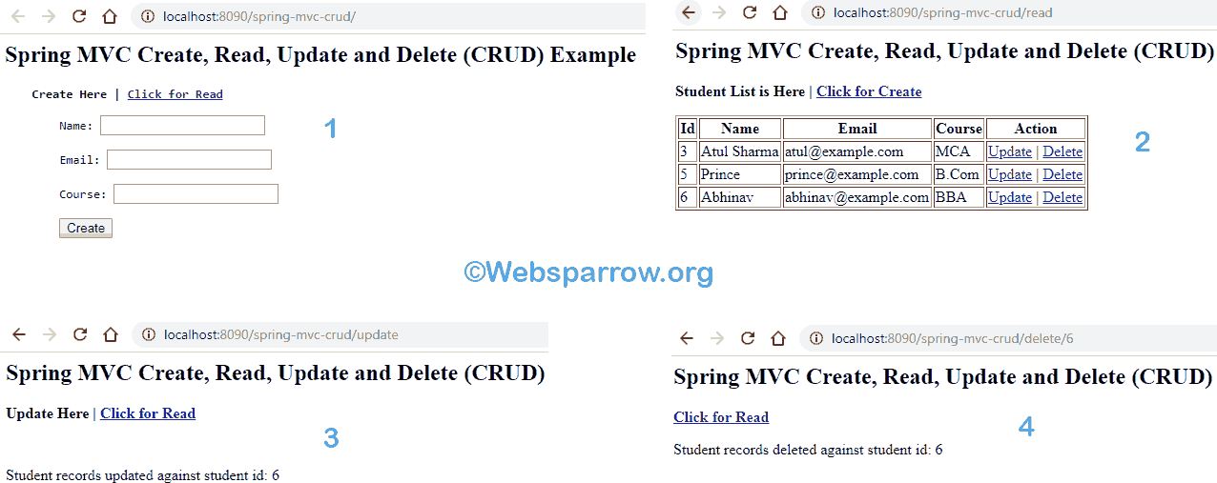

int counter = studentDao.update(student); if (counter > 0) {

mv.addObject("msg", "Student records updated against student id: " + student.getId());

} else { mv.addObject("msg", "Error- check the console log.");} mv.setViewName("update");

return mv;

}

}

**Output:**

