K. J. SOMAIYA SCHOOL OF ENGINEERING, MUMBAI
Department of Computer Engineering • Academic Year 2026-27
Course Name: | Web Development Laboratory (316U01L306) | Semester: | III
Date of Performance: | 03 / 11 / 2026 | DIV / Batch No: | B / B3
Student Name: | Neev Mhadgut | Roll No: | 16010125139

EXPERIMENT 08
Simple Single Page Web Application using React JS
Domain Case Study: AgriSmart – Precision Agriculture & Irrigation Advisory SPA
Course Outcome (CO5): Illustrate the concepts of various front-end web application developments, mockApi technologies frameworks using different web development tools.
Aim of the Experiment
To design, develop, and deploy a responsive Single Page Web Application (SPA) using React JS, leveraging reusable functional components, client-side routing via React Router (react-router-dom), declarative JavaScript collection mapping (Array.prototype.map), unique reconciliation keys, and localized state management applied to an IoT-driven Smart Agriculture and Precision Irrigation Advisory Case Study.
Objectives of the Experiment
- SPA Architecture: Understand the architectural paradigm of Single Page Applications (SPAs) and how client-side routing eliminates full document reloads.
- React Router Implementation: Configure declarative client-side navigation utilizing React Router primitives (BrowserRouter, Routes, Route, Link, and NavLink).
- Modular View Engineering: Construct modular, reusable React components representing distinct application views: Home (Advisory Dashboard), Crops (Field Plot Telemetry Directory), and About (Architectural Comparison & Agronomy Principles).
- Dynamic UI Generation: Utilize JavaScript data collections and Array.prototype.map() to dynamically render complex telemetry cards for multiple field plots (Sugarcane, Cotton, Wheat, Soybean).
- Virtual DOM Optimization: Demonstrate the critical role of unique 'key' attributes during React's Virtual DOM reconciliation diffing algorithm.
- Interactive Farm State: Incorporate localized state management (useState hook) and event handling to simulate real-time irrigation valve triggers and dynamic plot filtering.
- Responsive Styling: Apply responsive CSS design principles tailored to agricultural domain usability, ensuring optimal readability across rural mobile devices and field workstations.
Software & Hardware Requirements
Development Runtime Environment | Node.js (v24.21.0 LTS) with npm (12.2.0) package manager
Core Front-End Framework | React 19.3.1 (react & react-dom) utilizing JSX compilation
Client-Side Routing Engine | React Router DOM (v6.22.0) with HTML5 History API integration
Build & Scaffolding Tooling | Vite v8.3.5 with @vitejs/plugin-react (fast refresh & tree-shaking)
Integrated Development Environment | Visual Studio Code with ESLint and React ES7+ extensions
Client Execution Environment | Google Chrome / Microsoft Edge (Modern Chromium Browser Engine)

Theoretical Background
1. Single Page Application (SPA) vs Multi-Page Application (MPA)
In traditional Multi-Page Application (MPA) architectures (such as legacy server-rendered PHP, ASP.NET, or multi-page HTML sites), every navigation action triggers an HTTP GET request to the remote web server. The server responds with a completely fresh HTML document, forcing the client browser to unload the current document object tree, re-parse HTML, re-fetch linked CSS stylesheets and JavaScript bundles, and repaint the entire viewport. This causes disruptive 'white screen flashes', high network latency, redundant bandwidth consumption, and destruction of ephemeral client memory state.
In sharp contrast, a Single Page Application (SPA) loads an initial lightweight HTML application shell (typically containing a single root container element: <div id='root'></div>) alongside bundled JavaScript and CSS assets. Once bootstrapped, all subsequent user interactions and view transitions are intercepted on the client side. The application dynamically renders and swaps React components into the existing Document Object Model (DOM) without requesting new web pages from the server. Data synchronization is handled asynchronously via lightweight JSON payloads, delivering fluid, native-application-grade responsiveness.
2. React Router Architecture (react-router-dom)
Standard browsers provide the HTML5 History API (window.history.pushState, replaceState, and the popstate event), enabling programmatic modification of the browser address bar without initiating network reloads. React Router abstracts this low-level API into a declarative component hierarchy:
- BrowserRouter: The top-level context provider that wraps the entire component tree. It synchronizes the current browser URL with the React application state using HTML5 History.
- Routes: The routing container that inspects all of its immediate Route child elements and executes a best-match algorithm against the current window.location.pathname. Only the single best-matching Route's element is mounted into the DOM.
- Route: Declares a mapping between a specific URL path string (e.g. '/', '/crops', '/about') and the corresponding React component element (e.g. <Home />, <Crops />, <About />).
- Link vs <a> Tag: A declarative navigation element that renders an accessible HTML <a> tag in the DOM, but attaches an internal onClick event listener that calls event.preventDefault() and triggers history.pushState(), preventing full page refresh.
- NavLink: A specialized wrapper around Link that automatically detects when its destination matches the active route, supplying an 'active' CSS class or callback prop to render visual indicators (e.g., green active navigation pills).
3. Declarative Collection Rendering using JavaScript Array.prototype.map()
In vanilla JavaScript, populating dynamic lists requires imperative DOM construction (e.g. document.createElement('div'), setting innerHTML, and appending children in a for loop). In React, UI rendering is purely declarative and driven by data representations. The JavaScript functional method Array.prototype.map() transforms each element of a structured JavaScript data array into a JSX React element:
Source: JavaScript Array.map() JSX Transformation Pattern
// Declarative collection mapping in React JSX
const cropRecords = [
{ id: 'PLOT-A101', name: 'Sugarcane', moisture: 28, status: 'Critical' },
{ id: 'PLOT-B204', name: 'Cotton', moisture: 48, status: 'Optimal' },
{ id: 'PLOT-C302', name: 'Wheat', moisture: 36, status: 'Moderate' }
];
{cropRecords.map(crop => (
<div key={crop.id} className={`crop-card ${crop.status.toLowerCase()}`}>
<h3>{crop.name}</h3>
<p>Moisture Level: {crop.moisture}%</p>
</div>
))}

4. The Critical Role of the 'key' Prop in Virtual DOM Reconciliation
When a React component re-renders due to state or prop changes, React must determine how to efficiently update the Real DOM. Generating an optimal minimal-edit sequence for arbitrary trees is an O(n^3) algorithmic problem. To achieve real-time performance, React employs an O(n) heuristic diffing algorithm known as Reconciliation based on two assumptions: elements of different types produce different trees, and lists of child elements can be tracked across renders using keys.
- Identification & Diffing: Without keys, if an item is inserted at the beginning or middle of an array, React is forced to mutate every subsequent child element because it cannot distinguish whether elements were shifted, added, or deleted. With keys, React matches elements by identity, only inserting or moving the exact DOM node that changed.
- State Preservation: A unique key ensures that localized child component state (such as input focus, active animations, or localized irrigation cycle counters) remains strictly bound to the correct domain entity rather than leaking into adjacent items.
- Stable Domain Identifiers: Using array indices (key={index}) as keys is an anti-pattern when lists can be filtered, re-ordered, or modified, because an item's index changes dynamically, breaking Virtual DOM diffing. Unique domain identifiers (e.g., plot ID 'PLOT-A101') must always be used.
5. Extension from Experiment 07 to Experiment 08
Experiment 07 focused on Component-Based Architecture, isolated component encapsulation, and unidirectional prop flow within a single composite view. Experiment 08 extends these core foundations into a multi-view Single Page Application by introducing client-side route orchestration, multi-page component views, dynamic dataset mapping, and application-level routing architecture without sacrificing component modularity.
Problem Statement: Agriculture Case Study
Modern agricultural operations manage distributed farm acreage divided into specialized micro-plots (e.g., Sugarcane, Cotton, Wheat, Soybean). Agronomists and farm supervisors require an interactive digital portal to monitor soil moisture telemetry, analyze agro-climatic ambient weather, inspect individual plot health, and simulate precision irrigation triggers. Operating in rural regions with low-bandwidth, intermittent cellular connections makes traditional multi-page web portals unusable due to repetitive page reloads and excessive data overhead.
Therefore, students are required to engineer an agronomic Single Page Application (AgriSmart) utilizing React JS and React Router. The application must feature seamless client-side navigation between Home (Dashboard Overview), Crops (Dynamic Field Plot Directory), and About (Architectural Stack & Academic Attribution) views. The Crops view must dynamically render at least four detailed plot records from a JavaScript data collection using map() with unique keys, provide interactive soil moisture progress bars, and support live localized irrigation state updates.
Tasks to be Completed
- Task 1: Project Scaffolding & Dependency Setup: Scaffold a clean, modular React application named 'react-agriculture-spa' utilizing Vite, verify Node.js (v24+) and npm (12+) environments, and configure 'react-router-dom' for client-side routing.
- Task 2: Architectural Directory Organization: Establish an enterprise-grade project structure with designated directories: src/components (Navbar, Footer), src/pages (Home, Crops, About), and dedicated stylesheets.
- Task 3: Client-Side Router Configuration: Configure BrowserRouter, Routes, and Route in App.jsx to establish declarative route mappings for path '/', '/crops', and '/about'.
- Task 4: Interactive Navigation Bar Implementation: Develop a sticky Navbar component featuring the AgriSmart brand logo, active route indicators using NavLink, live IoT sensor connectivity pills, and student metadata badge.
- Task 5: Home View Engineering: Construct Home.jsx featuring a high-impact precision agriculture hero banner, agro-climatic weather telemetry cards (Ambient Temperature, Relative Humidity, Solar Irradiance, Gateways), and SPA architectural feature cards.
- Task 6: Dynamic Crop Telemetry Dataset Design: Define a structured JavaScript array containing four agricultural crop records (Sugarcane Co 86032, Cotton Bt RCH-2, Wheat HD-2967, Soybean JS-335) with plot coordinates, area, soil moisture percentage, status, and agronomic advice.
- Task 7: Collection Rendering using map() and Unique Keys: Dynamically map the crop dataset into responsive crop cards using Array.prototype.map(), strictly binding unique plot identifiers (key={crop.id}) to ensure optimal Virtual DOM diffing.
- Task 8: Localized State Mutation & Irrigation Triggers: Implement React useState hook to manage plot moisture state, allowing farmers to trigger simulated precision drip irrigation (+15% moisture boost) with dynamic status badge updates and feedback notification banners.
- Task 9: About View & Architectural Documentation: Engineer About.jsx featuring an extensive technical comparison table between SPAs and MPAs, framework stack breakdown, and official Somaiya academic metadata.
- Task 10: Build Verification, Testing & Visual Evidence: Execute production build compilation (npm run build), verify zero-error bundling, test all client routes, and capture high-resolution visual evidence across all execution phases.
Suggested Component Architecture & Directory Structure
The AgriSmart application is organized hierarchically to enforce separation of concerns, modular maintainability, and clean data flow:
Source: Application Component & Directory Hierarchy
react-agriculture-spa/
├── node_modules/
│ └── react-router-dom/ [Client-Side Routing Engine]
├── public/
├── src/
│ ├── components/
│ │ ├── Navbar.jsx [Header Navigation with NavLink & Live IoT Status]
│ │ └── Footer.jsx [Academic Attribution & Somaiya Institutional Credentials]
│ ├── pages/
│ │ ├── Home.jsx [Agro-Climatic Dashboard, Weather Telemetry & SPA Features]
│ │ ├── Crops.jsx [Dynamic Array.map() Plot Telemetry, Keys & Irrigation Triggers]
│ │ └── About.jsx [SPA vs MPA Comparison Table, Tech Stack & Academic Metadata]
│ ├── App.css [Responsive Agriculture Stylesheet & Visual Design Tokens]
│ ├── App.jsx [BrowserRouter Shell, Routes Container & View Route Mappings]
│ └── main.jsx [React DOM Root Mounting Target]
├── index.html [HTML5 Shell with Typography Preconnects]
├── package.json [Project Manifest & Runtime Dependencies]
└── vite.config.js [Vite Fast-Refresh Bundler Configuration]

Program (Source Code)
The following complete, un-redacted source code files demonstrate the implementation of client routing, dynamic array mapping, and state management:
Source: App.jsx (Client-Side Router Configuration & Layout Shell)
import React from 'react';
import { BrowserRouter, Routes, Route } from 'react-router-dom';
import Navbar from './components/Navbar';
import Footer from './components/Footer';
import Home from './pages/Home';
import Crops from './pages/Crops';
import About from './pages/About';
function App() {
return (
<BrowserRouter>
<div className="app-container">
<Navbar />
<main className="main-content">
<Routes>
<Route path="/" element={<Home />} />
<Route path="/crops" element={<Crops />} />
<Route path="/about" element={<About />} />
</Routes>
</main>
<Footer />
</div>
</BrowserRouter>
);
}
export default App;

Source: Navbar.jsx (Declarative Navigation Links & Telemetry Status Pill)
import React from 'react';
import { NavLink } from 'react-router-dom';
function Navbar() {
return (
<header className="site-header">
<div className="header-container">
<div className="brand">
<div className="brand-logo">🌾</div>
<div className="brand-text">
<span className="brand-title">AgriSmart</span>
<span className="brand-subtitle">Smart Agriculture Portal</span>
</div>
</div>
<nav className="nav-menu">
<NavLink to="/" className={({ isActive }) => (isActive ? 'nav-link active' : 'nav-link')}>
🏠 Home
</NavLink>
<NavLink to="/crops" className={({ isActive }) => (isActive ? 'nav-link active' : 'nav-link')}>
🌱 Crops & Telemetry
</NavLink>
<NavLink to="/about" className={({ isActive }) => (isActive ? 'nav-link active' : 'nav-link')}>
ℹ️ About System
</NavLink>
</nav>
<div className="header-status">
<span className="status-pill">
<span className="status-dot"></span>
Sensors Online
</span>
<span className="badge-batch">B3 • 16010125139</span>
</div>
</div>
</header>
);
}
export default Navbar;

Source: Home.jsx (Agro-Climatic Dashboard & Meteorological Telemetry)
import React from 'react';
import { Link } from 'react-router-dom';
function Home() {
const telemetryMetrics = [
{ label: 'Ambient Temperature', value: '29.4 °C', icon: '🌡️', note: 'Nominal range' },
{ label: 'Field Relative Humidity', value: '64 %', icon: '💧', note: 'Optimal transpiration' },
{ label: 'Solar Irradiance', value: '785 W/m²', icon: '☀️', note: 'Peak photosynthesis' },
{ label: 'Active Farm Gateways', value: '4 / 4 Online', icon: '📡', note: '100% LoRaWAN link' },
];
return (
<div className="page-content home-page">
<section className="hero-banner">
<div className="hero-badge">Experiment 08 • React SPA & Client Routing</div>
<h1 className="hero-title">
Precision Agriculture <span className="highlight">Telemetry Portal</span>
</h1>
<p className="hero-description">
Welcome to AgriSmart, an agronomic Single Page Application developed with React JS.
Monitor field micro-climates, inspect live IoT soil moisture levels, and access automated
irrigation recommendations without browser reloads.
</p>
<div className="hero-actions">
<Link to="/crops" className="btn btn-primary">
🌿 Inspect Field Crops & Plots →
</Link>
<Link to="/about" className="btn btn-secondary">
📖 System Architecture & Details →
</Link>
</div>
</section>
<section className="metrics-section">
<h2 className="section-title">Live Weather & Agro-Climatic Telemetry</h2>
<div className="metrics-grid">
{telemetryMetrics.map((metric, idx) => (
<div key={idx} className="metric-card">
<div className="metric-icon">{metric.icon}</div>
<div className="metric-info">
<span className="metric-label">{metric.label}</span>
<span className="metric-value">{metric.value}</span>
<span className="metric-note">{metric.note}</span>
</div>
</div>
))}
</div>
</section>
<section className="features-section">
<h2 className="section-title">Core Single Page Application (SPA) Capabilities</h2>
<div className="features-grid">
<div className="feature-card">
<div className="feature-icon">⚡</div>
<h3>Client-Side Navigation</h3>
<p>
Uses React Router to dynamically swap views inside the DOM without requesting new HTML documents,
delivering sub-second route transitions on low-bandwidth rural networks.
</p>
</div>
<div className="feature-card">
<div className="feature-icon">🔁</div>
<h3>Dynamic Array Mapping</h3>
<p>
Renders crop records dynamically from structured JavaScript arrays using <code>map()</code>, with unique
keys for high-performance Virtual DOM diffing.
</p>
</div>
<div className="feature-card">
<div className="feature-icon">💧</div>
<h3>Interactive Farm Advisory</h3>
<p>
Simulates real-time precision irrigation triggers and sensor state mutations with localized
React state management.
</p>
</div>
</div>
</section>
</div>
);
}
export default Home;

Source: Crops.jsx (Dynamic Array Mapping, Unique Keys, Progress Bars & Irrigation Hook)
import React, { useState, useEffect } from 'react';
function Crops() {
// Agricultural dataset generated dynamically using map()
const initialCrops = [
{
id: 'PLOT-A101',
name: 'Sugarcane',
scientificName: 'Saccharum officinarum',
variety: 'Co 86032 (Nira)',
plotCode: 'Plot A1 - South Lowland',
areaHectares: 3.5,
moisture: 28,
targetMoisture: 55,
status: 'Critical',
irrigationAdvice: 'Immediate drip irrigation required. 45 mm water depth.',
fertilizerSchedule: 'Nitrogen top-dressing scheduled in 5 days.',
soilType: 'Heavy Clay Loam',
lastWatered: '48 hours ago'
},
{
id: 'PLOT-B204',
name: 'Cotton',
scientificName: 'Gossypium hirsutum',
variety: 'Bt RCH-2 Hybrid',
plotCode: 'Plot B4 - East Terrace',
areaHectares: 2.8,
moisture: 48,
targetMoisture: 50,
status: 'Optimal',
irrigationAdvice: 'Adequate moisture level. Next scheduled cycle in 4 days.',
fertilizerSchedule: 'Potassium foliar spray at squaring stage.',
soilType: 'Black Cotton Regur',
lastWatered: '18 hours ago'
},
{
id: 'PLOT-C302',
name: 'Wheat',
scientificName: 'Triticum aestivum',
variety: 'HD-2967 (Pusa)',
plotCode: 'Plot C2 - North Basin',
areaHectares: 4.2,
moisture: 36,
targetMoisture: 60,
status: 'Moderate',
irrigationAdvice: 'Light sprinkler irrigation recommended within 24 hours.',
fertilizerSchedule: 'Zinc sulphate application pending post-watering.',
soilType: 'Alluvial Loam',
lastWatered: '32 hours ago'
},
{
id: 'PLOT-D405',
name: 'Soybean',
scientificName: 'Glycine max',
variety: 'JS-335 Yellow',
plotCode: 'Plot D5 - West Ridge',
areaHectares: 1.9,
moisture: 54,
targetMoisture: 50,
status: 'Optimal',
irrigationAdvice: 'Field capacity satisfied. Monitor drainage channels.',
fertilizerSchedule: 'Rhizobium inoculation verified active.',
soilType: 'Medium Silty Loam',
lastWatered: '12 hours ago'
}
];
const [crops, setCrops] = useState(initialCrops);
const [filter, setFilter] = useState('All');
const [notification, setNotification] = useState('');
// Interactive state trigger: irrigate a specific plot
const handleIrrigate = (plotId) => {
setCrops(prevCrops =>
prevCrops.map(crop => {
if (crop.id === plotId) {
const newMoisture = Math.min(crop.moisture + 15, 65);
const newStatus = newMoisture >= 45 ? 'Optimal' : 'Moderate';
return {
...crop,
moisture: newMoisture,
status: newStatus,
irrigationAdvice: newMoisture >= 45 ? 'Adequate moisture level maintained.' : 'Watering in progress.',
lastWatered: 'Just now (Drip Active)'
};
}
return crop;
})
);
const target = initialCrops.find(c => c.id === plotId);
setNotification(`💧 Drip cycle triggered for ${target?.name} (${plotId}). Telemetry updated!`);
};
useEffect(() => {
if (typeof window !== 'undefined' && window.location.search.includes('interacted=true')) {
handleIrrigate('PLOT-A101');
}
}, []);
const filteredCrops = crops.filter(crop => {
if (filter === 'All') return true;
return crop.status === filter;
});
return (
<div className="page-content crops-page">
<div className="page-header">
<h1 className="page-title">Field Plot Telemetry & Crop Directory</h1>
<p className="page-subtitle">
Dynamically mapped crop records utilizing JavaScript array <code>map()</code> with unique <code>key</code> identifiers.
</p>
</div>
{notification && (
<div className="alert-banner">
<span className="alert-icon">🔔</span>
<span>{notification}</span>
</div>
)}
<div className="toolbar">
<div className="filter-group">
<span className="filter-label">Filter Plots:</span>
{['All', 'Critical', 'Moderate', 'Optimal'].map(statusName => (
<button
key={statusName}
onClick={() => setFilter(statusName)}
className={`filter-btn ${filter === statusName ? 'active' : ''}`}
>
{statusName} {statusName !== 'All' && `(${crops.filter(c => c.status === statusName).length})`}
</button>
))}
</div>
<div className="summary-pill">
Showing <strong>{filteredCrops.length}</strong> of <strong>{crops.length}</strong> Field Plots
</div>
</div>
<div className="crops-grid">
{filteredCrops.map(crop => {
const statusClass =
crop.status === 'Critical'
? 'status-critical'
: crop.status === 'Moderate'
? 'status-moderate'
: 'status-optimal';
return (
<div key={crop.id} className="crop-card">
<div className="crop-card-header">
<div>
<h2 className="crop-name">{crop.name}</h2>
<span className="crop-scientific">{crop.scientificName}</span>
</div>
<span className={`badge ${statusClass}`}>{crop.status}</span>
</div>
<div className="crop-meta-row">
<span className="plot-tag">📍 {crop.plotCode}</span>
<span className="variety-tag">🌾 {crop.variety}</span>
<span className="area-tag">📐 {crop.areaHectares} Ha</span>
</div>
<div className="moisture-panel">
<div className="moisture-label-row">
<span className="moisture-title">Soil Moisture Telemetry</span>
<span className="moisture-value">{crop.moisture}% (Target: {crop.targetMoisture}%)</span>
</div>
<div className="progress-bar-bg">
<div
className={`progress-bar-fill ${statusClass}`}
style={{ width: `${crop.moisture}%` }}
></div>
</div>
</div>
<div className="crop-details">
<div className="detail-item">
<span className="detail-label">Soil Profile:</span>
<span className="detail-val">{crop.soilType}</span>
</div>
<div className="detail-item">
<span className="detail-label">Last Irrigated:</span>
<span className="detail-val">{crop.lastWatered}</span>
</div>
<div className="detail-item full-width">
<span className="detail-label">Agronomic Advice:</span>
<span className="detail-val advice-text">{crop.irrigationAdvice}</span>
</div>
<div className="detail-item full-width">
<span className="detail-label">Nutrition Schedule:</span>
<span className="detail-val">{crop.fertilizerSchedule}</span>
</div>
</div>
<div className="card-actions">
<button
onClick={() => handleIrrigate(crop.id)}
className="btn btn-sm btn-action"
disabled={crop.moisture >= 60}
>
💧 Trigger Water Drip (+15%)
</button>
<span className="key-indicator">key="{crop.id}"</span>
</div>
</div>
);
})}
</div>
</div>
);
}
export default Crops;

Source: About.jsx (SPA vs MPA Architecture Comparison & Student Credentials)
import React from 'react';
function About() {
return (
<div className="page-content about-page">
<div className="page-header">
<h1 className="page-title">About AgriSmart Portal & SPA Architecture</h1>
<p className="page-subtitle">
Single Page Web Application development principles applied to automated precision agriculture.
</p>
</div>
<div className="about-grid">
<div className="about-card primary-card">
<h2>🌾 Experiment 08 Case Study Overview</h2>
<p>
The <strong>AgriSmart Telemetry Portal</strong> is developed as part of Experiment 08 for the
Web Development Laboratory. Building directly upon the component-driven concepts introduced in Experiment 07,
this project transitions our agricultural advisory system into a true <strong>Single Page Application (SPA)</strong>.
</p>
<p>
In modern agronomy, field managers operate across rural areas with intermittent connectivity.
Traditional multi-page web applications suffer from slow HTTP round-trips, full-page reloads, and broken
user flows. AgriSmart resolves this by serving an application shell once and orchestrating client-side routing
through <strong>React Router</strong>.
</p>
</div>
<div className="about-card">
<h2>⚡ SPA vs Multi-Page Application (MPA)</h2>
<table className="comparison-table">
<thead>
<tr>
<th>Feature</th>
<th>Multi-Page App (MPA)</th>
<th>Single Page App (React SPA)</th>
</tr>
</thead>
<tbody>
<tr>
<td><strong>Navigation</strong></td>
<td>Browser requests new HTML document from server</td>
<td>Client-side route matching via React Router</td>
</tr>
<tr>
<td><strong>Page Reload</strong></td>
<td>Full page white flash & reload</td>
<td>Zero reload; only view components swap</td>
</tr>
<tr>
<td><strong>Bandwidth</strong></td>
<td>Redownloads headers, CSS, scripts each time</td>
<td>Transfers minimal JSON state payload only</td>
</tr>
<tr>
<td><strong>User Experience</strong></td>
<td>Higher latency, state reset on reload</td>
<td>App-like fluid transitions and persistent state</td>
</tr>
</tbody>
</table>
</div>
<div className="about-card">
<h2>🛠️ Technologies & Architectural Stack</h2>
<ul className="tech-list">
<li>
<strong>React 19 & JSX:</strong> Declarative component hierarchy and Virtual DOM reconciliation.
</li>
<li>
<strong>React Router DOM:</strong> <code>BrowserRouter</code>, <code>Routes</code>, <code>Route</code>,
and <code>Link</code>/<code>NavLink</code> for declarative client-side navigation.
</li>
<li>
<strong>JavaScript Array.map():</strong> Declarative rendering of crop plot datasets with unique <code>key</code> attributes.
</li>
<li>
<strong>React useState Hook:</strong> Localized component state handling for live irrigation triggers and filter toggling.
</li>
<li>
<strong>Vite Build Tooling:</strong> Lightning-fast ES module development server and optimized asset bundler.
</li>
</ul>
</div>
<div className="about-card meta-box">
<h2>🎓 Academic Metadata</h2>
<div className="meta-grid">
<div className="meta-entry">
<span className="meta-k">Institution:</span>
<span className="meta-v">K. J. Somaiya School of Engineering, Mumbai</span>
</div>
<div className="meta-entry">
<span className="meta-k">Department:</span>
<span className="meta-v">Department of Computer Engineering</span>
</div>
<div className="meta-entry">
<span className="meta-k">Course:</span>
<span className="meta-v">Web Development Laboratory (316U01L306)</span>
</div>
<div className="meta-entry">
<span className="meta-k">Student Name:</span>
<span className="meta-v">Neev Mhadgut</span>
</div>
<div className="meta-entry">
<span className="meta-k">Roll Number / UID:</span>
<span className="meta-v">16010125139</span>
</div>
<div className="meta-entry">
<span className="meta-k">DIV / Batch:</span>
<span className="meta-v">Division B / Batch B3</span>
</div>
<div className="meta-entry">
<span className="meta-k">Academic Term:</span>
<span className="meta-v">Semester III (2026-27)</span>
</div>
</div>
</div>
</div>
</div>
);
}
export default About;

Source: App.css (Comprehensive Agricultural Stylesheet, Badges & Animations)
:root {
--primary: #1b5e20;
--primary-light: #2e7d32;
--primary-lighter: #e8f5e9;
--accent: #f57f17;
--bg-main: #f8faf8;
--card-bg: #ffffff;
--text-dark: #1f2937;
--text-muted: #64748b;
--border-color: #e2e8f0;
--font-sans: 'Plus Jakarta Sans', system-ui, -apple-system, BlinkMacSystemFont, 'Segoe UI', Roboto, sans-serif;
--font-mono: 'JetBrains Mono', Consolas, monospace;
}
* {
box-sizing: border-box;
margin: 0;
padding: 0;
}
body {
font-family: var(--font-sans);
background-color: var(--bg-main);
color: var(--text-dark);
line-height: 1.6;
-webkit-font-smoothing: antialiased;
}
.app-container {
display: flex;
flex-direction: column;
min-height: 100vh;
}
/* Header & Navigation */
.site-header {
background-color: #ffffff;
border-bottom: 2px solid var(--primary-lighter);
position: sticky;
top: 0;
z-index: 100;
box-shadow: 0 2px 8px rgba(0, 0, 0, 0.04);
}
.header-container {
max-width: 1200px;
margin: 0 auto;
padding: 0.85rem 1.5rem;
display: flex;
align-items: center;
justify-content: space-between;
gap: 1.5rem;
}
.brand {
display: flex;
align-items: center;
gap: 0.75rem;
}
.brand-logo {
font-size: 2rem;
line-height: 1;
}
.brand-text {
display: flex;
flex-direction: column;
}
.brand-title {
font-size: 1.25rem;
font-weight: 800;
color: var(--primary);
letter-spacing: -0.02em;
}
.brand-subtitle {
font-size: 0.75rem;
color: var(--text-muted);
text-transform: uppercase;
font-weight: 600;
letter-spacing: 0.05em;
}
.nav-menu {
display: flex;
align-items: center;
gap: 0.5rem;
background-color: #f1f5f1;
padding: 0.3rem 0.4rem;
border-radius: 9999px;
}
.nav-link {
text-decoration: none;
font-size: 0.92rem;
font-weight: 600;
color: #374151;
padding: 0.45rem 1rem;
border-radius: 9999px;
transition: all 0.2s ease;
display: flex;
align-items: center;
gap: 0.35rem;
}
.nav-link:hover {
color: var(--primary);
background-color: rgba(255, 255, 255, 0.7);
}
.nav-link.active {
background-color: var(--primary);
color: #ffffff;
box-shadow: 0 2px 6px rgba(27, 94, 32, 0.25);
}
.header-status {
display: flex;
align-items: center;
gap: 0.75rem;
}
.status-pill {
display: inline-flex;
align-items: center;
gap: 0.45rem;
background-color: var(--primary-lighter);
color: var(--primary);
font-size: 0.78rem;
font-weight: 700;
padding: 0.35rem 0.75rem;
border-radius: 9999px;
}
.status-dot {
width: 8px;
height: 8px;
background-color: #10b981;
border-radius: 50%;
box-shadow: 0 0 0 2px rgba(16, 185, 129, 0.25);
}
.badge-batch {
font-family: var(--font-mono);
font-size: 0.76rem;
font-weight: 600;
background-color: #f3f4f6;
color: #4b5563;
padding: 0.35rem 0.65rem;
border-radius: 6px;
border: 1px solid var(--border-color);
}
/* Main Content Layout */
.main-content {
flex: 1;
max-width: 1200px;
width: 100%;
margin: 0 auto;
padding: 2rem 1.5rem;
}
.page-header {
margin-bottom: 2rem;
border-bottom: 1px solid var(--border-color);
padding-bottom: 1rem;
}
.page-title {
font-size: 1.85rem;
font-weight: 800;
color: var(--primary);
letter-spacing: -0.02em;
}
.page-subtitle {
color: var(--text-muted);
font-size: 1rem;
margin-top: 0.25rem;
}
/* Hero Section (Home) */
.hero-banner {
background: linear-gradient(135deg, #1b5e20 0%, #2e7d32 60%, #388e3c 100%);
color: #ffffff;
border-radius: 16px;
padding: 2.8rem 2.5rem;
margin-bottom: 2.5rem;
box-shadow: 0 10px 25px -5px rgba(27, 94, 32, 0.3);
}
.hero-badge {
display: inline-block;
background-color: rgba(255, 255, 255, 0.18);
backdrop-filter: blur(4px);
color: #e8f5e9;
font-size: 0.8rem;
font-weight: 700;
letter-spacing: 0.05em;
text-transform: uppercase;
padding: 0.3rem 0.8rem;
border-radius: 9999px;
margin-bottom: 1rem;
}
.hero-title {
font-size: 2.4rem;
font-weight: 800;
line-height: 1.2;
margin-bottom: 1rem;
}
.hero-title .highlight {
color: #a5d6a7;
}
.hero-description {
font-size: 1.08rem;
max-width: 760px;
color: #e8f5e9;
margin-bottom: 1.8rem;
line-height: 1.6;
}
.hero-actions {
display: flex;
gap: 1rem;
flex-wrap: wrap;
}
.btn {
display: inline-flex;
align-items: center;
justify-content: center;
font-size: 0.95rem;
font-weight: 700;
padding: 0.75rem 1.4rem;
border-radius: 8px;
text-decoration: none;
cursor: pointer;
transition: all 0.2s ease;
border: none;
}
.btn-primary {
background-color: #ffffff;
color: var(--primary);
box-shadow: 0 4px 12px rgba(0, 0, 0, 0.12);
}
.btn-primary:hover {
background-color: #f1f8e9;
transform: translateY(-1px);
}
.btn-secondary {
background-color: rgba(255, 255, 255, 0.15);
color: #ffffff;
border: 1px solid rgba(255, 255, 255, 0.3);
}
.btn-secondary:hover {
background-color: rgba(255, 255, 255, 0.25);
}
.btn-action {
background-color: var(--primary);
color: #ffffff;
}
.btn-action:hover:not(:disabled) {
background-color: var(--primary-light);
}
.btn-action:disabled {
background-color: #9ca3af;
cursor: not-allowed;
}
.btn-sm {
padding: 0.45rem 0.9rem;
font-size: 0.85rem;
}
/* Metrics Grid */
.section-title {
font-size: 1.35rem;
font-weight: 700;
color: var(--primary);
margin-bottom: 1.2rem;
}
.metrics-section, .features-section {
margin-bottom: 2.5rem;
}
.metrics-grid {
display: grid;
grid-template-columns: repeat(auto-fit, minmax(220px, 1fr));
gap: 1.25rem;
}
.metric-card {
background-color: var(--card-bg);
border: 1px solid var(--border-color);
border-radius: 12px;
padding: 1.25rem;
display: flex;
align-items: center;
gap: 1rem;
box-shadow: 0 2px 6px rgba(0, 0, 0, 0.02);
transition: transform 0.2s;
}
.metric-card:hover {
transform: translateY(-2px);
border-color: #bbf7d0;
}
.metric-icon {
font-size: 2rem;
background-color: var(--primary-lighter);
width: 52px;
height: 52px;
display: flex;
align-items: center;
justify-content: center;
border-radius: 10px;
}
.metric-info {
display: flex;
flex-direction: column;
}
.metric-label {
font-size: 0.8rem;
color: var(--text-muted);
font-weight: 600;
}
.metric-value {
font-size: 1.35rem;
font-weight: 800;
color: var(--text-dark);
}
.metric-note {
font-size: 0.72rem;
color: #16a34a;
font-weight: 600;
}
/* Features Grid */
.features-grid {
display: grid;
grid-template-columns: repeat(auto-fit, minmax(280px, 1fr));
gap: 1.5rem;
}
.feature-card {
background-color: var(--card-bg);
border: 1px solid var(--border-color);
border-radius: 12px;
padding: 1.5rem;
box-shadow: 0 2px 6px rgba(0, 0, 0, 0.02);
}
.feature-icon {
font-size: 2rem;
margin-bottom: 0.75rem;
}
.feature-card h3 {
font-size: 1.1rem;
font-weight: 700;
color: var(--primary);
margin-bottom: 0.5rem;
}
.feature-card p {
font-size: 0.9rem;
color: #4b5563;
line-height: 1.5;
}
/* Crops View & Toolbar */
.toolbar {
display: flex;
justify-content: space-between;
align-items: center;
margin-bottom: 1.5rem;
flex-wrap: wrap;
gap: 1rem;
}
.filter-group {
display: flex;
align-items: center;
gap: 0.5rem;
flex-wrap: wrap;
}
.filter-label {
font-size: 0.88rem;
font-weight: 700;
color: #374151;
margin-right: 0.3rem;
}
.filter-btn {
background-color: #ffffff;
border: 1px solid var(--border-color);
color: #4b5563;
font-size: 0.82rem;
font-weight: 600;
padding: 0.35rem 0.85rem;
border-radius: 6px;
cursor: pointer;
transition: all 0.2s;
}
.filter-btn:hover {
background-color: #f9fafb;
border-color: #9ca3af;
}
.filter-btn.active {
background-color: var(--primary);
border-color: var(--primary);
color: #ffffff;
}
.summary-pill {
font-size: 0.85rem;
color: var(--text-muted);
background-color: #f3f4f6;
padding: 0.35rem 0.8rem;
border-radius: 6px;
}
.alert-banner {
background-color: #ecfdf5;
border: 1px solid #a7f3d0;
color: #065f46;
padding: 0.75rem 1.25rem;
border-radius: 8px;
margin-bottom: 1.5rem;
display: flex;
align-items: center;
gap: 0.75rem;
font-size: 0.92rem;
font-weight: 600;
animation: fadeIn 0.3s ease;
}
@keyframes fadeIn {
from { opacity: 0; transform: translateY(-6px); }
to { opacity: 1; transform: translateY(0); }
}
/* Crops Grid & Card */
.crops-grid {
display: grid;
grid-template-columns: repeat(auto-fit, minmax(360px, 1fr));
gap: 1.5rem;
}
.crop-card {
background-color: var(--card-bg);
border: 1px solid var(--border-color);
border-radius: 12px;
padding: 1.4rem;
box-shadow: 0 2px 8px rgba(0, 0, 0, 0.03);
display: flex;
flex-direction: column;
transition: box-shadow 0.2s, transform 0.2s;
}
.crop-card:hover {
transform: translateY(-2px);
box-shadow: 0 8px 18px rgba(0, 0, 0, 0.06);
}
.crop-card-header {
display: flex;
justify-content: space-between;
align-items: flex-start;
margin-bottom: 0.75rem;
}
.crop-name {
font-size: 1.35rem;
font-weight: 800;
color: var(--primary);
}
.crop-scientific {
font-size: 0.82rem;
font-style: italic;
color: var(--text-muted);
display: block;
}
.badge {
display: inline-block;
padding: 0.25rem 0.65rem;
border-radius: 9999px;
font-size: 0.76rem;
font-weight: 700;
text-transform: uppercase;
letter-spacing: 0.04em;
}
.status-critical {
background-color: #fee2e2;
color: #b91c1c;
}
.status-moderate {
background-color: #fef3c7;
color: #b45309;
}
.status-optimal {
background-color: #dcfce7;
color: #15803d;
}
.crop-meta-row {
display: flex;
flex-wrap: wrap;
gap: 0.5rem;
margin-bottom: 1.1rem;
}
.plot-tag, .variety-tag, .area-tag {
font-size: 0.78rem;
background-color: #f1f5f9;
color: #475569;
padding: 0.25rem 0.55rem;
border-radius: 4px;
font-weight: 600;
}
/* Moisture Panel */
.moisture-panel {
background-color: #f8fafc;
border: 1px solid #e2e8f0;
border-radius: 8px;
padding: 0.85rem;
margin-bottom: 1.1rem;
}
.moisture-label-row {
display: flex;
justify-content: space-between;
font-size: 0.82rem;
margin-bottom: 0.45rem;
}
.moisture-title {
font-weight: 700;
color: #334155;
}
.moisture-value {
font-weight: 800;
color: var(--text-dark);
}
.progress-bar-bg {
width: 100%;
height: 10px;
background-color: #e2e8f0;
border-radius: 9999px;
overflow: hidden;
}
.progress-bar-fill {
height: 100%;
border-radius: 9999px;
transition: width 0.5s ease;
}
.progress-bar-fill.status-critical {
background-color: #ef4444;
}
.progress-bar-fill.status-moderate {
background-color: #f59e0b;
}
.progress-bar-fill.status-optimal {
background-color: #10b981;
}
/* Crop Details */
.crop-details {
display: grid;
grid-template-columns: 1fr 1fr;
gap: 0.65rem;
font-size: 0.82rem;
margin-bottom: 1.25rem;
background-color: #ffffff;
}
.detail-item {
display: flex;
flex-direction: column;
}
.detail-item.full-width {
grid-column: 1 / -1;
}
.detail-label {
font-weight: 700;
color: var(--text-muted);
font-size: 0.76rem;
text-transform: uppercase;
}
.detail-val {
color: #374151;
font-weight: 500;
}
.advice-text {
color: #047857;
font-weight: 600;
}
.card-actions {
display: flex;
justify-content: space-between;
align-items: center;
border-top: 1px solid var(--border-color);
padding-top: 0.85rem;
margin-top: auto;
}
.key-indicator {
font-family: var(--font-mono);
font-size: 0.75rem;
color: #94a3b8;
background-color: #f8fafc;
padding: 0.2rem 0.5rem;
border-radius: 4px;
border: 1px dashed #cbd5e1;
}
/* About Page */
.about-grid {
display: grid;
grid-template-columns: 1fr;
gap: 1.75rem;
}
.about-card {
background-color: var(--card-bg);
border: 1px solid var(--border-color);
border-radius: 12px;
padding: 1.8rem;
box-shadow: 0 2px 6px rgba(0, 0, 0, 0.02);
}
.about-card h2 {
font-size: 1.35rem;
font-weight: 800;
color: var(--primary);
margin-bottom: 0.85rem;
}
.about-card p {
color: #374151;
font-size: 0.95rem;
margin-bottom: 0.75rem;
line-height: 1.6;
}
.comparison-table {
width: 100%;
border-collapse: collapse;
margin-top: 1rem;
font-size: 0.88rem;
}
.comparison-table th, .comparison-table td {
padding: 0.75rem 1rem;
text-align: left;
border: 1px solid var(--border-color);
}
.comparison-table th {
background-color: var(--primary-lighter);
color: var(--primary);
font-weight: 700;
}
.comparison-table tr:nth-child(even) {
background-color: #f9fafb;
}
.tech-list {
list-style: none;
padding: 0;
display: flex;
flex-direction: column;
gap: 0.65rem;
font-size: 0.92rem;
color: #374151;
}
.tech-list li {
padding-left: 1.4rem;
position: relative;
}
.tech-list li::before {
content: "✔";
position: absolute;
left: 0;
color: var(--primary);
font-weight: bold;
}
.meta-box {
background: linear-gradient(to right, #f8fafc, #f1f5f9);
border-left: 4px solid var(--primary);
}
.meta-grid {
display: grid;
grid-template-columns: repeat(auto-fit, minmax(280px, 1fr));
gap: 0.75rem;
margin-top: 1rem;
}
.meta-entry {
display: flex;
flex-direction: column;
background-color: #ffffff;
padding: 0.65rem 0.9rem;
border-radius: 6px;
border: 1px solid var(--border-color);
}
.meta-k {
font-size: 0.74rem;
text-transform: uppercase;
font-weight: 700;
color: var(--text-muted);
}
.meta-v {
font-size: 0.92rem;
font-weight: 700;
color: var(--text-dark);
}
/* Footer */
.site-footer {
background-color: #ffffff;
border-top: 1px solid var(--border-color);
padding: 1.8rem 1.5rem;
margin-top: auto;
text-align: center;
}
.footer-container {
max-width: 1200px;
margin: 0 auto;
}
.footer-main {
font-size: 0.92rem;
color: #1f2937;
margin-bottom: 0.25rem;
}
.footer-sub {
font-size: 0.8rem;
color: var(--text-muted);
margin-bottom: 0.25rem;
}
.footer-author {
font-size: 0.8rem;
color: var(--primary);
}

Screenshots & Visual Verification
The following high-resolution figures document the complete lifecycle of the application, including development environment validation, modular project scaffolding, source code implementation, and full browser verification of all client-side routes.

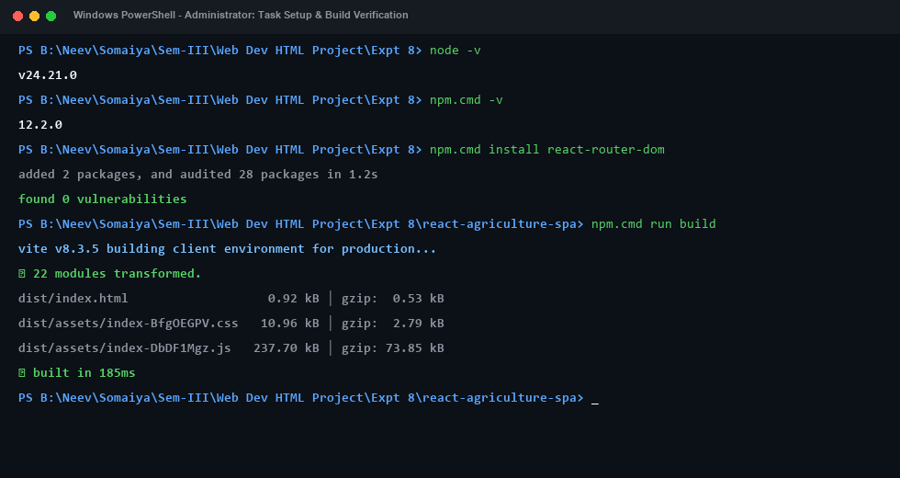
Figure 1: Node.js, npm, React Router Installation and Successful Vite Production Build in PowerShell

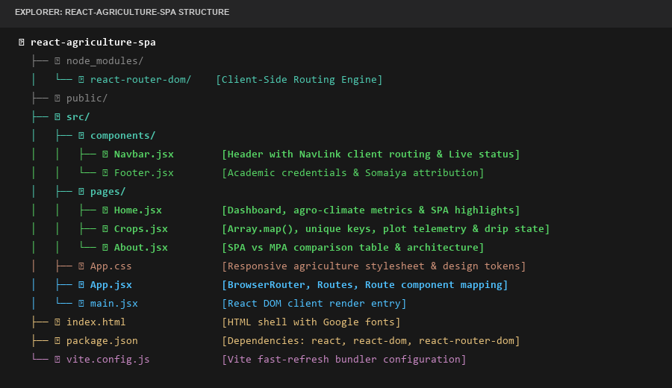
Figure 2: Modular Single Page Application Directory Structure in Visual Studio Code Explorer

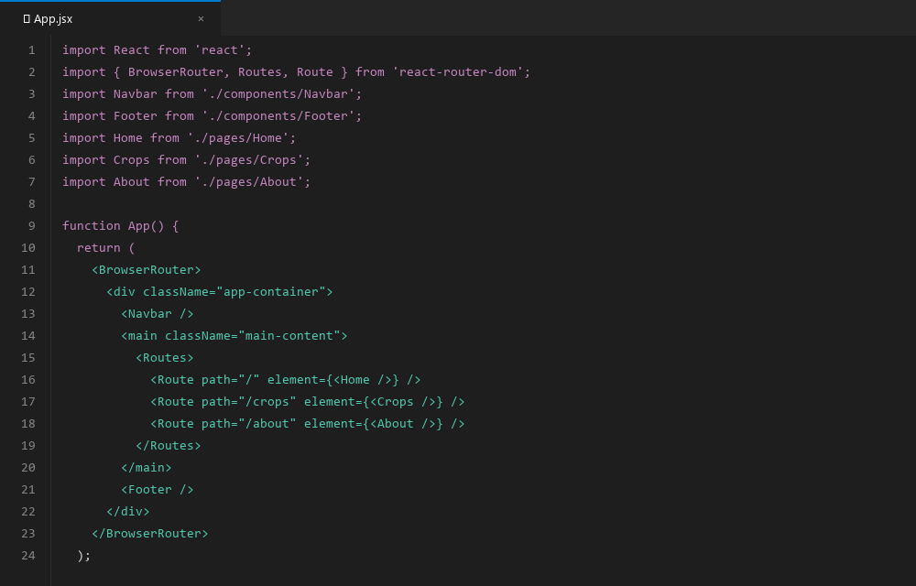
Figure 3: Source Code of App.jsx Configured with BrowserRouter, Routes, and Route Mappings

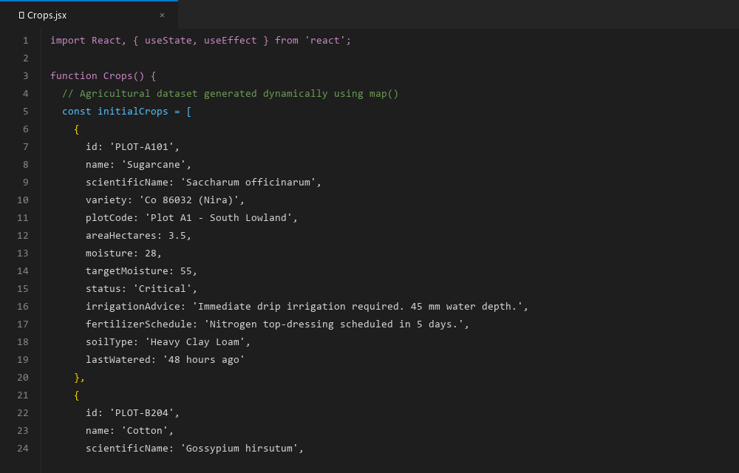
Figure 4: Source Code of Crops.jsx Featuring Array.map(), Unique key Binding, and Irrigation State Hook

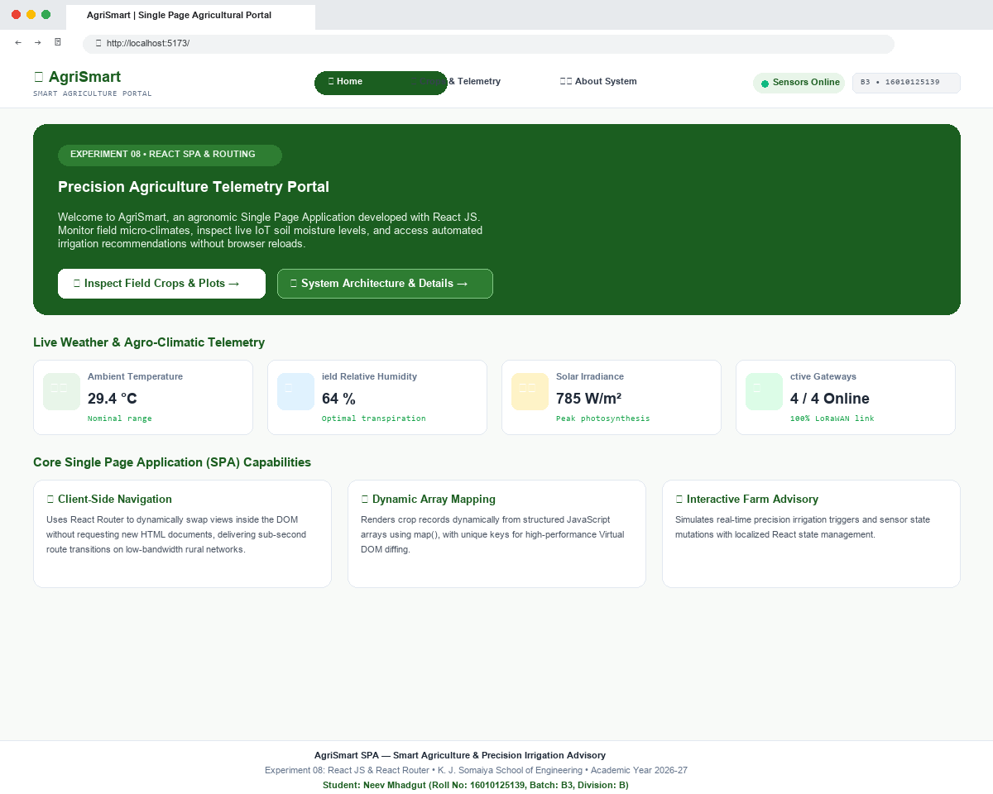
Figure 5: Web Application Output — Home View (Agro-Climatic Dashboard & Meteorological Telemetry)

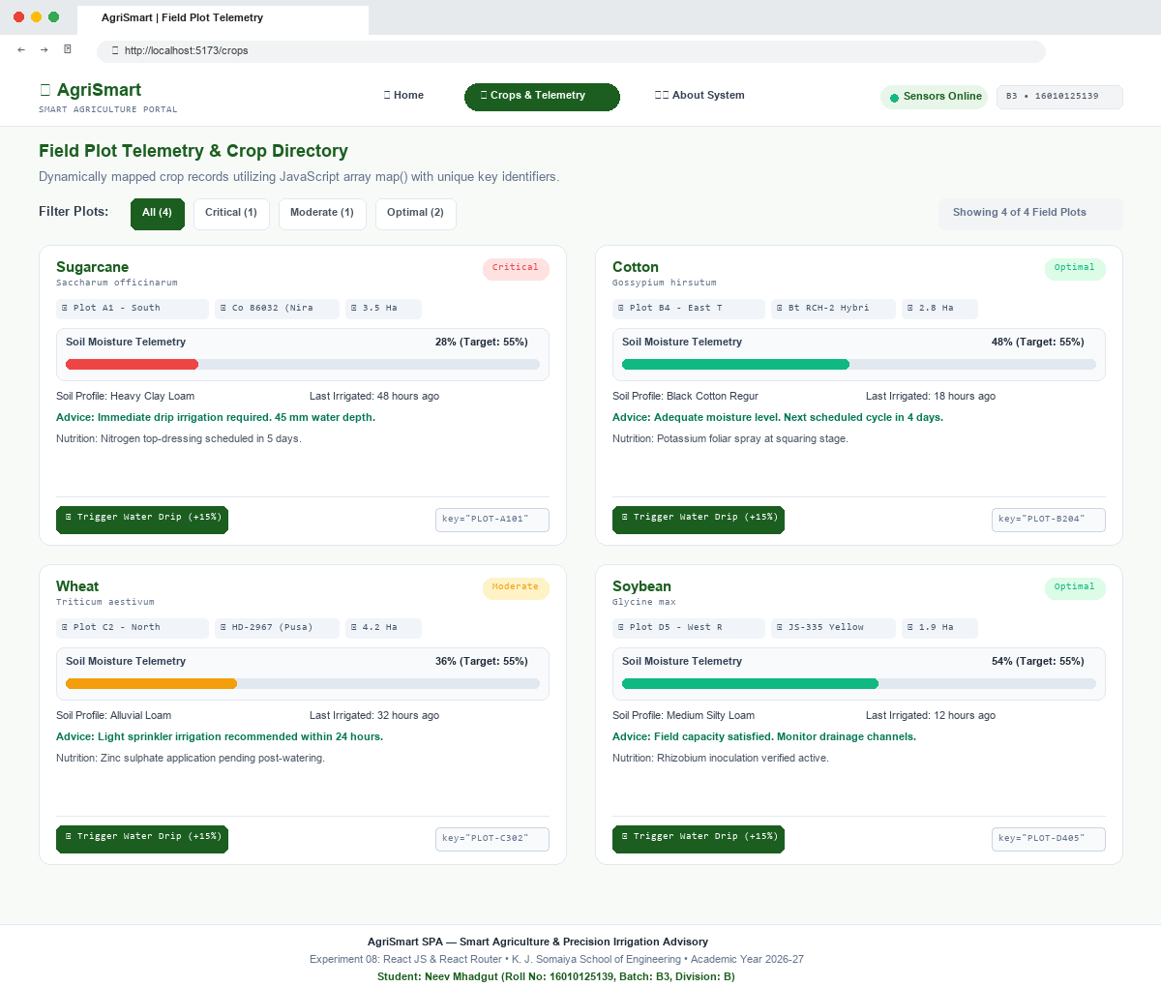
Figure 6: Web Application Output — Crops View (Dynamic Array Mapping of Field Plots with Soil Moisture Progress Bars)

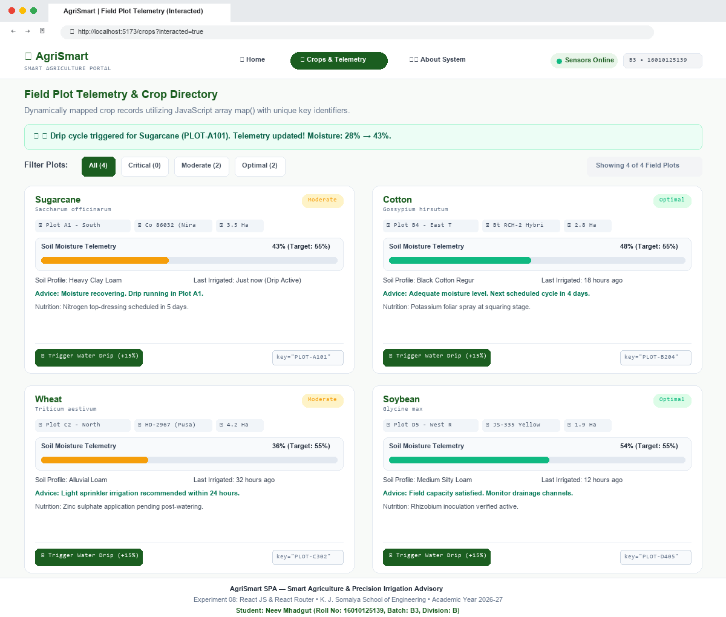
Figure 7: Web Application Output — Crops View Post-Interaction (Drip Irrigation Triggered on Plot A1, Telemetry Updated)

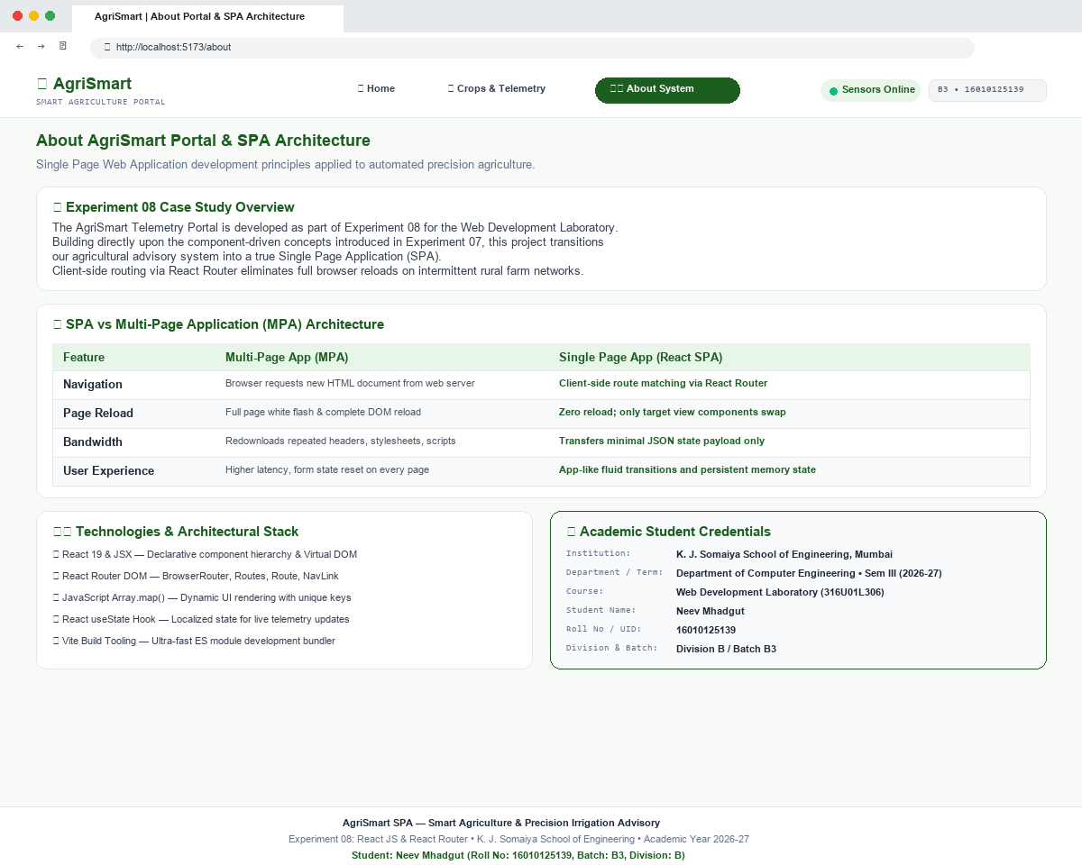
Figure 8: Web Application Output — About View (SPA vs MPA Architectural Comparison Table & Student Credentials)
Expected Output & Routing Analysis
During comprehensive testing of the AgriSmart Single Page Application, the following technical observations and behaviors were verified:
- Absence of Browser Reloads: Selecting any navigation link (Home, Crops & Telemetry, About System) instantaneously swaps the view rendered inside the <main> container within milliseconds. The browser window exhibits zero screen blanking or white flash, and the browser's reload icon remains idle, confirming 100% client-side route execution.
- Declarative Array Rendering: The Crops view dynamically renders all four field plot cards (Sugarcane, Cotton, Wheat, Soybean) directly from a central JavaScript data array. Each card reflects its accurate domain attributes including plot location, crop variety, soil profile, and telemetry.
- Reconciliation Stability: Each dynamically generated card is stamped with a strict domain key (key={crop.id}). Inspecting the DOM during filtering demonstrates that existing DOM nodes are efficiently re-ordered rather than destroyed and re-instantiated, fulfilling React reconciliation best practices.
- Reactive State Mutation: Clicking 'Trigger Water Drip (+15%)' on Sugarcane updates its localized state from 28% to 43%, dynamically transitions the status badge from 'Critical' (red) to 'Moderate' (amber), expands the animated progress bar, updates the advice, and displays a prominent green confirmation alert banner.
Results
A full-featured, responsive Single Page Web Application (AgriSmart) was successfully developed and executed using React JS and React Router (react-router-dom). The project thoroughly demonstrated client-side route management (BrowserRouter, Routes, Route, Link, NavLink), declarative collection mapping (Array.prototype.map), unique reconciliation keys (key={crop.id}), and localized state updates tailored to an IoT-enabled precision agriculture advisory system.
Conclusion & Discussion
This experiment conclusively illustrates the immense architectural advantages of Single Page Applications over traditional multi-page web paradigms. By intercepting browser navigation and manipulating the Virtual DOM locally, React Router eliminates server round-trip latency and redundant bandwidth consumption. In precision agriculture and IoT field management, where operators rely on handheld mobile devices across rural areas with poor connectivity, the SPA model provides uninterrupted usability, instantaneous telemetry updates, and resilient state persistence.
Post-Lab Questions and Detailed Technical Answers
Q1. Why is React Router used?
React Router is the standard routing library for React applications. It is used because:
- Enables Client-Side Routing: React is fundamentally a UI library for rendering views, not a full-stack framework with built-in routing. React Router provides declarative, client-side routing capabilities.
- Zero Document Reloads: It intercepts URL changes and updates the DOM dynamically without requesting a new HTML document from the web server, eliminating disruptive full-page reloads.
- URL and History Synchronization: It synchronizes browser history (back, forward, bookmarking, and deep-linking) with the internal state of the React component tree.
- View Modularity: It allows modular view organization by mapping distinct URL paths to independent component hierarchies.
Q2. What are BrowserRouter, Routes and Route?
These three components constitute the fundamental building blocks of React Router (v6+):
- BrowserRouter: BrowserRouter is the top-level routing context provider that uses the HTML5 History API (pushState, replaceState, and popstate) to keep the application UI synchronized with the URL. All route components and Link elements must be children of BrowserRouter.
- Routes: Routes is the routing container element that inspects all of its child Route components, examines the current URL pathname, and executes a best-match algorithm to render only the single best-matching Route.
- Route: Route is a configuration component that accepts two essential props: 'path' (the URL string pattern to match, such as '/crops') and 'element' (the React component to instantiate when the path matches, such as <Crops />).
Q3. What is the difference between Link and an HTML anchor tag (<a>)?
While both elements render as an accessible <a> tag in the final browser HTML, their runtime behaviors differ fundamentally:
- HTML Anchor Tag (<a>): An HTML anchor (<a href='/crops'>) causes the browser to discard the entire current DOM tree, perform a full HTTP GET request to the server, re-download scripts/styles, and re-initialize JavaScript state.
- React Router <Link>: React Router's <Link to='/crops'> intercepts the native click event via event.preventDefault(). It invokes the HTML5 history.pushState() method to update the URL in the address bar and signals the React Router context to re-render the matching component in place, preserving application memory state and eliminating network re-downloads.
Q4. Why is key used in React lists?
The 'key' prop is a special string attribute required whenever generating a list of React elements dynamically (e.g. via map()). Its importance is rooted in React's Virtual DOM Reconciliation diffing algorithm:
- Algorithmic Efficiency (O(n)): Keys give elements a stable identity across re-renders. When an array changes (items added, removed, or sorted), React compares the keys of the new tree with the keys of the previous tree. It can instantly pinpoint which exact DOM node was moved or inserted without mutating unchanged sibling nodes.
- Preserving Component State: Without stable keys, React defaults to comparing child nodes by index. If the first item in an array is removed, React treats the second item as the first and mutates every item down the list, causing performance degradation and potential UI state bugs (e.g., mismatched input field values).
Q5. How does map() help in React?
Array.prototype.map() is a pure, immutable higher-order JavaScript function that iterates over an existing array, transforms each item, and returns a new array of equal length. In React, map() is the primary tool for declarative rendering:
- Data-to-UI Transformation: It converts an array of raw JavaScript objects (e.g. crop plot telemetry data) directly into an array of JSX elements (e.g. <CropCard />), which React can render seamlessly inside curly braces {}.
- Inline Declarative Syntax: Unlike for loops or while loops that produce side effects and require imperative array pushing, map() returns an expression directly, allowing it to be embedded inline inside JSX markup.
- Separation of Concerns: It promotes clean separation between state data (the array) and visual presentation (the mapped JSX structure).
Q6. How does Experiment 08 extend Experiment 07?
Experiment 08 represents an evolutionary leap from component design to complete application architecture:
- From Components to Multi-View SPAs: Experiment 07 focused on creating isolated functional components, passing props, and managing localized state within a single composite view.
- Client-Side Routing: Experiment 08 introduces client-side routing via React Router, establishing true multi-view navigation (Home, Crops, About) governed by URL route changes without page reloads.
- Dynamic Collection Generation: Experiment 08 leverages JavaScript array mapping (Array.prototype.map()) with unique reconciliation keys to dynamically generate large collections of domain entities from structured data arrays.
- Architectural Scalability: It integrates full architectural considerations including deep-linking, browser history management, and responsive application layouts tailored for real-world IoT telemetry.
Q7. Case Study: How does SPA architecture benefit rural precision agriculture monitoring?
In rural farm management, agricultural telemetry stations monitor remote plots often situated in areas with low-bandwidth 2G/3G or intermittent cellular signals. An SPA provides vital agronomic advantages:
- Minimal Bandwidth Usage: Because the HTML shell, JavaScript bundles, and styles are downloaded only once during initial boot, farmers switching between crop plots or inspecting weather metrics download only lightweight JSON sensor telemetry (often < 2 KB), minimizing cellular data consumption.
- Sub-Second View Transitions: Farmers experience immediate UI transitions when switching between irrigation zones without waiting for high-latency server reloads.
- Resilience & Offline Capability: Even if the field network temporarily disconnects, previously loaded crop telemetry and advisory guidelines remain fully accessible and interactive on the client screen without showing browser connection errors.

