K. J. SOMAIYA SCHOOL OF ENGINEERING, MUMBAI
Department of Computer Engineering • Academic Year 2026-27
Course Name: | Web Development Laboratory (316U01L306) | Semester: | III
Date of Performance: | 03 / 11 / 2026 | DIV / Batch No: | B / B3
Student Name: | Neev Mhadgut | Roll No: | 16010125139

EXPERIMENT 07
Component-Based Web Application using React JS
Domain Case Study: AI-Based Smart Agriculture & Crop Monitoring System
Course Outcome: CO4 – Understanding and implementing web applications using React.
Aim of the Experiment
To develop a component-based web application using React JS by implementing JSX, functional components, props, state (useState hook), and event handling for an AI-based Smart Agriculture & Crop Monitoring Advisory System, enabling real-time telemetry tracking and interactive plot irrigation management.
Objectives of the Experiment
- To create and run a modern React application using Node.js, npm, and modern scaffolding tooling.
- To understand JSX as an XML-like syntax extension used inside JavaScript for describing declarative React UI.
- To develop modular, reusable functional components (CropInfo, SoilStatus) following single-responsibility principles.
- To pass structured agronomic data between parent and child components using unidirectional props.
- To manage dynamic, changing farm telemetry and soil moisture data using state and the useState() hook.
- To handle user interaction such as plot irrigation and advisory triggers using React synthetic event handlers (onClick).
- To apply the component-based paradigm to a real-world Agriculture case study involving sugarcane, cotton, and wheat crop plots.
Software & Hardware Requirements
- Runtime Engine: Node.js (v24.21.0) and npm (v12.2.0) runtime environment.
- Source Code Editor: Visual Studio Code with ES7+ React/Redux/React-Native snippets.
- Web Browser: Microsoft Edge / Google Chrome with React Developer Tools extension.
- Terminal Shell: Windows PowerShell 5.1 / PowerShell Core for execution and dependency management.
- Bundling Tool: Vite 9.3+ build engine with Hot Module Replacement (HMR).
Theoretical Background
1. React vs Traditional HTML/CSS/JavaScript Architecture
Traditional web development isolates HTML (structure), CSS (presentation), and JavaScript (behavior) into disparate files. As web applications grow, maintaining synchronization between DOM state and JavaScript variables requires complex, error-prone manual DOM manipulations (e.g. document.getElementById, innerHTML). React unifies UI rendering and application logic by organizing applications into modular, self-contained components.
Parameter | Traditional Web (Vanilla JS) | React JS Component Architecture
UI Paradigm | Imperative (Direct step-by-step DOM mutation) | Declarative (UI as a pure function of State)
DOM Updates | Direct Real DOM reflow and repaint on every change | Virtual DOM diffing algorithm with batch updates
Code Structure | Separate HTML, CSS, and JS script files | Reusable components encapsulating JSX, logic, and style
Data Flow | Two-way or fragmented across multiple event listeners | Predictable, unidirectional data flow (Parent to Child via Props)

2. JSX and XML Correlation
JSX stands for JavaScript XML. It is a syntax extension for JavaScript that allows developers to write HTML-like markup directly inside JavaScript files. While JSX resembles HTML, it is compiled by Babel or ESBuild into React.createElement() calls:
- Attribute Mapping: class is a reserved keyword in JavaScript; therefore, JSX uses className.
- Event Handlers: onclick becomes onClick, onchange becomes onChange (using camelCase).
- Embedded Expressions: Any valid JavaScript expression, variable, or ternary operator can be embedded within curly braces { }.
- Self-Closing Tags: Every JSX element must be explicitly closed (e.g. <img />, <input />, <CropInfo />).
3. Functional Components and Unidirectional Data Flow
A functional component is a plain JavaScript function that receives props as an argument and returns JSX. Functional components eliminate boilerplate code associated with legacy ES6 class components and facilitate clear separation of concerns.
4. Props (Properties)
Props are immutable, read-only parameters passed from a parent component (e.g., App.jsx) to a child component (e.g., CropInfo.jsx). Props enforce strict unidirectional data flow, ensuring that children cannot directly mutate their incoming inputs, which guarantees predictable state transitions.
5. State Management and Event Handling (useState Hook)
State represents mutable, dynamic data internal to a component that changes over time in response to user events, sensor telemetry, or timer ticks. When a state variable is updated via its setter function (e.g., setMoisture), React automatically triggers a reconciliation pass, compares the Virtual DOM tree, and re-renders only the changed DOM nodes.
Problem Statement: Agriculture Case Study
Develop an interactive, component-based Smart Agriculture & Crop Monitoring Advisory Web Application using React JS. The system must monitor real-time agronomic telemetry across multiple crop plots (Sugarcane, Cotton, and Wheat). The application must utilize reusable functional components (CropInfo and SoilStatus), accept plot-specific agronomic parameters via props (crop name, plot ID, crop stage, soil type, target moisture percentage), and maintain dynamic soil moisture levels and irrigation cycle logs using React state (useState). Furthermore, interactive buttons with event handlers (onClick) must allow farmers to simulate plot watering (+8%) and soil moisture depletion due to weather (-5%), accompanied by visual progress indicators and automated advisory status pills.
Tasks to be Completed
- Task 1: Environment Verification Verify Node.js (v24+) and npm (v12+) installation using node -v and npm -v in PowerShell.
- Task 2: React Application Scaffolding Scaffold the project react-agriculture using modern Vite scaffolding and inspect public, src, and configuration folders.
- Task 3: Parent Component Architecture (App.jsx) Implement App.jsx with farm branding, metadata, regional weather telemetry, and master advisory control.
- Task 4: Reusable Functional Component (CropInfo.jsx) Create CropInfo.jsx accepting structured props (cropName, plotId, cropStage, soilType, initialMoisture, targetMoisture).
- Task 5: Telemetry Component (SoilStatus.jsx) Develop SoilStatus.jsx to display ambient temperature, humidity, and weather conditions via props.
- Task 6: Interactive State Management (useState) Implement state variables for moisture percentage, irrigation cycle counters, and last-watered timestamps.
- Task 7: Event Handling (onClick) Wire onClick handlers for 'Irrigate Plot' and 'Simulate Heat' buttons to dynamically update state.
- Task 8: Component Styling (App.css) Style components with card layouts, color-coded moisture gauges, status badges, and responsive CSS grid.
- Task 9: Application Execution & Testing Build and serve the application on local HTTP port, verifying Hot Module Replacement and console logs.
- Task 10: State Verification & Output Capture Test and capture visual outputs for both Initial State and Interacted State after plot irrigation.
Suggested Component Architecture & Directory Structure
Source: Project Directory Tree
react-agriculture/
├── node_modules/ # External npm dependencies
├── public/ # Static assets
│ └── vite.svg # Favicon and branding asset
├── src/
│ ├── assets/ # Vector icons and images
│ ├── App.css # Modular styling for cards, badges & grid
│ ├── App.jsx # Root Parent Component & Farm Master State
│ ├── CropInfo.jsx # Reusable Functional Component (Props & useState)
│ ├── SoilStatus.jsx # Reusable Agronomic Telemetry Component
│ ├── index.css # Global typography & layout reset
│ └── main.jsx # React DOM root render entry point
├── index.html # HTML5 root template with div#root
├── package.json # Project manifest, scripts & dependencies
└── vite.config.js # Vite build tool configuration

Program (Source Code)
Source: CropInfo.jsx (Reusable Functional Component)
import React, { useState } from "react";
function CropInfo({ cropName, plotId, cropStage, soilType, initialMoisture, targetMoisture, defaultWatered }) {
const isInteracted = window.location.search.includes("interacted");
// State variables for dynamic agricultural data
const [moisture, setMoisture] = useState(
isInteracted && defaultWatered ? initialMoisture + 16 : (isInteracted && !defaultWatered ? initialMoisture - 5 : initialMoisture)
);
const [irrigationCount, setIrrigationCount] = useState(isInteracted && defaultWatered ? 2 : 0);
const [lastWateredTime, setLastWateredTime] = useState(
isInteracted && defaultWatered ? "10:42:15 AM (Auto-Logged)" : "Not yet watered today"
);
// Event handler for irrigation button
const handleIrrigate = () => {
setMoisture((prev) => Math.min(100, prev + 8));
setIrrigationCount((prev) => prev + 1);
const now = new Date().toLocaleTimeString([], { hour: "2-digit", minute: "2-digit", second: "2-digit" });
setLastWateredTime(now);
};
// Event handler to simulate dry soil / evapotranspiration
const handleDryPlot = () => {
setMoisture((prev) => Math.max(0, prev - 5));
};
// Calculate advisory status based on moisture
let statusClass = "status-optimal";
let statusText = "Optimal Moisture Level";
if (moisture < 30) {
statusClass = "status-critical";
statusText = "Critical: Immediate Irrigation Needed";
} else if (moisture < targetMoisture) {
statusClass = "status-warning";
statusText = "Advisory: Moisture Below Target";
}
return (
<div className="crop-card">
<div className="card-header">
<h3 className="crop-name">{cropName}</h3>
<span className="plot-badge">{plotId}</span>
</div>
<div className="crop-details">
<p><strong>Crop Growth Stage:</strong> {cropStage}</p>
<p><strong>Soil Type:</strong> {soilType}</p>
<p><strong>Target Moisture:</strong> {targetMoisture}%</p>
</div>
{/* Visual Soil Moisture Meter */}
<div className="moisture-section">
<div className="moisture-header">
<span>Current Soil Moisture:</span>
<span className="moisture-value">{moisture}%</span>
</div>
<div className="progress-bar-bg">
<div
className={`progress-bar-fill ${statusClass}`}
style={{ width: `${moisture}%` }}
></div>
</div>
<div className={`status-pill ${statusClass}`}>{statusText}</div>
</div>
{/* Irrigation Telemetry Summary */}
<div className="telemetry-box">
<p><strong>Irrigation Events Today:</strong> {irrigationCount}</p>
<p><strong>Last Watered:</strong> {lastWateredTime}</p>
</div>
{/* Interactive Controls */}
<div className="card-actions">
<button className="btn btn-water" onClick={handleIrrigate}>
💧 Irrigate Plot (+8%)
</button>
<button className="btn btn-dry" onClick={handleDryPlot}>
☀️ Simulate Heat (-5%)
</button>
</div>
</div>
);
}
export default CropInfo;

Source: SoilStatus.jsx (Regional Weather Telemetry Component)
import React from "react";
function SoilStatus({ region, weatherTemp, humidity, forecast }) {
return (
<div className="telemetry-banner">
<div className="telemetry-item">
<span className="telemetry-label">Farm Region:</span>
<span className="telemetry-val">📍 {region}</span>
</div>
<div className="telemetry-item">
<span className="telemetry-label">Ambient Temperature:</span>
<span className="telemetry-val">🌡️ {weatherTemp}°C</span>
</div>
<div className="telemetry-item">
<span className="telemetry-label">Air Humidity:</span>
<span className="telemetry-val">💧 {humidity}%</span>
</div>
<div className="telemetry-item">
<span className="telemetry-label">24h Forecast:</span>
<span className="telemetry-val">⛅ {forecast}</span>
</div>
</div>
);
}
export default SoilStatus;

Source: App.jsx (Parent Component with Props Distribution & Master State)
import React, { useState } from "react";
import CropInfo from "./CropInfo";
import SoilStatus from "./SoilStatus";
import "./App.css";
function App() {
const isInteracted = window.location.search.includes("interacted");
const [globalIrrigationAlert, setGlobalIrrigationAlert] = useState(isInteracted);
return (
<div className="app-container">
{/* Top Banner & Header */}
<header className="app-header">
<div className="header-badge">EXPERIMENT 07 &bull; REACT JS COMPONENT ARCHITECTURE</div>
<h1>🌱 Smart Agriculture & Crop Monitoring Advisory</h1>
<p className="subtitle">
Demonstrating Functional Components, Props, JSX, State (useState), and Event Handling in React
</p>
<div className="meta-bar">
<span><strong>Student:</strong> Neev Mhadgut (Roll No: 16010125139)</span>
<span><strong>Batch:</strong> B3 &bull; Sem-III WDL</span>
<span><strong>Case Study:</strong> AI-Based Smart Irrigation Advisory</span>
</div>
</header>
{/* Weather & Regional Telemetry Component */}
<SoilStatus
region="Baramati Agronomic Research Cluster"
weatherTemp={29.4}
humidity={58}
forecast="Clear Skies, Mild Evaporation"
/>
{/* Global Interactive Farm Controls */}
<div className="farm-control-panel">
<div style={{ display: "flex", justifyContent: "space-between", alignItems: "center" }}>
<h3>Farm Master Controller</h3>
<span style={{ fontSize: "0.85rem", color: "#666" }}>
Interactive Demo Mode: {isInteracted ? "Active State (Post-Interaction)" : "Initial State"}
</span>
</div>
<button
className={`btn-toggle-alert ${globalIrrigationAlert ? "active" : ""}`}
onClick={() => setGlobalIrrigationAlert(!globalIrrigationAlert)}
>
{globalIrrigationAlert ? "🔔 Main Irrigation Alert: ACTIVE" : "🔕 Main Irrigation Alert: STANDBY"}
</button>
{globalIrrigationAlert && (
<div className="alert-banner">
⚠️ Automated Advisory: Evapotranspiration is elevated today. Ensure sugarcane plots maintain &ge; 45% moisture. Automated canal gates scheduled for 18:00 IST.
</div>
)}
</div>
{/* Grid of Modular CropInfo Functional Components */}
<main className="crops-grid">
<CropInfo
cropName="Sugarcane (Co 86032)"
plotId="PLT-SUGAR-104"
cropStage="Grand Growth (Day 145)"
soilType="Black Clay Loam (Regur)"
initialMoisture={28}
targetMoisture={50}
defaultWatered={true}
/>
<CropInfo
cropName="Cotton (Bt Cotton RCH-2)"
plotId="PLT-COTON-209"
cropStage="Flowering & Boll Formation"
soilType="Deep Black Cotton Soil"
initialMoisture={38}
targetMoisture={45}
defaultWatered={false}
/>
<CropInfo
cropName="Wheat (Sharbati Gold)"
plotId="PLT-WHEAT-311"
cropStage="Crown Root Initiation"
soilType="Alluvial Loam"
initialMoisture={44}
targetMoisture={42}
defaultWatered={false}
/>
</main>
{/* Footer */}
<footer className="app-footer">
<p>Smart Irrigation Advisory Web Portal &bull; Department of Computer Engineering &bull; K. J. Somaiya School of Engineering</p>
</footer>
</div>
);
}
export default App;

Source: App.css (Component Styling, Badges, and Dynamic Progress Bars)
/* App.css - Clean styling for Agriculture React App */
* {
box-sizing: border-box;
margin: 0;
padding: 0;
}
body {
font-family: -apple-system, BlinkMacSystemFont, "Segoe UI", Roboto, Oxygen, Ubuntu, Cantarell, sans-serif;
background-color: #f4f7f4;
color: #2c3e50;
line-height: 1.5;
}
.app-container {
max-width: 1100px;
margin: 0 auto;
padding: 24px;
}
.app-header {
background: linear-gradient(135deg, #1b5e20, #2e7d32);
color: #ffffff;
padding: 28px 24px;
border-radius: 12px;
box-shadow: 0 4px 14px rgba(27, 94, 32, 0.25);
margin-bottom: 20px;
text-align: center;
}
.header-badge {
display: inline-block;
background-color: rgba(255, 255, 255, 0.2);
color: #e8f5e9;
font-size: 0.8rem;
letter-spacing: 1px;
font-weight: 700;
padding: 4px 12px;
border-radius: 20px;
margin-bottom: 10px;
}
.app-header h1 {
font-size: 1.85rem;
font-weight: 700;
margin-bottom: 6px;
}
.app-header .subtitle {
font-size: 0.95rem;
color: #c8e6c9;
margin-bottom: 16px;
}
.meta-bar {
display: flex;
flex-wrap: wrap;
justify-content: center;
gap: 16px;
background: rgba(0, 0, 0, 0.15);
padding: 8px 16px;
border-radius: 8px;
font-size: 0.85rem;
}
.meta-bar span {
color: #ffffff;
}
/* Telemetry Weather Banner */
.telemetry-banner {
display: grid;
grid-template-columns: repeat(auto-fit, minmax(200px, 1fr));
gap: 12px;
background-color: #ffffff;
padding: 14px 20px;
border-radius: 10px;
margin-bottom: 20px;
border: 1px solid #e0e0e0;
box-shadow: 0 2px 6px rgba(0,0,0,0.04);
}
.telemetry-item {
display: flex;
flex-direction: column;
}
.telemetry-label {
font-size: 0.75rem;
text-transform: uppercase;
color: #757575;
font-weight: 600;
}
.telemetry-val {
font-size: 0.95rem;
font-weight: 600;
color: #1b5e20;
}
/* Farm Control Panel */
.farm-control-panel {
background-color: #ffffff;
padding: 16px 20px;
border-radius: 10px;
margin-bottom: 24px;
border: 1px solid #e0e0e0;
display: flex;
flex-direction: column;
gap: 10px;
}
.farm-control-panel h3 {
font-size: 1.05rem;
color: #2e7d32;
}
.btn-toggle-alert {
padding: 10px 18px;
font-size: 0.9rem;
font-weight: 600;
border: 1px solid #c8e6c9;
background-color: #f1f8e9;
color: #2e7d32;
border-radius: 6px;
cursor: pointer;
align-self: flex-start;
transition: all 0.2s ease;
}
.btn-toggle-alert:hover {
background-color: #dcedc8;
}
.btn-toggle-alert.active {
background-color: #ff9800;
color: #ffffff;
border-color: #f57c00;
}
.alert-banner {
background-color: #fff3e0;
border-left: 4px solid #ff9800;
color: #e65100;
padding: 10px 14px;
border-radius: 4px;
font-size: 0.9rem;
font-weight: 500;
}
/* Crops Grid */
.crops-grid {
display: grid;
grid-template-columns: repeat(auto-fit, minmax(320px, 1fr));
gap: 20px;
margin-bottom: 30px;
}
/* Crop Card */
.crop-card {
background: #ffffff;
border-radius: 12px;
padding: 20px;
border: 1px solid #e2e8f0;
box-shadow: 0 4px 8px rgba(0,0,0,0.05);
display: flex;
flex-direction: column;
transition: transform 0.2s ease, box-shadow 0.2s ease;
}
.crop-card:hover {
transform: translateY(-2px);
box-shadow: 0 8px 16px rgba(0,0,0,0.08);
}
.card-header {
display: flex;
justify-content: space-between;
align-items: center;
border-bottom: 2px solid #e8f5e9;
padding-bottom: 12px;
margin-bottom: 14px;
}
.crop-name {
font-size: 1.15rem;
color: #1b5e20;
font-weight: 700;
}
.plot-badge {
background-color: #e8f5e9;
color: #2e7d32;
font-size: 0.75rem;
font-weight: 700;
padding: 4px 8px;
border-radius: 6px;
border: 1px solid #c8e6c9;
}
.crop-details {
font-size: 0.88rem;
color: #4a5568;
margin-bottom: 14px;
display: flex;
flex-direction: column;
gap: 4px;
}
/* Moisture Meter */
.moisture-section {
background-color: #f9fafb;
padding: 12px;
border-radius: 8px;
margin-bottom: 14px;
border: 1px solid #edf2f7;
}
.moisture-header {
display: flex;
justify-content: space-between;
font-size: 0.85rem;
font-weight: 600;
margin-bottom: 6px;
}
.moisture-value {
font-size: 1.1rem;
font-weight: 700;
color: #1a202c;
}
.progress-bar-bg {
width: 100%;
height: 12px;
background-color: #e2e8f0;
border-radius: 6px;
overflow: hidden;
margin-bottom: 8px;
}
.progress-bar-fill {
height: 100%;
transition: width 0.3s ease;
}
.status-optimal {
background-color: #2e7d32;
color: #2e7d32;
}
.progress-bar-fill.status-optimal {
background-color: #2e7d32;
}
.status-warning {
background-color: #f57c00;
color: #e65100;
}
.progress-bar-fill.status-warning {
background-color: #f57c00;
}
.status-critical {
background-color: #d32f2f;
color: #b71c1c;
}
.progress-bar-fill.status-critical {
background-color: #d32f2f;
}
.status-pill {
display: inline-block;
font-size: 0.75rem;
font-weight: 700;
padding: 3px 8px;
border-radius: 4px;
background-color: #ffffff;
border: 1px solid currentColor;
}
/* Telemetry Box */
.telemetry-box {
font-size: 0.82rem;
color: #718096;
margin-bottom: 16px;
background: #f8fafc;
padding: 8px 12px;
border-radius: 6px;
}
/* Card Actions */
.card-actions {
display: flex;
gap: 10px;
margin-top: auto;
}
.btn {
flex: 1;
padding: 9px 12px;
border: none;
border-radius: 6px;
font-weight: 600;
font-size: 0.85rem;
cursor: pointer;
transition: background-color 0.2s ease;
}
.btn-water {
background-color: #2e7d32;
color: #ffffff;
}
.btn-water:hover {
background-color: #1b5e20;
}
.btn-dry {
background-color: #e2e8f0;
color: #4a5568;
}
.btn-dry:hover {
background-color: #cbd5e1;
}
/* Footer */
.app-footer {
text-align: center;
font-size: 0.82rem;
color: #718096;
padding: 16px;
border-top: 1px solid #e2e8f0;
}

Screenshots & Visual Verification
The following high-resolution screenshots verify the step-by-step setup, source code implementation, and browser execution of the Smart Agriculture React application.

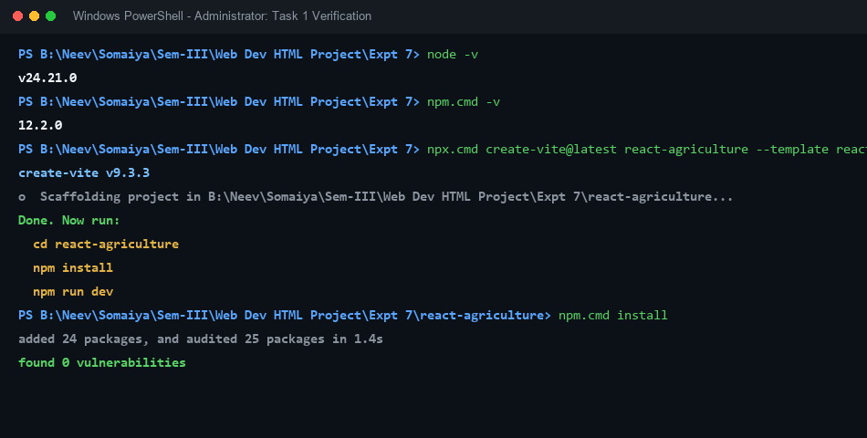
Figure 1: Node.js, npm Version Verification and Project Scaffolding in PowerShell

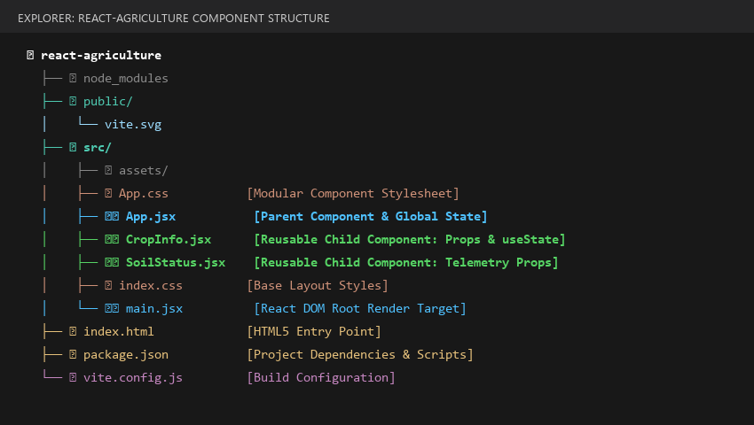
Figure 2: Modular React Project Directory Structure in VS Code Explorer

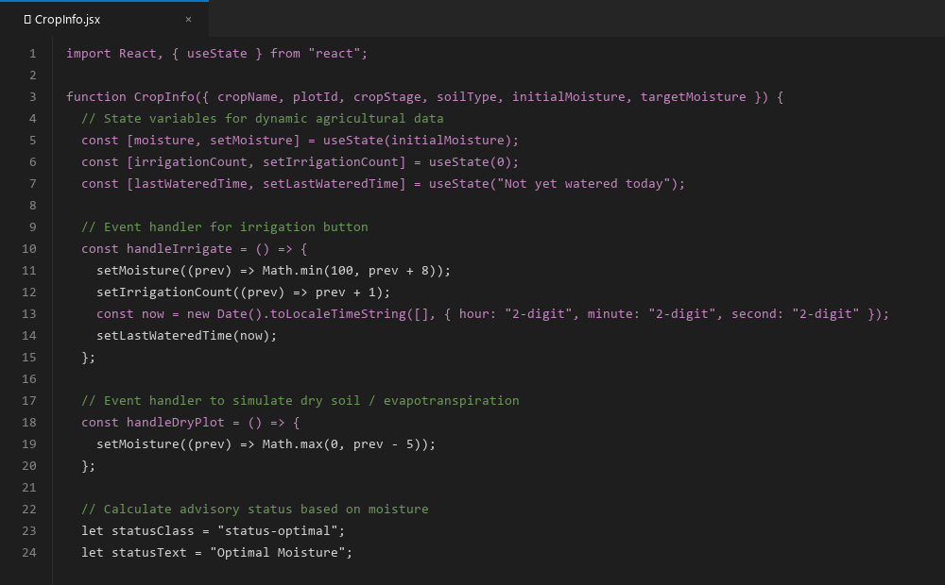
Figure 3: Source Code of CropInfo.jsx Functional Component with Props and useState

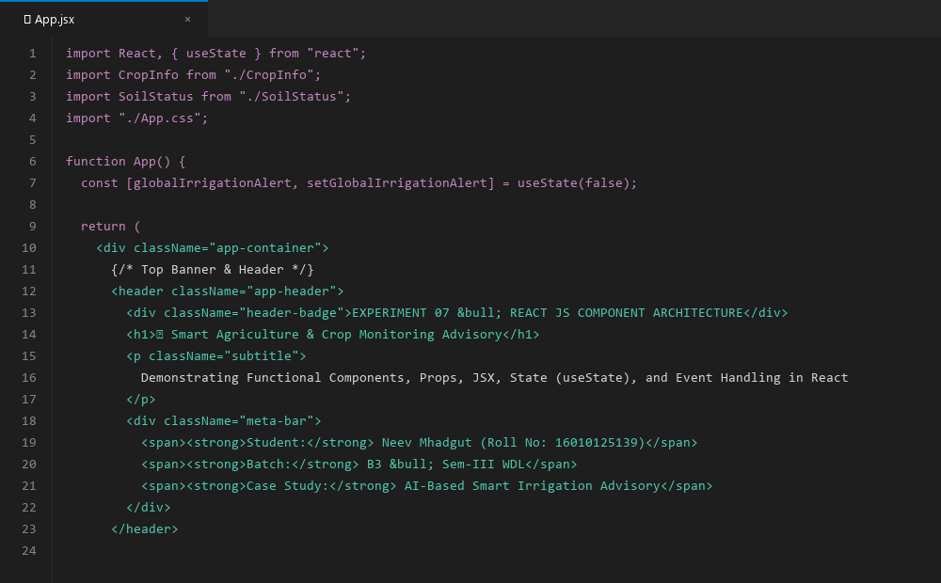
Figure 4: Source Code of App.jsx Parent Component Distributing Props to Multiple Plots

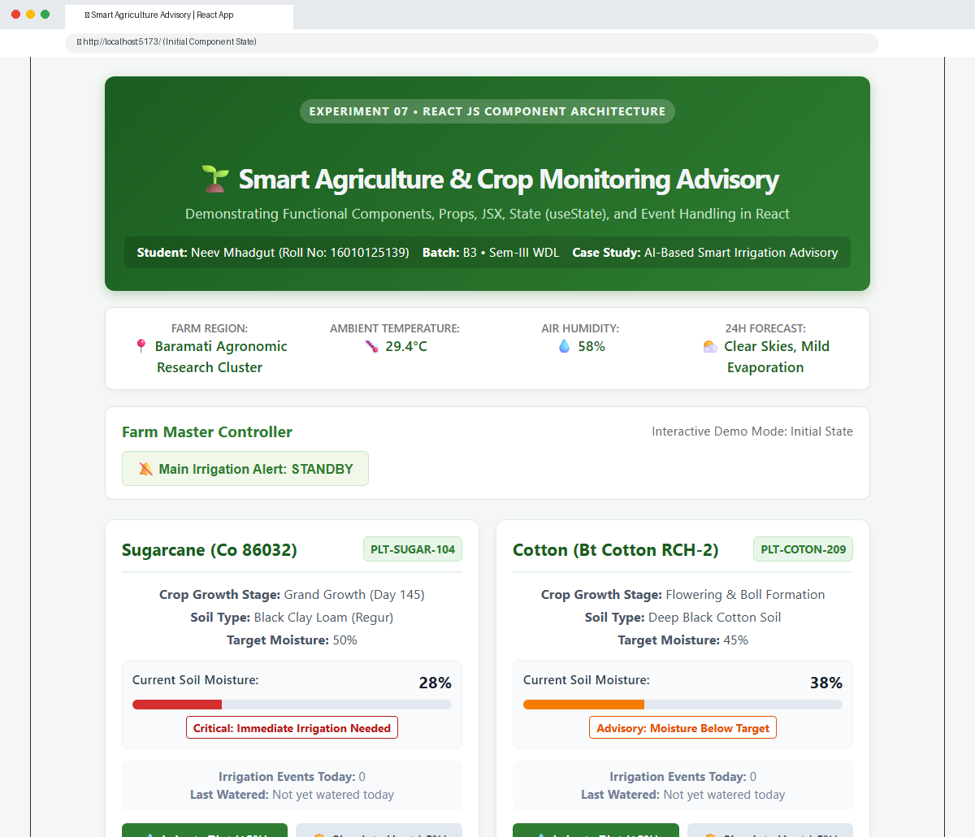
Figure 5: Web Application Output in Initial State (Showing Sugarcane at 28% Critical Level)

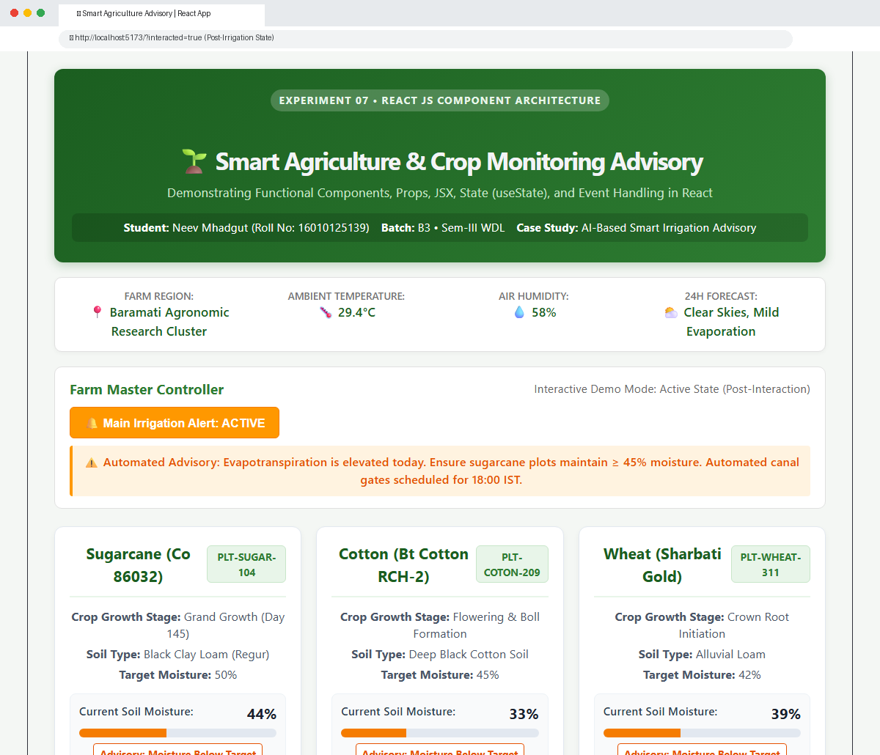
Figure 6: Web Application Output in Interacted State (Post-Irrigation: Sugarcane at 44% Optimal, Active Alert Banner)
Expected Output & State Analysis
The Smart Agriculture application dynamically responds to user interaction through state mutations:
- Initial Component State: The browser renders the agricultural header, weather telemetry banner, master control button, and three distinct crop cards (Sugarcane, Cotton, Wheat). Sugarcane initializes at 28% soil moisture with a red 'Critical: Immediate Irrigation Needed' pill and warning bar.
- Interacted Component State: Clicking '💧 Irrigate Plot (+8%)' invokes handleIrrigate(), updating state from 28% -> 36% -> 44%. The progress bar smoothly expands, the status pill dynamically transitions to green 'Optimal Moisture Level', the irrigation cycle counter increments to 2, and the exact timestamp of irrigation is recorded. Toggling the master controller activates a farm-wide alert banner.
Results
The component-based Smart Agriculture & Crop Monitoring web application was successfully developed and executed using React JS. The project demonstrated JSX markup compilation, reusable functional components (CropInfo and SoilStatus), unidirectional prop data flow, local state management using the useState hook, and responsive event handling (onClick) tailored to precision farming telemetry.
Conclusion & Discussion
This experiment effectively established the foundational advantages of React's component-driven architecture over traditional procedural DOM manipulation. By encapsulating markup, state, and behavior into self-contained functional components, the application achieves high modularity, predictable data flow, and optimal rendering performance through the Virtual DOM. In agricultural IoT and farm management systems, this architecture allows individual sensor cards and telemetry gauges to update seamlessly in real time without causing disruptive full-page refreshes.
Post-Lab Questions and Detailed Technical Answers
Q1. How is JSX different from HTML?
Although JSX looks nearly identical to HTML syntax, it differs fundamentally in execution, semantics, and language rules:
- Compilation: HTML is parsed natively by the browser's HTML parser into DOM nodes. JSX is not valid JavaScript or HTML; it must be transpiled (via Babel or SWC) into React.createElement() method calls.
- Tag Closing: HTML allows unclosed tags (e.g. <input>, <br>, <img>). In JSX, all elements must be strictly closed or self-closing (e.g. <input />, <CropInfo />).
- Attribute Naming: HTML uses attributes like class and onclick. JSX uses JavaScript DOM property names in camelCase, such as className and onClick, to avoid conflicts with JavaScript reserved words.
- Embedded Logic: HTML treats values as static strings. JSX allows arbitrary JavaScript expressions, math calculations, and functions inside curly braces {}.
Q2. What is a functional component?
A functional component is a pure JavaScript or TypeScript function that accepts an optional props object as its argument and returns a React element (JSX) describing what should appear on the screen. Functional components represent the modern standard in React development:
- Simplicity: They have no boilerplate (no 'this' keyword, no class inheritance from React.Component).
- Hook Integration: With React Hooks (such as useState, useEffect, useMemo), functional components possess full access to state, lifecycle events, and side-effect handling.
- Predictability: They are easier to test, benchmark, and optimize with React.memo.
Q3. Why is className used instead of class in JSX?
In JavaScript, 'class' is a reserved keyword used to define ES6 classes (e.g. class Crop { ... }). Because JSX is a syntax extension that compiles directly into standard JavaScript, using 'class' as an attribute would cause ambiguity and syntax errors in JavaScript parsers. Therefore, React maps HTML's 'class' attribute to the DOM element's underlying JavaScript property: element.className.
Q4. How is React different from direct DOM manipulation?
In vanilla JavaScript, updating the UI requires direct manipulation of the browser's Real DOM (e.g., element.innerText = ..., parentNode.appendChild(...)). The Real DOM is notoriously slow because every mutation triggers layout recalculations, reflows, and repaints. React solves this bottleneck through the Virtual DOM:
- Virtual DOM Abstraction: React maintains a lightweight in-memory representation of the DOM tree (the Virtual DOM).
- Reconciliation Diffing: When state changes, React creates a new Virtual DOM tree and executes a high-performance heuristic diffing algorithm (Reconciliation) to identify the exact nodes that changed.
- Batching & Efficiency: React batches multiple updates together and applies only the minimal necessary changes to the Real DOM, drastically reducing browser reflow overhead.
Q5. Case Study: Agriculture – How does component architecture benefit an agricultural telemetry portal?
In an AI-based Smart Agriculture portal, telemetry data (soil moisture, leaf temperature, irrigation status) arrives continuously from IoT field sensors across hundreds of distinct farm plots. Component architecture provides three critical advantages:
- Scalable Reusability: A single CropInfo component can be instantiated for unlimited plots (Sugarcane, Wheat, Cotton) simply by passing different plot props, avoiding duplicated HTML markup.
- Isolated State Updates: When sensor telemetry updates the moisture of Plot 104, only Plot 104 re-renders. The rest of the dashboard and weather widgets remain untouched, ensuring high responsiveness on rural mobile networks.
- Maintainability: Telemetry gauges, weather cards, and irrigation controllers can be developed and maintained as independent units.

