Intitally, Take the dataset and see its first five elements

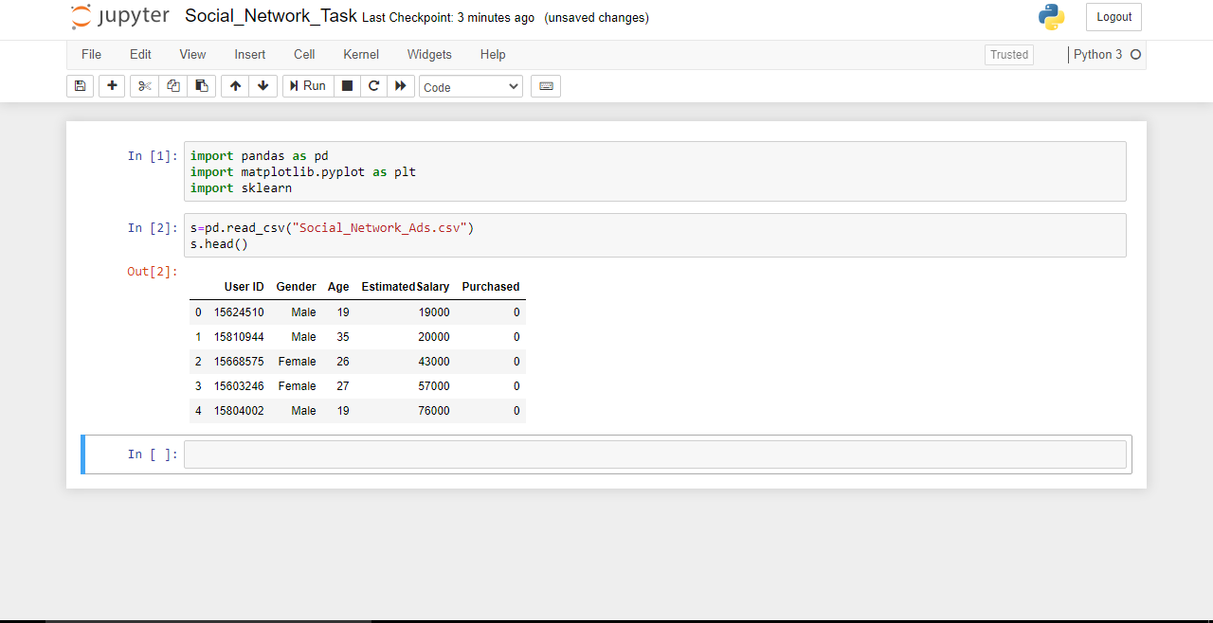

Now to see the correlation between the columns plot a heatmap from seaborn library

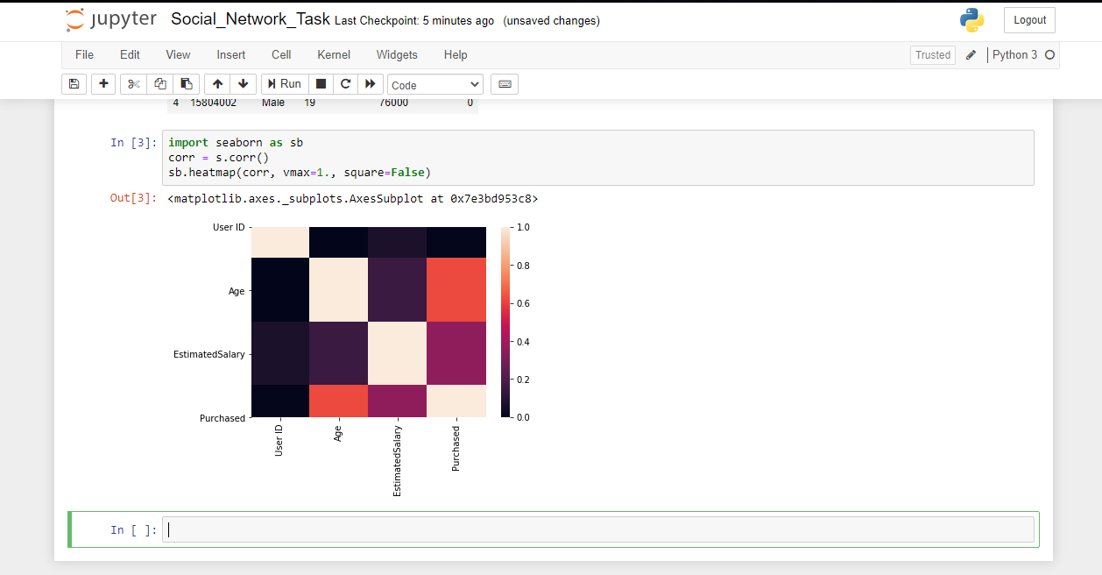

Now take the x and y variables and create a dataframe for it

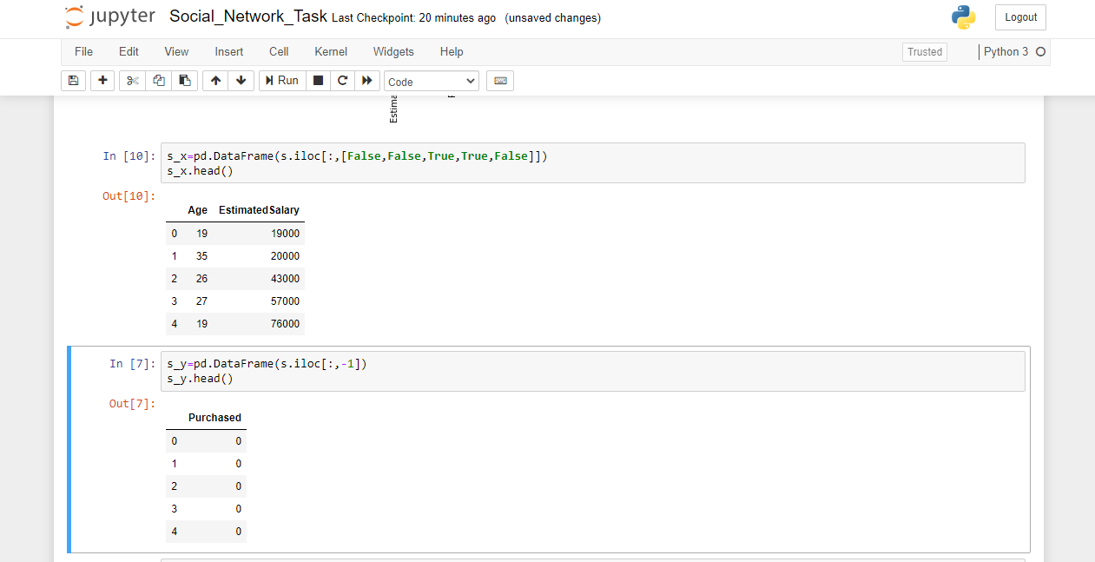

Now, here we can have two models to compare our results  
1) Multivariate Linear Regression

2) Decision Tree Regressor

3) Decision Tree Classifier

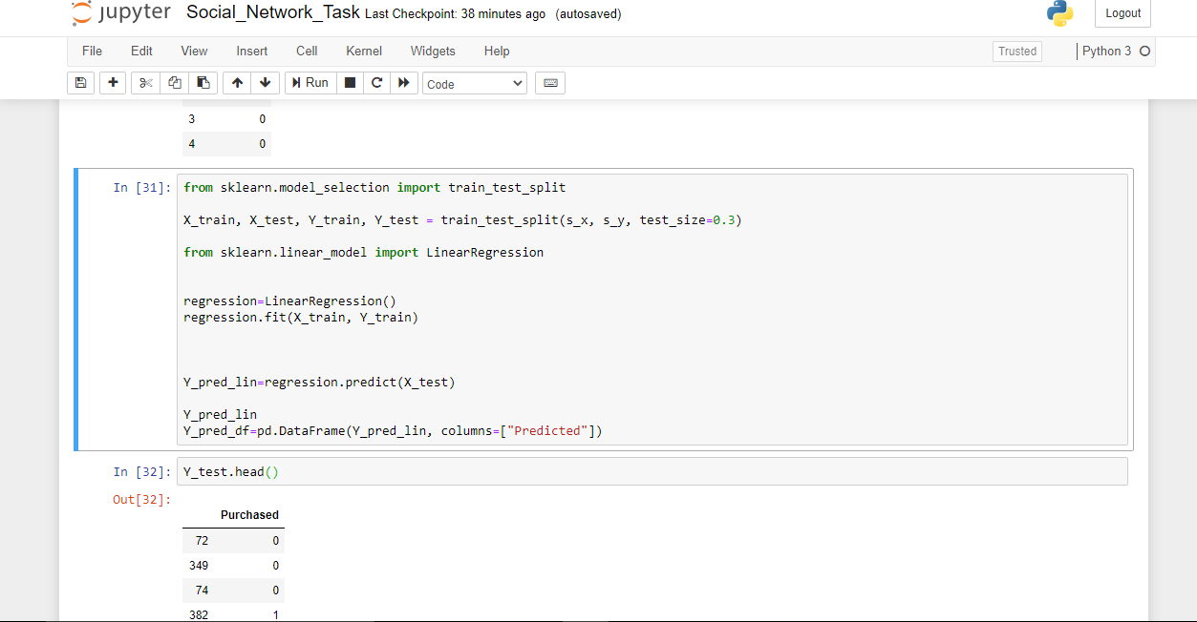

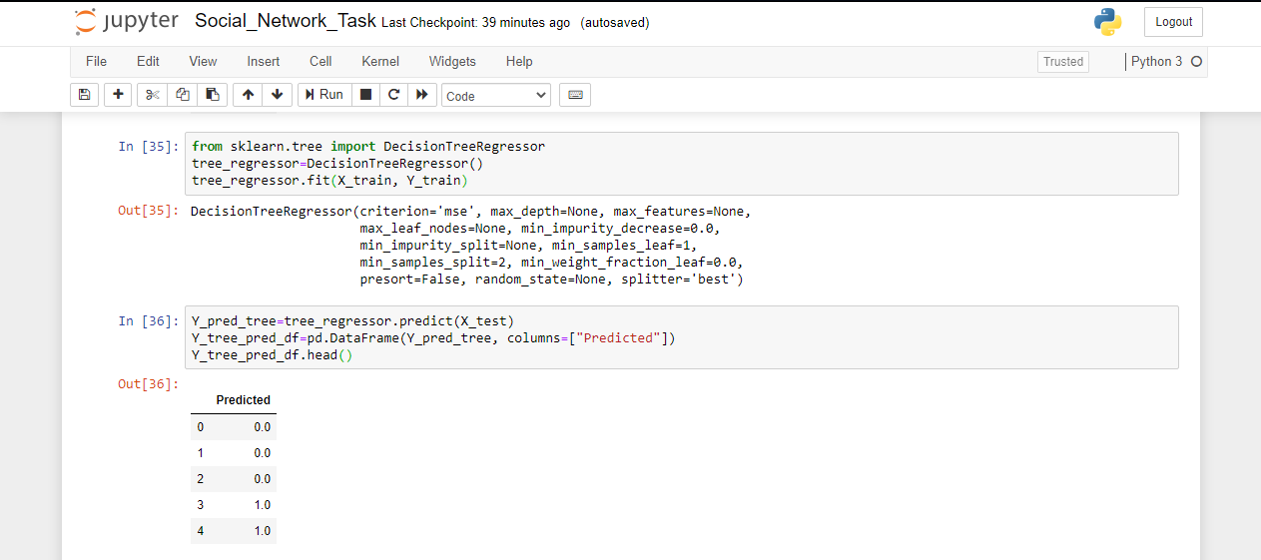

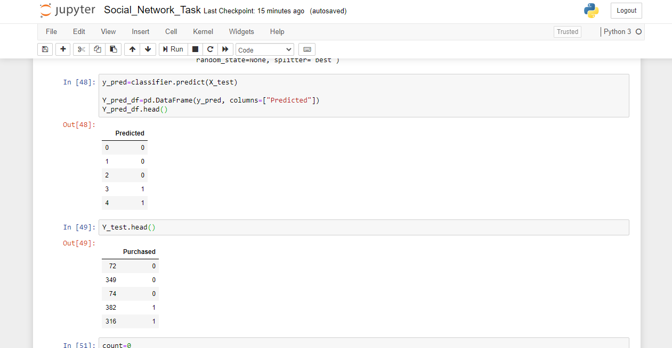

Next, we compare the error values between that is the difference between actual and predicted values and check the accuracy score for all the models and see which one is suitable

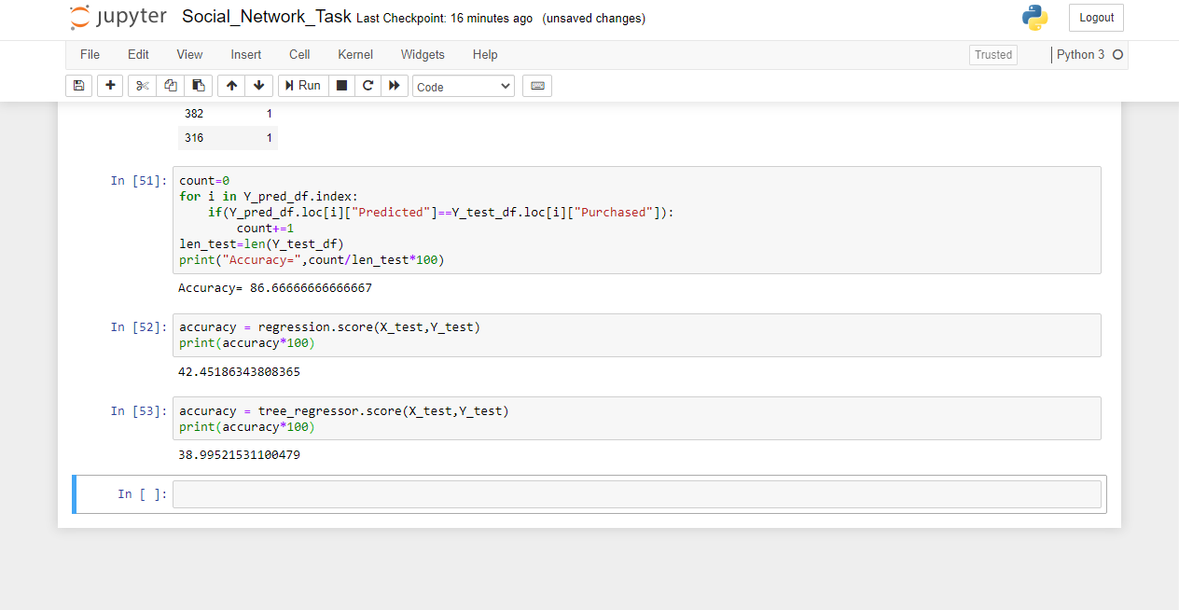

And so the conclusion is that Decision Tree Classifier Model Suits the best with more than 85% accuracy